# TAX Exception on customer

How to create Tax Exemption:

Navigate to Tax Manager à Parties à Party Tax Profiles

Query the specific Customer (make sure the party type is ‘Third Party’)

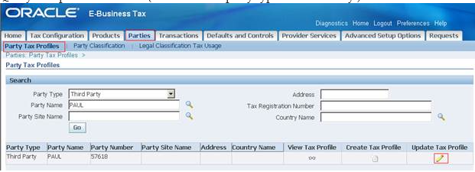

Now click on ‘Update Profile’

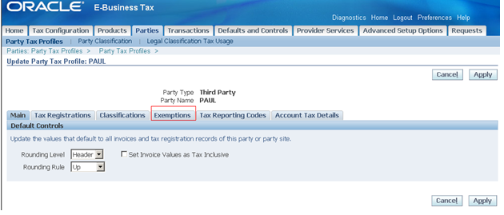

Go to Exemptions tab

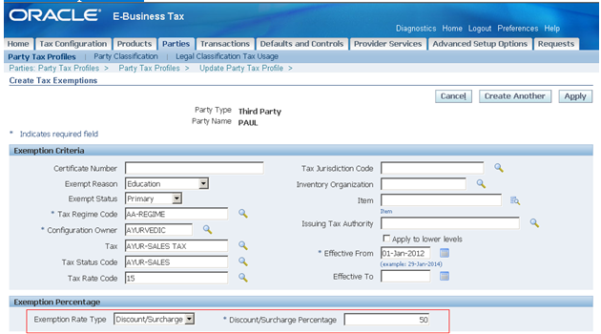

Enter all the details shown above

Here the rate entered Discount / Surcharge %: 50 and click on Apply

Actual rate is 15 %, Discount %: 50, New rate: 15 * 50/100 = 7.5 %

When there are no Tax Exemptions, the tax rate is 15 % and below is the example

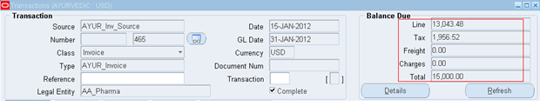

13,043.48 * 15/100 = 1,956.52

We will enter a Transaction, to see the how Tax Exemptions work

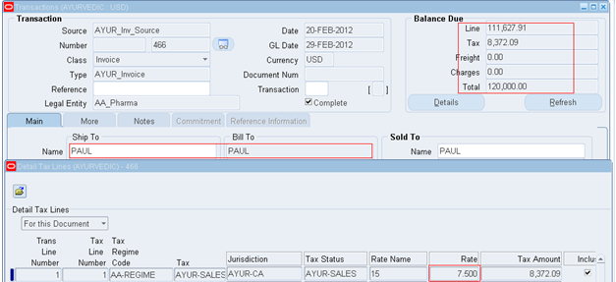

111,627.91*7.5% = 8.372.09