**Navigation:** Service Contracts Manager, Vision Enterprices 🡪 Contract Adminstration 🡪 Launch Pad

Select Operating Unit as Vision Operations and Category as Subscription Agreement

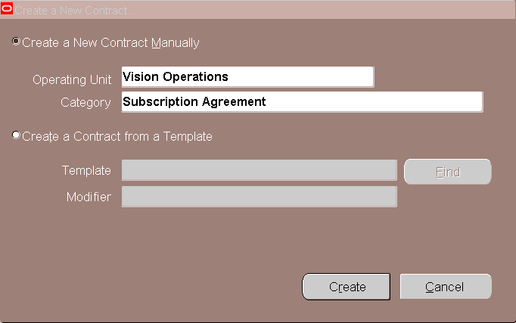

Click on Create

Enter the Contract Service Start Date and End Date

Enter the Description

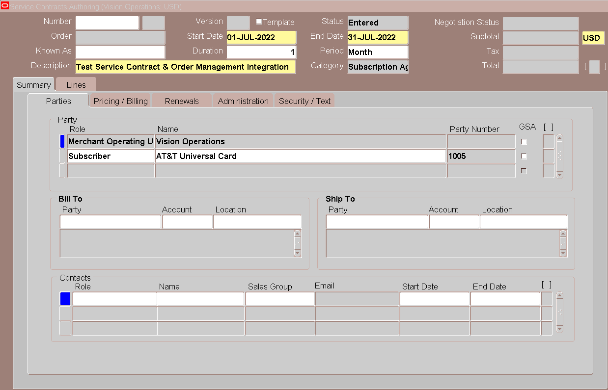

Click in Role

It will Populate Merchant Operating Unit

Select Role as Subscriber and Select Customer as Subscriber

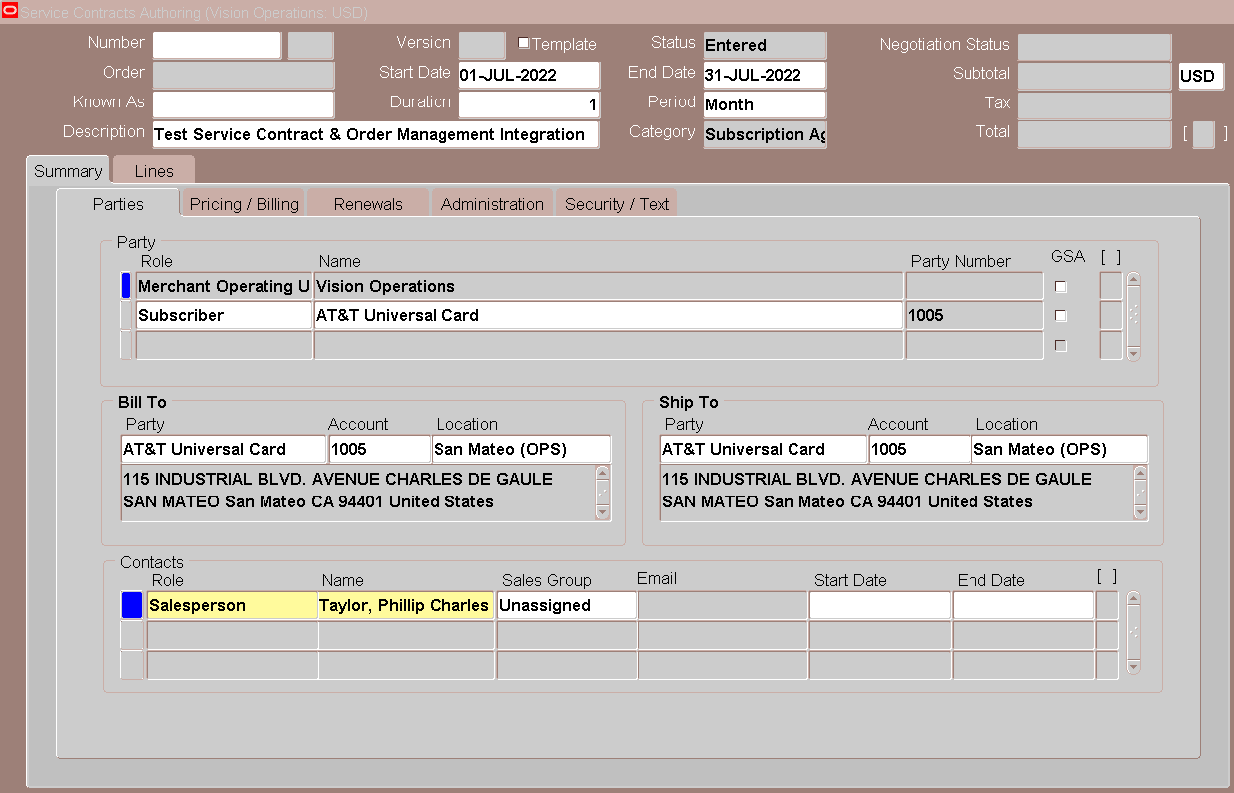

Select Bill To and Ship To Customer and Location

Select Role as Salesperson

Select Name for Salesperson

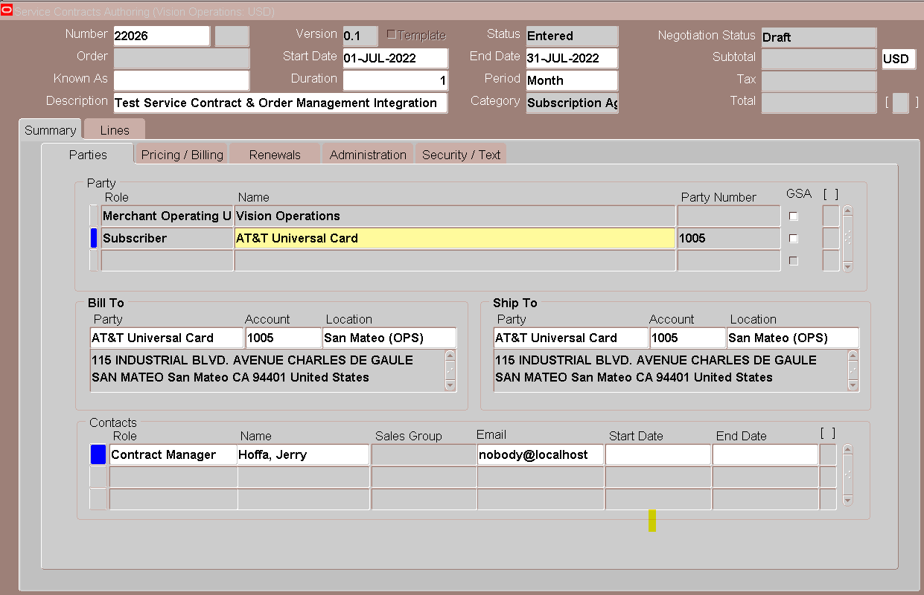

Click on Subscriber

Select Role as Contract Manager

Select Name for Contract Manager

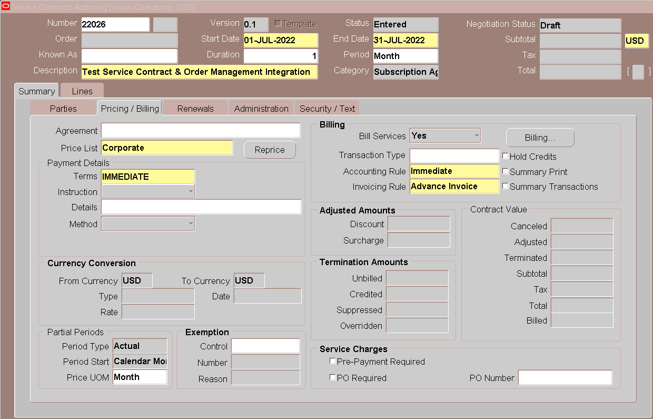

Select for Price List, Terms, Accounting Rule and Invoicing Rule

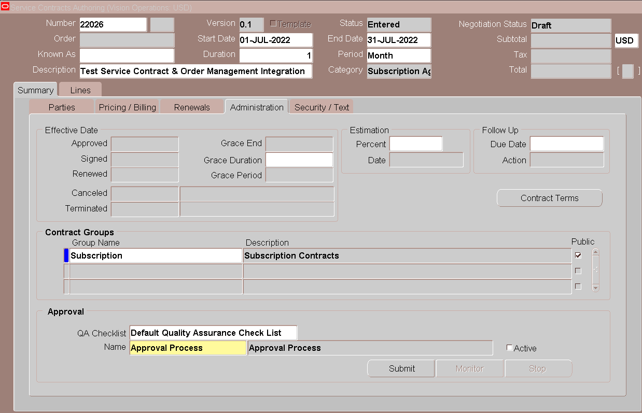

Select Group Name as Subscription

Select Approval Name as Approval Process

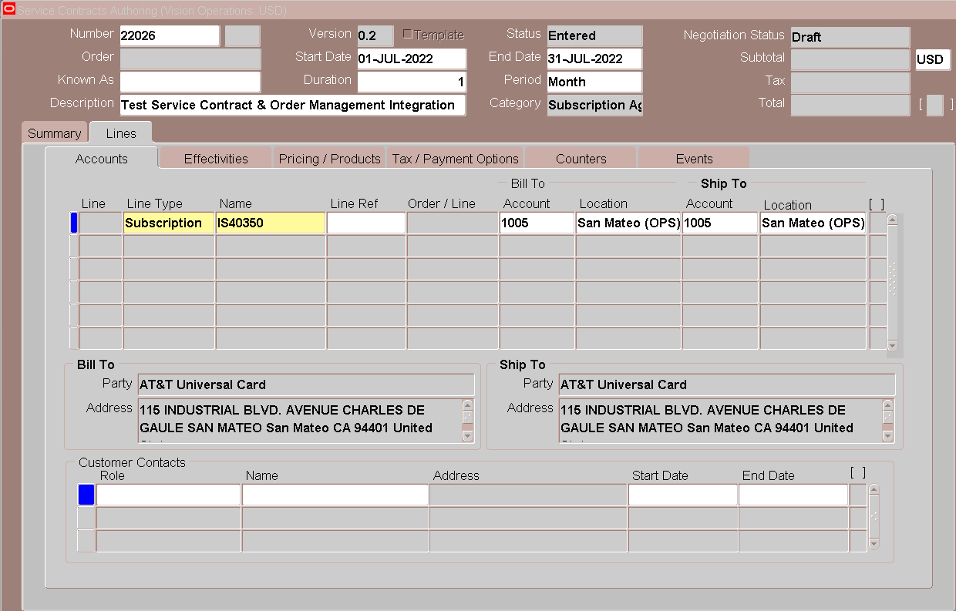

Go to Lines Tab

Select Subscription Item

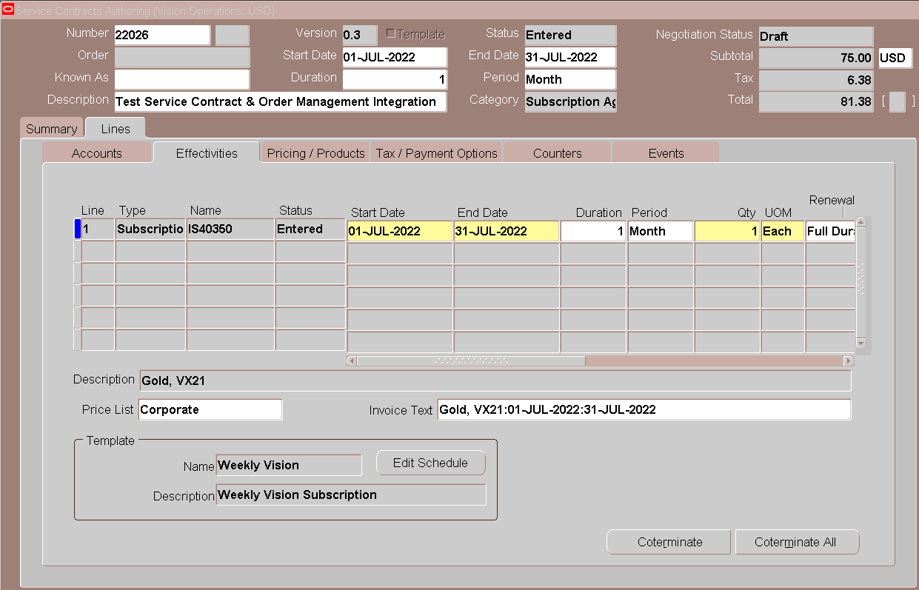

Go to Effectivities

Click in Edit Schedule

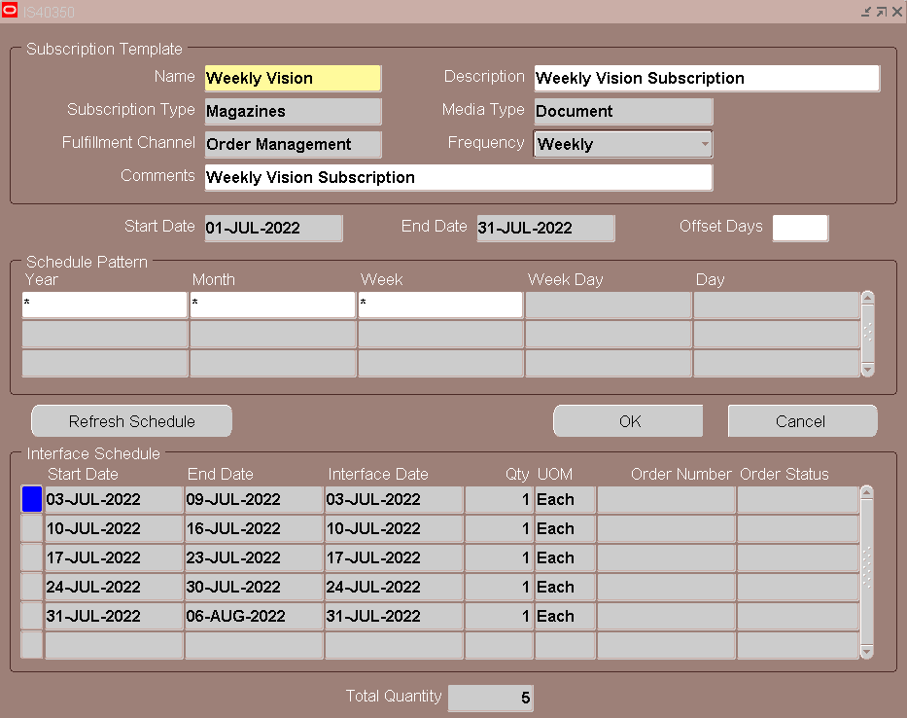

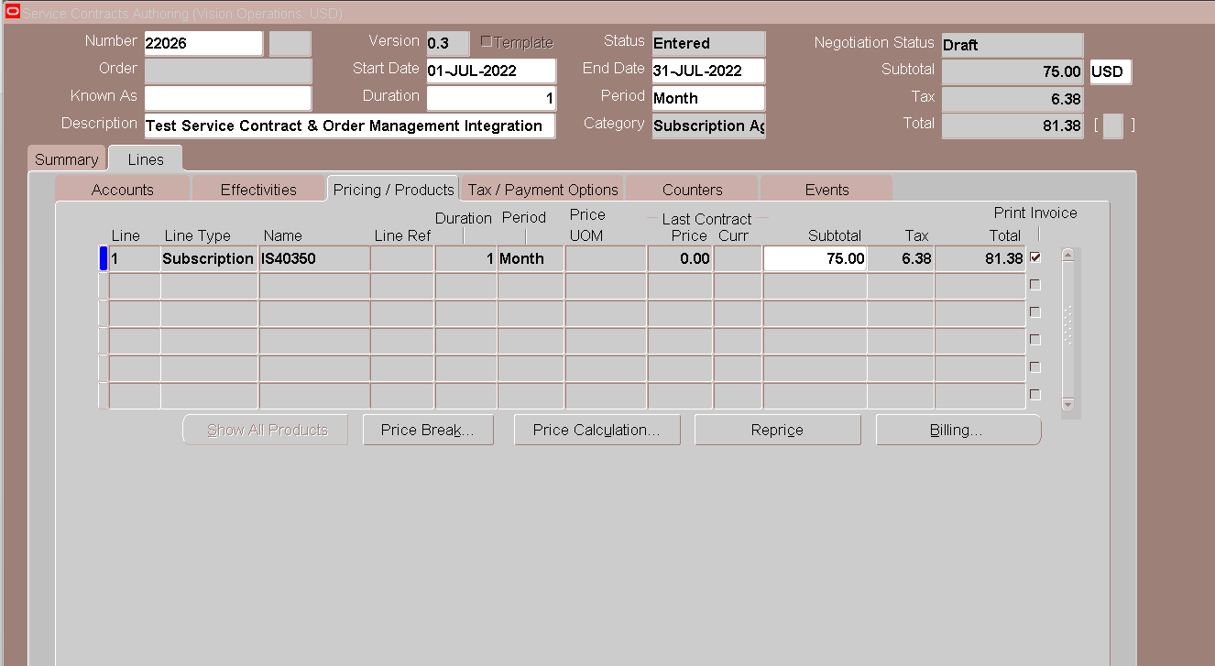

Click on Pricing/Products Tab

Click on Billing

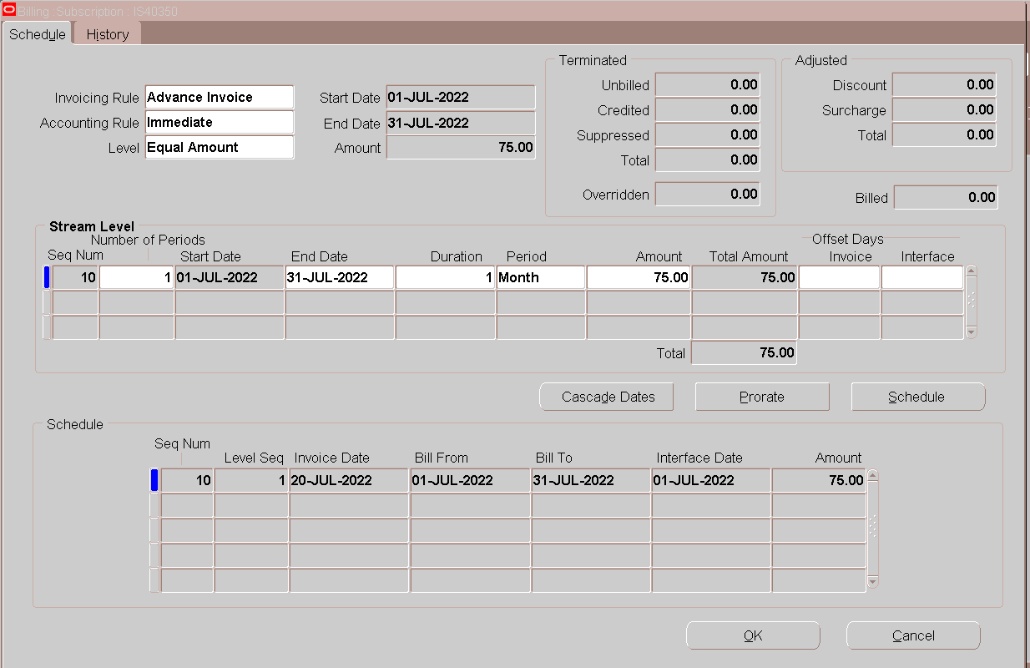

Click On Schedule

Click on OK

Go To Tools 🡪 Sales Credit

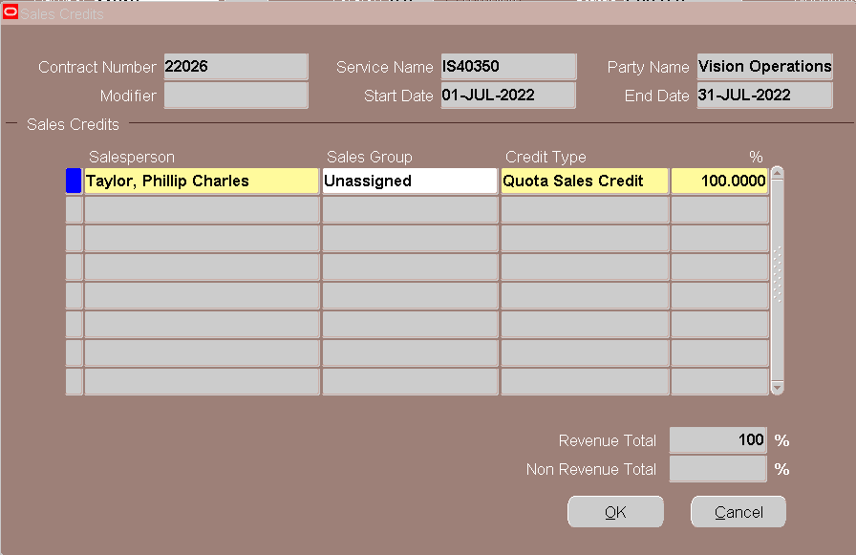

Go to Tools 🡪 Check QA

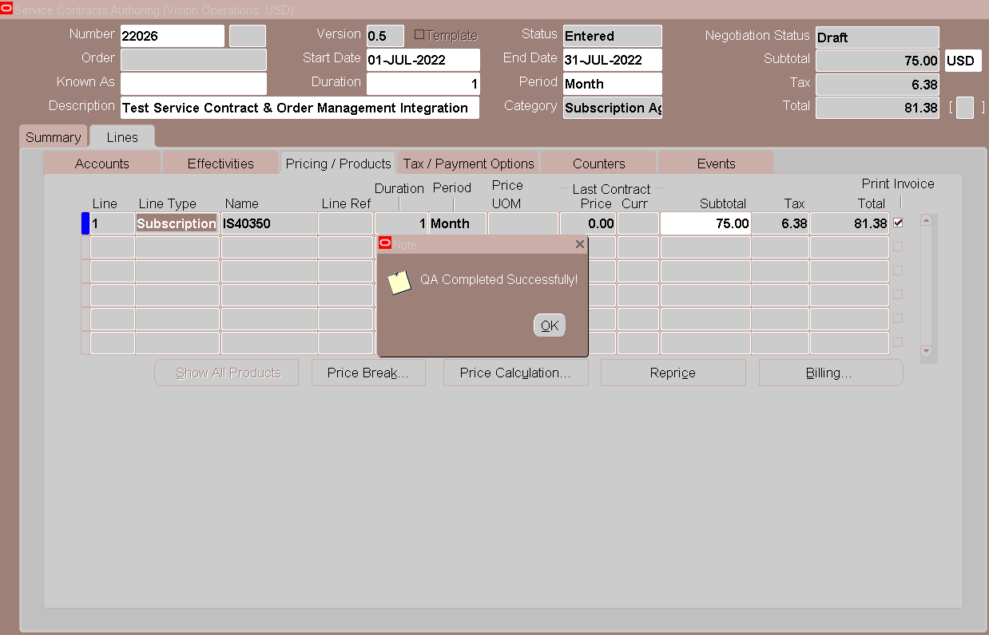

Go To Actions 🡪 Submit for Approval

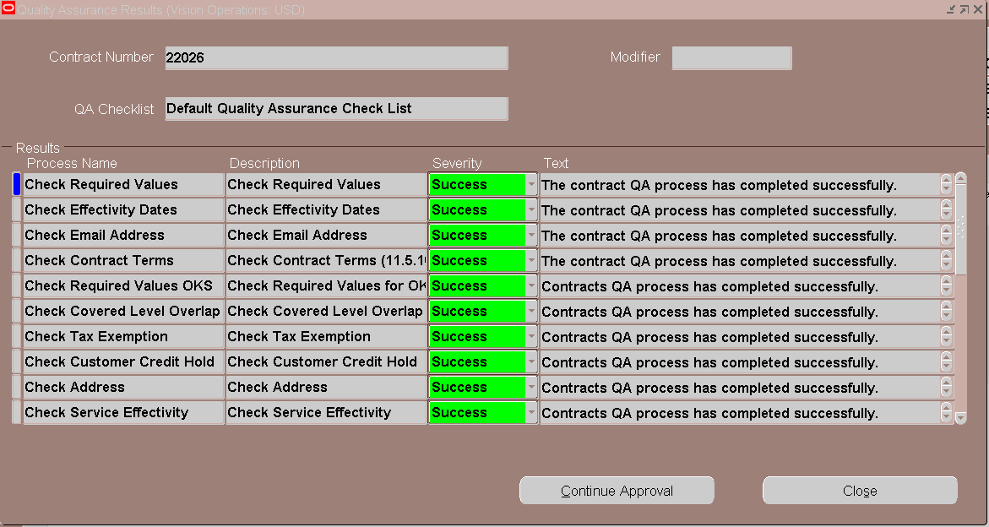

Click on Continue Approval

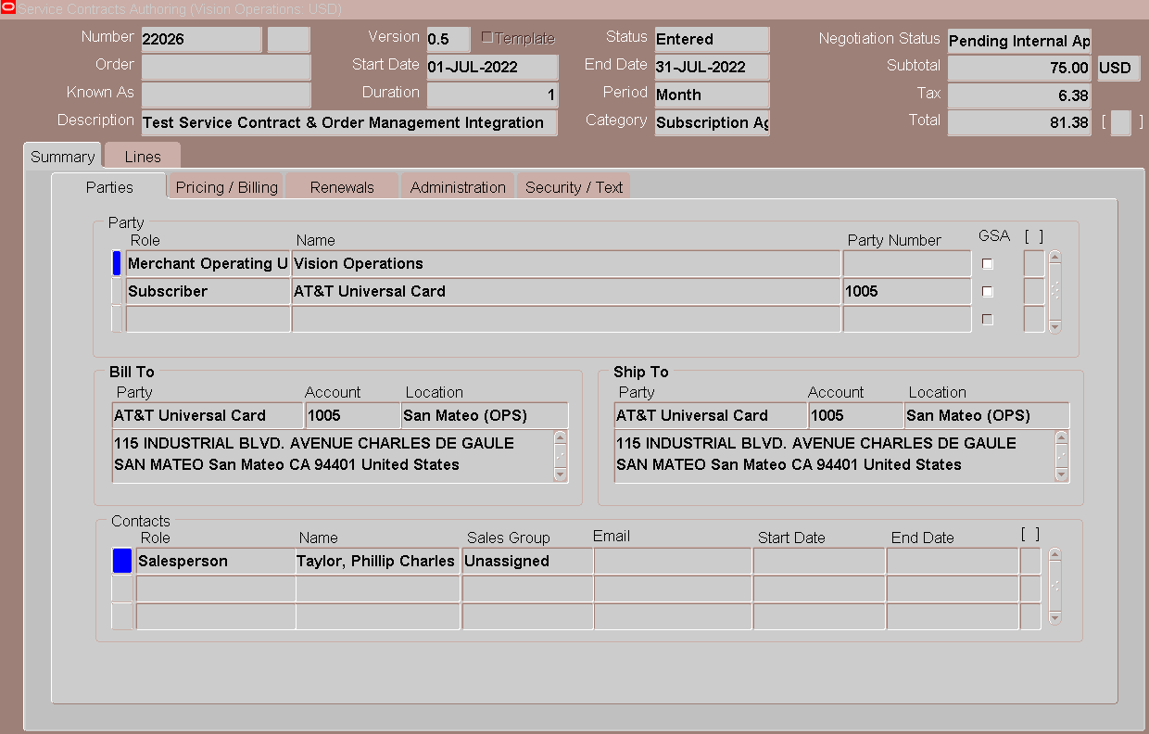

Login with Sales Person

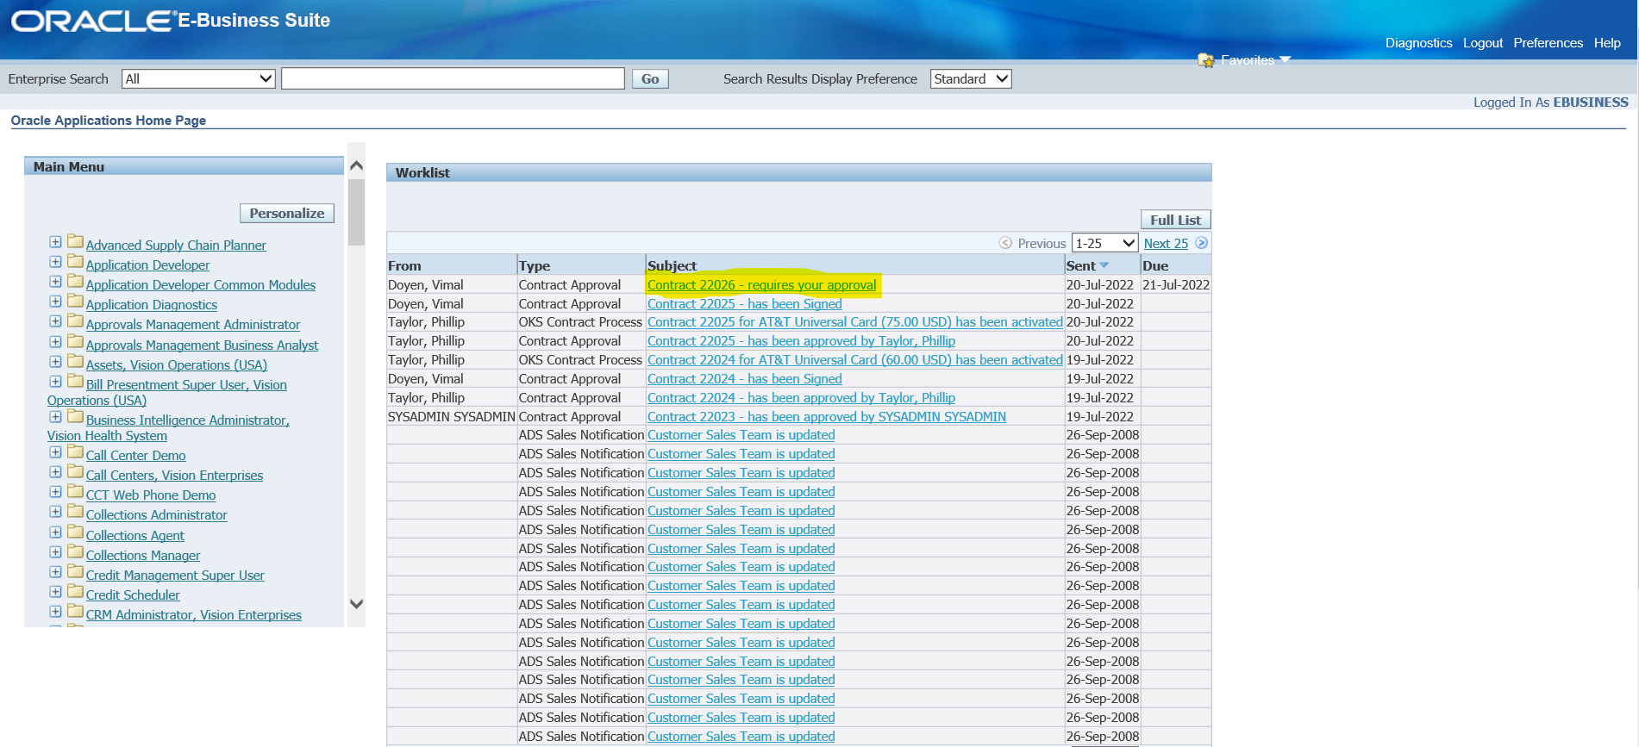

Click on the Contract Approval Notification

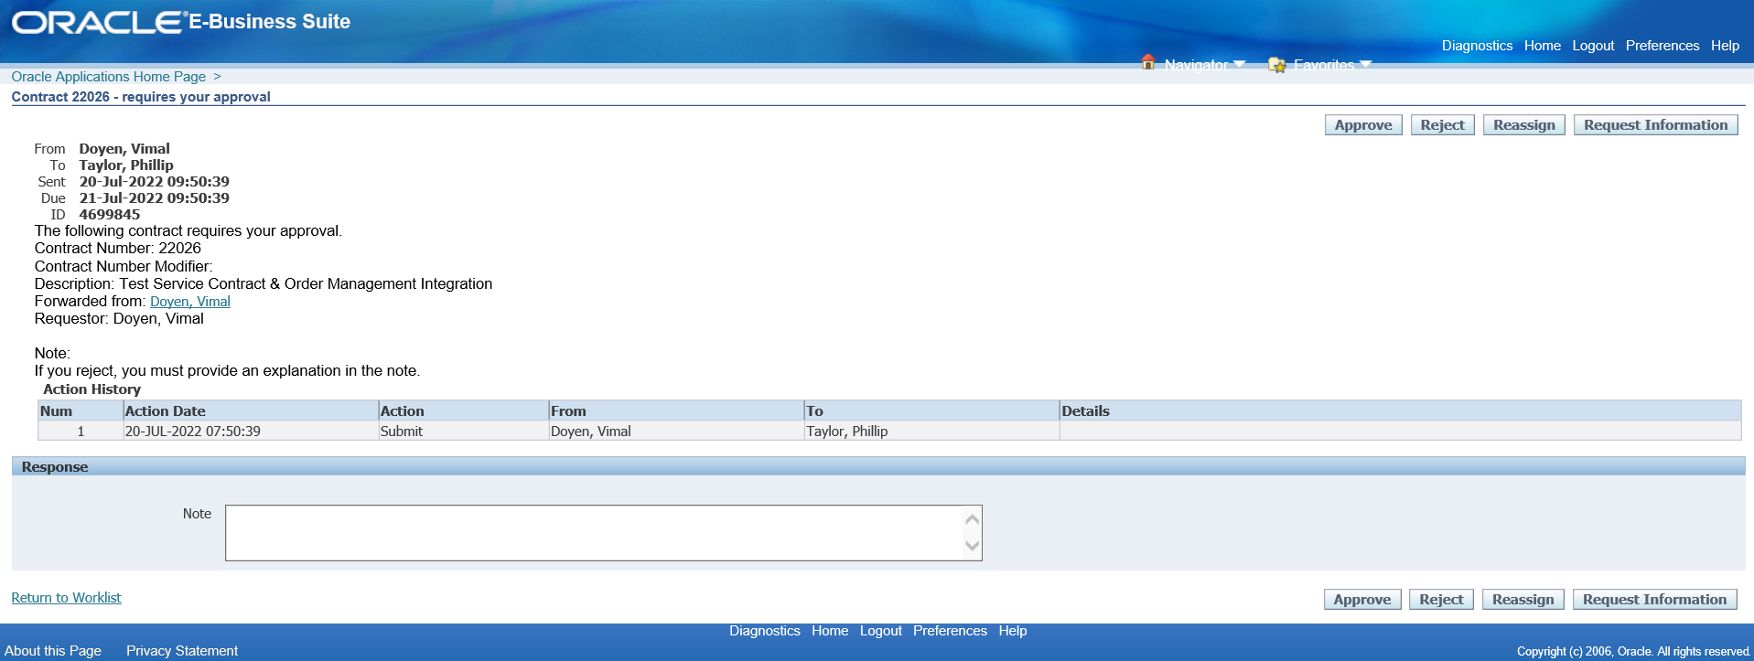

Click on Approve Button

Login with User

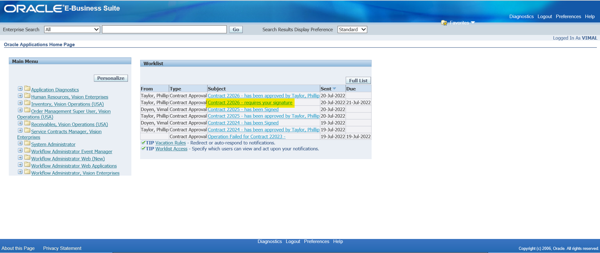

Click on the Require Signature Notification

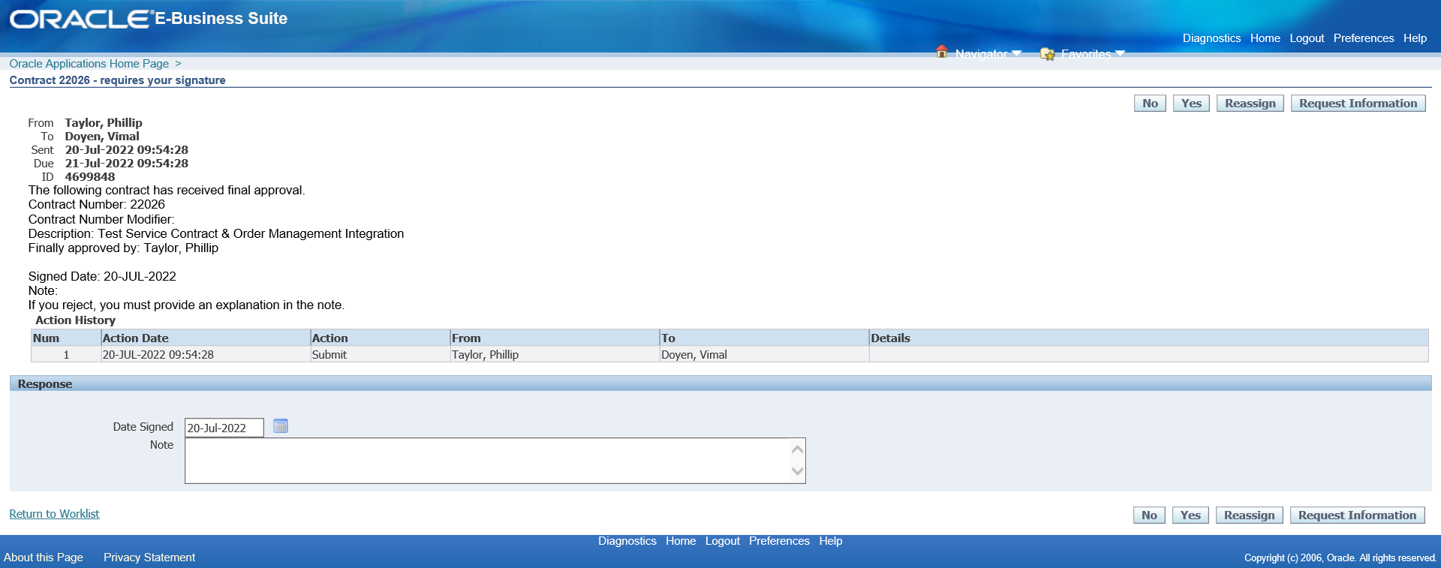

Click on Yes

Check the Service Contract Status

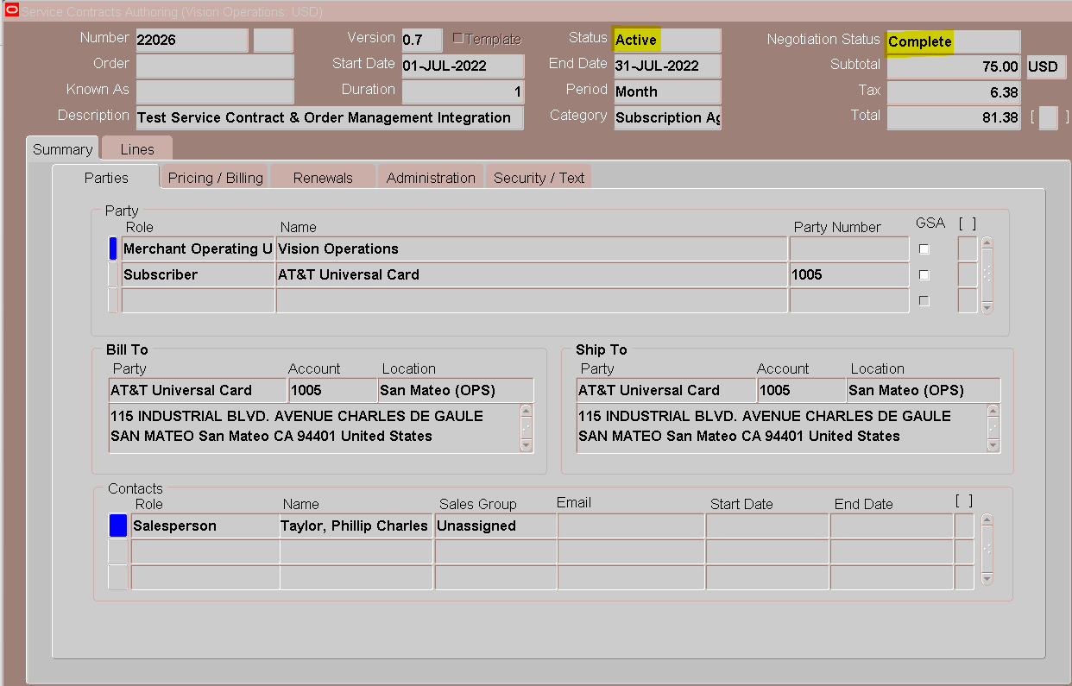

Run- Service Contracts Subscription Fulfilment Program

