## **CREATE ITEMS**

Create the below items and apply the proper item templates and then assign the cost.

|  |  |  |
| --- | --- | --- |
| **Items** | **Template** | **Cost** |
| I20_CAR | Finished Goods |  |
| I20_Engine | Purchased Item | 500 |
| I20_Chasis | Purchased Item | 400 |
| I20_Seat | Purchased Item | 75 |
| I20_Tyre | Purchased Item | 30 |
| I20_Alloy Wheel | Purchased Item | 25 |
| I20_Axle | Purchased Item | 20 |

**Navigation:** Inventory 🡪 Items 🡪 Master Items

1. **I20_CAR:**

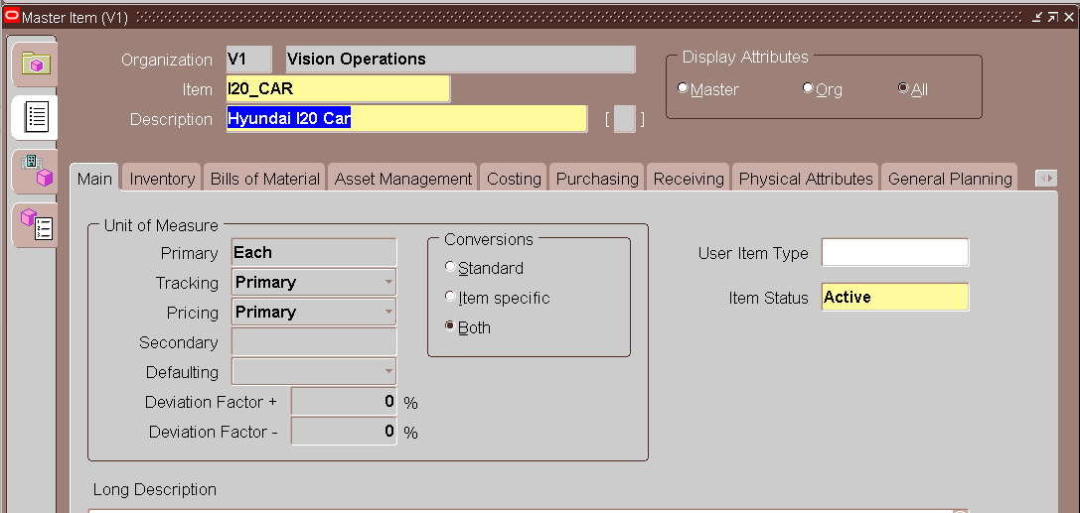

Assign Template

Go to Tools 🡪 Copy Form

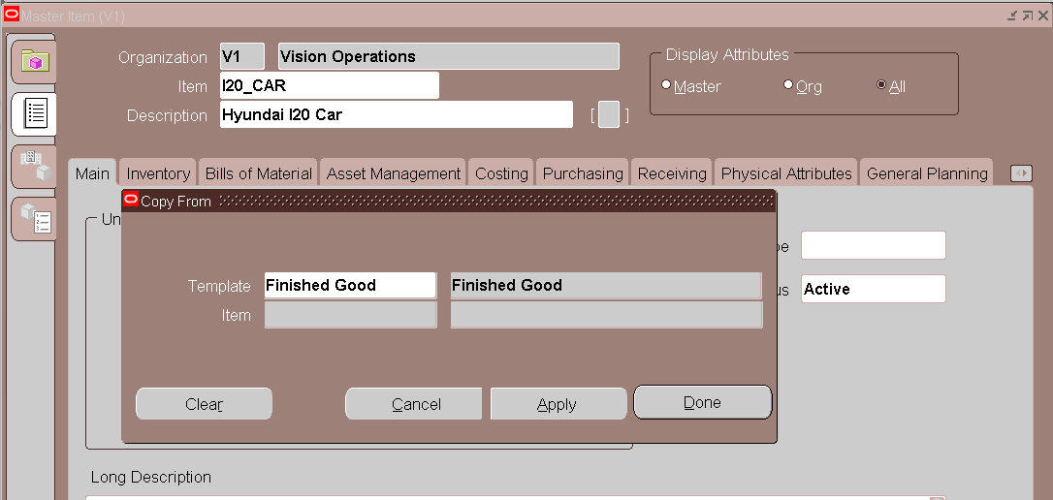

Click on Apply and then on Done

Organization Assignment

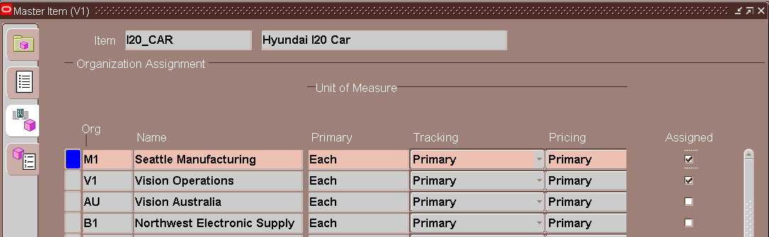

Save the Details.

Follow the same steps to define the below items.

1. **I20_Engine:**

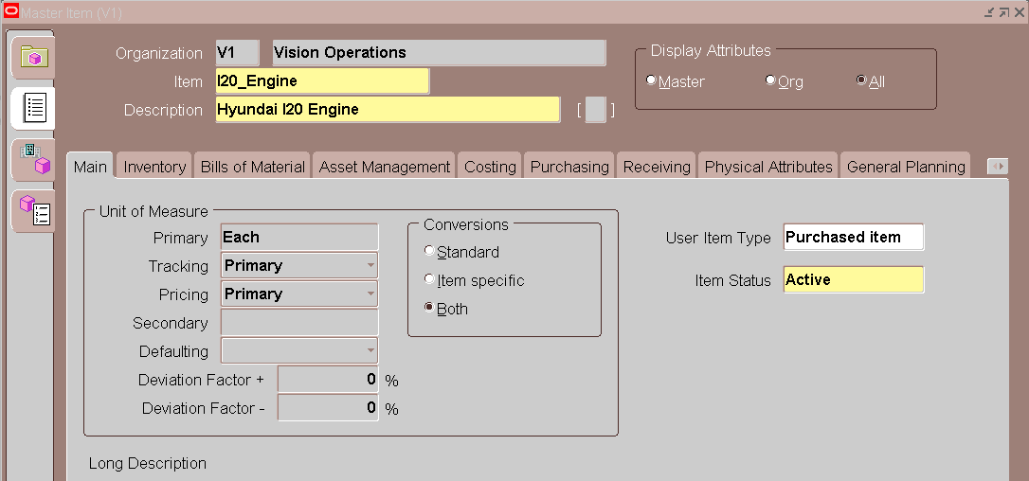

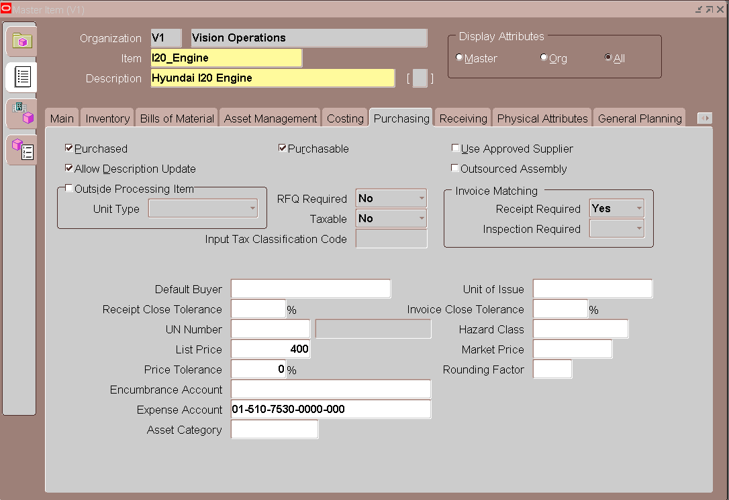

1. **I20_Chasis:**

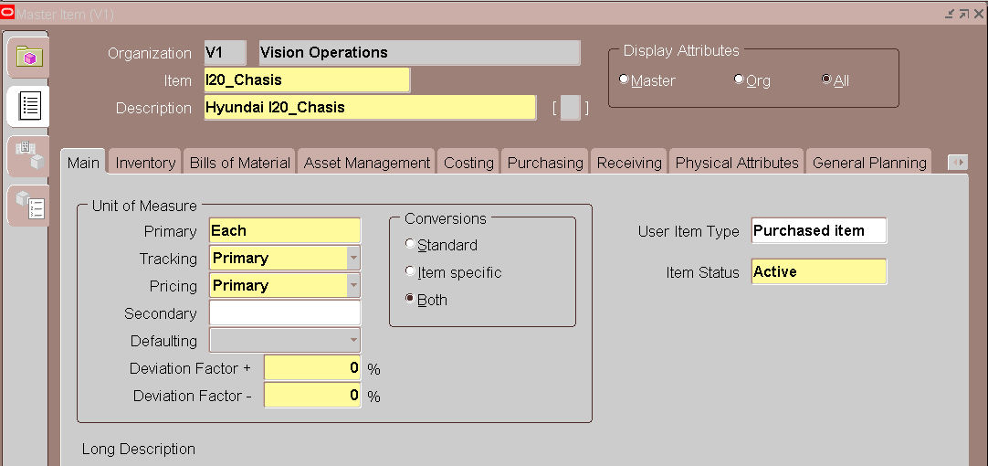

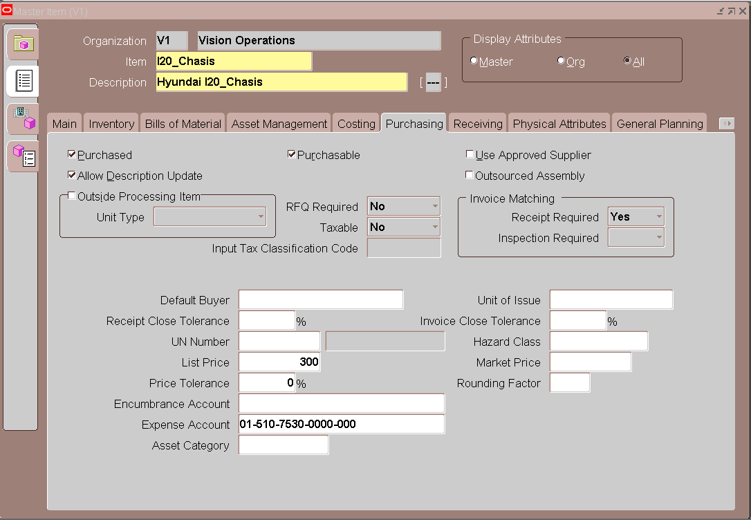

1. **I20_Seat:**

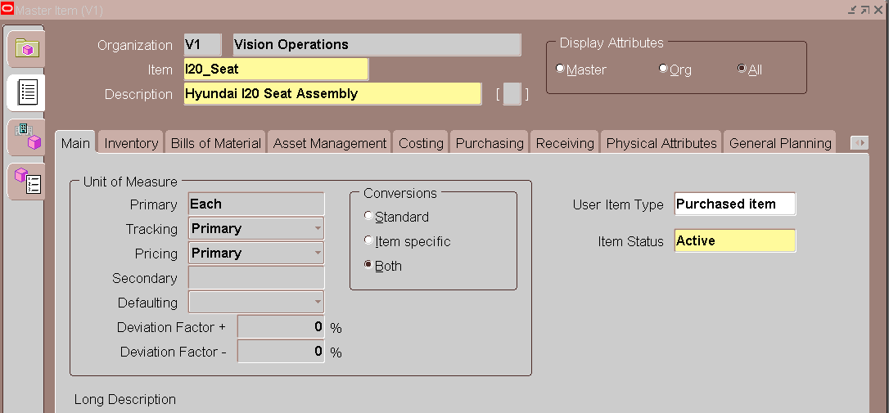

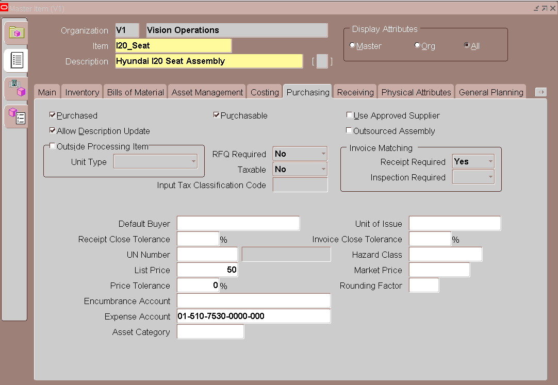

1. **I20_Wheel:**

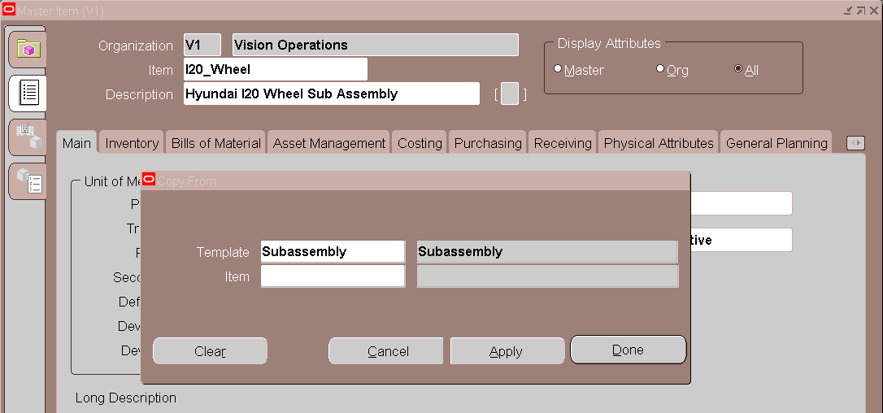

1. **I20_Tyre:**

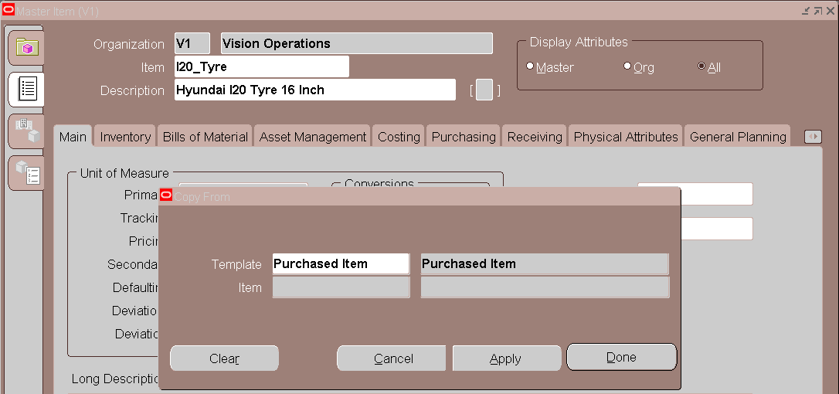

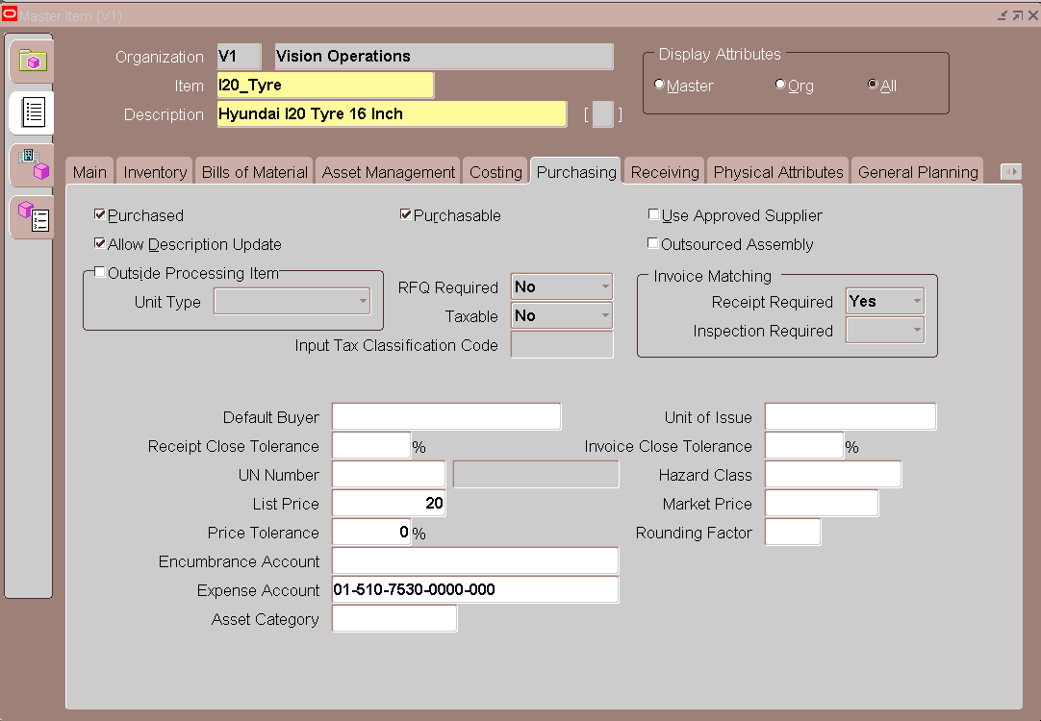

1. **I20_Alloy Wheel:**

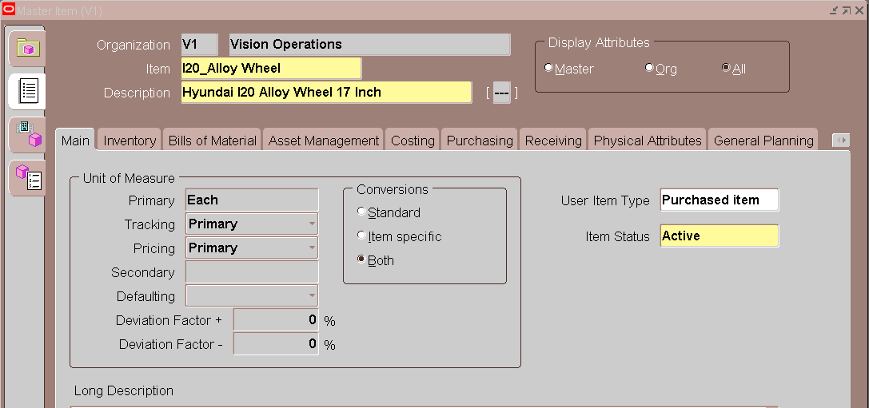

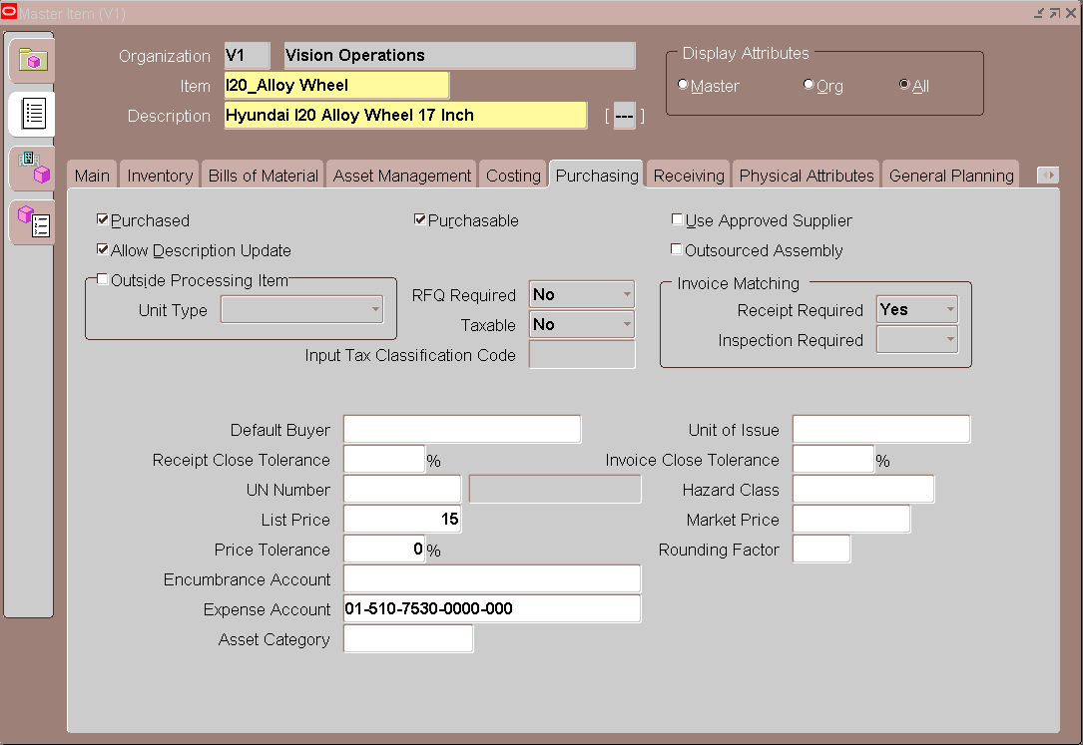

1. **I20_Axle:**

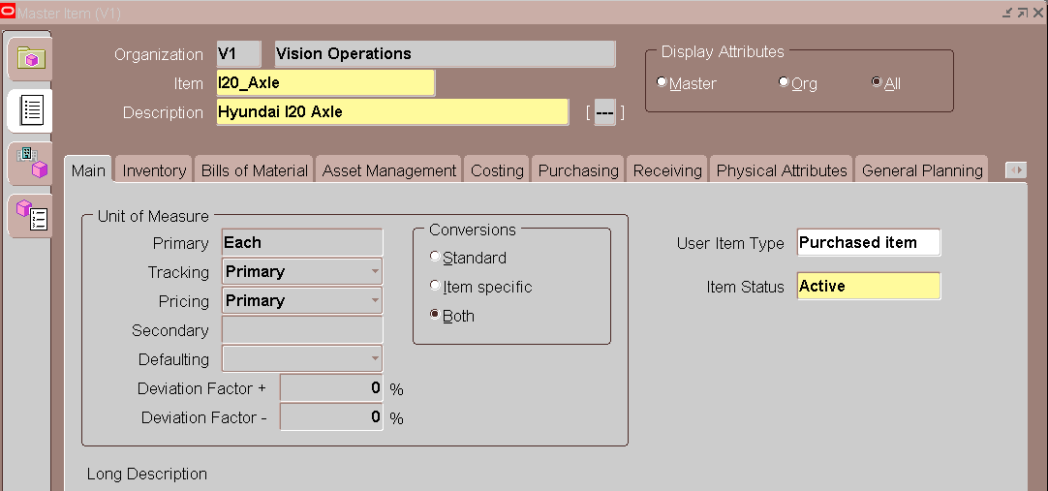

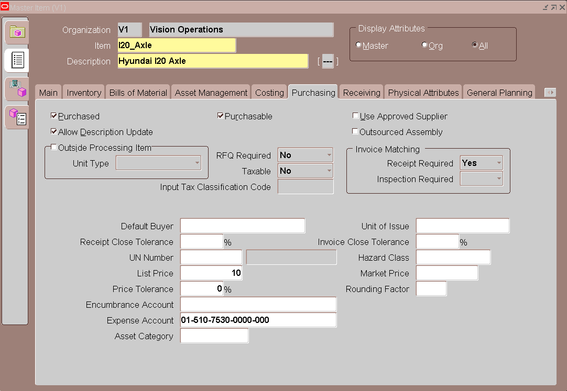

ENTER ITEM COST

**Navigation:** Inventory 🡪 Costs 🡪 Item Costs

Click on "**New**" and enter the Item Code and Cost Type as "**Pending**"

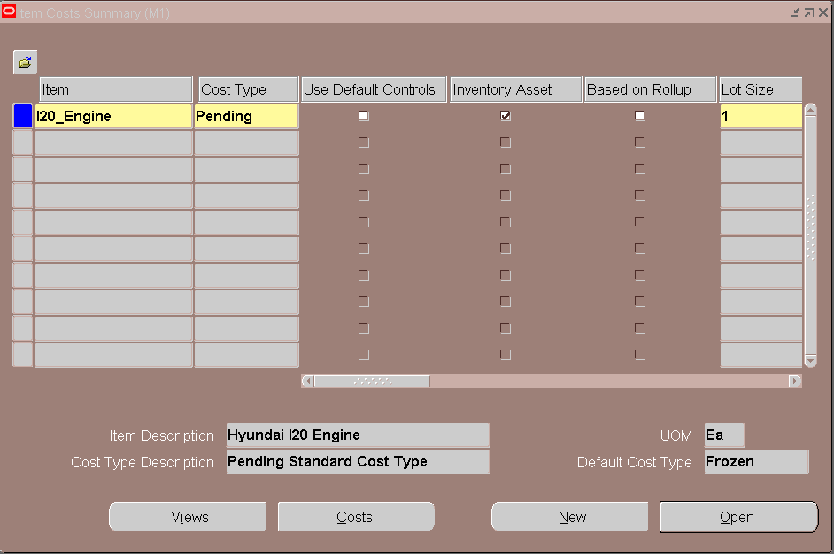

Click on "**Open**" and then "**Costs**"

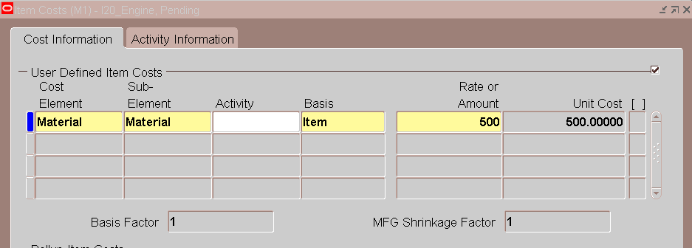

Likewise enter the costs for remaining items

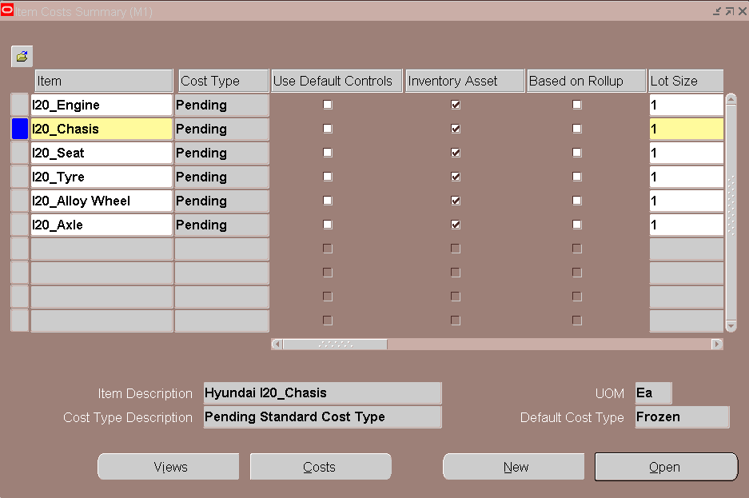

If you query these items again then, we can see one more record for each item in "**Frozen**" cost type

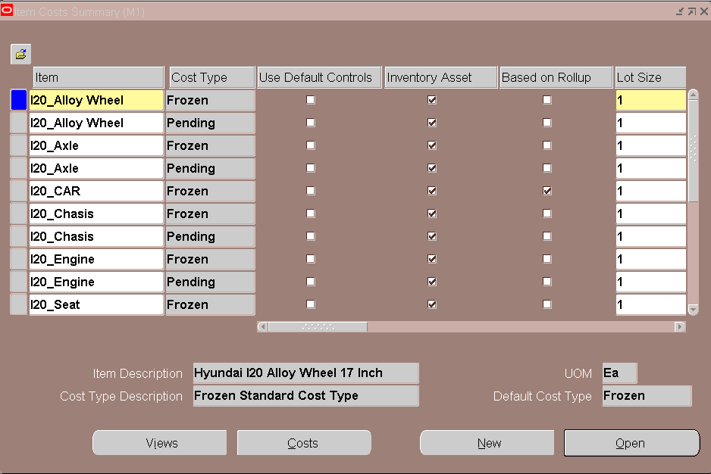

**Note:**

For every item will have 2 records. One record will be in "Pending" Cost Type and the another one will be in "Frozen" cost type. Because, this DYN Organization is a Standard Cost Organization. By default the item cost will be defined in "Pending" cost type. Then if we run the "Update Standard Cost" program then the cost will be moved to "Frozen" Cost Type.

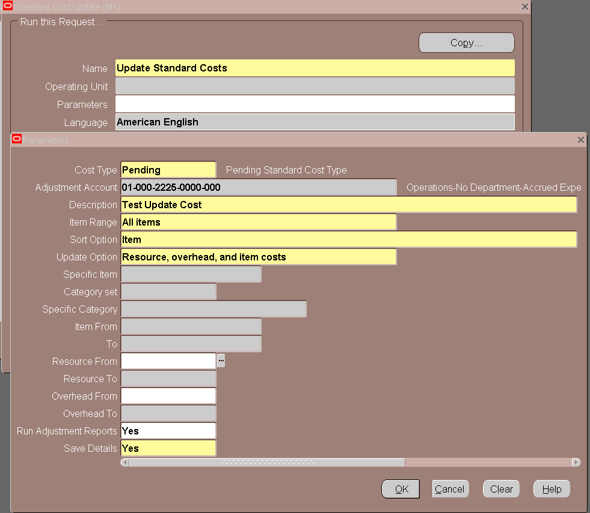

**DEFINE RESOURCES:**

**Various Resource Types:**

* **Amount -** We can use this type when we use money transactions.
* **Currency -** We can use this type when we use USD currency for transactions.
* **Machine -** We can use this type when the resource is a Machine.
* **Miscellaneous -** We can use this type during OSP or other transactions.
* **Person -** We can use this type when the resource is a Human/Person.

**Various Charge Types:**

* **Manual -** Charges will trigger when we manually move the Resources in Jobs
* **PO Receipt -** Charges will trigger when we do PO Receipts for OSP Purchase Orders
* **PO Move -** Charges will trigger when we complete the PO Receipts and do Move Transactions in OSP Operation
* **WIP Move -** Charges will trigger when we do the Move Transactions in Discrete Jobs

When defining the Rates for Resources, we should define the rates using "Pending" Cost Types. Because this is a Standard Costing Organization.

**Navigation:** Bills of Materials 🡪 Routing 🡪 Resources

Define the Resources with the below details

|  |  |  |  |  |  |
| --- | --- | --- | --- | --- | --- |
| **Resource** | **Description** | **Type** | **UOM** | **Charge Type** | **Rate** |
| A_MCHN | Assembly Machine | Machine | HR | WIP Move | 200 |
| A_LBR | Assembly Labour | Person | HR | WIP Move | 75 |
| HELPER | Helper | Person | HR | WIP Move | 50 |
| TESTER | Tester | Person | HR | WIP Move | 100 |

1. **A_MCHN:**

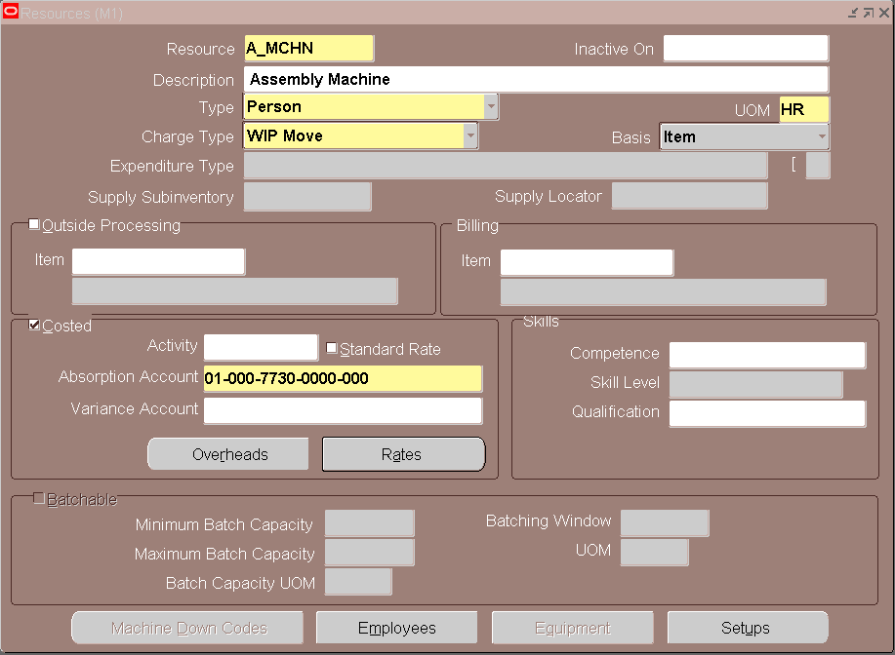

Rates

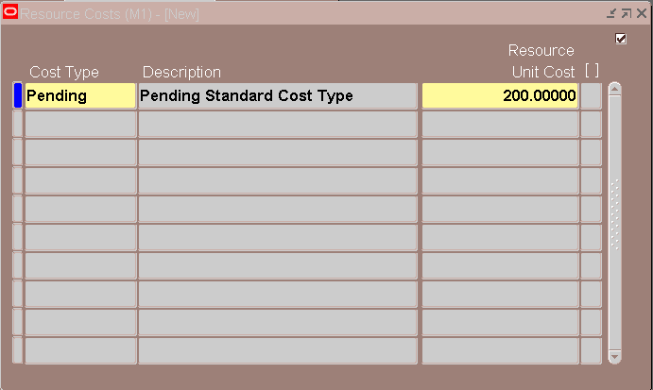

1. **A_LBR:**

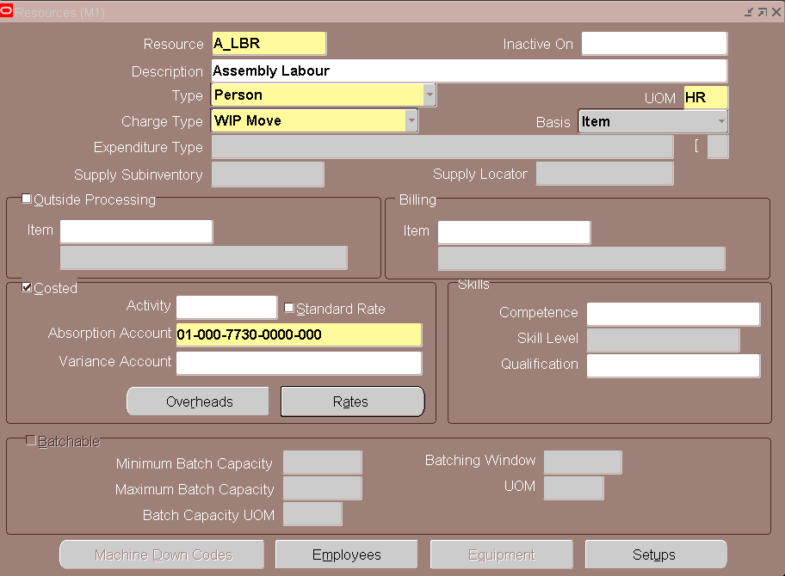

Rates

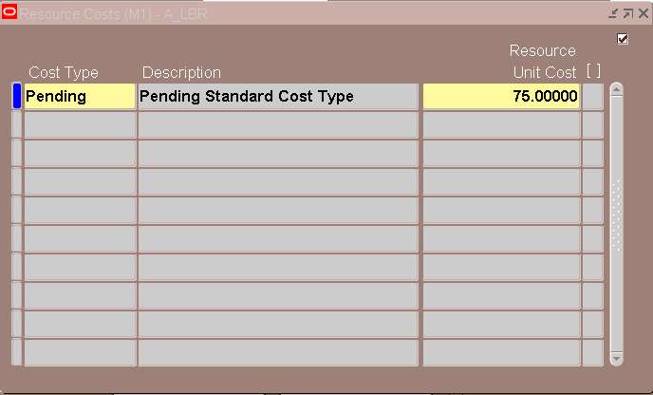

1. **HELPER:**

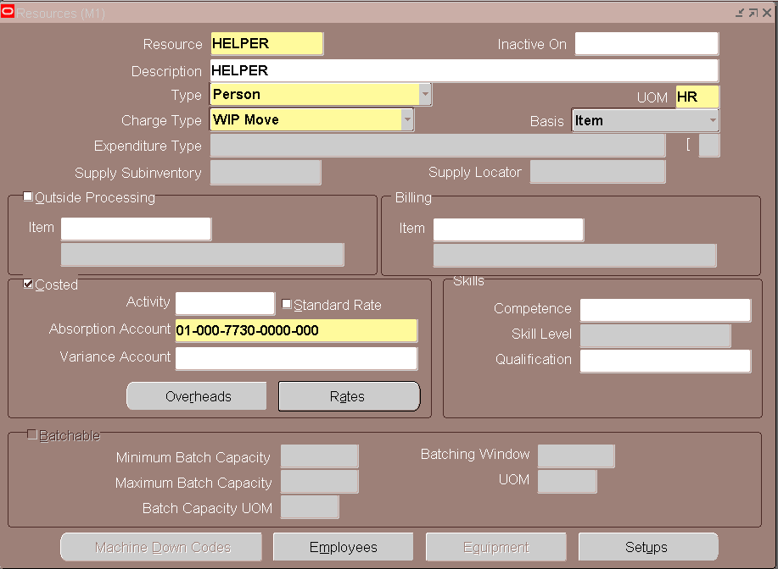

Rates

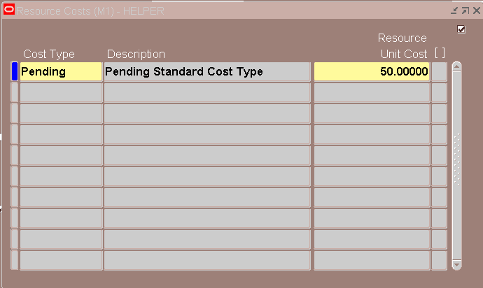

1. **TESTER:**

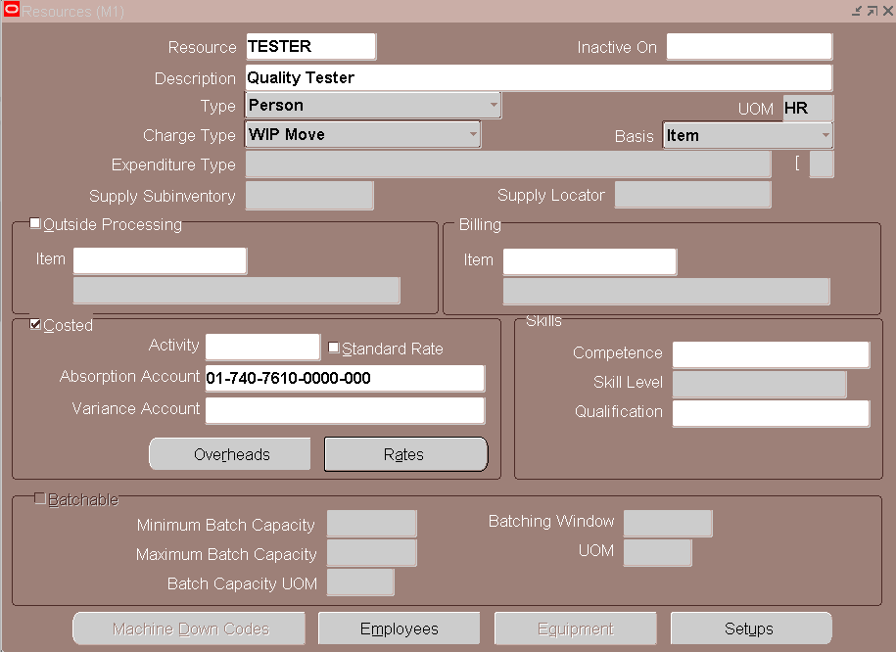

Rates

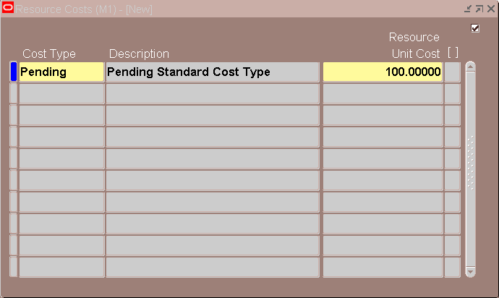

**DEFINE DEPARTMENTS:**

You can define departments as areas within your organization where you perform work and/or collect costs.

**Navigation:** Bills of Materials 🡪 Routings 🡪 Departments

Enter the Department Name and Description along with the Department Class

1. **Assembly Department:**

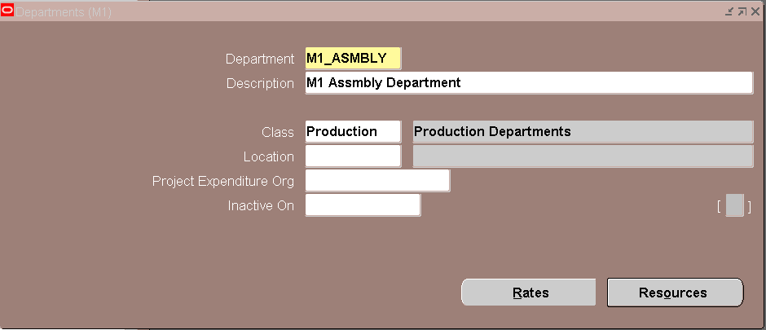

Click on Resources

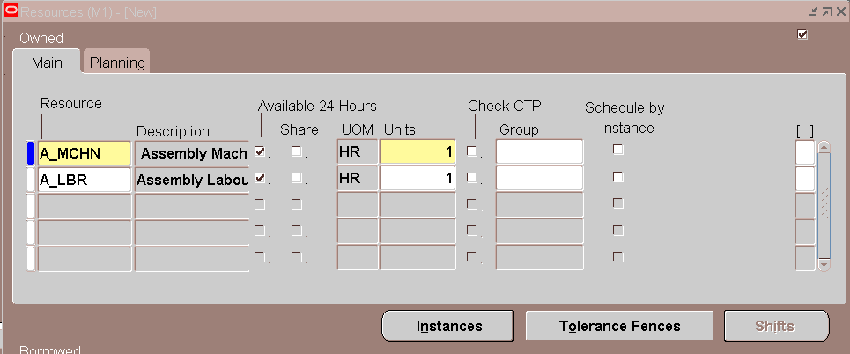

Save the Details

1. **Painting Department:**

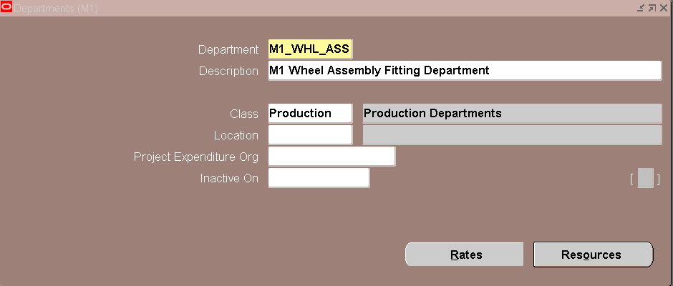

Click on Resources

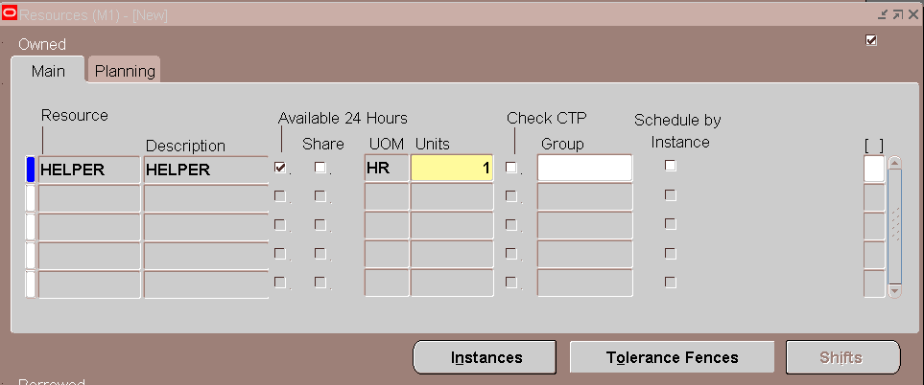

Save the Details

1. **Quality Check Department:**

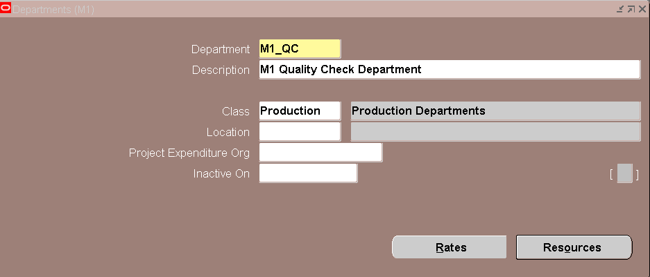

Click on Resources

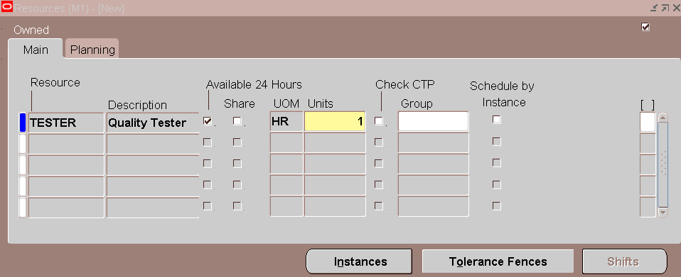

Save the Details

**DEFINE STANDARD OPERATIONS:**

**Navigation:** Bills of Materials 🡪 Routing 🡪 Standard Operations

1. **Mechanical Component Assembly:**

Enter the Standard Operations Code and attach the Department

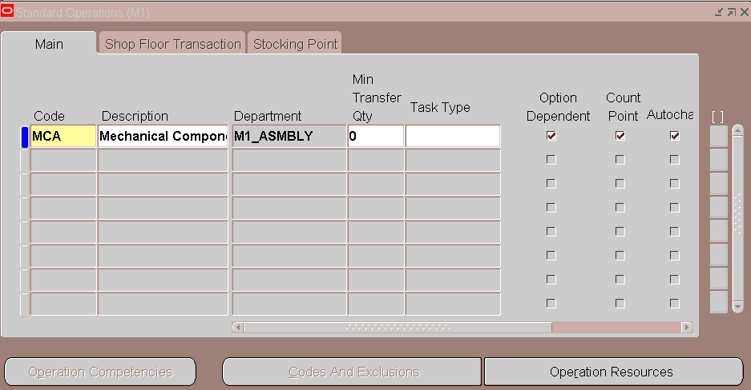

Click on "Operation Resources" and assign the Resources

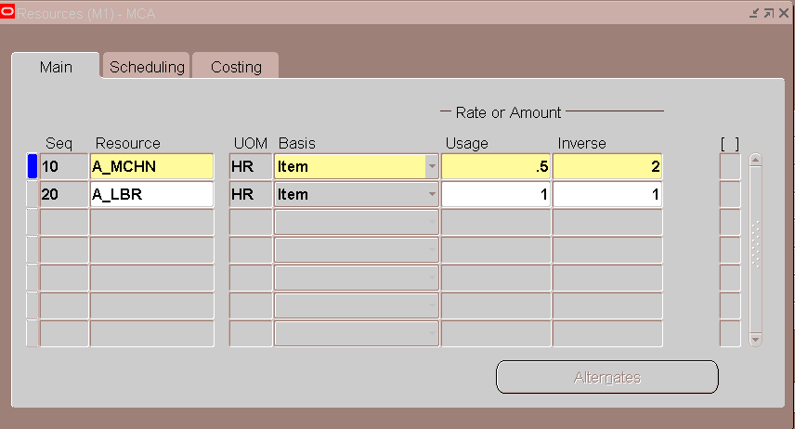

**Usage & Inverse:**

*If we use the Resource "A_MCHN" for half an hour (Usage) then we can produce 1 unit (Inverse).*

*Otherwise, if we want 2 Units output then we need to use the resource "A_MCHN" for 1 hour. At the same time, if we use the resource "A_LBR" for 1 hour then we will produce 1 Unit.*

1. **WHL Operation:**

Enter the Standard Operations Code and attach the Department

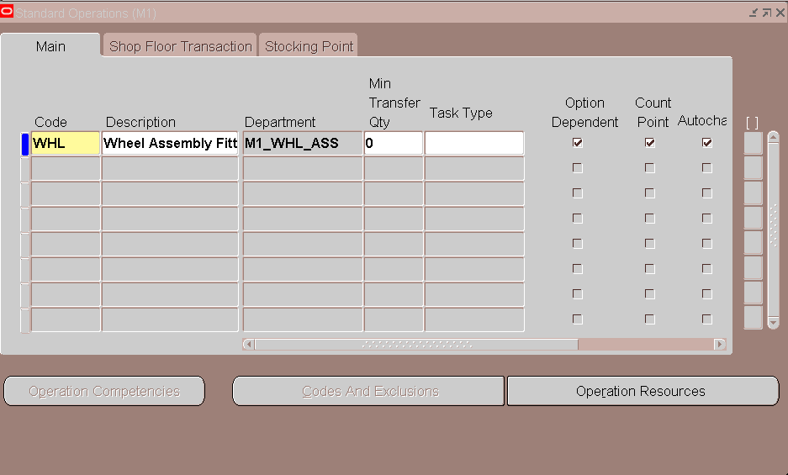

Click on "Operation Resources" and assign the Resources



1. **Quality Operation:**

Enter the Standard Operations Code and attach the Department

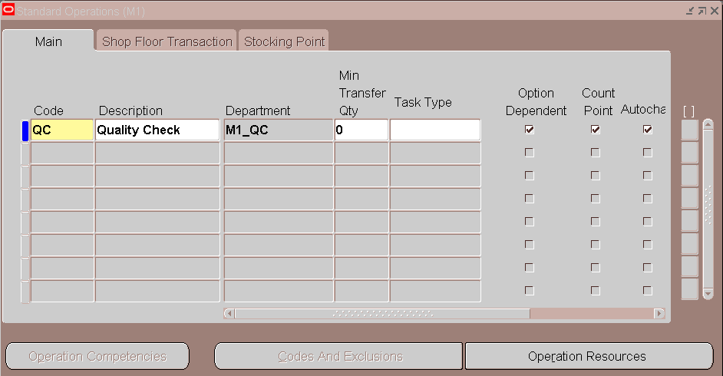

Click on "Operation Resources" and assign the Resources

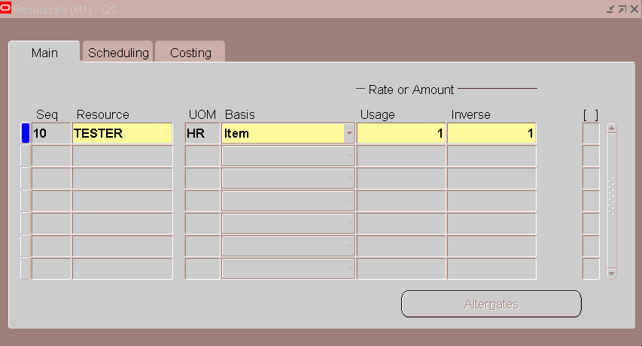

**Define Routing:**

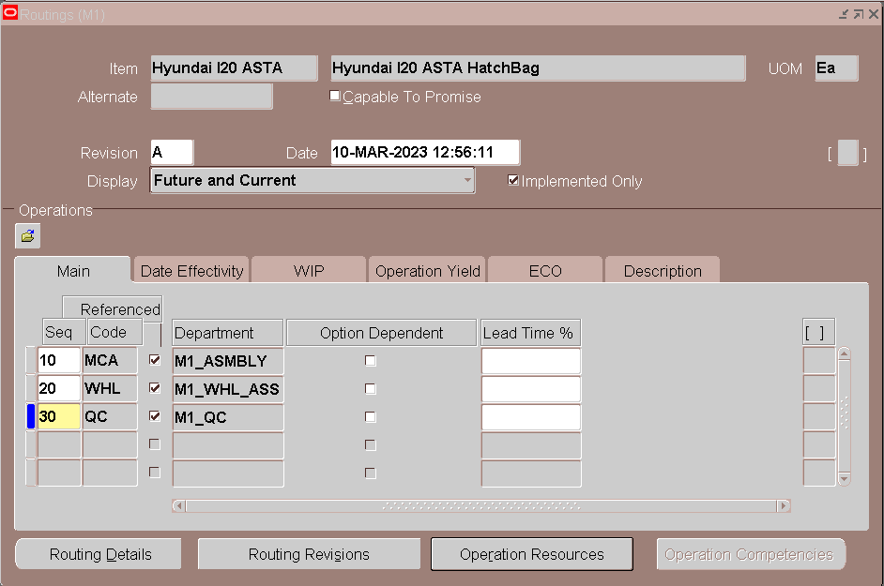

**Define Bill:**

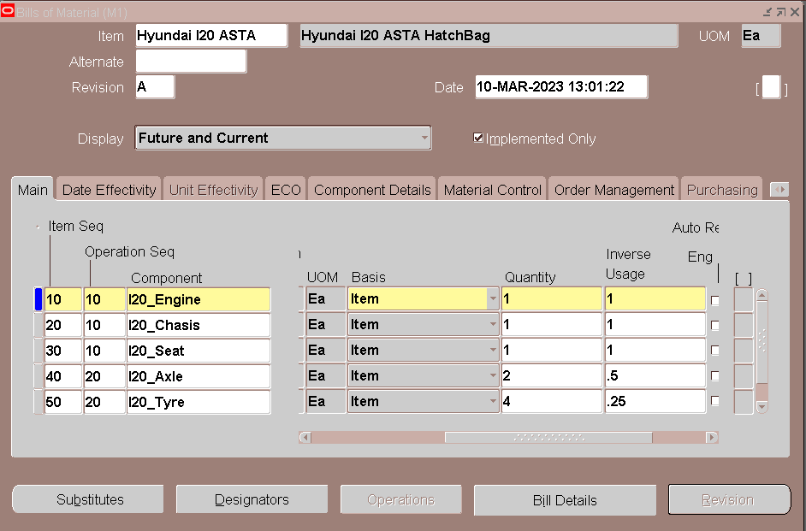

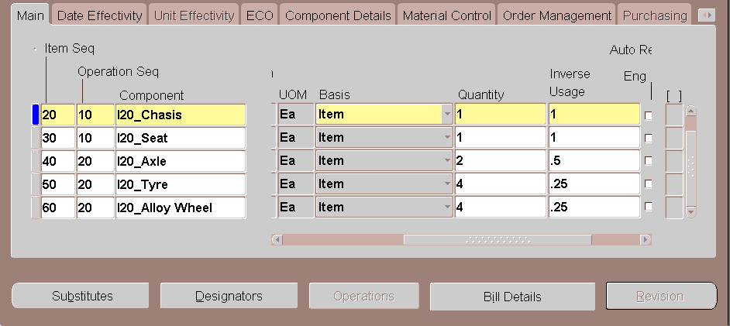

**Material Control**

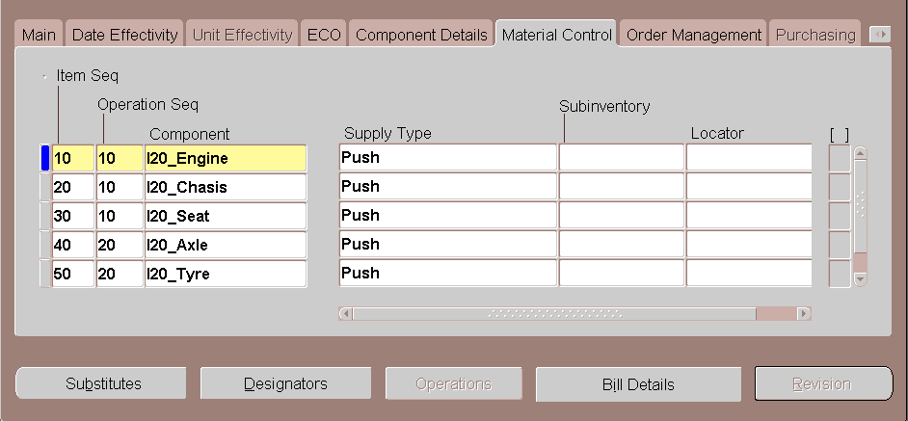

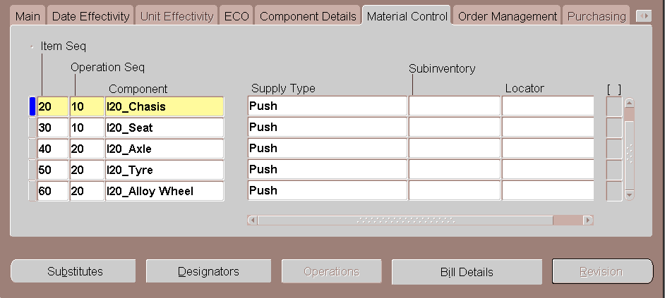

**Create Standard Discreate Jobs:**

**Navigation:** WIP🡪 Discrete 🡪 Discrete Job

Job number Generation is Seeded

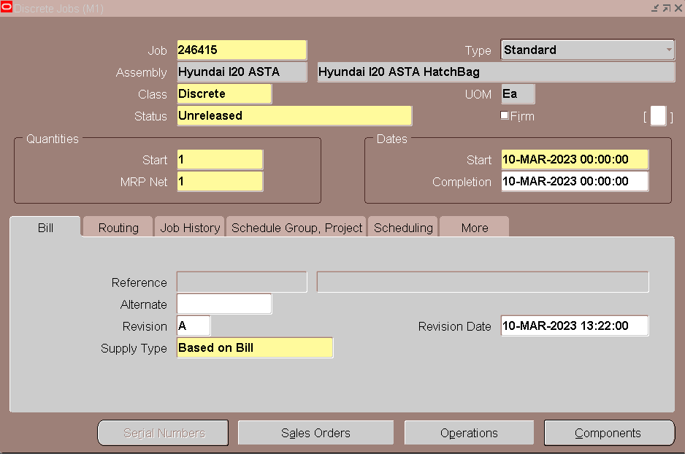

Click on Operations Button

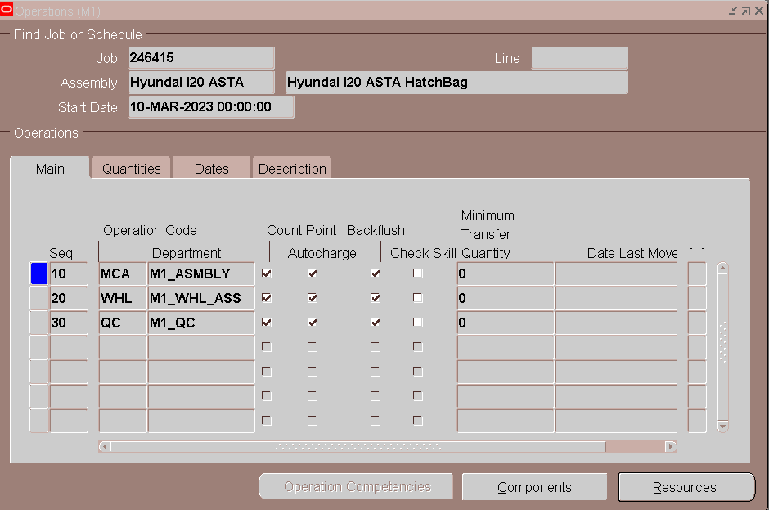

Go to Quantities Tab, Interoperation Status

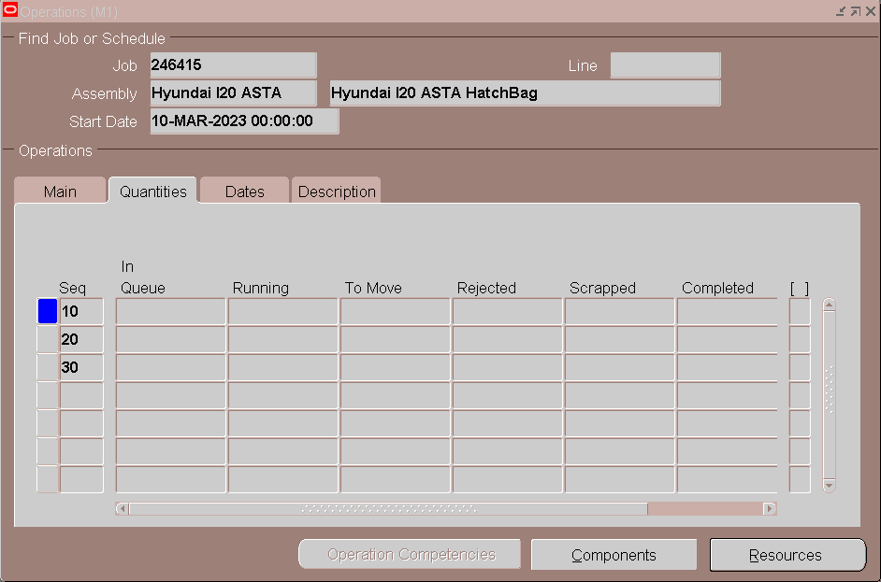

Click on Components Button

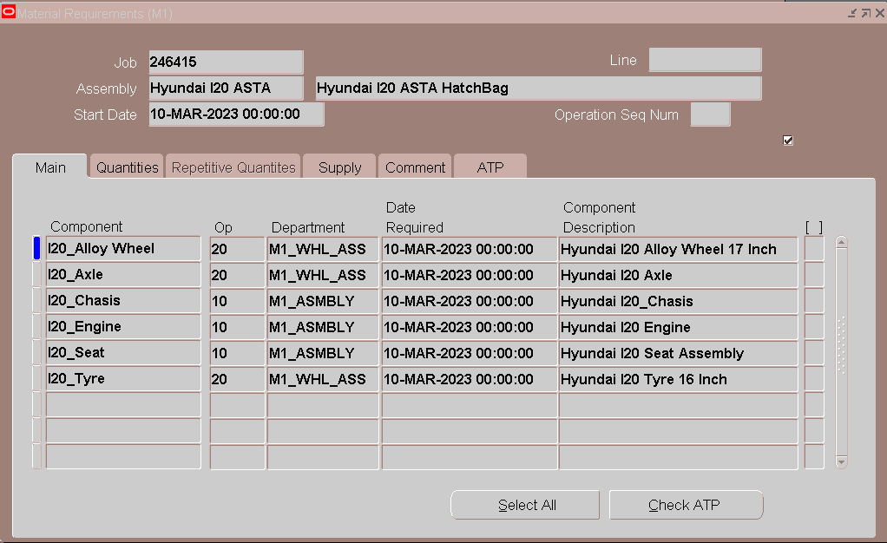

Change the Status from Unreleased to Released

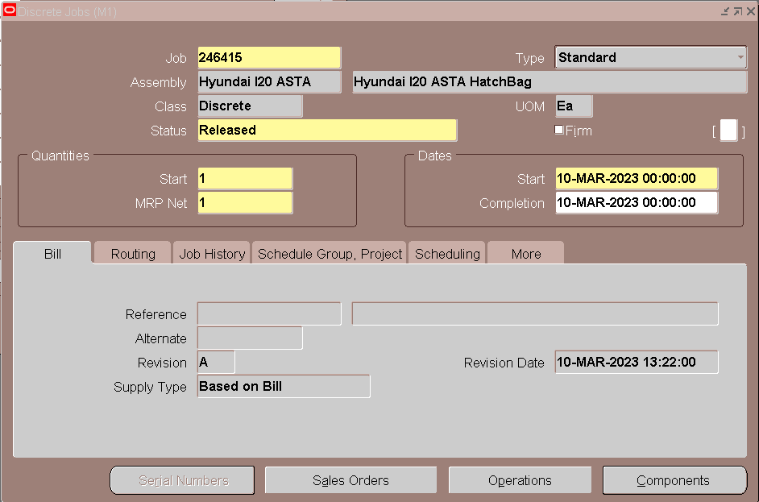

After Released the Work Order, Operations 🡪 Quantities

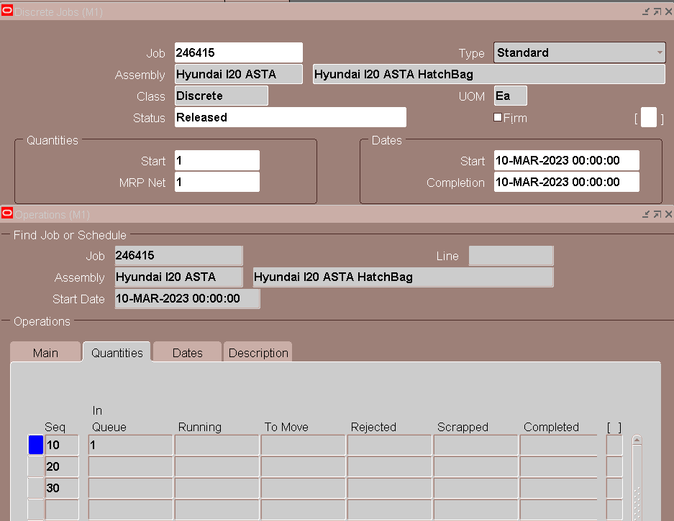

Click on Components and go to Quantities Tab

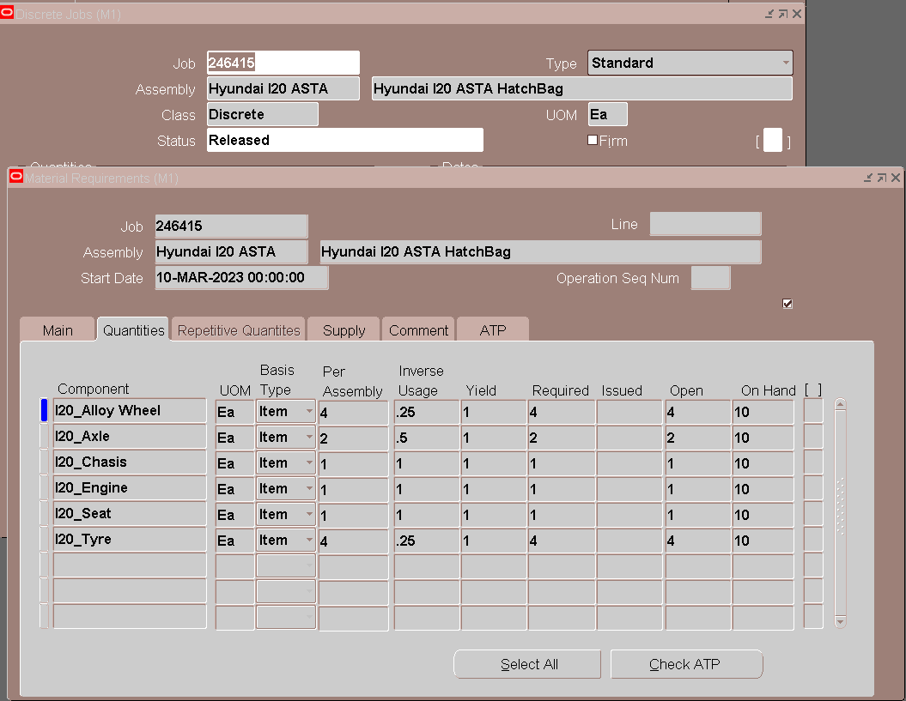

**Create Move Transaction for**

**Navigation:** Work in Process🡪 Move Transactions 🡪 Move Transactions

1. Move Transaction (Ope-10 Queue to 10-Run):

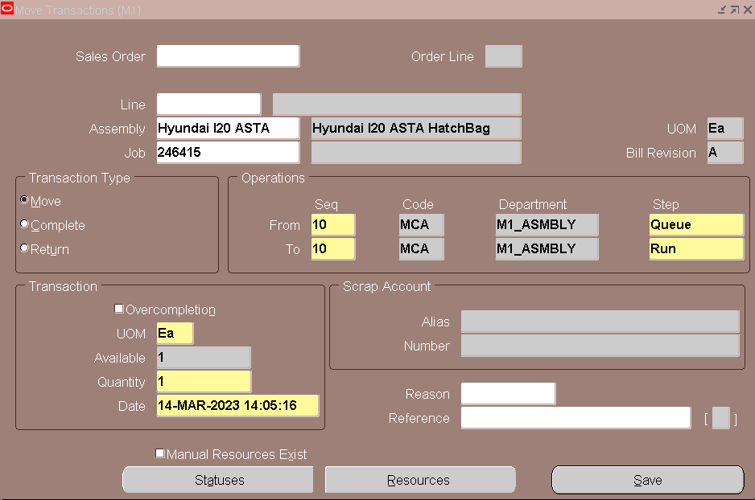

Save the Details.

Verify the DJ’s Operations 🡪Quantities Details

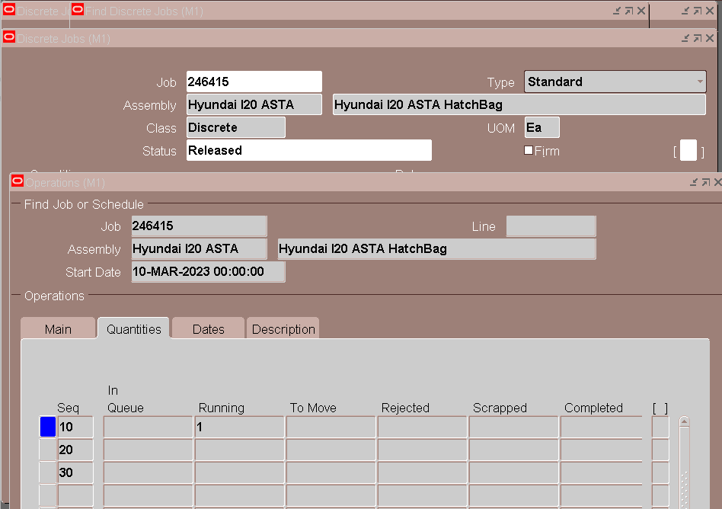

**WIP Issue Transaction for Operation 10:**

**Navigation:** Work in Process 🡪 Material transactions 🡪 WIP Material Transactions

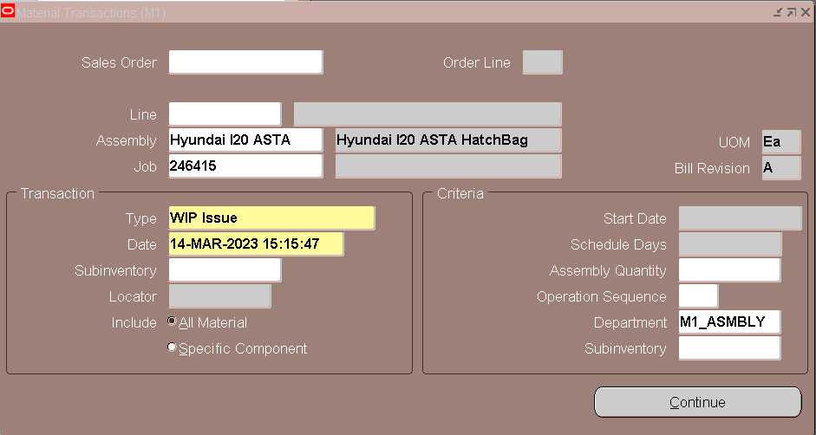

Click on Continue

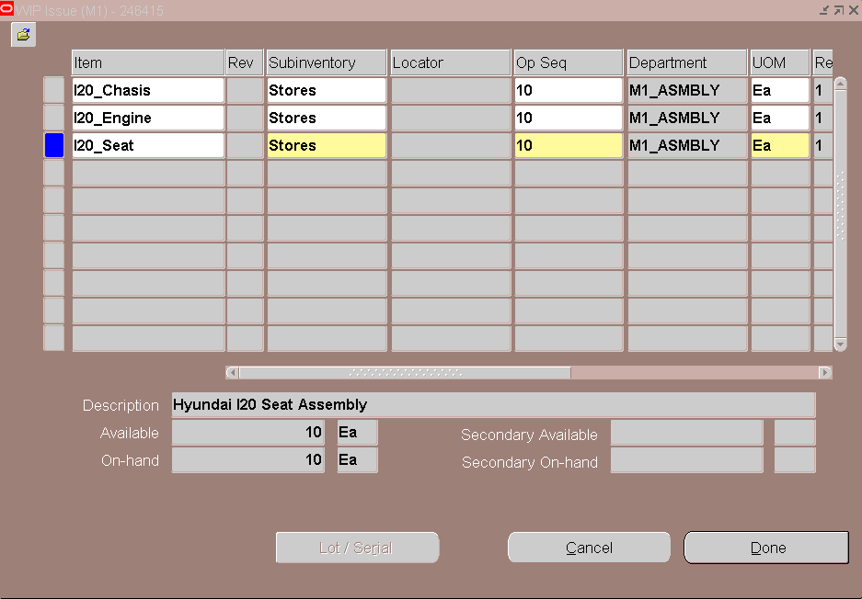

Click on Done.

Verify the Operations🡪 Components

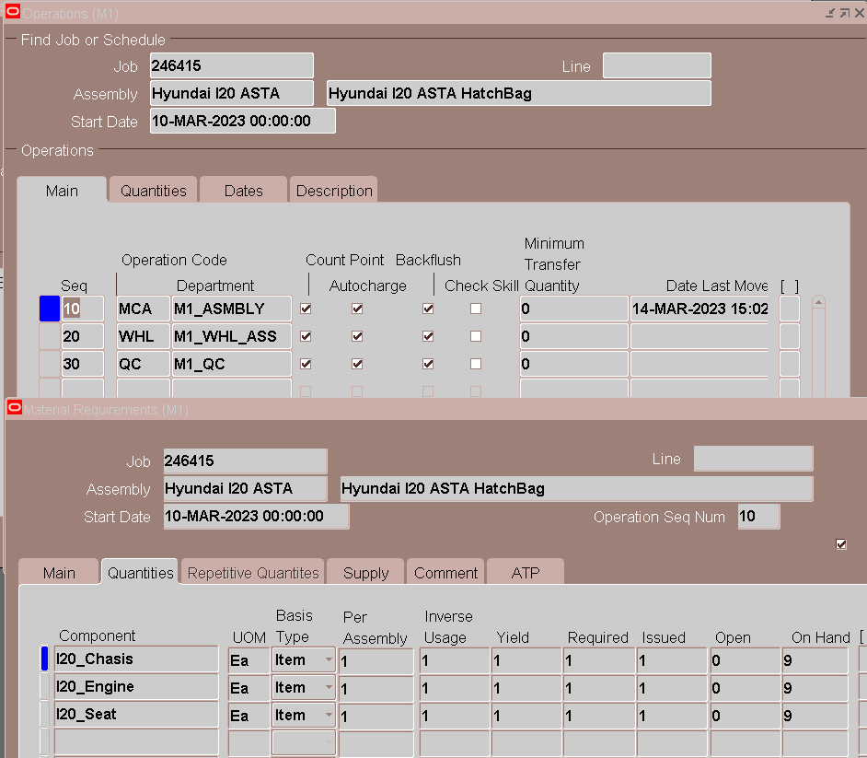

Verify the Components 🡪 Quantities

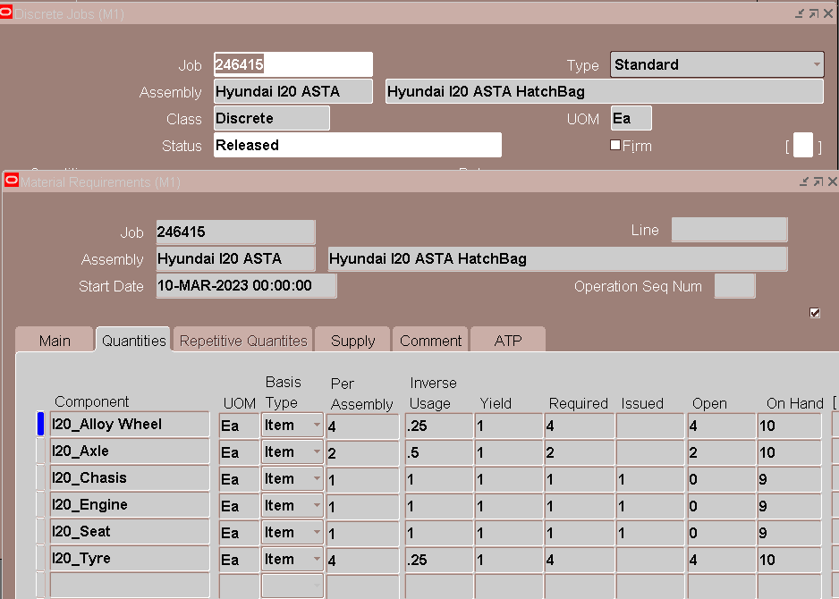

1. **Move Transaction (Ope-10 Run to 20-Queue):**

Enter the Operation from and to sequence, Step details

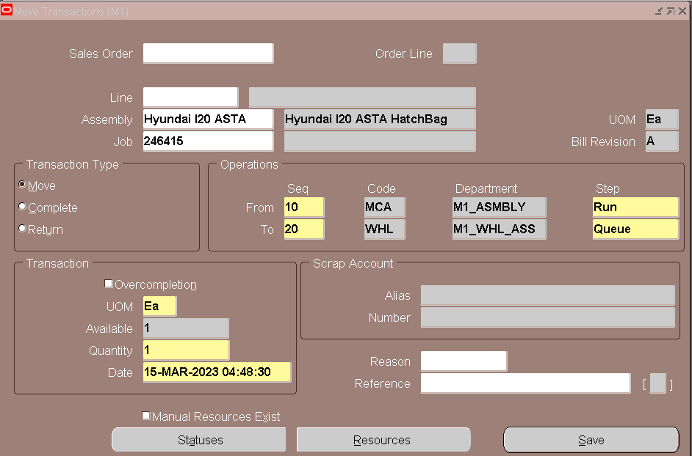

Save the Details.

Verify the DJ’s Operations 🡪Quantities Details

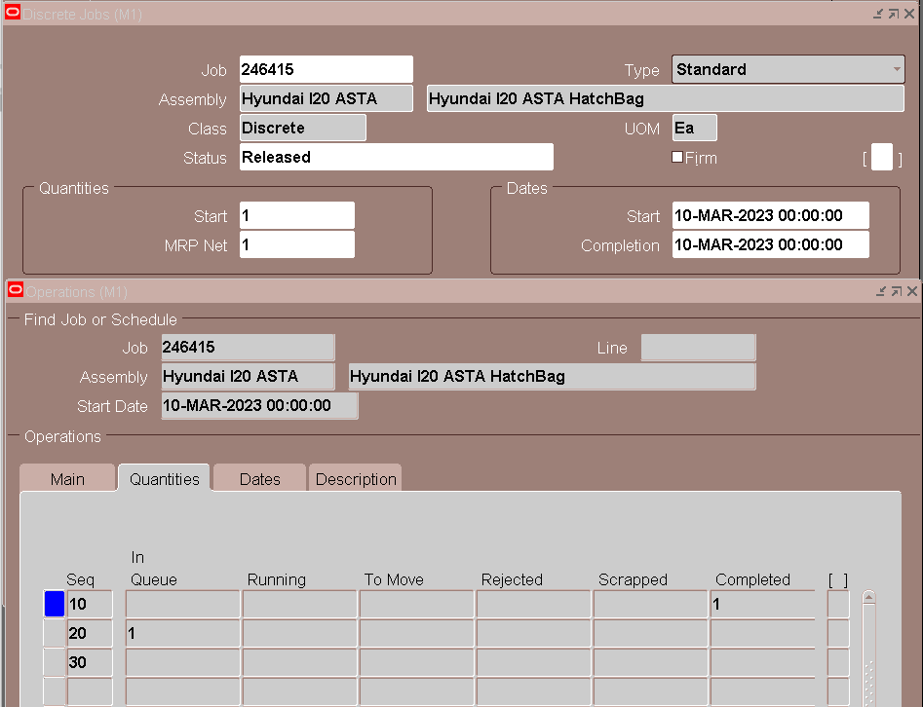

1. **Move Transaction (Ope-20-Queue to 20-Run):**

Enter the Operation from and to sequence, Step details

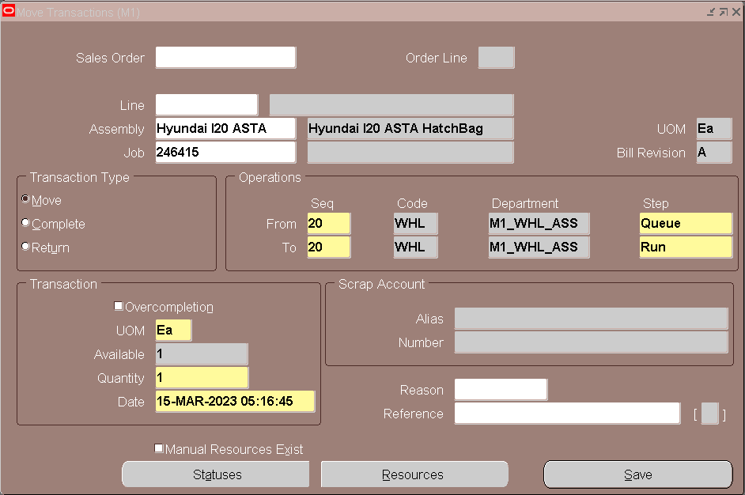

Save the Details.

Verify the DJ’s Operations 🡪Quantities Details

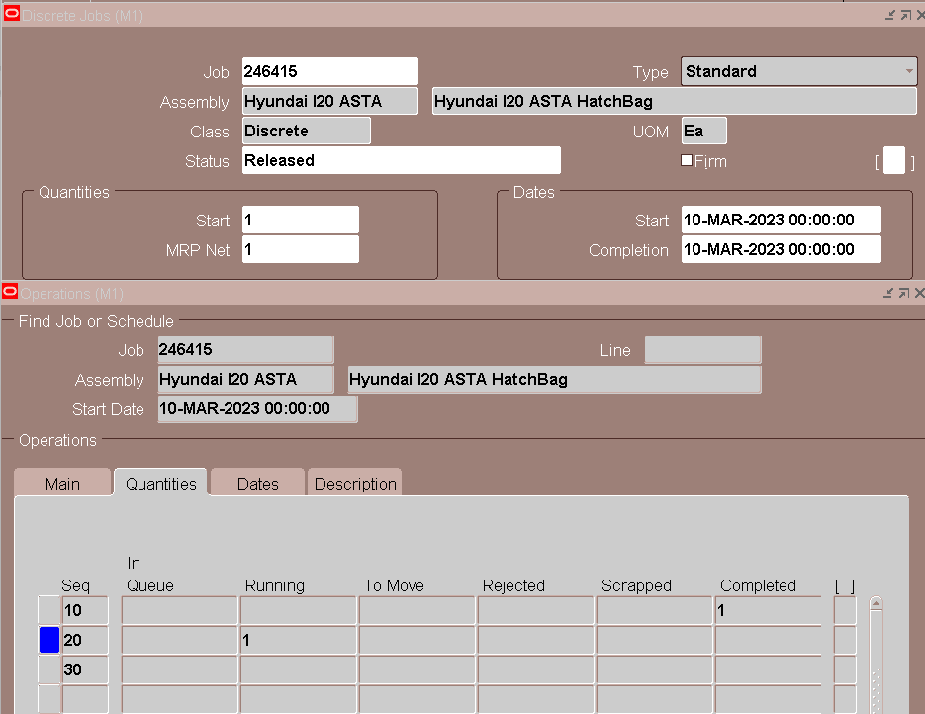

**WIP Issue Transaction for Operation 20:**

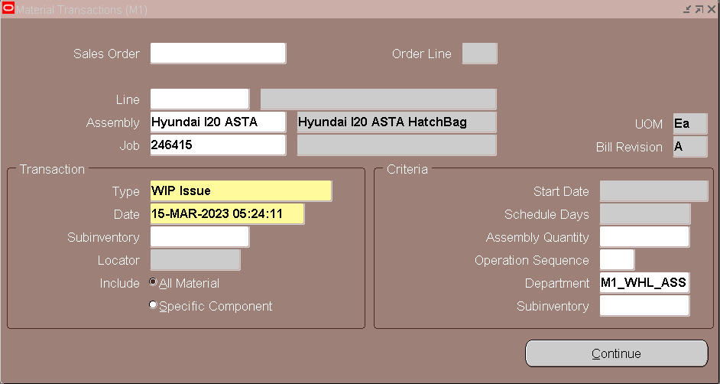

Click on Continue.

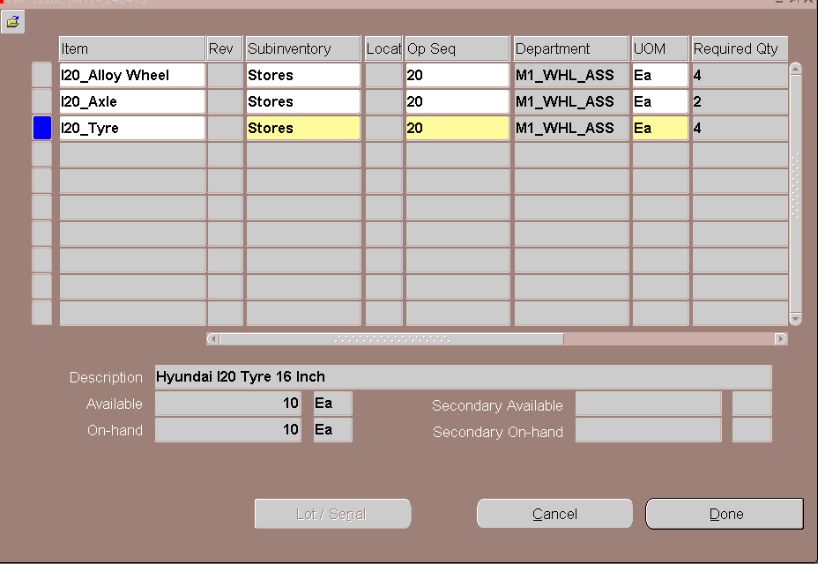

Verify the Operations🡪 Components

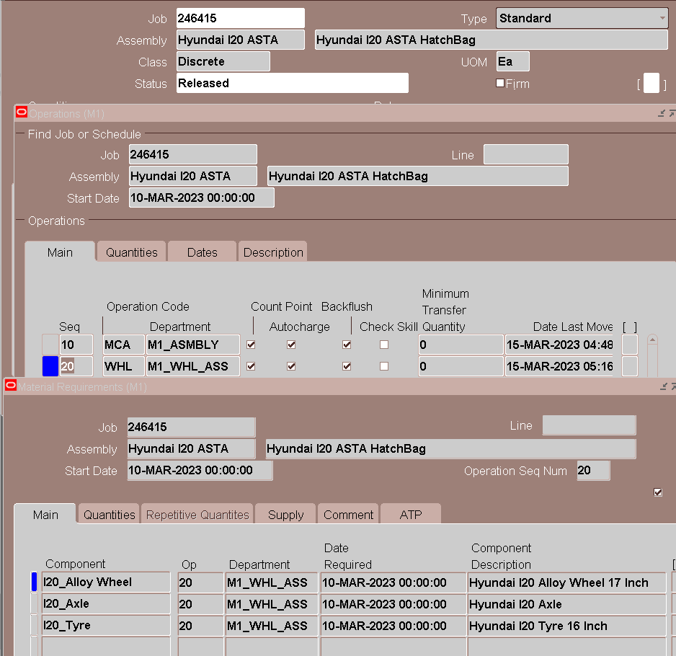

Verify the Components 🡪 Quantities

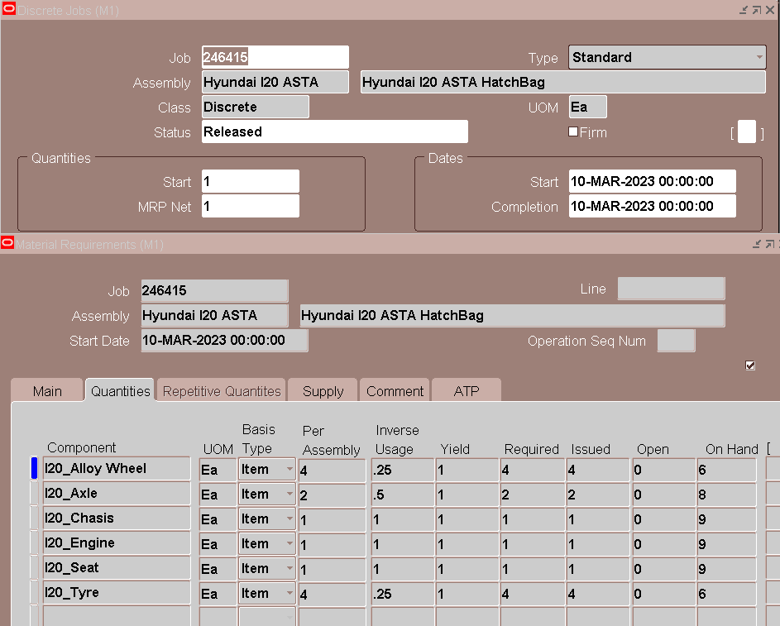

1. **Move Transaction (Ope-20-Queue to 30 Move):**

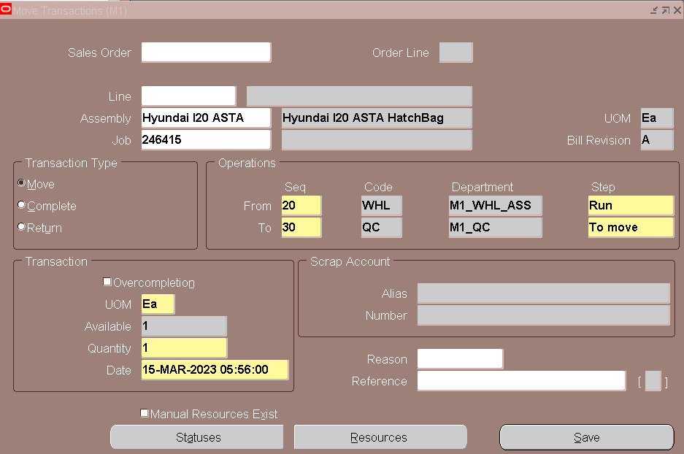

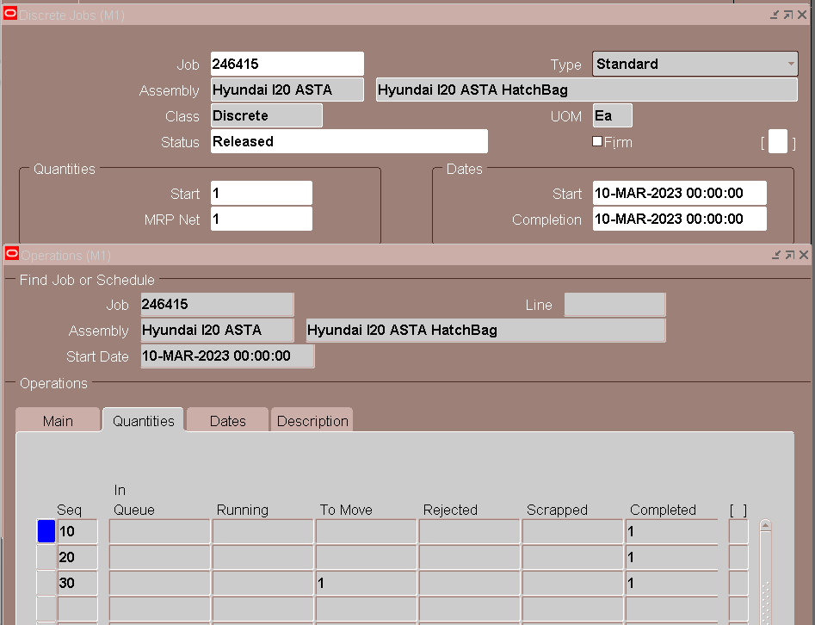

**Completion Transaction:**

**Navigation:** Work in Process 🡪 Material Transactions 🡪 Completion Transactions

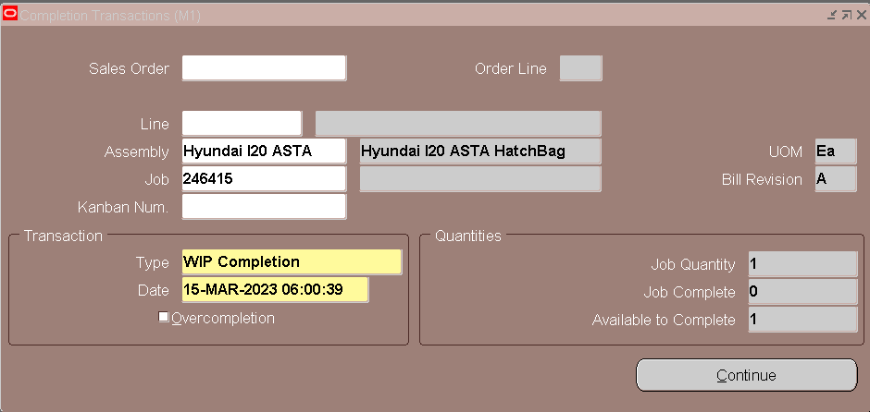

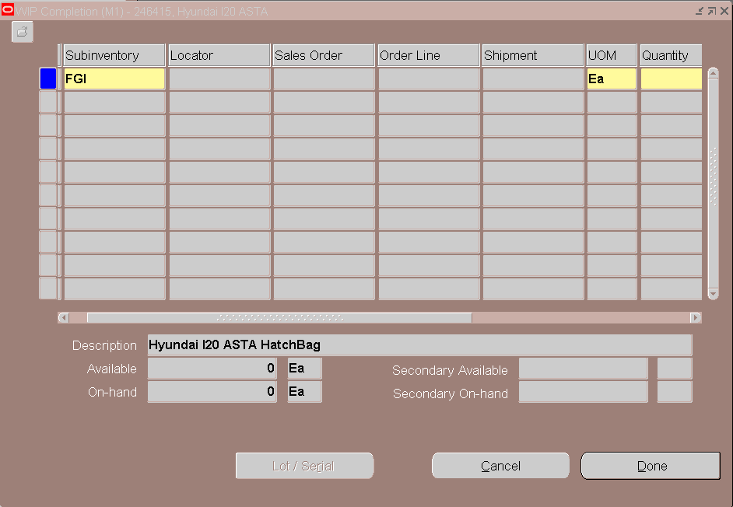

Verify the Work Order Status

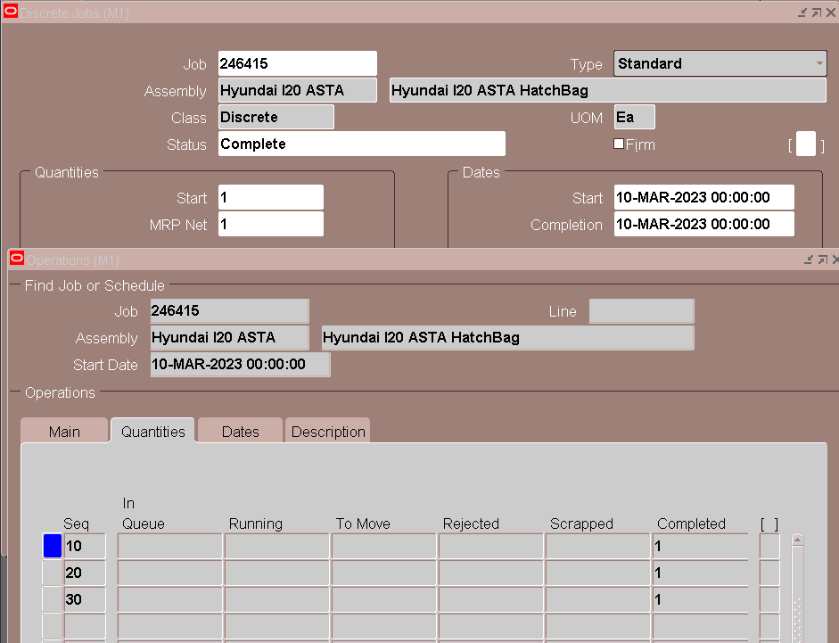

**Find On Hand Availability for Finish Good:**

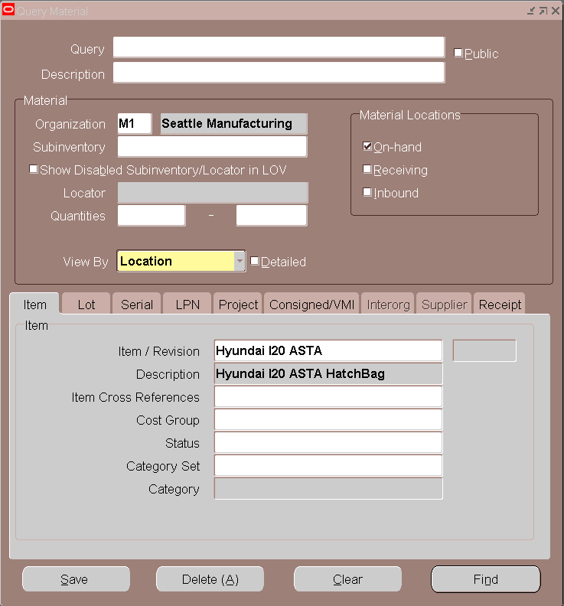

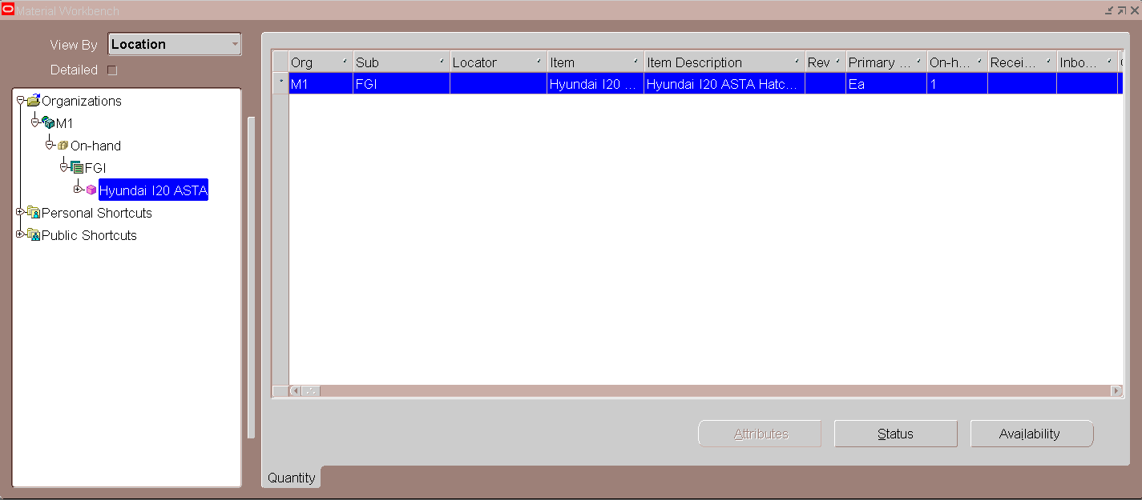

**Find the Material Transaction against Work Order**

**Navigation:** Inventory 🡪 Transactions 🡪 Material Transactions

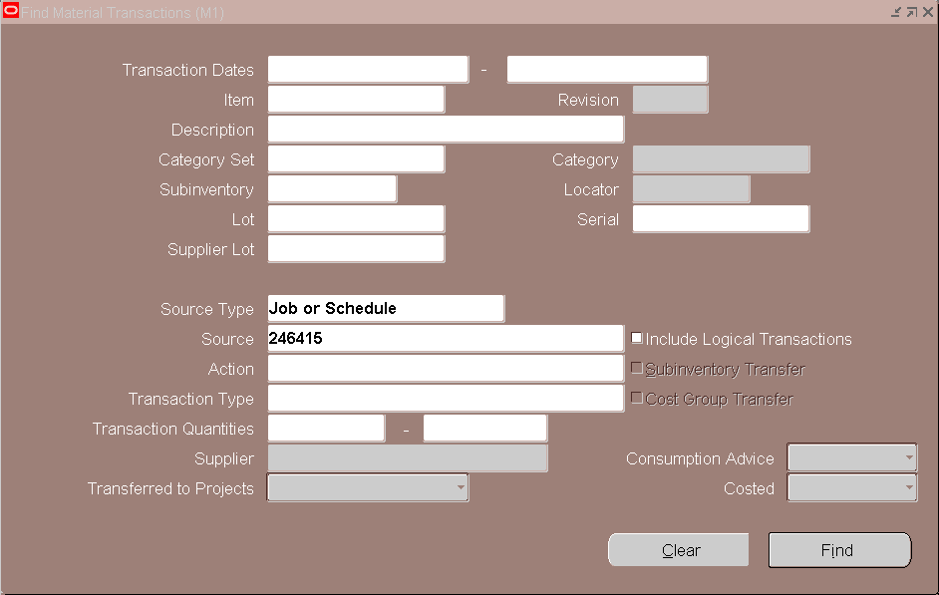

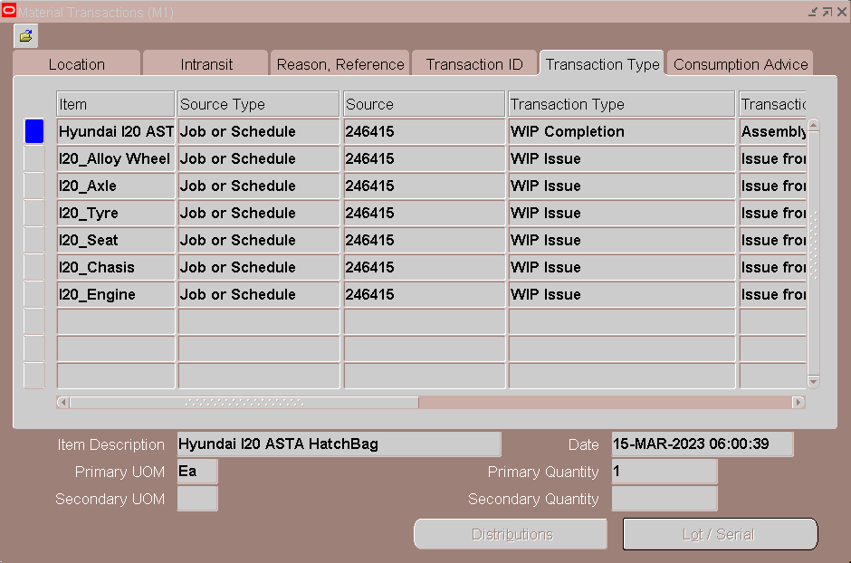

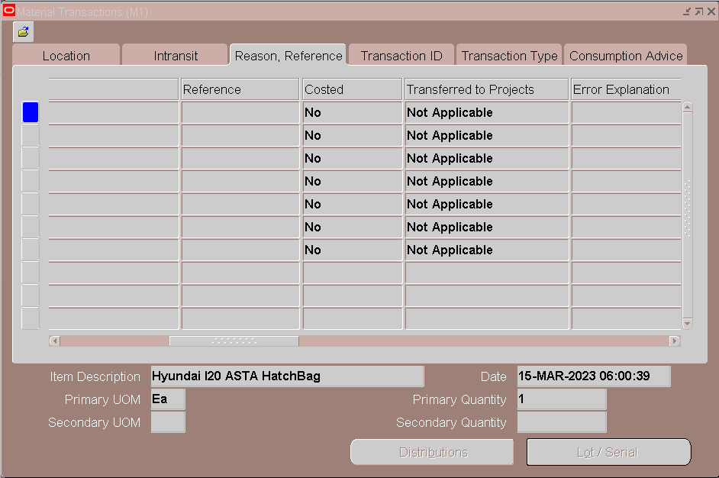

***Also, we can see the Material Transaction from Work in Process,***

***Navigation: WIP🡪 Material Transactions 🡪 View Material Transactions.***

Transactions are not Costed, Check the Cost Manager

Navigation: Inventory 🡪 Transactions 🡪 Interface Manager

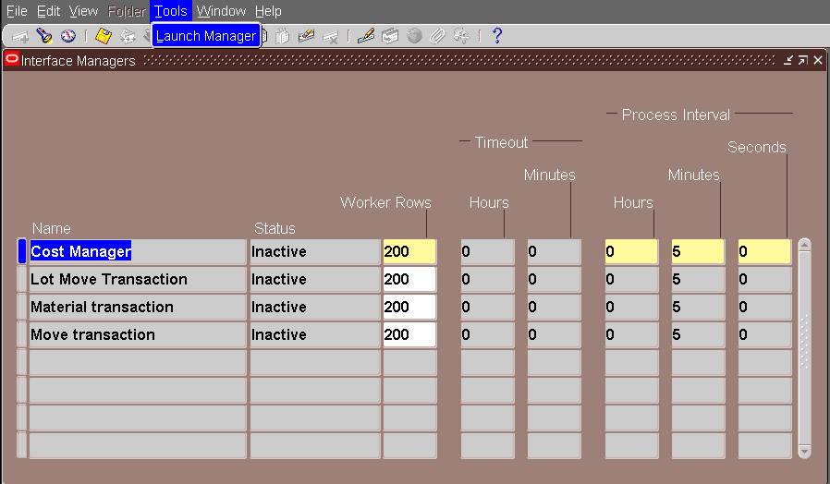

**Find the Resource Transactions:**

**Navigation:** Work in Process 🡪 Resource Transactions 🡪 View Resource Transactions

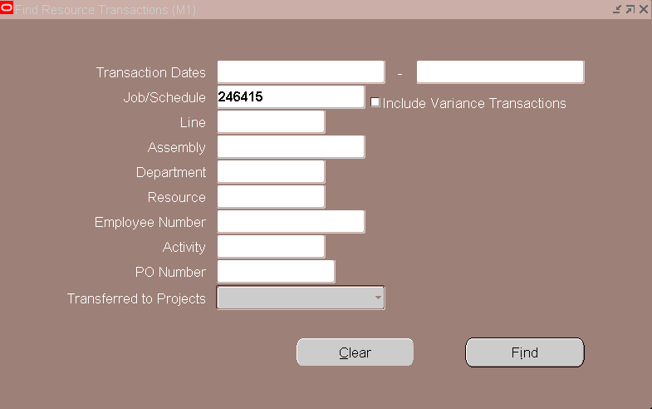

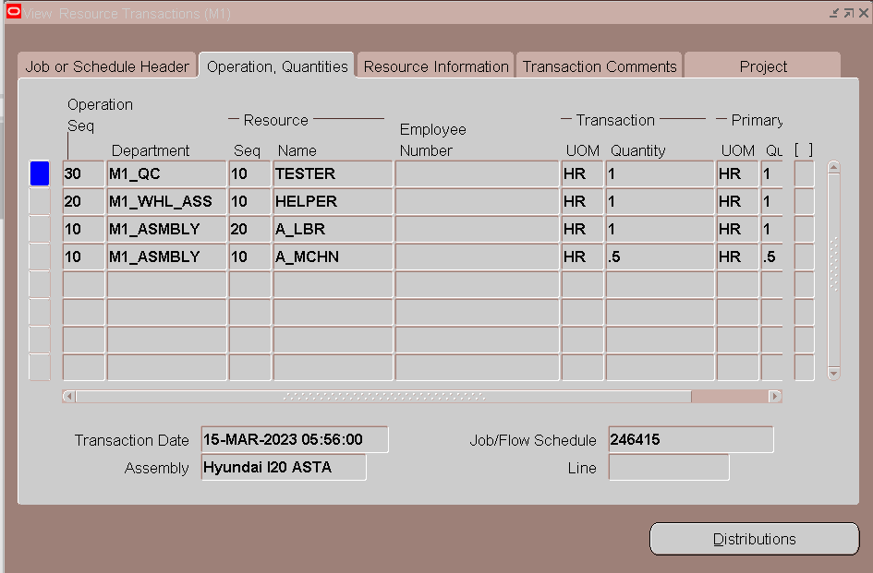

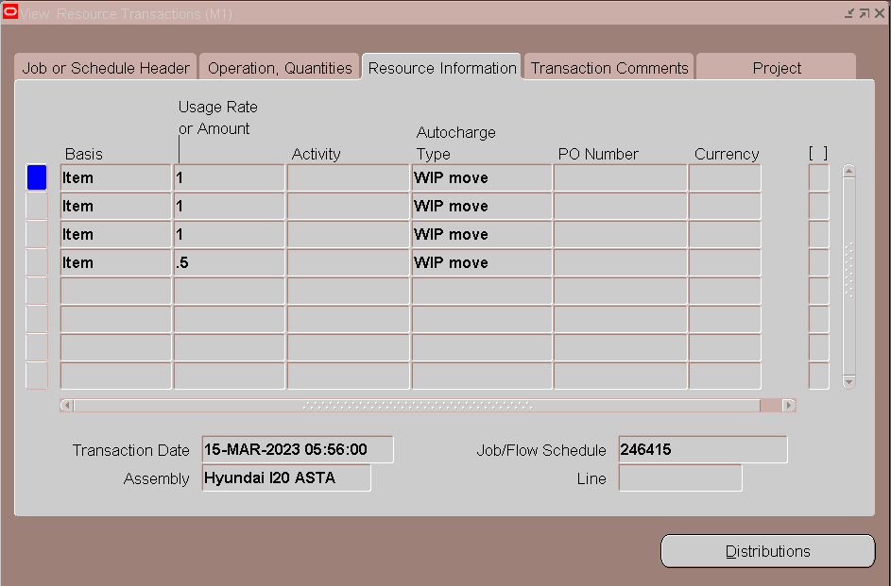

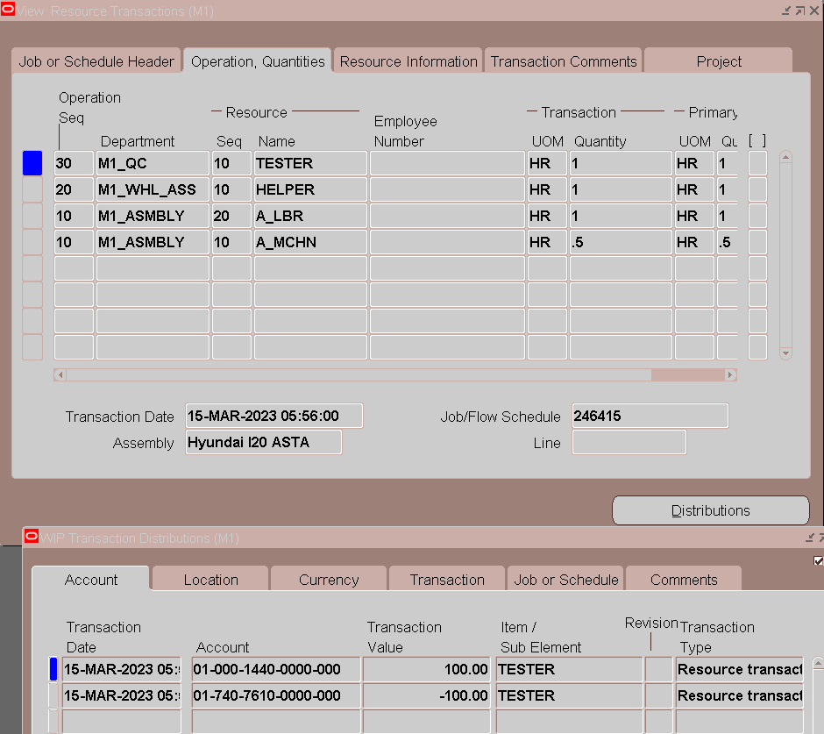

**Supply Chain Bills of Material Indented Cost Report:**

|  |  |  |  |  |
| --- | --- | --- | --- | --- |
|  | **Item / Cost Element** | **Quantity** | **Rate/Cost** | **Extended Cost** |
| Material | I20_Engine | 1 | 500 | 500 |
| I20_Chasis | 1 | 400 | 400 |
| I20_Seat | 1 | 75 | 75 |
| I20_Tyre | 4 | 30 | 120 |
| I20_Axle | 2 | 20 | 40 |
| I20_Alloy Wheel | 4 | 20 | 80 |
| Resources | A_MCHN | 0.5 | 200 | 100 |
| A_LBR | 1 | 75 | 75 |
| HELPER | 1 | 50 | 50 |
| TESTER | 1 | 100 | 100 |
|  | **Hyundai I20 ASTA (Finish Good)** | | | **$1540** |

**Navigation:** Cost Management 🡪 Supply Chain Costing 🡪 Supply Chain Cost Rollup

Select the Organization as "**M1 - Seattle Manufacturing**"

Submit a single request and submit " **Supply Chain Cost Rollup - Print Report**"

Enter the parameters like below

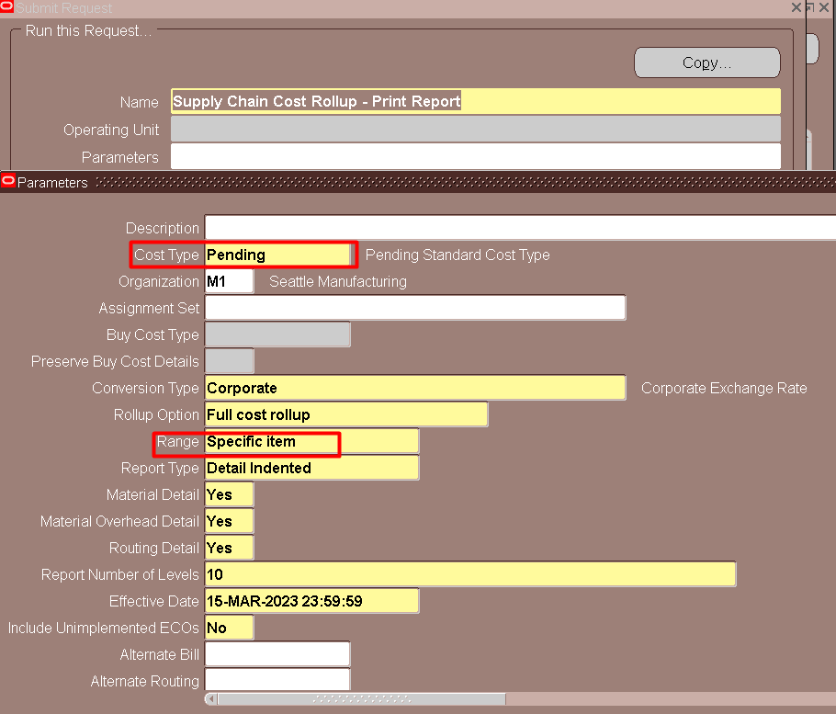

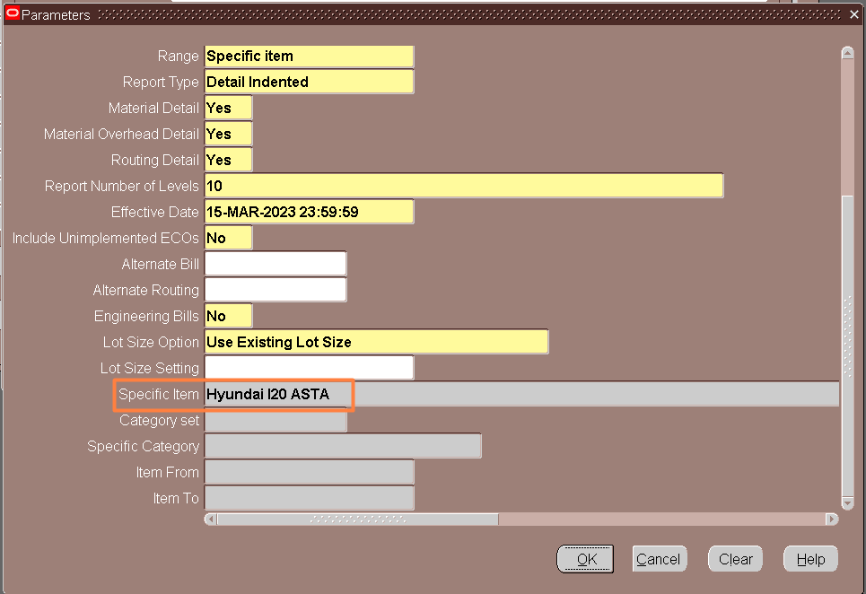

**Submit** and **View Output** for "Supply Chain Cost Rollup - Print Report"



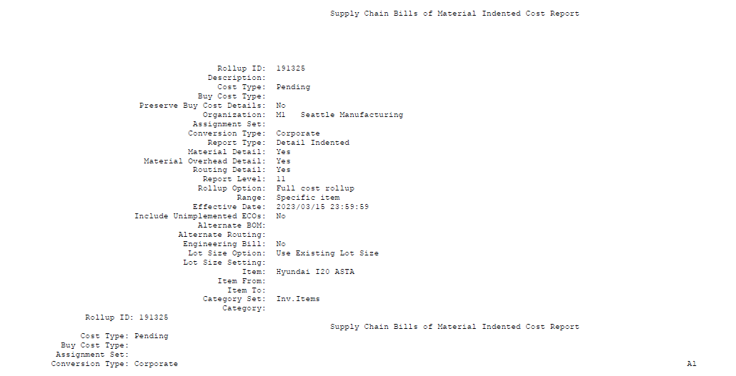

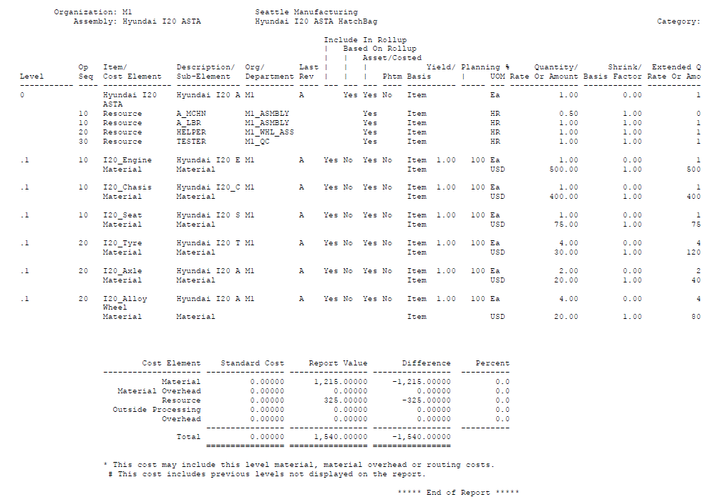

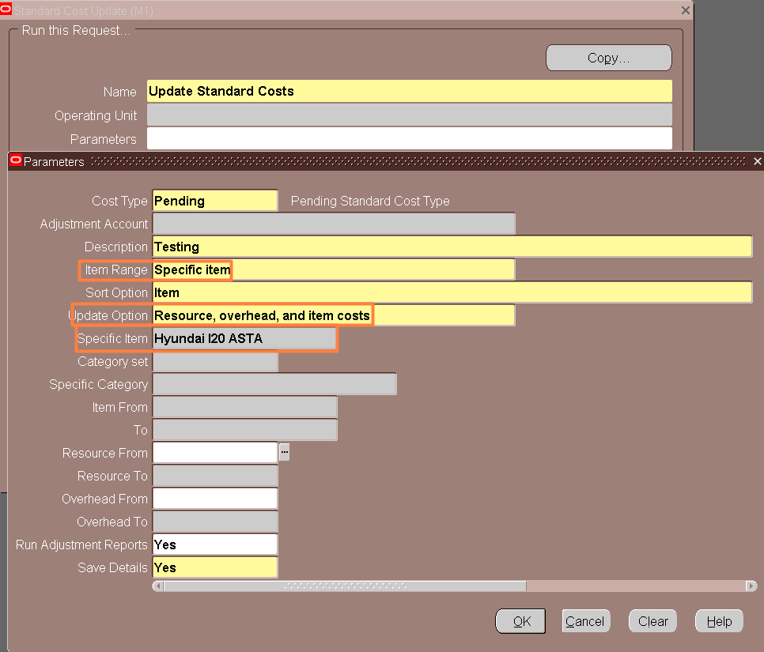Update Standard Cost

**CLOSE DISCRETE JOBS**

**Navigation:** Work In Process 🡪 Discrete 🡪 Close Discrete Jobs 🡪 Close Discrete Jobs (Forms)

Query the Discrete Jobs# 246415 which we have completed recently

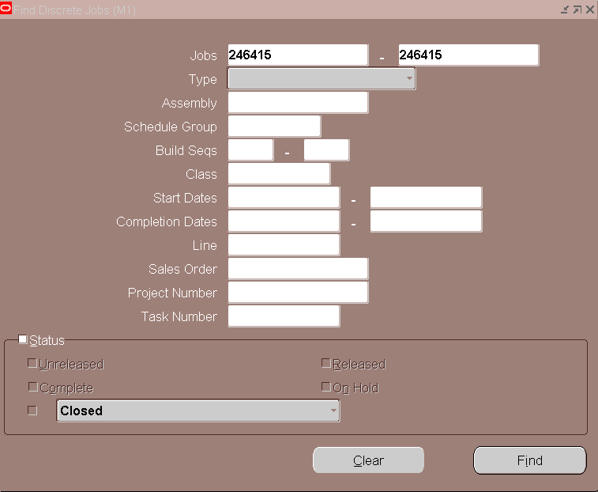

Before closing the Discrete Jobs, check the Pending Transactions. To check the Pending Transactions

**Navigation:** Tools > Pending Actions

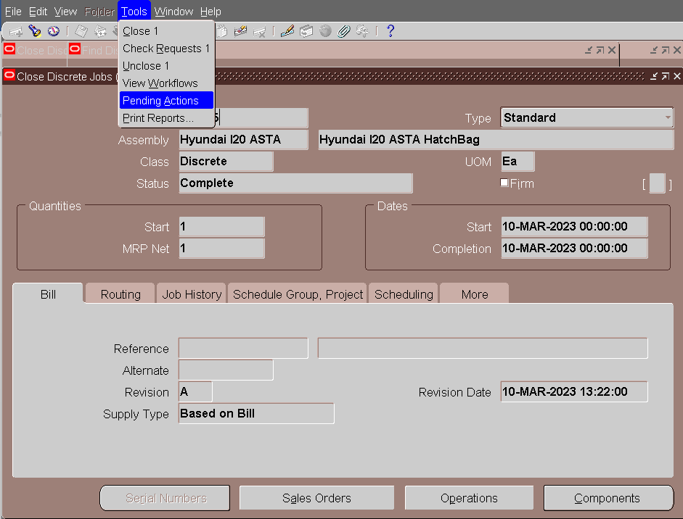

Select the "**Pending Actions**" option from Tools Menu and check for any pending actions

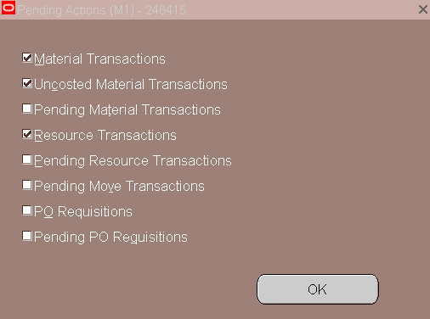

Only "Material Transactions" and "Resource Transactions" are enabled.

If anything, other than the below mentioned actions are enabled then that means there are some pending actions

1. Material Transactions
2. Resource Transactions
3. PO Requisitions

In our Discrete Jobs, there are no pending actions. So, it is eligible to Close.

To Close the Discrete Jobs, Navigate to Tools Menu and select the Close option

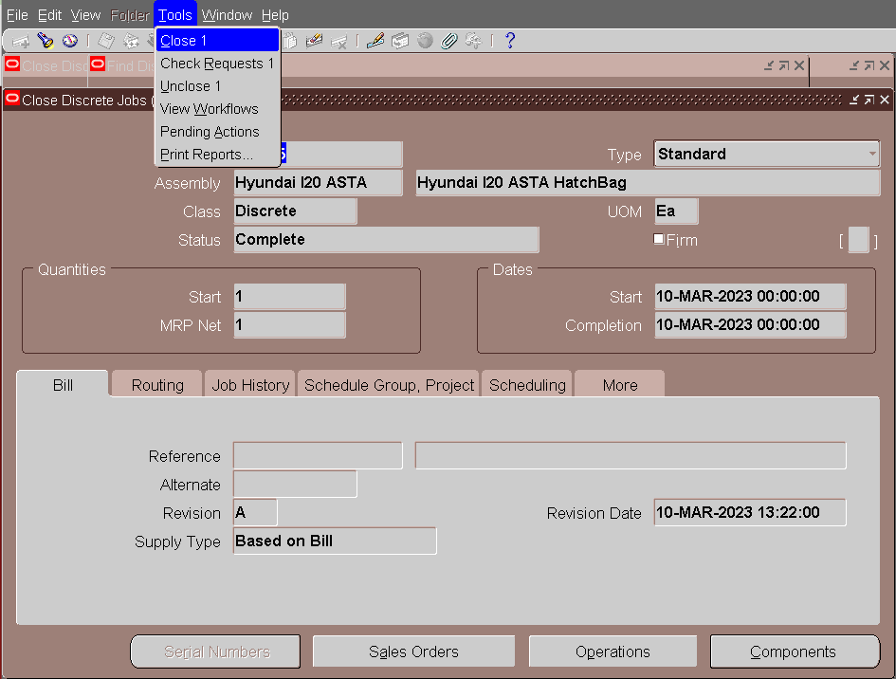

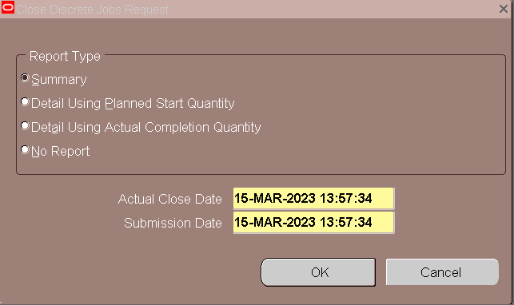

Select "**Summary**" and click "**OK**"

Discrete Job Status = Pending Close

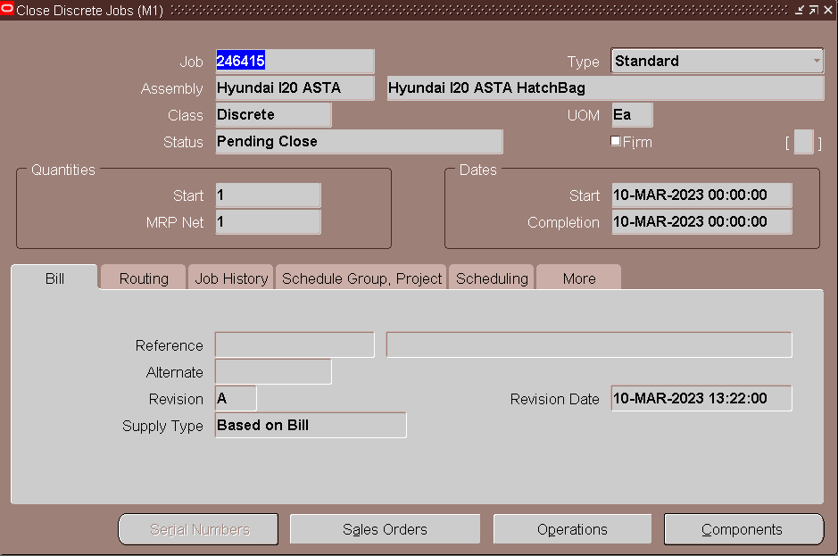

**Navigation:** Tools > View > Request

Can see two requests

1. Close Discrete Jobs
2. Discrete Job Value Report - Standard Costing

If there are any pending actions then the second request will not run

Select the second request "**Discrete Job Value Report - Standard Costing**" and check the output