**Steps to configure company segment to be defaulted from the Item change account for recoverable tax lines**

**Step 1 :** Create a Account rules : Navigate to “Manage Account Rules”

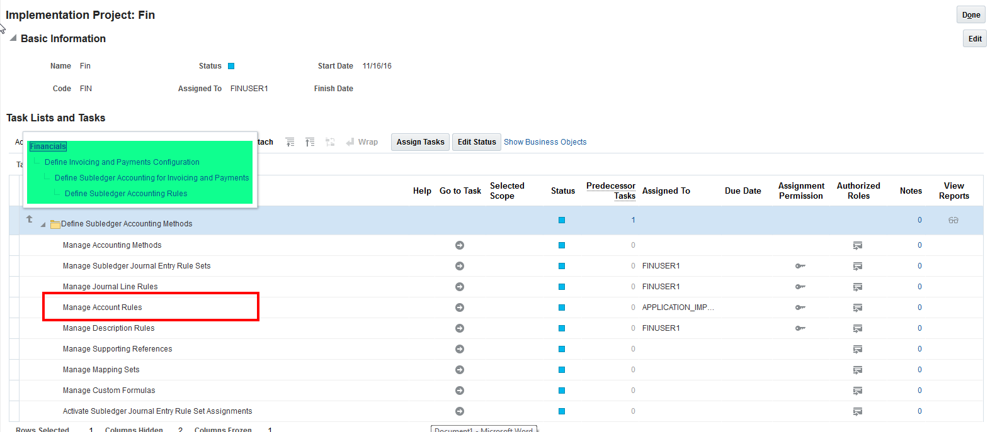

With Rule Type as “Segment” and segment value as “Primary Balancing segment”

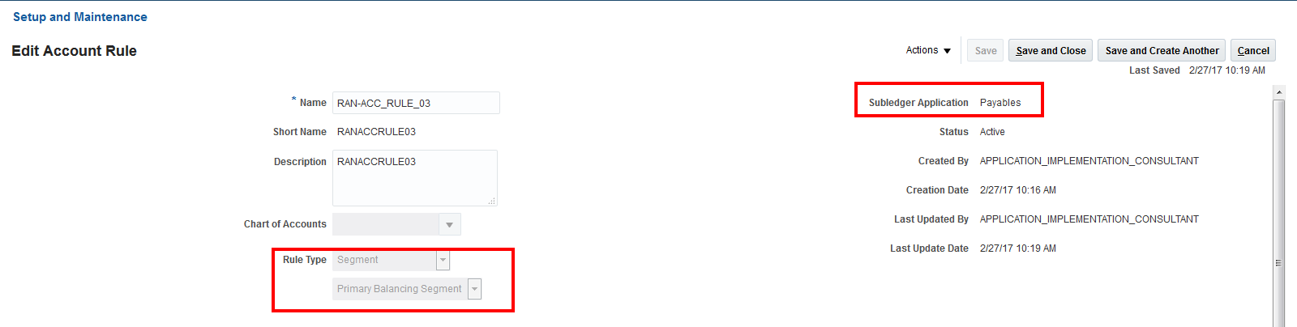

In the Rules region

* Add a new Row with Value type as “Source” and value as “Item Change account for Tax”
* In the Condition region put the condition as “Invoice Distribution Type”(AP)=REC_TAX
  + Select “Invoice Distribution Type” from Source button
  + Select = from operations, and
  + Type the text as “ REC_TAX
* Click validate and ensure that there are no error

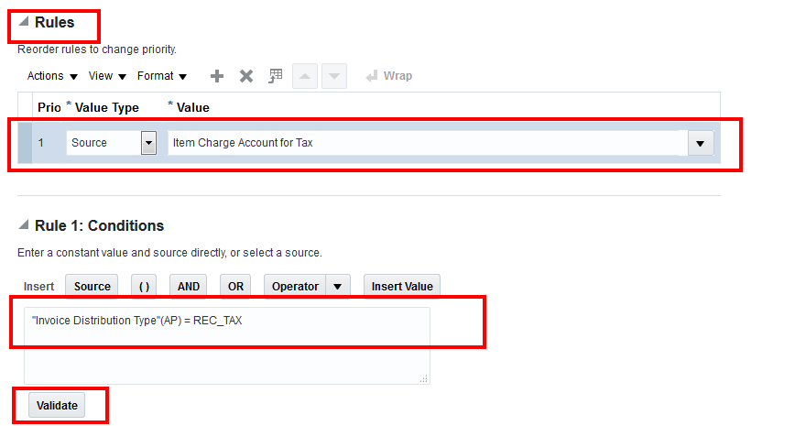

In the same rule add the 2nd row with value type as “Source” and Value as “ Invoice Distribution account” “no Condition to be added”

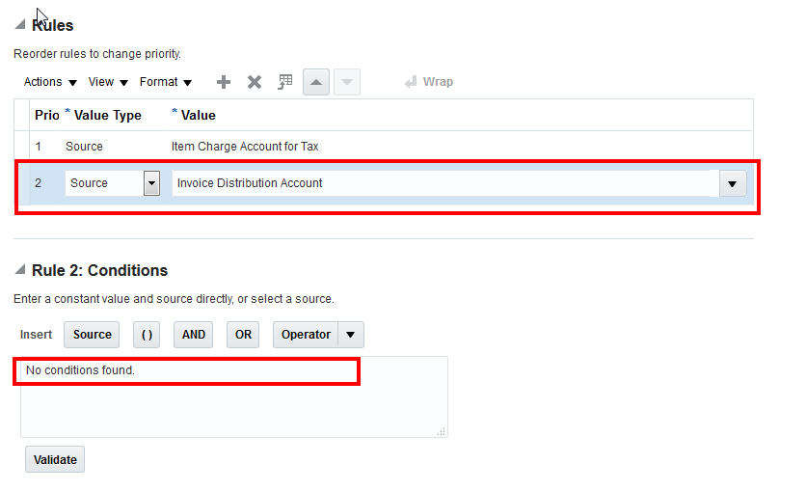

Save and close the account rule

**Step 2 :** Create of new Journal Entry rule set : Navigate to “ Manage Subledger journal entry rule sets”

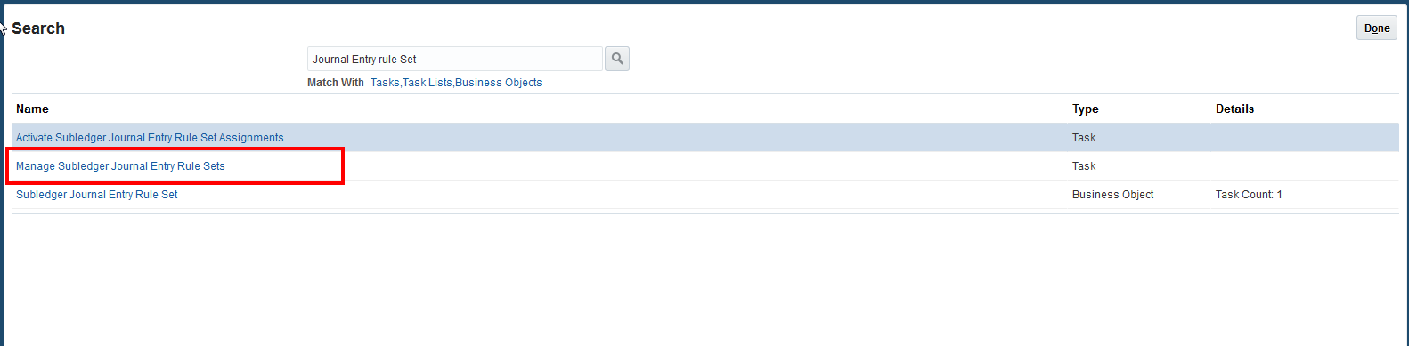

* Search for “Invoice Accrual”
* In the search results, select the “Invoice Accrual Basis” row and take “Duplicate” from actions

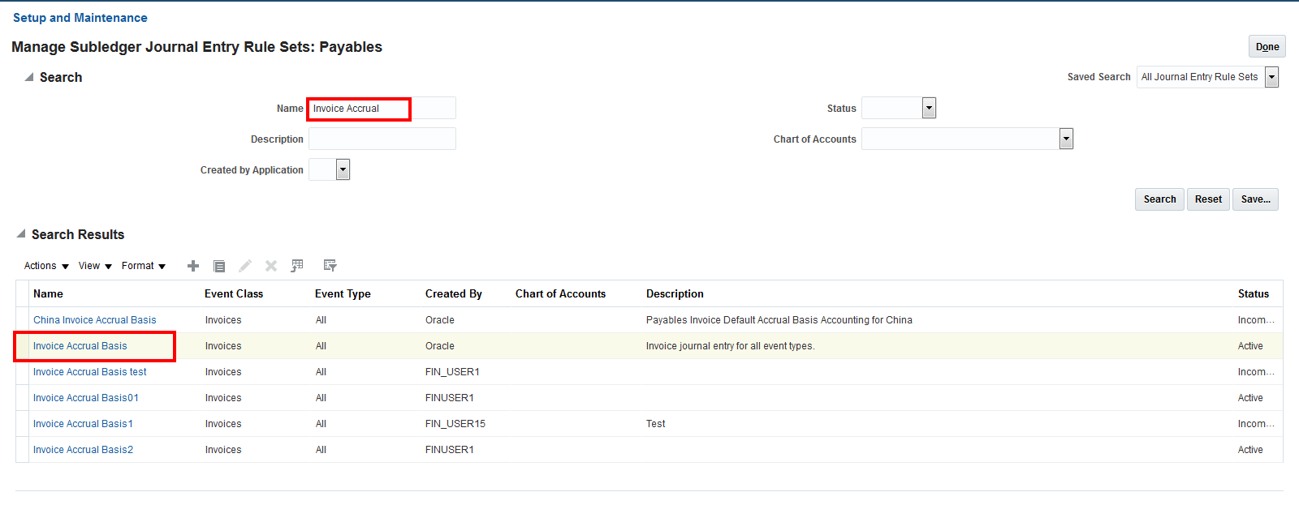

Name the journal Entry rule set, in the Journal line region,

* select the journal line with Journal line rule as “ Recoverable tax” and Line Type as “debit”
* for this Line in the “Primary Balancing segment” column LOV, select Account rule created in Step 1
* Save and close the Journal entry rule set

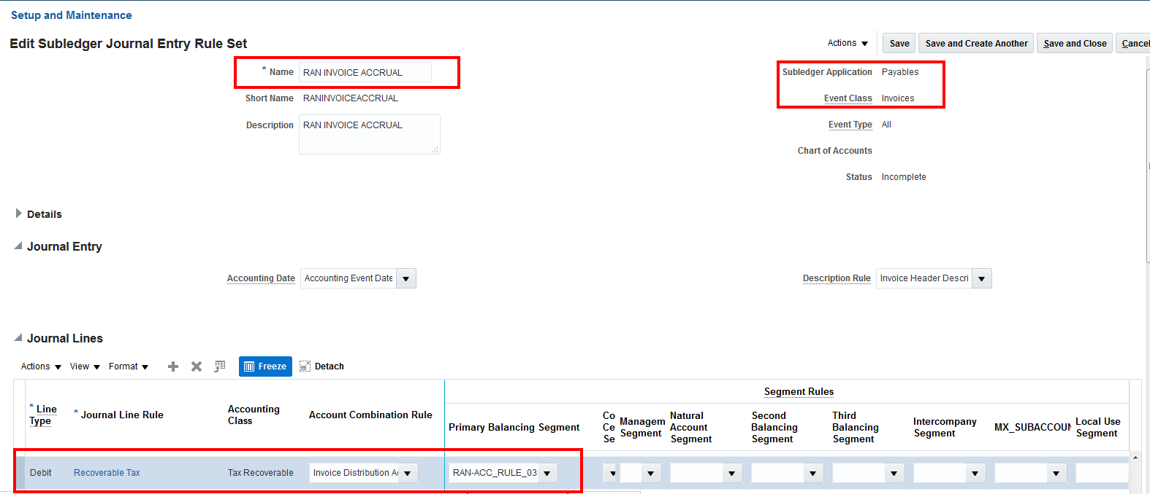

Step 3 : Create a New Accounting Methods and Map the New Journal Entry rule set to Invoice Event class :

* Naviagte to “Manage Accounting Methods”
* Search for “Standard Accrual”
* In the search results, select the “Standard Accrual” row and take “Duplicate” from actions

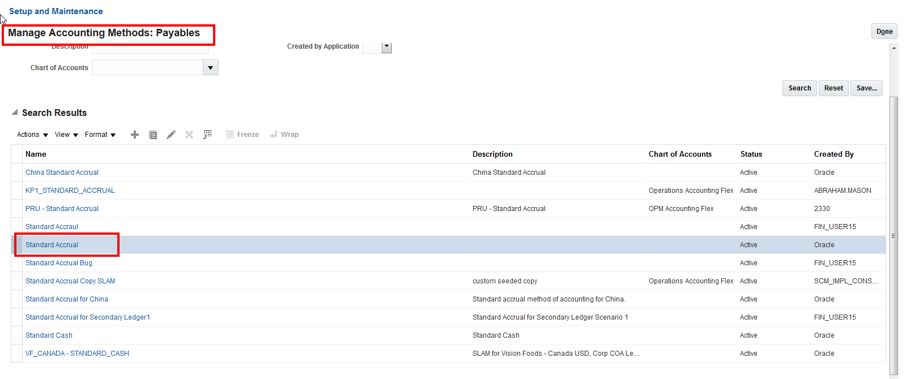

* Save the New accounting menthod
* Go to Payables Tab
* Look for Event Class as “Invoice” Event Type “ALL” and Rule Set “Invoiec Accrual Basis” and delete this row

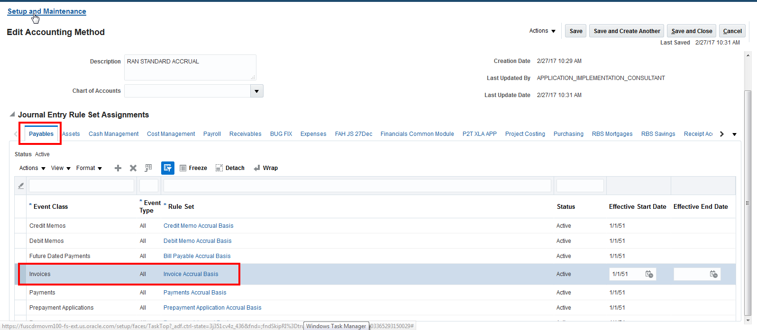

* Add a new row with Event Class as “Invoice”, Event Type “ALL” and Rule Set “JLR crerated in Step 2”

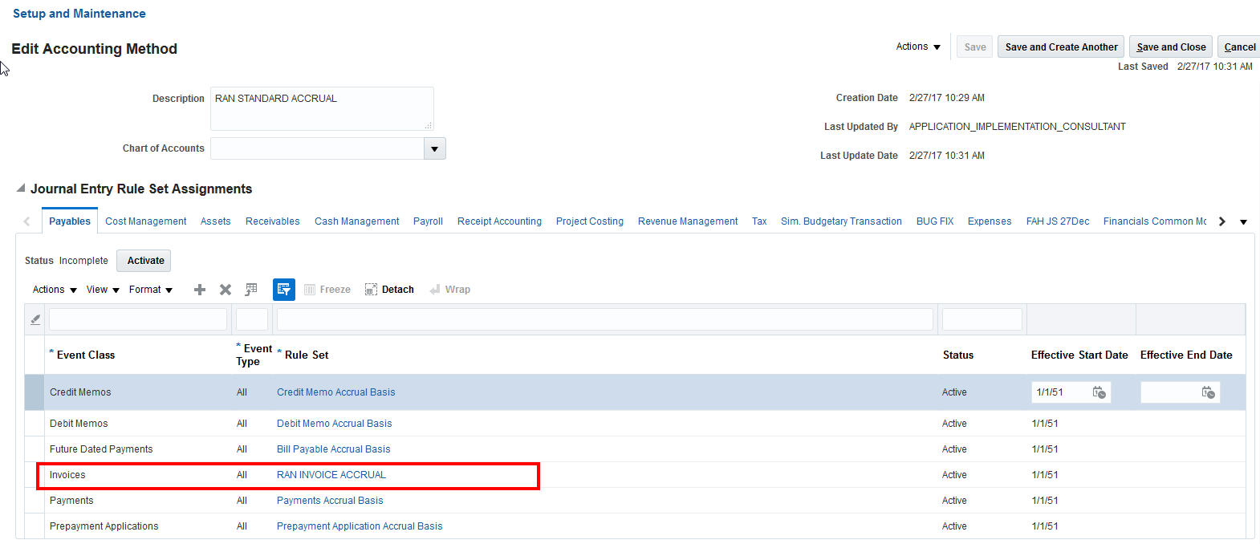

* Save and close.

Step 4 : Map the New Created Accounting methiod to Ledger. In Manage Primary Ledger