# Charge back Transaction creation

To test this charge back create invoice transaction with 10000 and due date today only and customer paid 8000 still 2000 due, customer is requesting to postpone the remaining due date (2000) to future date in this case we can do by postpone the remaining amount we can create the charge back transaction.

1. Create Transaction with 10000
2. Customer paid (8000) half amount and applies that to Transaction
3. Perform charge back ( system will create charge back transaction automatically for this setup is required and we have to create transaction type and transaction source and we have to create receivable activity for charge back)
4. System Create the charge back transaction 2000
5. Create receivable activity for charge back

## Create Charge back activity at receivable activity

Oracle provide charge back activity go and assign the charge back in that

* Go to setup and maintenance
* Setup: Finance
* Functional area: Receivables
* Task : %Manage% receivable % activities%
* Select Manage Receivable Activities
* Query the seeded data and select the charge back adjustment activity

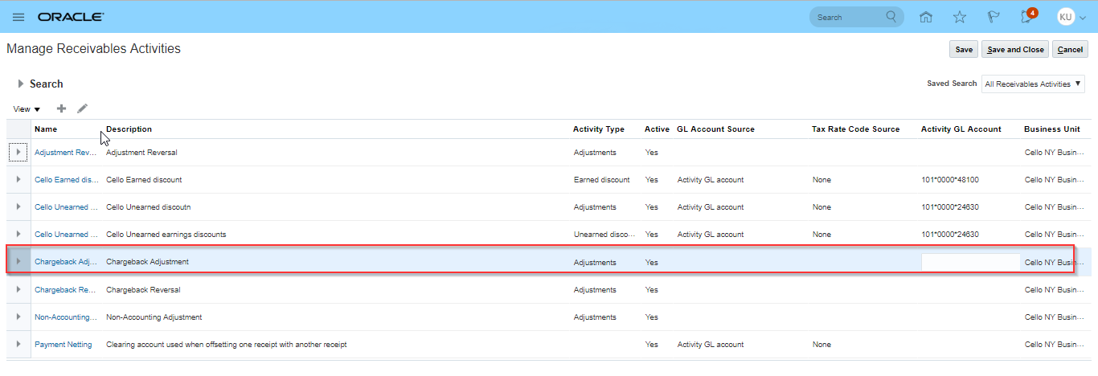

* Give the details of mandatory

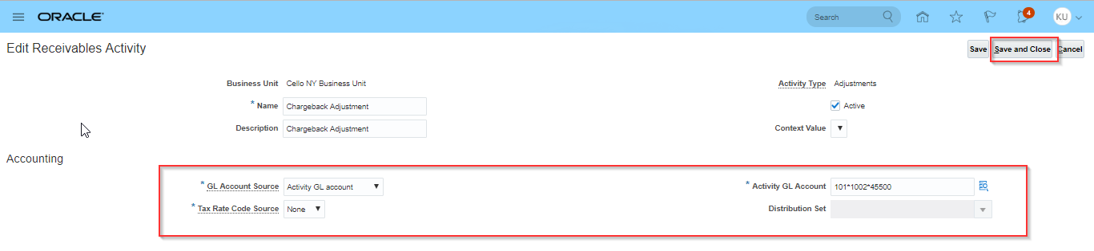

* Click on save and close

## Create invoice transaction with 10000

* Go to Home Page
* Click on Receivables
* Click on Billing
* Go to Task list and click on Credit Transaction
* Give the details and click on complete and review
* Go to actions and click on post to ledger

## Create Receipt with 8000

* Go to Home Page
* Click on Receivables
* Click on Accounts Receivables
* Go to Task list and click on Crate Receipt

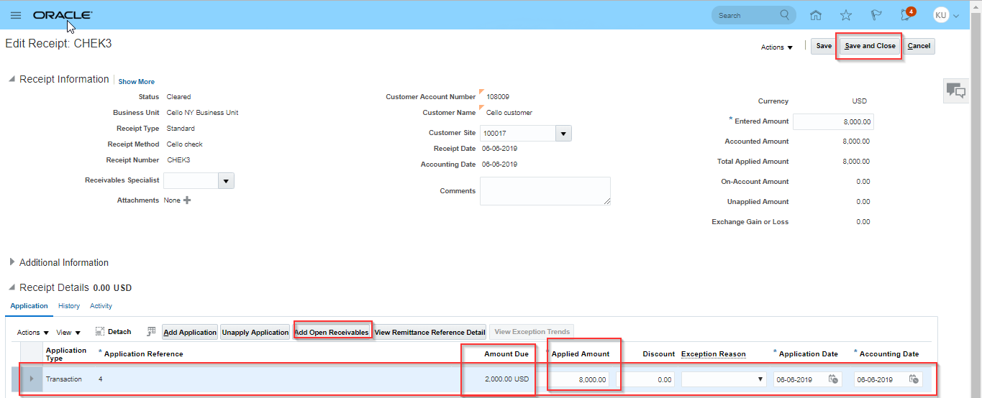

* Save and close
* Select the invoice transaction go to actions and click on charge back and give the type account and amount then it will create the charge account

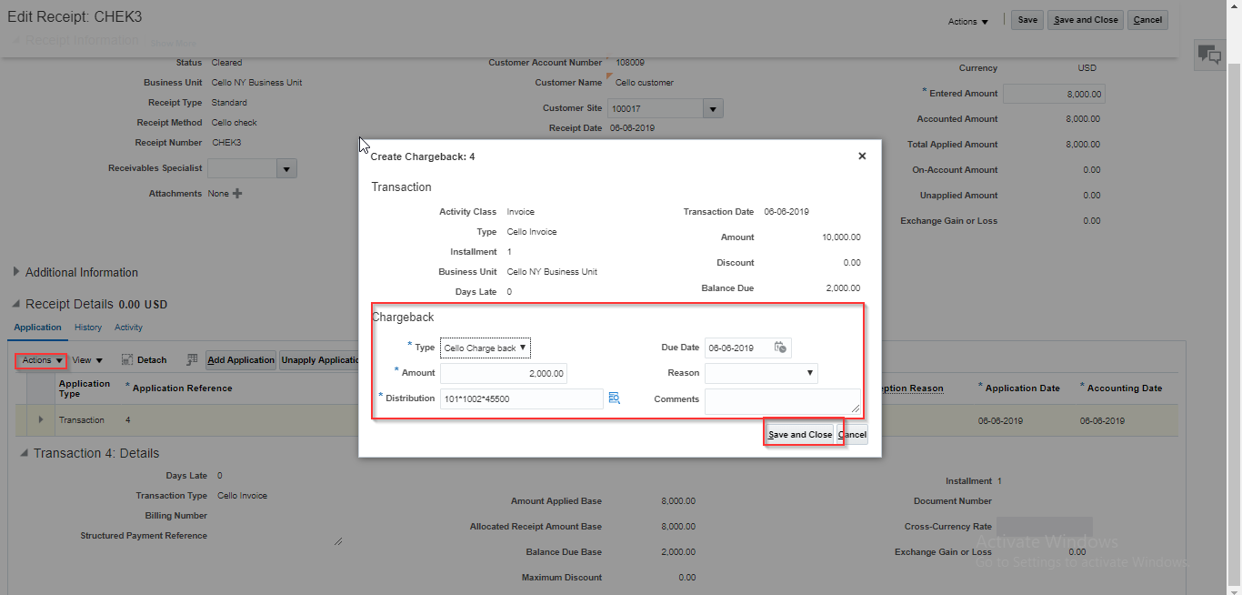

* Click on save and close
* Query with the customer you can see the automated charge back invoice

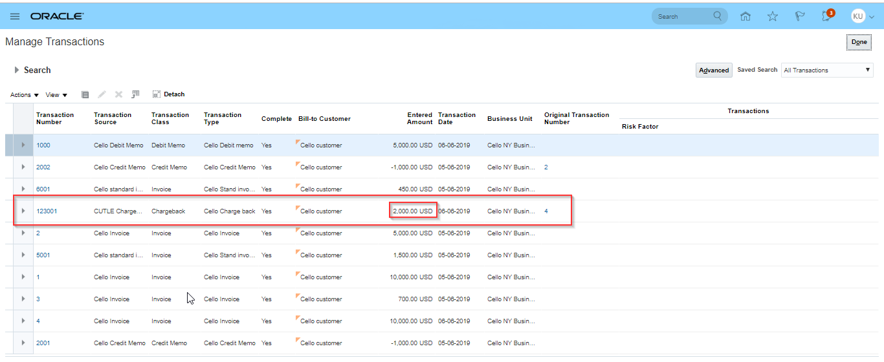

* Save and close