**Employee Assignment Update Integration – Oracle Fusion HCM.**

**Introduction:**

This blog explains about how to call a bip report placed in the oracle fusion hcm instance. And then transfer the report data to the third party application. This will be an outbound integration.

**Cause of the issue:**

For every 2 hours once, recently altered employee assignment details in Oracle fusion HCM that needs to be passed to the third party system.

Since client has the third party system has the base application to generate all sorts of reports related to employees.

**How do we solve:**

**Employee Assignment Update Integration(Child) :-**

This integration will be a App Driven Integration. This integration will calls the bip report based on the parameter Last Run Date Time using the below soap service and operation.

• ExternalReportWSSService: runReport method

• xmlpserver/services/ExternalReportWSSService?wsdl

**Child Integration Flow :**

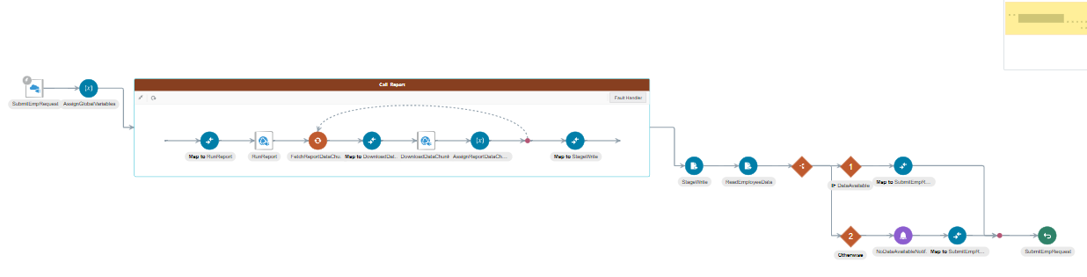

**SCHEDULEEMPLOYEEASSIGNMENT Integration (Master) :-**

This integration will be a scheduled integration with a scheduled parameter. This integration will calls the child integration (EMPLOYEE ASSIGNMENT UPDATE) and then collects the data from the bip report based on the parameter Last Run Date Time and then transfers the data to the third party system using the Rest API.

**Master Integration Flow :**

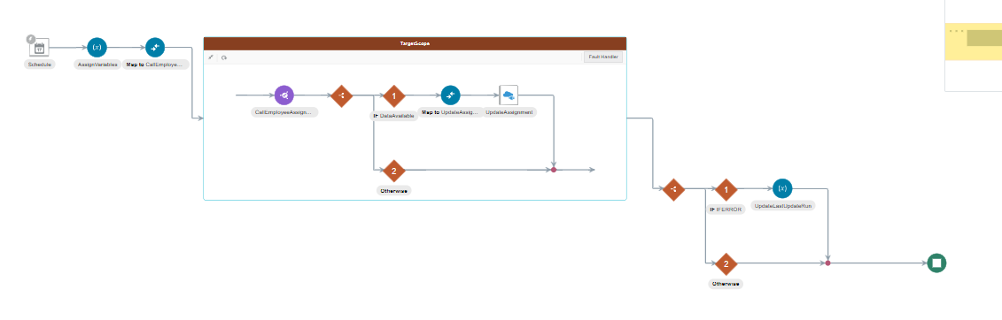

SCHEDULEEMPLOYEEASSIGNMENT is the master integration which in turn calls the child integration (Employee Assignment Update). The child integration invokes the bip report in fusion and then sends the data to the third party API. Sending the data to the third party API is dealt in the Master integration. Whenever there is no data is fetched by the report no data notification will be sent to concerned team and in case of any error error notification will be sent to the concerned team.

The parameters that needs to be passed to the soap service are shown in the below screen shot. It has one parameter in the Last Run Date Time which will be passed as input to the bip report. And then other parameters like report absolute path which defines the actual path of the bip report location, along with the report name in fusion instance, attribute template parameter which will takes on the value xml and then the attribute format takes on the value XML. Since the output of the report will be in XML format we are considering the attribute template and attribute format properties as XML value.

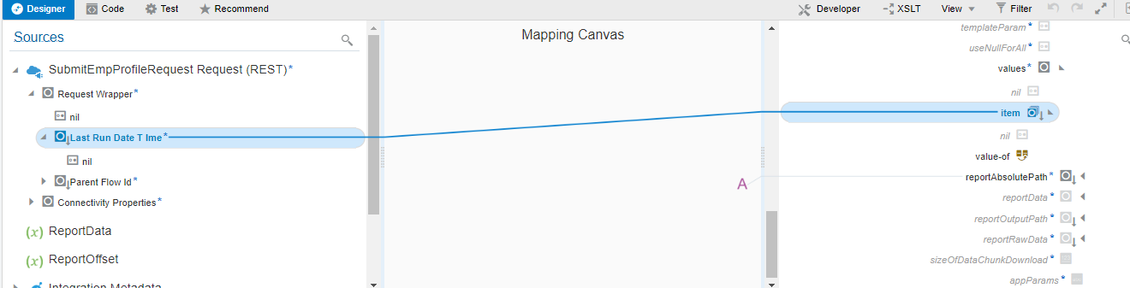

**IAR File:**



