Template for Writing the Blog

Introduction/Issue write the issue that you face or the issue that you want to provide a solution through this blog

This document is requested by business to update new Postal Code ‘X91 E799’ in Cloud for IM IE BU. Need to add this to supplier FOCUS ONE - 507323.

Why we need to do/Cause of the issue:

Write the details about the issue

postal code X91 E799 is not available in oracle data for Ireland. Need to add this to supplier FOCUS ONE - 507323. refer attached.

How do we solve: Write the Query or the steps to solve the issue with your real-time example or scenarios Note: do not mention any customer name/VPN details.

**Step1:Settings and Actions--->Procurement-->Select Suppliers--->All Tasks-->Manage Geographies-->Search Coutry Name as Ireland-->Choose Hierarchy-->Geography Type as Country and Name as Ireland--> select Ireland-->add ireland-->add code**

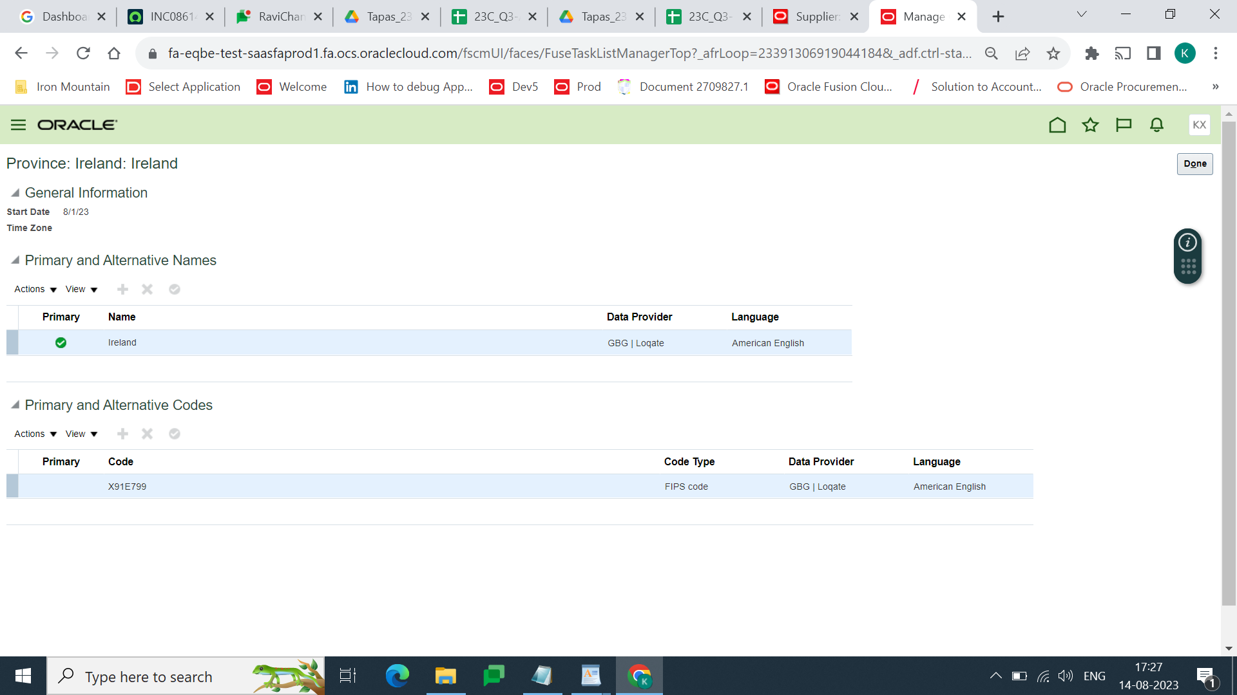

**Home-->Procurement-->Supplier--->Search FOCUS ONE--->Open Supplier**

