Automation of Populating Need by and Promise Date in PO screen -Form Personalization

Table of Contents
Contents
Contents 2
1. Overview 3
2. Technologies and Tools Used 3
3. Use Case 3
4. Architecture 3
5. Examples 5

Overview

It’s used to automate need by date and promise date based on PO Country through form personalization into EBS (Oracle E-Business Suite)

Technologies and Tools Used
The following technology has been used to achieve the same.
- Oracle SQL
- Database server
- Oracle Application

Use Case
Need by and Promise date will get automated based on PO country Code provided.

Architecture
Steps:
- First, we need to write custom package for calculating need by date and promise date based on origin of country from PO.
- Then do form personalization steps based on the date populated in PO screen against need by date and promise date columns.

Step1:

Seq | Description | Level | Enabled
28 | Need By Date Change in Shipment Level | Function | Yes
Condition
Trigger Event | WHEN-NEW-ITEM-INSTANCE
Trigger Object | PO_SHIPMENTS.NEED_BY_DATE
Condition | TO_DATE(:PO_SHIPMENTS.PROMISED_DATE,'DD-MM-RRRR HH24:MI:SS') <>  nvl((SELECT TO_DATE(PROMISED_DATE,'DD-MM-RRRR HH24:MI:SS')  FROM PO_LINE_LOCATIONS_ALL  WHERE LINE_LOCATION_ID = :PO_SHIPMENTS.LINE_LOCATION_ID),sysdate)
Processing Mode | Both

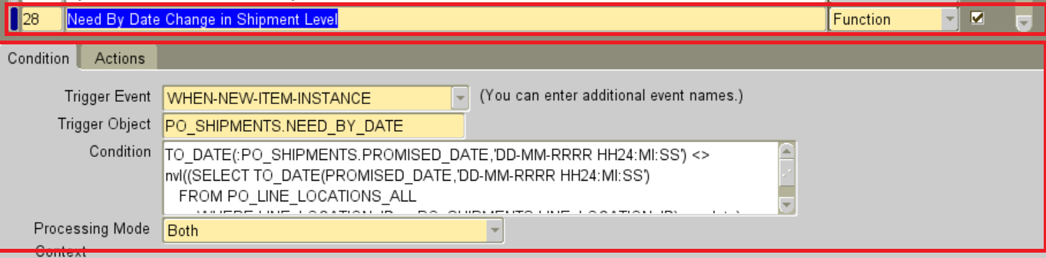

Actions

Seq | Type | Description | Language | Enabled
1 | Property |  | All | Yes

Object Type | Item
Target Object | PO_SHIPMENTS.NEED_BY_DATE
Property Name | VALUE
Value | =select to_char(xdmc_po_date_calc_pkg.get_date_fnc(''||${item.PO_SHIPMENTS.PROMISED_DATE.value}||'',  ''||${item.PO_HEADERS.VENDOR_SITE_ID.value}||'', 'N')) FROM DUAL

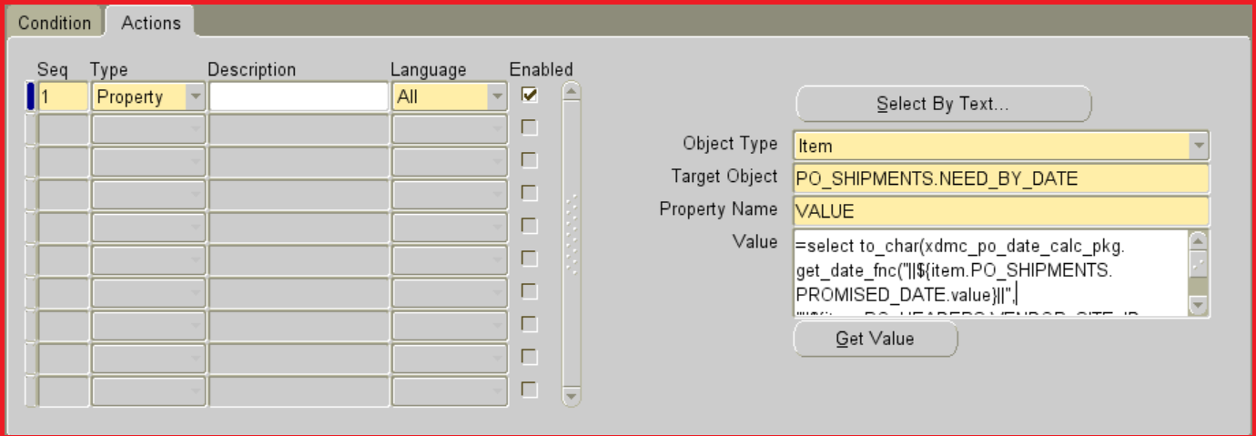
Step2:

Seq | Description | Level | Enabled
29 | Promise Date Change in Shipment Level | Function | Yes
Condition
Trigger Event | WHEN-NEW-ITEM-INSTANCE
Trigger Object | PO_SHIPMENTS.NOTE_TO_RECEIVER
Condition | TO_DATE(:PO_SHIPMENTS.NEED_BY_DATE,'DD-MM-RRRR HH24:MI:SS') <>  nvl((SELECT TO_DATE(NEED_BY_DATE,'DD-MM-RRRR HH24:MI:SS')  FROM PO_LINE_LOCATIONS_ALL  WHERE LINE_LOCATION_ID = :PO_SHIPMENTS.LINE_LOCATION_ID),sysdate)
Processing Mode | Both

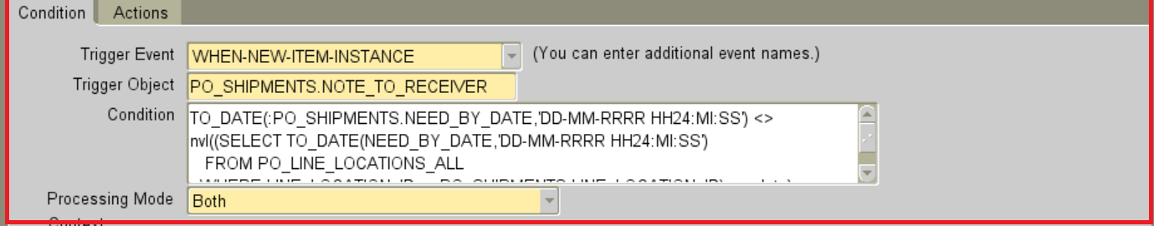
Actions

Seq | Type | Description | Language | Enabled
1 | Property |  | All | Yes

Object Type | Item
Target Object | PO_SHIPMENTS.PROMISED_DATE
Property Name | VALUE
Value | =select to_char(xdmc_po_date_calc_pkg.get_date_fnc(''||${item.PO_SHIPMENTS.NEED_BY_DATE.value}||'',  ''||${item.PO_HEADERS.VENDOR_SITE_ID.value}||'','P')) FROM DUAL

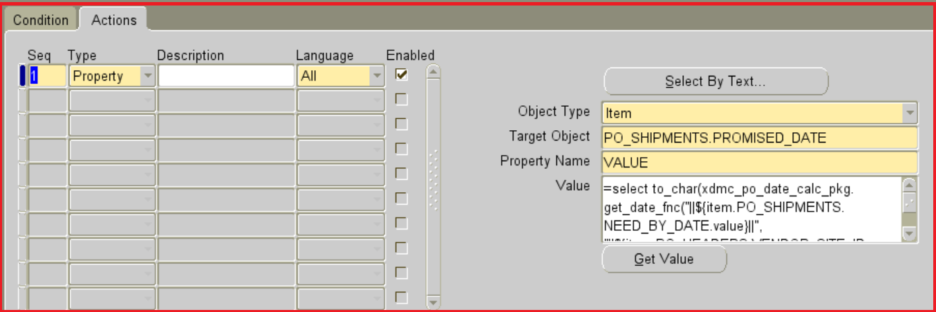

Step3:

Seq | Description | Level | Enabled
30 | Need By Date Change in Line Level | Function | Yes
Condition
Trigger Event | WHEN-NEW-ITEM-INSTANCE
Trigger Object | PO_LINES.NEED_BY
Condition | TO_DATE(:PO_LINES.PROMISED_DATE,'DD-MM-RRRR HH24:MI:SS') <>  nvl((SELECT TO_DATE(PROMISED_DATE,'DD-MM-RRRR HH24:MI:SS')  FROM PO_LINE_LOCATIONS_ALL  WHERE PO_LINE_ID = :PO_LINES.PO_LINE_ID AND ROWNUM=1),sysdate)
Processing Mode | Both

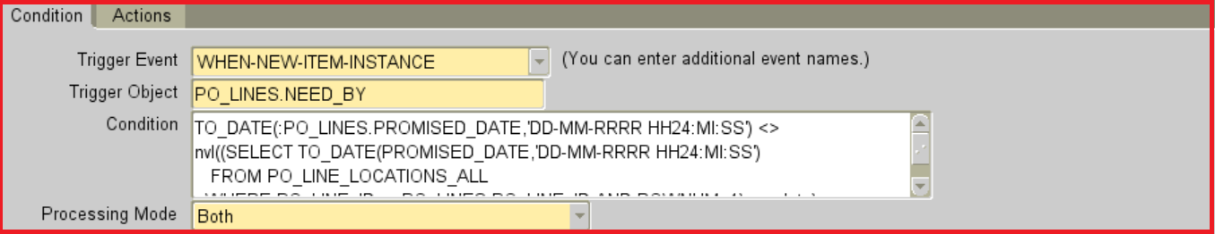

Actions

Seq | Type | Description | Language | Enabled
1 | Property |  | All | Yes

Object Type | Item
Target Object | PO_LINES.NEED_BY
Property Name | VALUE
Value | =select to_char(xdmc_po_date_calc_pkg.get_date_fnc(''||${item.PO_LINES.PROMISED_DATE.value}||'',  ''||${item.PO_HEADERS.VENDOR_SITE_ID.value}||'', 'N')) FROM DUAL

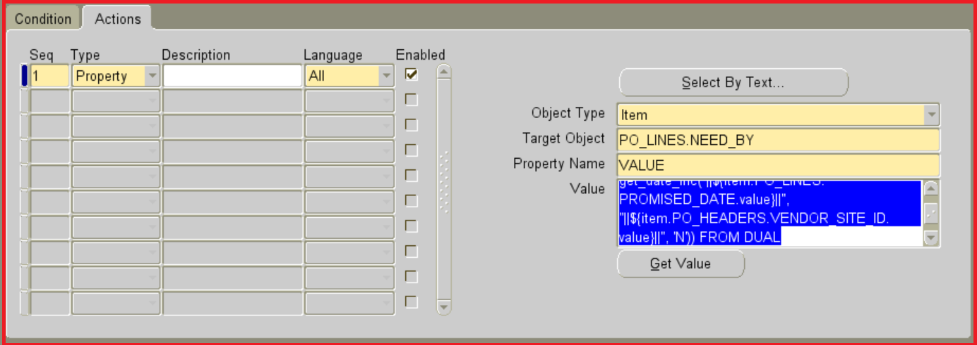

Step4:

Seq | Description | Level | Enabled
31 | Promise Date Change in Line Level | Function | Yes
Condition
Trigger Event | WHEN-NEW-ITEM-INSTANCE
Trigger Object | PO_LINES.VENDOR_PRODUCT_NUM
Condition | TO_DATE(:PO_LINES.NEED_BY,'DD-MM-RRRR HH24:MI:SS') <>  nvl((SELECT TO_DATE(NEED_BY_DATE,'DD-MM-RRRR HH24:MI:SS')  FROM PO_LINE_LOCATIONS_ALL  WHERE PO_LINE_ID = :PO_LINES.PO_LINE_ID AND ROWNUM=1),sysdate)
Processing Mode | Both

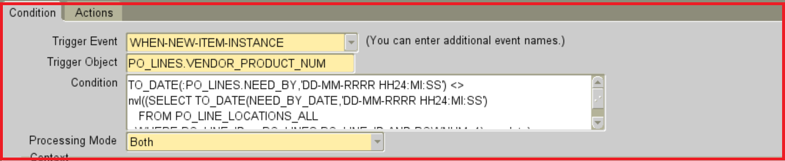

Actions

Seq | Type | Description | Language | Enabled
1 | Property |  | All | Yes

Object Type | Item
Target Object | PO_LINES.PROMISED_DATE
Property Name | VALUE
Value | =select to_char(xdmc_po_date_calc_pkg.get_date_fnc(''||${item.PO_LINES.NEED_BY.value}||'',  ''||${item.PO_HEADERS.VENDOR_SITE_ID.value}||'', 'P')) FROM DUAL

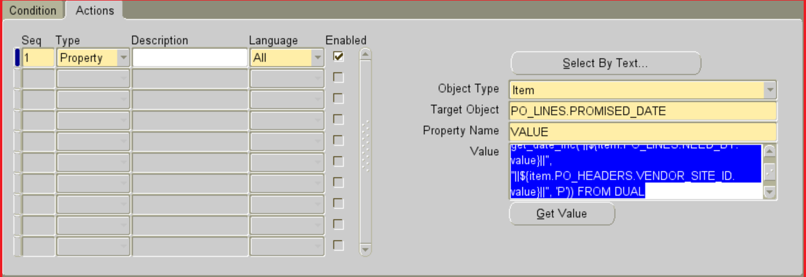

Step5:
Seq | Description | Level | Enabled
32 | Promise Date Change in Line Level Cursor | Function | Yes
Condition
Trigger Event | WHEN-NEW-ITEM-INSTANCE
Trigger Object | PO_LINES.PROMISED_DATE
Condition | TO_DATE(:PO_LINES.NEED_BY,'DD-MM-RRRR HH24:MI:SS') <>  nvl((SELECT TO_DATE(NEED_BY_DATE,'DD-MM-RRRR HH24:MI:SS')  FROM PO_LINE_LOCATIONS_ALL  WHERE PO_LINE_ID = :PO_LINES.PO_LINE_ID AND ROWNUM=1),sysdate)
Processing Mode | Both

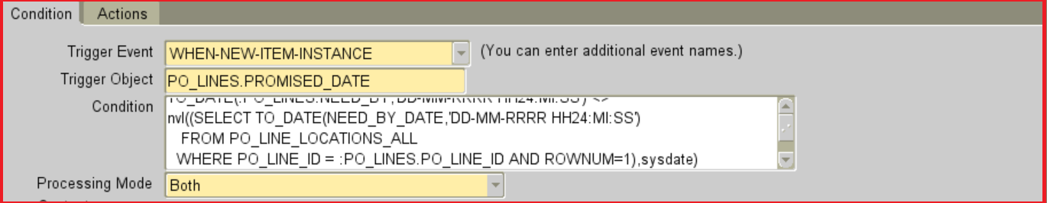
Actions

Seq | Type | Description | Language | Enabled
1 | Property |  | All | Yes

Object Type | Item
Target Object | PO_LINES.PROMISED_DATE
Property Name | VALUE
Value | =select to_char(xdmc_po_date_calc_pkg.get_date_fnc(''||${item.PO_LINES.NEED_BY.value}||'',  ''||${item.PO_HEADERS.VENDOR_SITE_ID.value}||'', 'P')) FROM DUAL

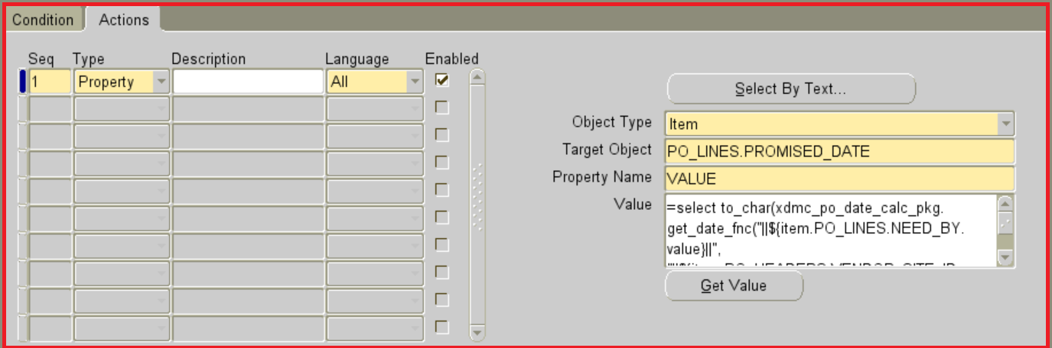
Step6:
Seq | Description | Level | Enabled
33 | Promise Date Change in Shipment Level Cursor | Function | Yes
Condition
Trigger Event | WHEN-NEW-ITEM-INSTANCE
Trigger Object | PO_SHIPMENTS.PROMISED_DATE
Condition | TO_DATE(:PO_SHIPMENTS.NEED_BY_DATE,'DD-MM-RRRR HH24:MI:SS') <>  nvl((SELECT TO_DATE(NEED_BY_DATE,'DD-MM-RRRR HH24:MI:SS')  FROM PO_LINE_LOCATIONS_ALL  WHERE LINE_LOCATION_ID = :PO_SHIPMENTS.LINE_LOCATION_ID),sysdate)
Processing Mode | Both

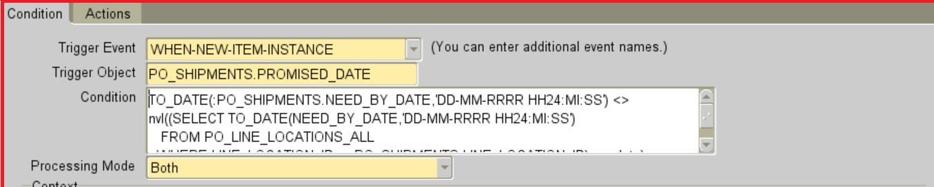

Actions

Seq | Type | Description | Language | Enabled
1 | Property |  | All | Yes

Object Type | Item
Target Object | PO_SHIPMENTS.PROMISED_DATE
Property Name | VALUE
Value | =select to_char(xdmc_po_date_calc_pkg.get_date_fnc(''||${item.PO_SHIPMENTS.NEED_BY_DATE.value}||'',  ''||${item.PO_HEADERS.VENDOR_SITE_ID.value}||'','P')) FROM DUAL

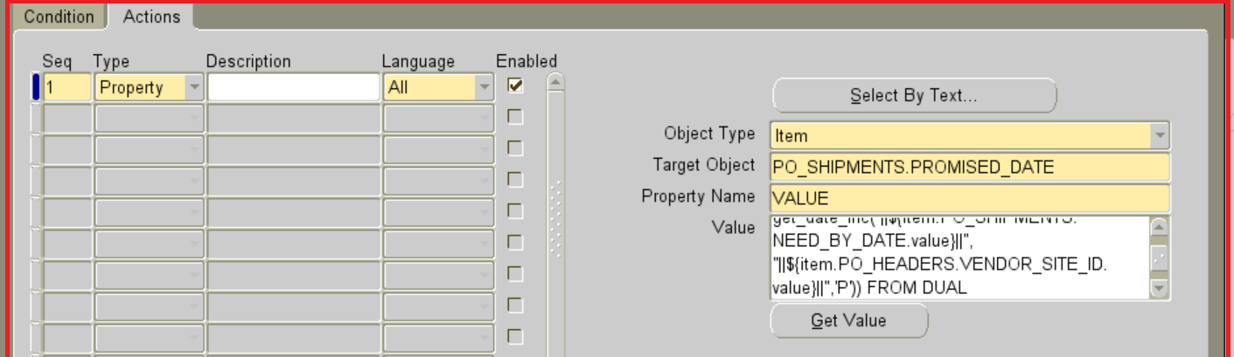

Examples
Go to Purchasing Responsibility and navigate to Purchase Orders-> Purchase Orders.

Press F11 and enter Purchase Order Number in PO,Rev (eg. 334943) and press CTRL+F11
