**Introduction:**

Back Date Sales Order Creation, we generally come across this case during period closure, post period closure and starting of new month, we need to book AR invoice in previous month, this will help calculate incentive for sales persons or if we need to book AR invoice in previous month to show the sales turn over in previous month.

**Sales Order Creation:**

Navigation > Order, Returns > Order Organizer.

Click on New Order Button.

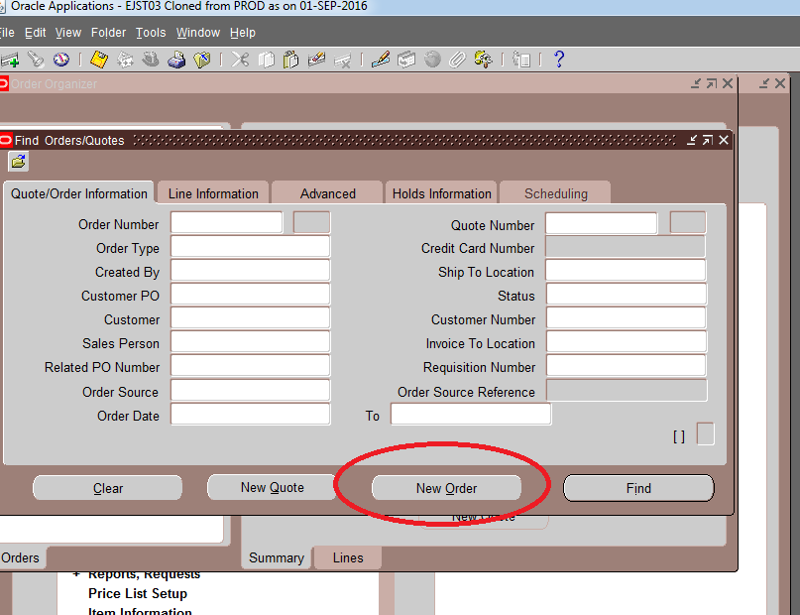

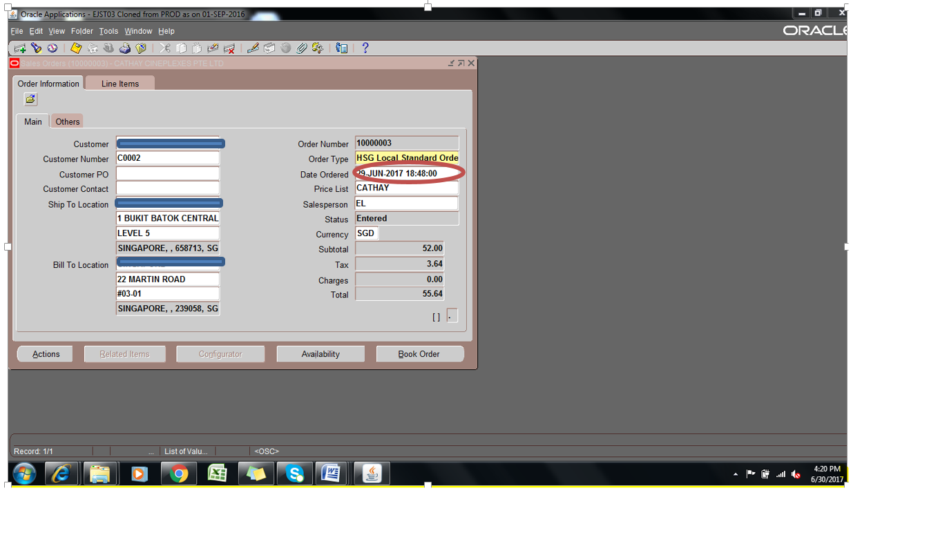

Book the order with back date (29 Jun 2017) 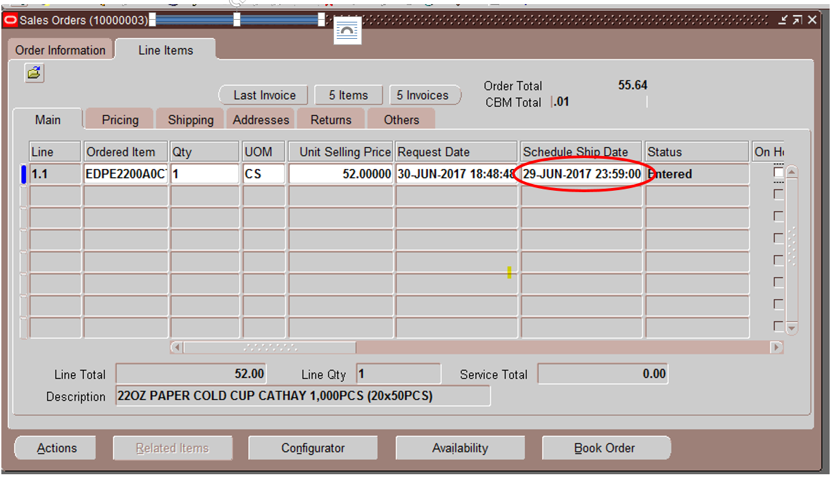

Enter the back dated schedule ship date

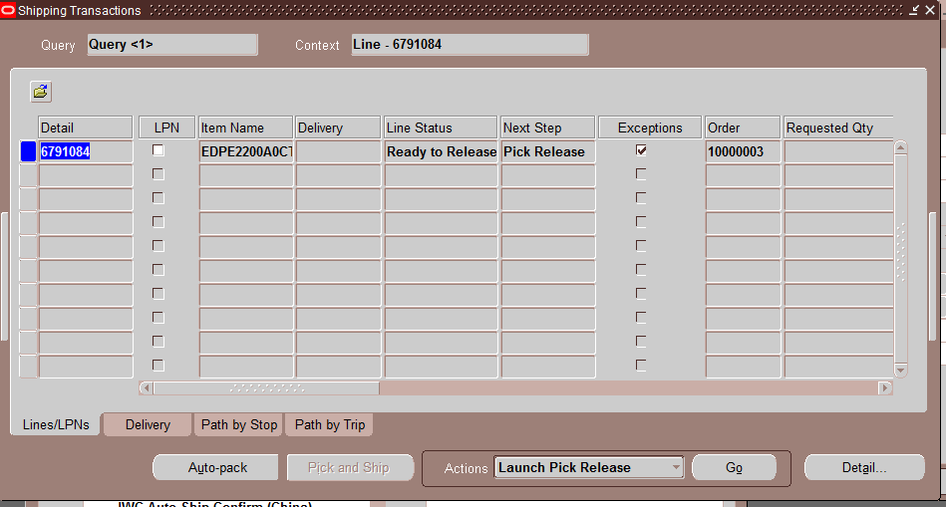

Do Launch pick release as usaual.

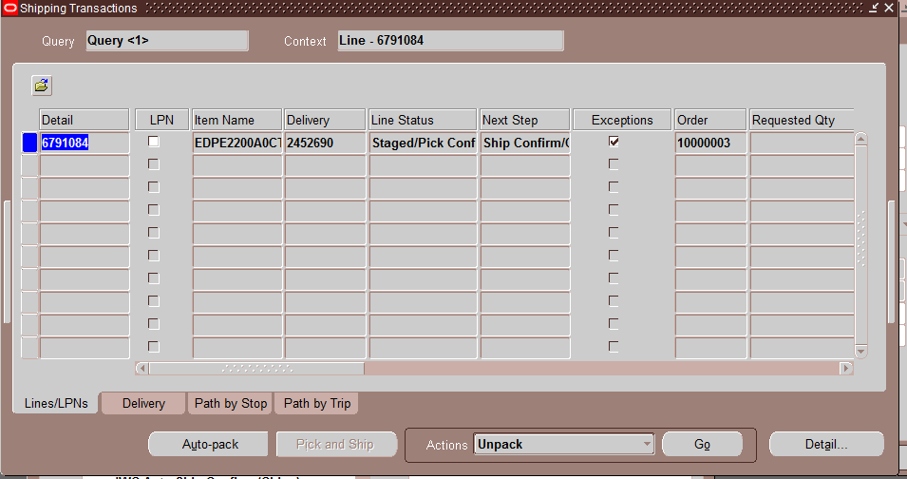

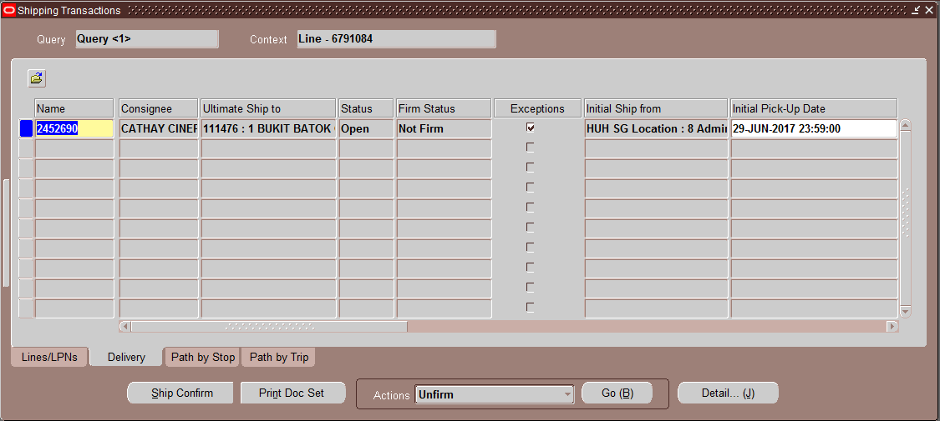

Change the initial pick-up date to back date before ship confirm.

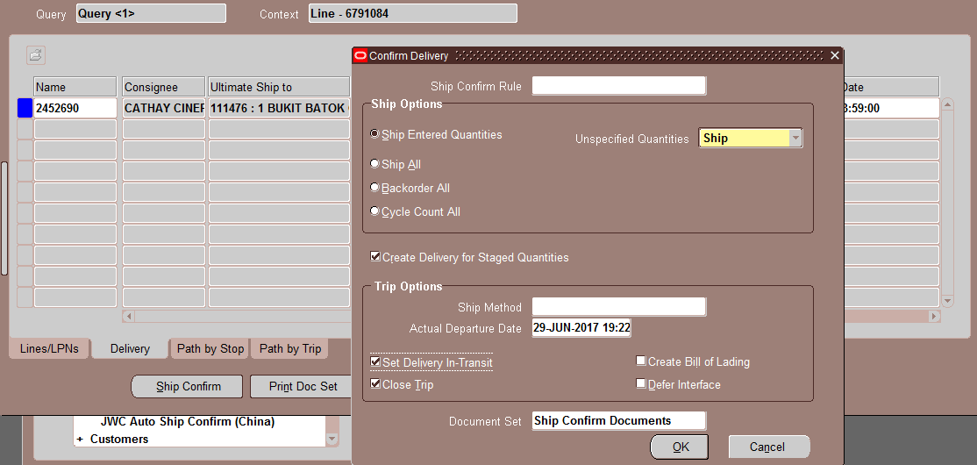

Change the Actual Departure date to Back date while ship confirm.

Note : this step is very Important.