Scheduling is a concept, which helps to place the demand in the inventory based on the availability.

**Scheduling helps with the following:**

* Find the availability of the item
* Populate the Schedule Ship Date, Arrival Date and the Last Acceptable Date based on the calculate ATP date
* Performs the reservation based on Scheduled Ship Date
* Calculates the delivery lead time based on ship method
* Prevents over demand by setting the items attribute Check ATP.

Scheduling is a communications tool that helps balance customer demands with your ability to fulfil that demand.

* **What Happens on Scheduling:**  
    
  Scheduling is an action performed on an order line or a group of lines. The action  
  does the following -
* Determines the source (warehouse) for the order line. If the warehouse is  
  entered on the line, either manually or using defaulting rules, the scheduling  
  action uses the requested warehouse and the other scheduling results are based  
  on it. If the warehouse is blank, the scheduling action determines the best  
  warehouse based on the sourcing rules.
* Determines the schedule ship date, the schedule arrival date, the delivery lead  
  time and the shipping method.
* Makes the line visible to the planning applications and consumes supply for  
  the item. When a line is successfully scheduled the VISIBLE_DEMAND_FLAG is set to Yes.
* If the reservation time fence is set and the schedule ship date is within the  
  reservation time fence, automatically reserves the line.

**Key Features:**

Scheduling in Order Management includes the ability to:

* Schedule at multiple points - either manually or automatically as the line is entered, when the order is booked, or later using a background process.
* Determine the best warehouse for an order line using sourcing rules. This includes using ATO models.
* Define by customer whether the request date is the requested ship date or requested arrival date.
* Automatically set the scheduled ship and arrival dates based on the calculated ATP date.
* Define a shipping network and determine the number of days required for delivery based on the transit time.
* Automatically reserve on-hand inventory to order lines.
* Control, based on order transaction type, the level of scheduling which should occur.
* View availability for multiple warehouses at one time.
* Group lines into arrival sets which may be shipped from different warehouses on different days but should arrive at the customer site on the same day, or group lines into ship sets which ship on the same day from the same location.
* Reserve scheduled lines from multiple orders using the Reserve Orders concurrent program. Optionally, you can use reservations strategies such as Fair Share, Percentage, and Partial. You can choose whether to simulate or commit the reservations. An API Hook is provided for those who want to write an API to tailor reservation logic for business-specific processes. Reserve Orders can be run either from the concurrent request menu or from Scheduling across Orders.
* Override Available to Promise (ATP). This feature allows authorized users to override ATP schedule date from the sales order window as needed for exceptions.
* Perform scheduling actions on multiple lines across orders.
* Scheduling can be updated based on the latest planning output for planned items.
* Configured items can be matched at scheduling for planned items.
* Flexible scheduling parameters allow users to control the use of Promise Date, the impact of Request Date and Shipping Method on Schedule Date, the behavior of the LAD with manual scheduling, and whether to allow partial reservations for manual reservations and the reservation time fence.
* ATP/Scheduling uses Transportation calendars like Shipping Calendar, In-transit (Carrier) Calendar, and Receiving Calendar to calculate the ship/arrival dates
* The ATP window displays the scheduling results for all recent (related to the current order) scheduling actions- successes as well as failures. [Check the blog post on Available to Promise (ATP)](http://oracleapps4u.blogspot.in/2012/09/setup-available-to-promise-in-order.html)

**Scheduling happens during any one of the following events:**

* + Automatic scheduling upon entry
  + Manual scheduling upon entry
  + Scheduling during booking
  + Scheduling after booking

**Different ways of Auto Scheduling:**

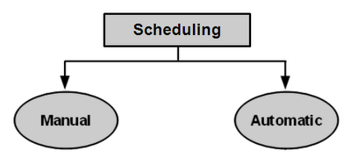

1. Auto Schedule through “**OM: Auto Schedule**” Profile Option

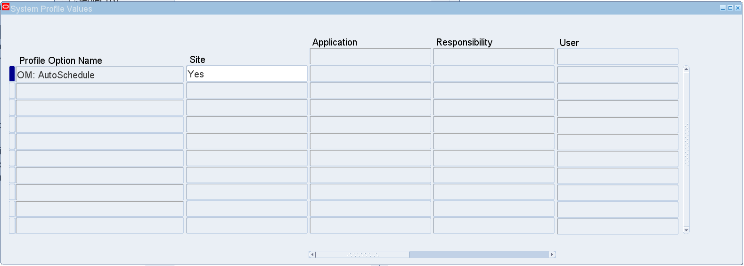

1. **Auto Schedule** Check box on **Transaction Type** window on the Shipping Tab

Select the Auto Schedule check box if you want automatic scheduling for this order type. This is applicable only to order transaction types.

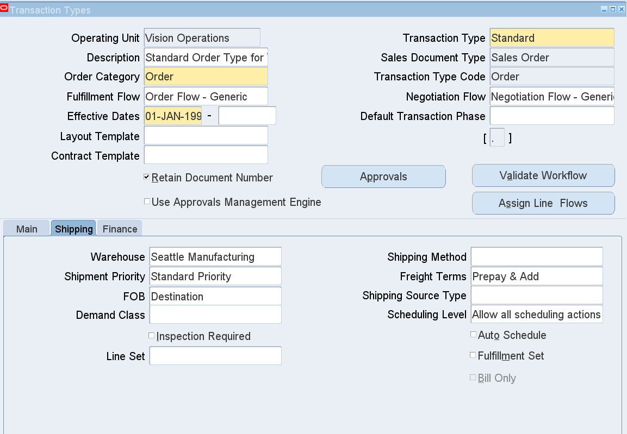

The Scheduling level on the order transaction type determines what type of scheduling is allowed. The possible values are:

* **ATP Only** - You will not be able to schedule or reserve lines on the order.  This could be used for Bill-Only or Bill-Only with Inventory Interface flows, or possibly for quoting scenarios.
* **No Reservations -** You can perform all scheduling functions except for reserving inventory.
* **Allow All Scheduling Actions -** All scheduling actions can be performed.
* **Inactive Demand with Reservations -** You can manually enter any schedule date, but the system does not schedule. The line can be reserved. The schedule date is not visible to MRP / APS. This functionality is only for standard items, and it does not support ship or arrival sets.
* **Inactive Demand Without Reservations -** You can manually enter any schedule date, but the system does not schedule. No reservation can be placed on the line. The schedule date is not visible to MRP/APS. This functionality is only for standard items, and it does not support ship or arrival sets.

1. Auto Schedule using the Tools Menu when entering the Order

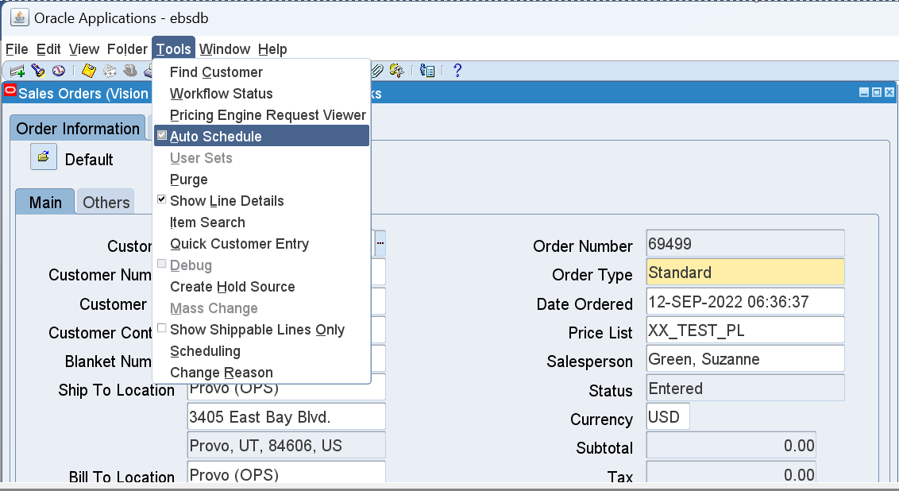

1. Scheduling Concurrent Program - This program selects all lines which are  
   eligible for scheduling and attempts to schedule them. The user can select  
   orders based on the order number

Navigation: OM Superuser Responsibility 🡪 Orders, Returns 🡪 Schedule Order

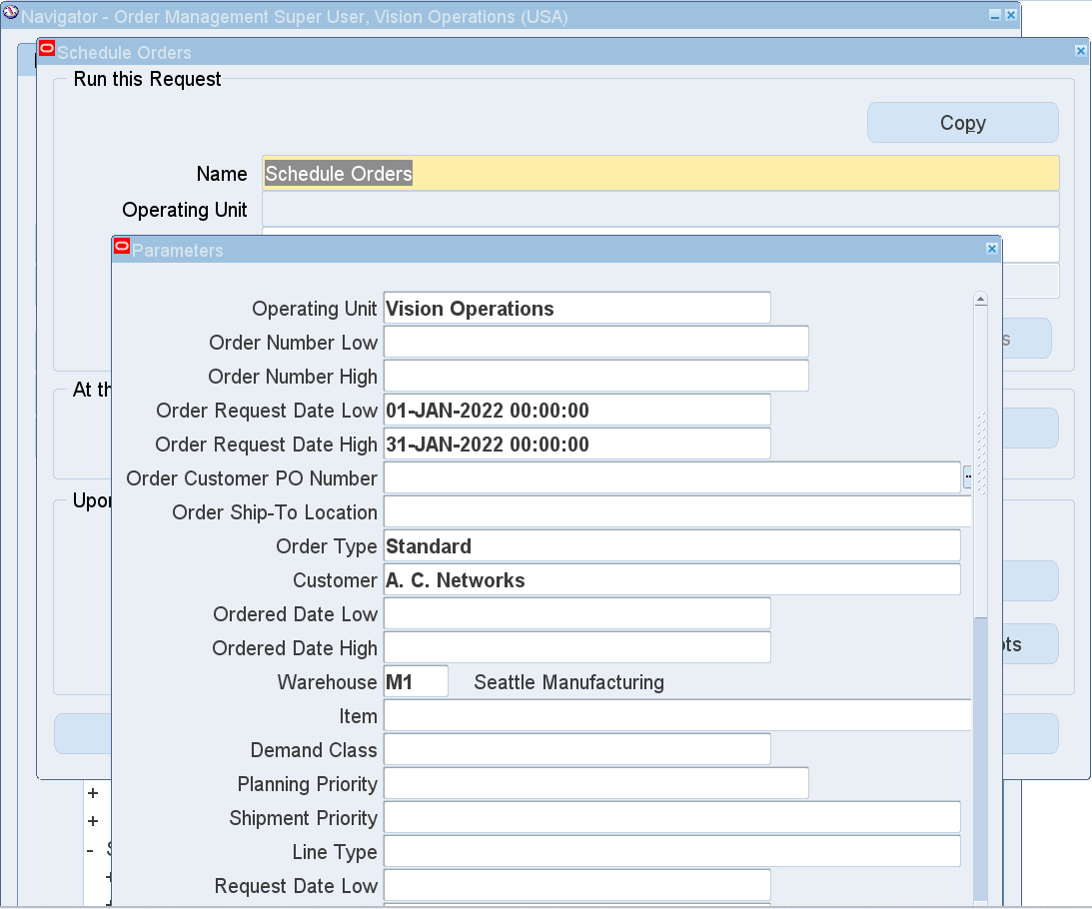

**OM: AUTOSCHEDULE:**

* When a new order is created / entered, the order will automatically create demand records in MTL_DEMAND if the profile option "**OM: Auto Schedule**" is set to **Yes**.
* The demand does not reduce the availability of the item or promise the on-hand quantity to the order as long as a reservation is not created.
* The demand is used for advanced scheduling purposes in the MRP (Oracle Master Scheduling) application.

For example, if one was to create two orders for equal amounts and the demand was reduced to a negative number by the second order, the pick release would process successfully for which ever order was run first. The second order would receive an error that negative quantity is not allowed assuming that your organization does not allow negative inventory.

* Note that the "OM: Auto schedule" profile option is not the only way to set the 'Auto schedule' feature.

One could also set this feature via the transaction type setup, or by manually setting the auto schedule selection to Yes or No via Tools > Auto schedule in the Order Management entry form.

**OM: RESERVATION TIME FENCE**

* If the profile option, "**OM: Reservation Time Fence**", is set to a number greater than zero, a reservation will be created for the item as soon as the order is entered if the required date is within the reservation time fence window of days. The time fence is the system date plus the profile number of days.

For example, if the profile is set to 30 days, then as long as the schedule date for the order is before the system date plus 30 days, then a reservation is created.  The reservation will reduce the availability of the item.  Even when the autoschedule profile is not set, the reservation will be created as soon as soon as one enters the 'Schedule Date' field.

For example, when booking an order, the scheduled date is automatically entered if

one did not already exist.  This occurs even when "OM: AutoSchedule" is not used.  The reservation then is created when the order is booked as the booking process enters the schedule date.  As a side note, according to the OM manual, if a NULL value is entered for the "OM: Reservation Time Fence" then the system will not create a reservation automatically. However, tests have shown that when the profile is not entered (NULL) at the site level, it still acts as if it were set to zero (0).

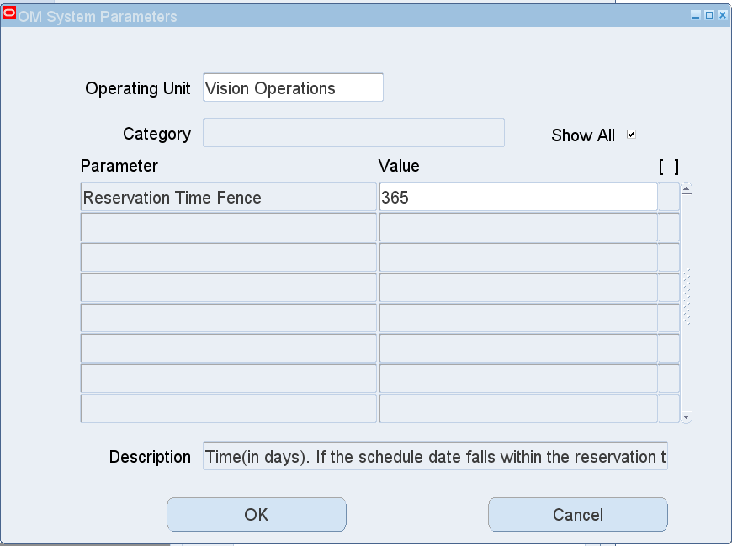

**ENTIRE QUANTITY ONLY**

If the entire quantity is not available, the reservation is not created automatically by the scheduling process. However, you could manually reserve the quantity available in the reservation form.

You could use the Tools > Scheduling > Reservation Details option OR go to Inventory > On Hand > Reservations and create a new reservation.

You could then schedule the "**Reserve Orders**" program to run every few hours looking for On Hand quantity for partially reserved orders.

Understanding the following terms will help you understand how scheduling works  
in OM.

**Request Date -** The date the customer requests that the products be either  
shipped or received.

**Promise Date -** The date on which you agree you can ship the products to your  
customer or that your customer will receive the products. This field is for tracking  
purposes only. It may be defaulted from the schedule ship date or the schedule  
arrival date.

**Schedule Ship Date -** The date returned by the system on which you can ship the  
products.

**Actual Ship Date -** The date the order line is shipped. This date is recorded by the  
ship confirm action.  
  
**Actual Arrival Date -** The date the order line arrives at the customer site.

**Schedule Arrival Date -** The date returned by the system on which your customer  
can receive the products.  
  
* Schedule Arrival Date = Schedule Ship Date + Delivery Lead Time  
  
**Arrival Set -** A set of order lines which arrive at the same time at the destination.

**Ship Set** - A set of lines which will be shipped together from the same warehouse  
to the same location.

**Sourcing -** Selecting the warehouse for the order lines.  
  
**Supply -** Incoming inventory. Some Oracle transactions that generate supply are  
purchase orders, discrete manufacturing work orders and flow manufacturing  
schedules.

**Demand -** Requests which consume inventory such as sales orders. Discrete  
manufacturing work orders and flow manufacturing schedules place demand for  
component items, and sales orders place demand for finished goods.

**Reservation -** A guaranteed allotment of product to a specific sales order. Once  
reserved, the product cannot be allocated to any other source of demand. Also  
known as a hard reservation.  
  
**Reservation Time Fence** - Time (in days) before the schedule date, within which a  
line should be automatically reserved.  
  
This is Set by Profile option OM:Reservation time fence  
  
**Available to Promise (ATP) -** The quantity of current on-hand stock, outstanding  
receipts and planned production not already committed to sales orders or other  
sources of demand.  
  
**ATP Date -** The date that a requested quantity will be available to promise.  
  
**Delivery Lead Time -** Time (in days) for items to reach the customer once they are  
shipped.  
  
There are two ways to help system calculate this date.  
  
1) Create a location for the Ship-to address and assign it as the internal location and then define inter-location transit time  
2)Create a Zone/Region and then assign the inter-location transit time  
  
  
**Latest Acceptable date (LAD):**  
LAD is populated only when the Latest Schedule Limit (LSL) is provided at the time of order creation.  
  
Latest Schedule Limit is defaulted from the site level or customer level based on defaulting rules.  
  
* Latest Acceptable Date = Request date + Latest Schedule Limit  
  
**Request Date Type -** Possible values are arrival and ship. If the value is arrival  
then the request date and promise date will be considered arrival dates by the  
system; if the value is ship then they will be considered ship dates. The request  
date type can be defaulted from the customer information to the order, and  
the user can change it on the order if required.

 **Latest Schedule Limit -** This field can contain any numeric positive integer  
value. When you enter an order line, the latest acceptable date will be  
calculated by adding the latest schedule limit to the request date. When the  
scheduling action occurs, the schedule date will only be returned if it is  
between the requested date and the latest acceptable date. If it is not within  
this range, the scheduling action fails.

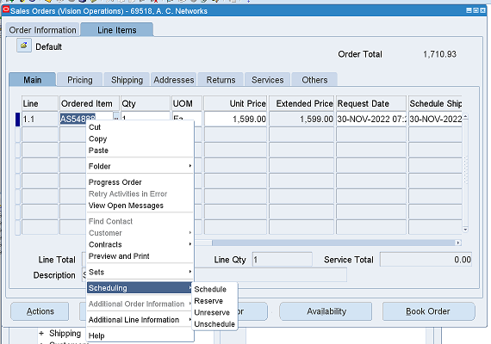

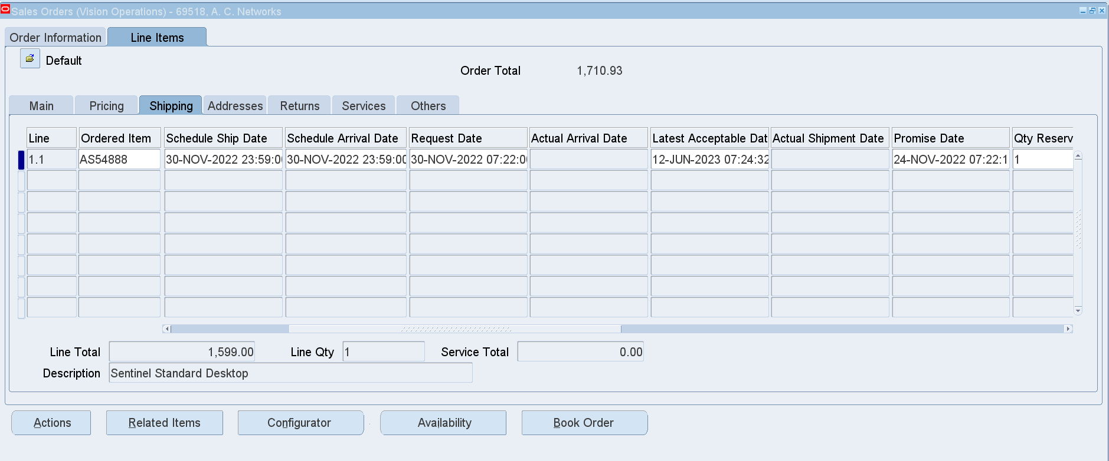

**Test Case :01** (OM: Auto Schedule=Yes at Site Level)

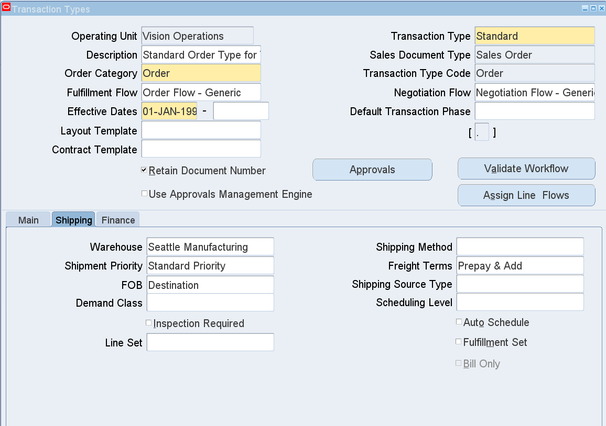

**Result:** Reservation and Scheduling completed Automatically

Navigation: Go to Tools 🡪 Scheduling

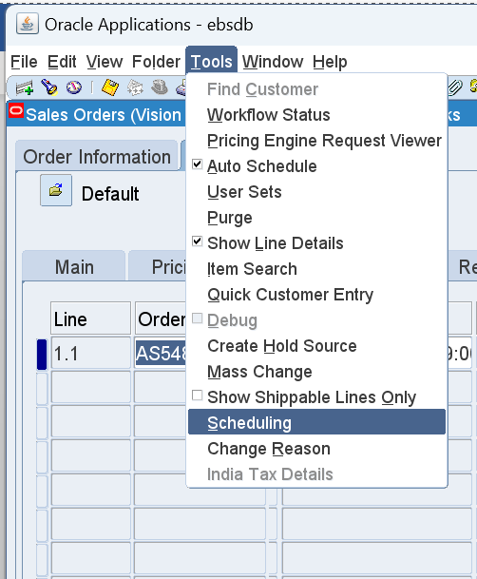 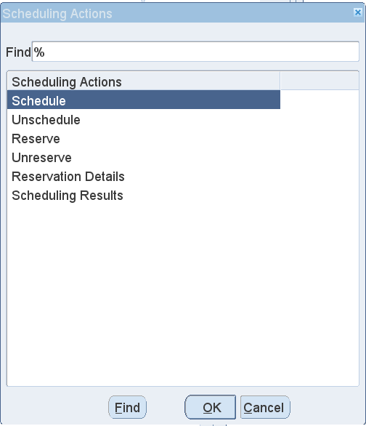

Scheduling Actions

**Scheduling Details:**

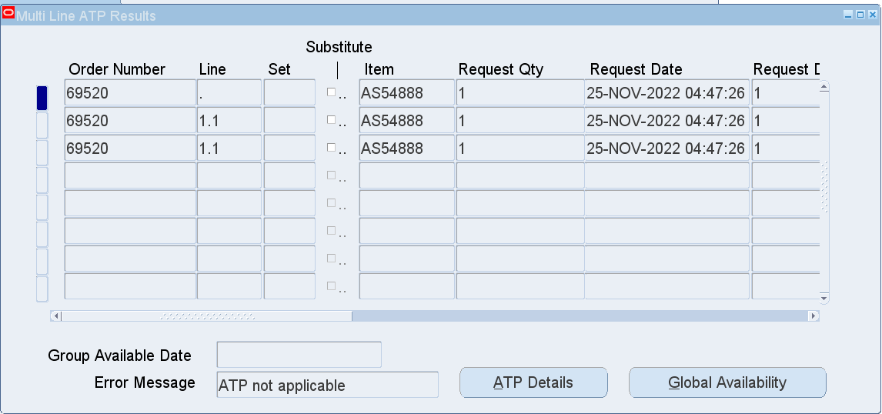

Calculated the Schedule Ship Date Automatically

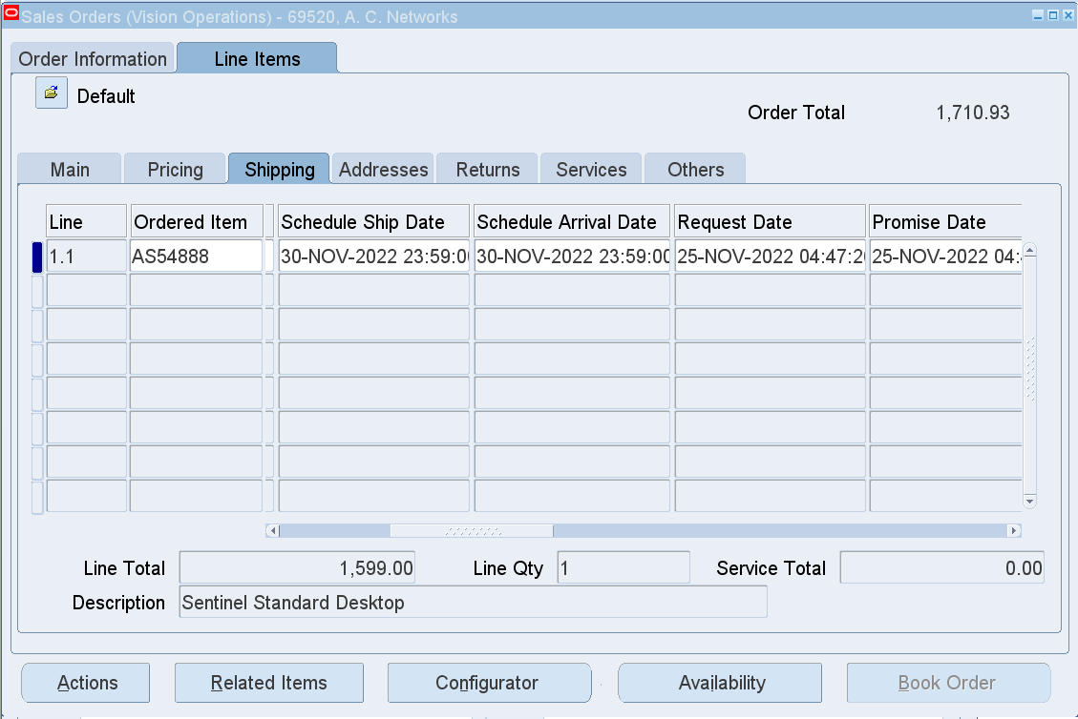

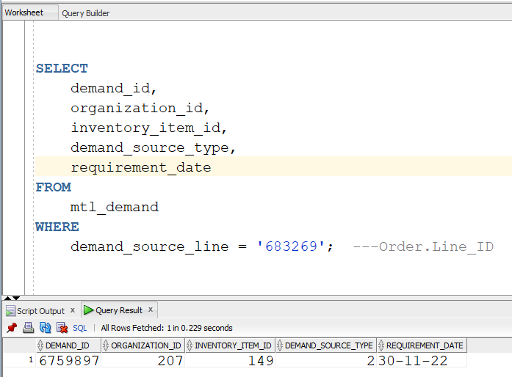

*SELECT demand_id, organization_id, inventory_item_id, demand_source_type, requirement_date FROM mtl_demand WHERE demand_source_line = '683269'; ---Order_lines.Line_ID*

**Reservation Details:**

