# Translation

Translation is the process of translating account balances from functional currency to another (reporting or foreign) currency. This process translates balances only. It doesn’t translate individual transactions. While doing translation makes sure previous month period status should be open Ex: Mar 🡪 Feb, Apr🡪Mar

Translation rates

* Expenses & Revenue 🡪 Average rate
* Assets & Liabilities 🡪 Period end rate
* Equity & Owner ship 🡪 Period end rate/ Historical rate

Setups

1. Define Translation adjustment account and period end ,period average rates at specify ledger options
2. Manage Conversion rates for period end, period average rates
3. Manage Historical rates conversion
4. Create translation ledger
5. Run translation process
6. Run General ledger trail balances report

## Define Translation adjustment account and period end, period average rates at specify ledger options

* Go to set up and maintenance
* Set up: Financials
* Task: %specify %ledger%
* Select Specify ledger options
* Update translation adjustment account under period close tab and give the period and average rates
* Save and close

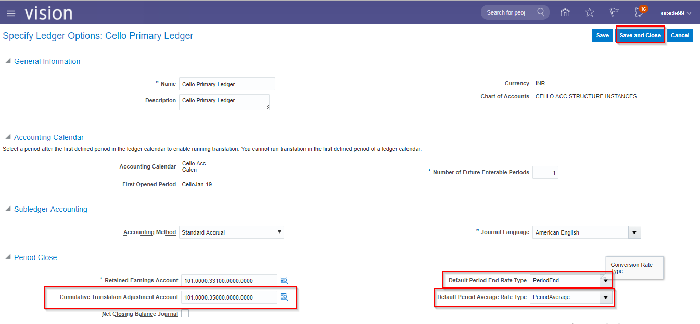

## Create Conversion rates for period end, period average rates

* Go to set up and maintenance
* Set up: Financials
* Task: %manage% daily%
* Select Manage daily rates
* Go to daily rates tab
* Click on spread sheet
* Give the period and average rate

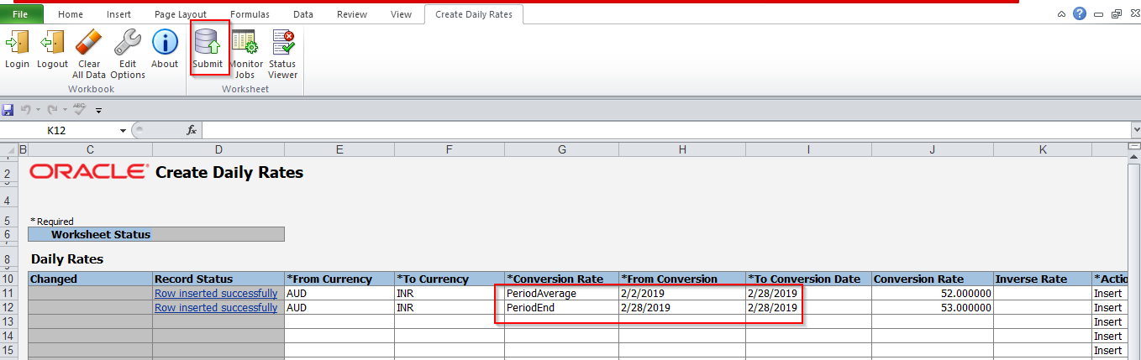

* Check the results in the system

## Manage Historical rates conversion

* Go to set up and maintenance
* Set up: Financials
* Task: %manage% daily%
* Select Manage daily rates
* Go to historical rates tabs
* Give the ledger name, target currency and rate type
* Click on spread sheet

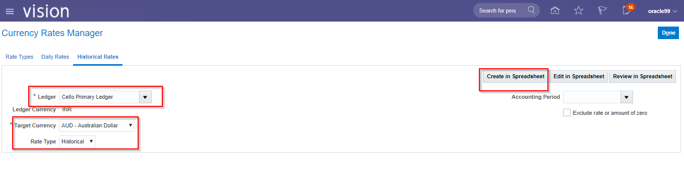

* Give the details and submit

## Create translation ledger

* Go to set up and maintenance
* Set up: Financials
* Task: %manage% reporting%
* Select Manage reporting currencies
* Click on + to create
* Give the details
* Save and close

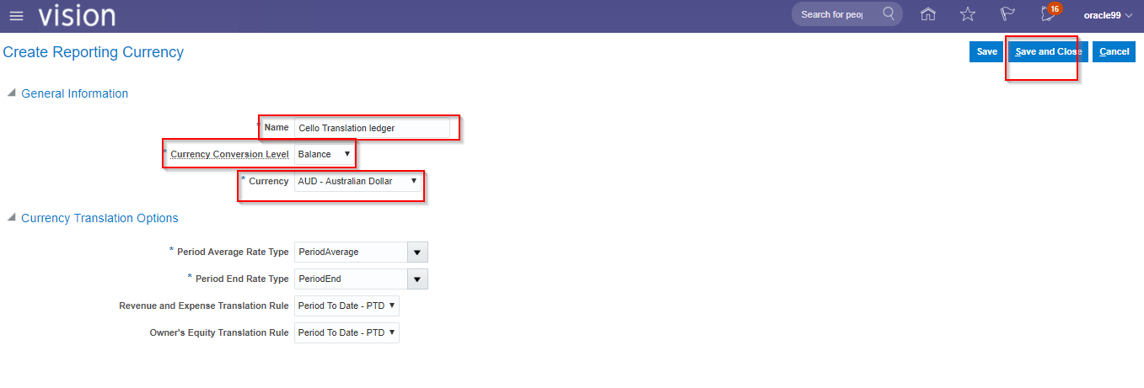

* Currency conversion level : If you select the remaining options it will take it as foreign currency or reporting currency

## Run translation process

* Go to navigator
* Go to general accounting
* Select period close
* Go to Task icon
* Click on Translate balances under multi-currency

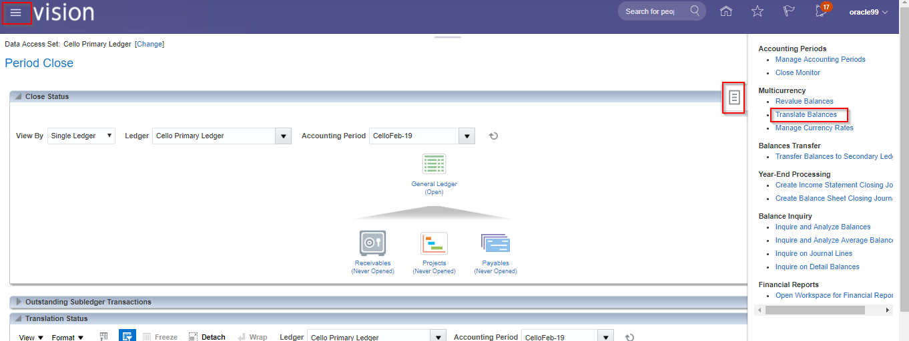

* Give the details and submit

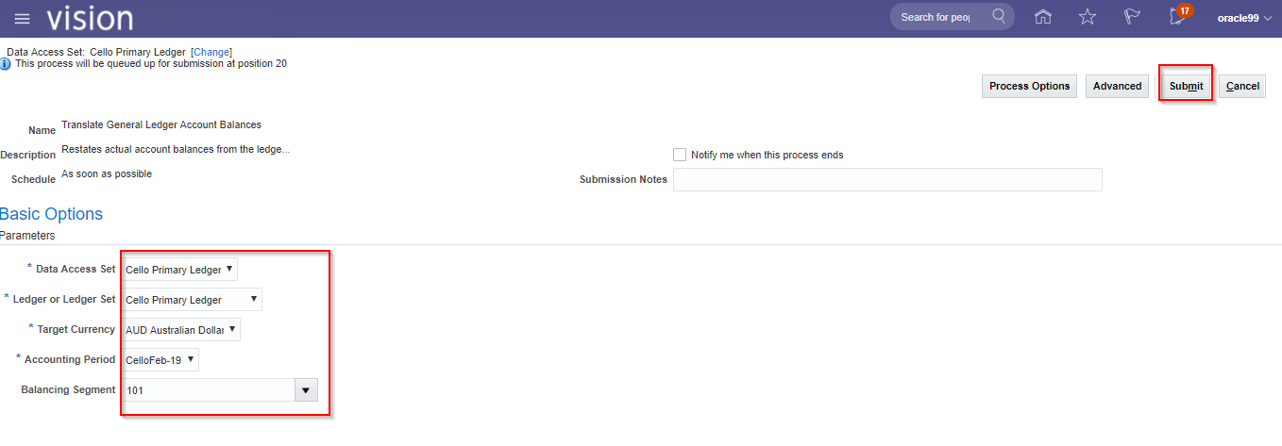

* Check in Scheduled process for result it should be succeeded

## Run General ledger trail balances report

* Go to navigator
* Go to tools
* Select scheduled process
* Click on the schedule new process
* Run a program called General ledger trail balance
* Give the details

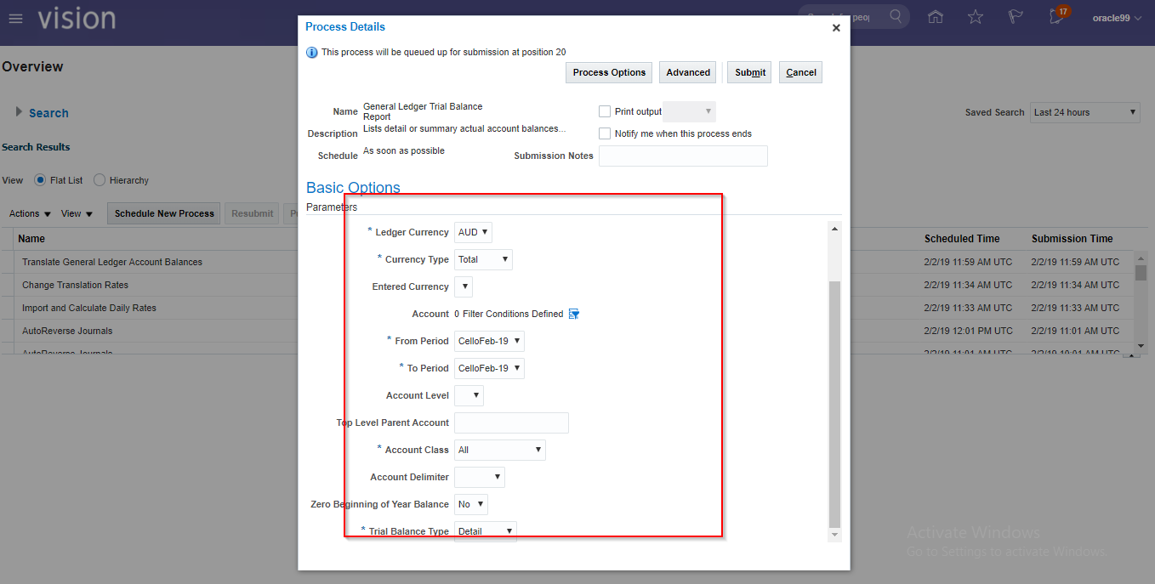

* In the same way we can run another report called Trial Balances report(In R 12 we don’t have this)
* After succeeded the scheduled process see the results
* Scroll down click on the publish🡪select which type of document you want and see the result