Requirement:Company and location segment for recoverable tax account

**1.Location segment should come from Tax setup 2.Company segment will be divided in two ways.** 2.1PO invoices - Company segment will fetch from PO charge account  
 2.2Non PO invoices - Company segment fetch from Item line.

**1.Location segment should come from Tax setup**

Source, Invoice Distribution Account

Condition:"Ledger Name"(XLA,Y,S) = IM CA CAD US GAAP

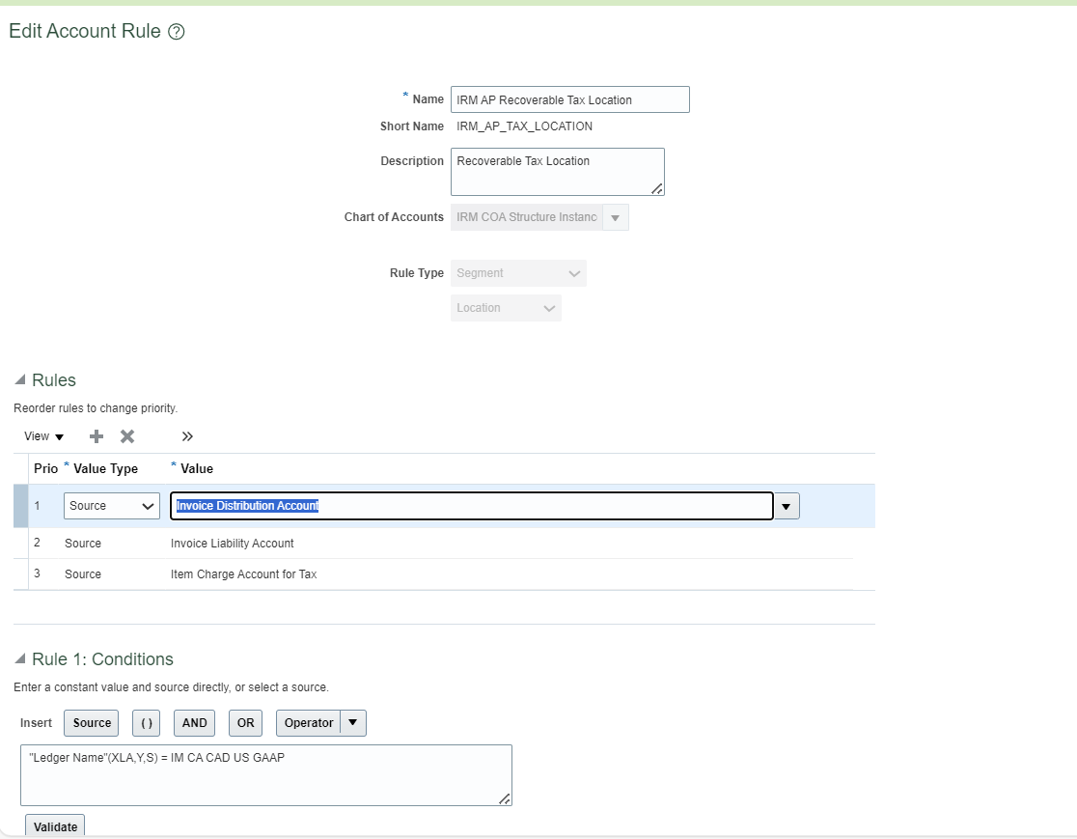

**Rule2.1: PO invoices - Company segment will fetch from PO charge account**

Source , Purchase Order Charge Account

Condition: "Ledger Name"(XLA,Y,S) = IM CA CAD US GAAP 'AND' "Purchase Order Number"(AP,S,S) is not null

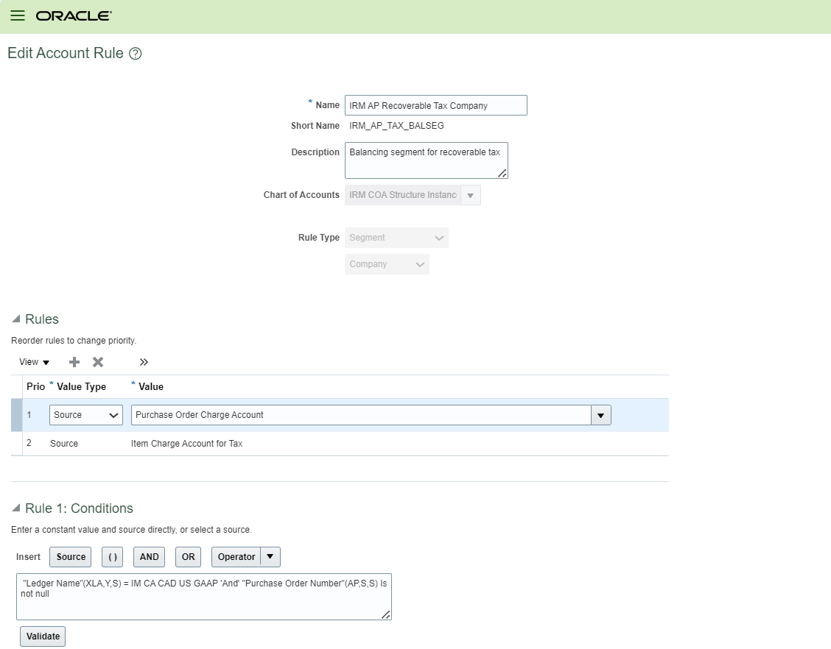

2.2: **Non PO invoices - Company segment fetch from Item line.**

Source , Item Charge Account for Tax

Condition: "Purchase Order Number"(AP,S,S) is null 'AND' ("Ledger Name"(XLA,Y,S) = IM CA CAD US GAAP

