**Broad access in oracle cloud**

**Introduction/ Issue:**

We getting multiple business unit’s access below duty roles In Oracle cloud.

**Why we need to do**

We noticed that when added the "Cash Manager" Role to a specific user, the user get full access to all organization in the Account Payable modules whiteout any security. We need to remove the below custom role and user can view only their data access BU.

**Duty roles**

Bank Statement and Reconciliation Custom

Cash Positioning and Forecasting Management Custom

Payables Invoice Import Submission Duty role

**Impacted roles in oracle cloud**

* Cash Management
* Expense Audit Manager
* Expense Audit
* Application Implementation Consultant
* Supplier Customer Service Representative
* Procurement Application Administrator
* Corporate Card Administrator

**Steps to remove the duty role which are assigned to the roles**

Navigate to Tools 🡪 Security Console

Roles section🡪 Open the role like Expense manager🡪 open duty role hierarchy 🡪 search the duty role name🡪 Bank Statement and Reconciliation🡪 remove the duty role in section🡪 save and close the role.

**Before**

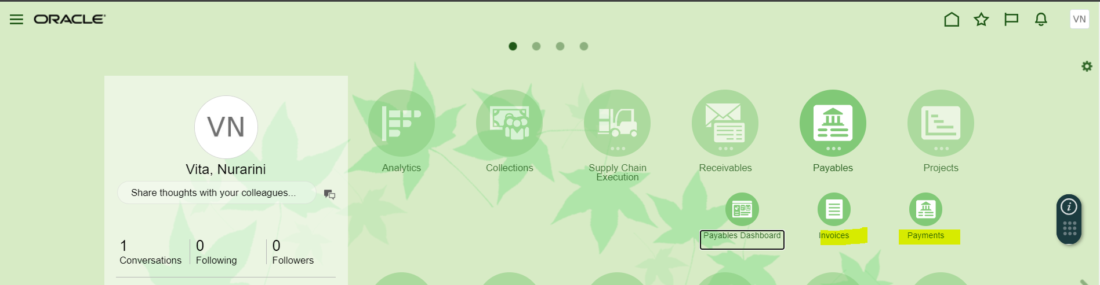

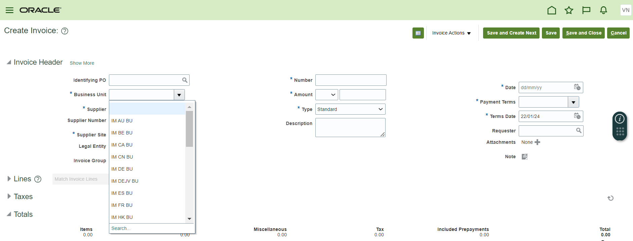

**Showing broad BU access in the Payment (AP).**

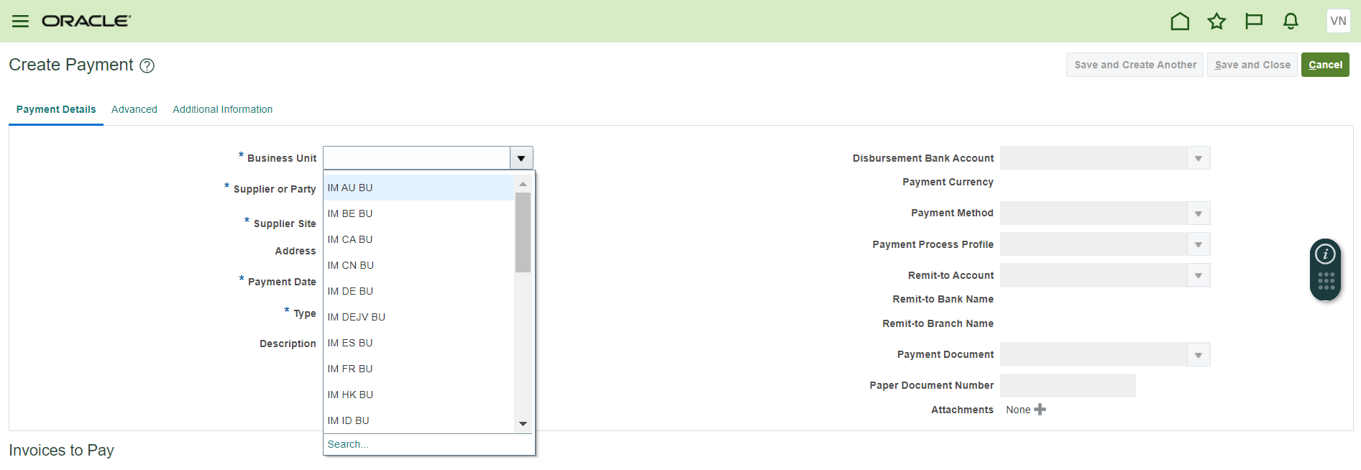

**Removing the Duty roles in custom roles**

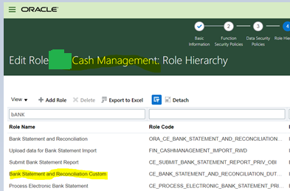

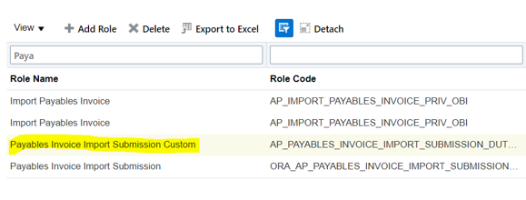

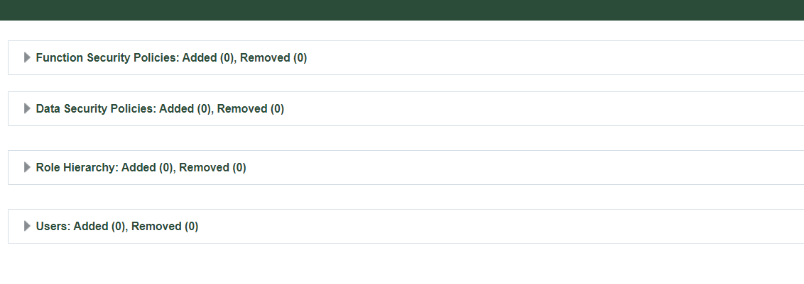

**Save and Close the role**

**Once removed the Duty role user can able to view only ID BU access in the AP (Invoice and Payment)**

Now assign this role to the User along with any other sub ledger related role. Remove the seeded Cash Manager and remaining roles if assigned to the user.

Now Login with this user and this user should have only one BU access in the AP or other sub ledger application pages.

Now assign the roles to user along with Any Payables Role.

Navigate to Manage Data Access for Users and Assign the Business Unit for both these Roles.

**Save and close**. Please wait for 15-20 Min until the Roles Sync process is completed

Now Login with this user and this user should have only Assigned BU access.

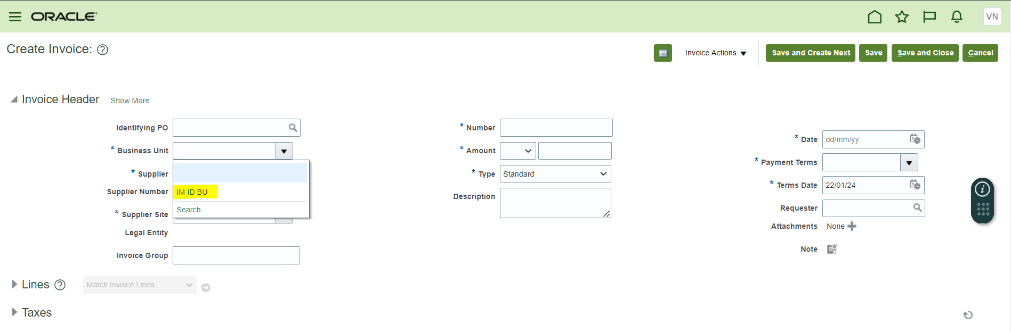

For Create Payment can able to view only ID BU

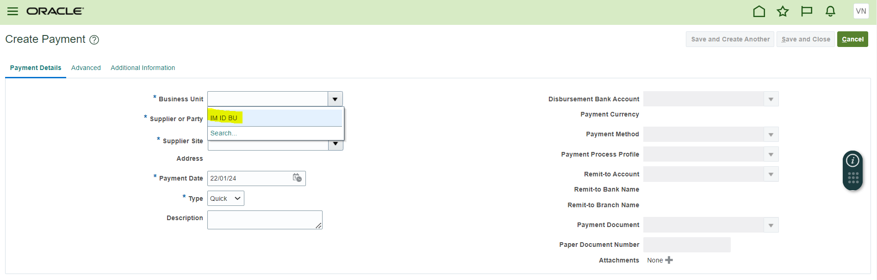

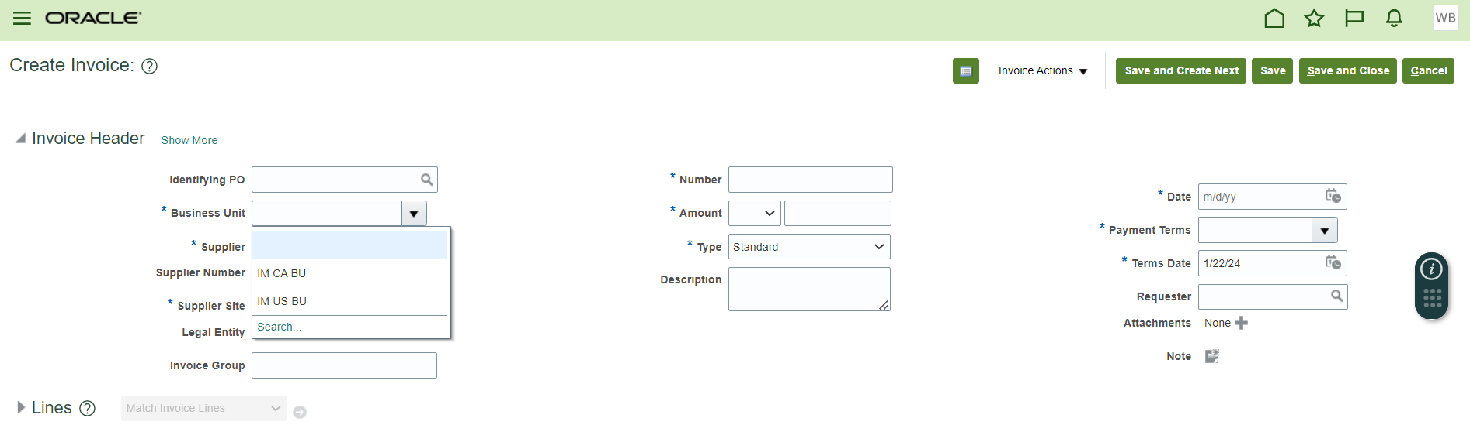\

**Conclusion**

After removed the Duty roles. User can view only their own BU’s.