# Revenue Recognition

Revenue recognition is a generally accepted accounting principle (GAAP) that determines the specific conditions in which revenue is recognized or accounted for. Generally, revenue is recognized only when a critical event has occurred, and the amount of revenue is measurable.

In Revenue Recognition we have two concepts in oracle apps.  
                 1. Invoicing Rule.  
                 2. Accounting Rule.  
**Invoicing Rule:**  
Invoice rules will be determined the accounting period in which receivables are recognized.  
There are 2 types of Invoice Rules:  
                 1. Bills in advance  
                 2. Bills in Arrears  
**Bills in advance:** System will recognize the invoice amount as a advance or starting of a project. In case of Bill in advance Unearned Revenue will come into the picture.  
If you enter an invoice with a Bill in Advance invoicing rule, Receivables creates the following journal entries.  
In first Period:  
                 Receivables A/c.....Dr  
                                 To Unearned Revenue A/c......Cr  
                                  To Tax A/c ...........................Cr  
                                  To Freight A/c.......................Cr  
In all periods of the rule for the portion that is recognized:  
                  Unearned Revenue A/c ......Dr  
                                  To Revenue...........Cr  
**Bills in Arrears:** System will recognize amount at the end of the contract or project. In case of Bills in Arrears " Unbilled Receivable" will come into the picture. If you enter an invoice with a Bill in Arrears invoicing rule, Receivables creates the following journal entry:  
In first Period, Second period till the last period the following entry will be generated.  
              Unbilled Receivable A/c.......DR  
                                 To Revenue ..............CR  
At the completion of Project and at the last Period the following entry will be generated by system.  
               Receivables A/c..............DR  
                              To Unbilled Receivables A/c.............CR  
                              To Tax.........................................CR  
                              To Freight...................................CR  
**Accounting Rules:**  
Accounting Rules will determined the Accounting Period in which Revenues are recognized.  
There are 2 types of accounting rules:  
                        1. Fixed Schedule  
                        2. Variable Schedule  
**Fixed Schedule:**  
We will define duration of the project and % of Revenue of each accounting period, at the time of fixed scheduled accounting rule setup.

**Variable Schedule:**  
At the time of set up the Variable Schedule Rule we will not enter duration of the project & % of Revenue for each accounting period.  
We enter only first period Revenue % at the time of accounting rule set up. Duration of the project will be entered at the time of invoice entry.

<https://docs.oracle.com/cd/A60725_05/html/comnls/us/ar/transa12.htm>

<http://oracleappserpsolutions.blogspot.com/2015/06/revenue-recognition.html>

1. Configure Auto accounting for Revenue Recognition (Unbilled revenues and Unbilled receivables)
2. Create Revenue Schedules (Accounting Rule)
3. Create Transaction including invoicing rule, revenue schedules
4. Run “Revenue Recognition”

## Manage Auto accounting for Revenue Recognition (Invoicing Rules)

### Unearned Revenue

* Go to setup and maintenance
* Setup: Financials
* Functional area: Customer billing
* Task : %Manage% auto %accounting% rules%
* Select Manage AutoAccoutning Rules
* Click on + icon to create rules select our BU and account type is unearned revenue
* Give the constant values and click on Done

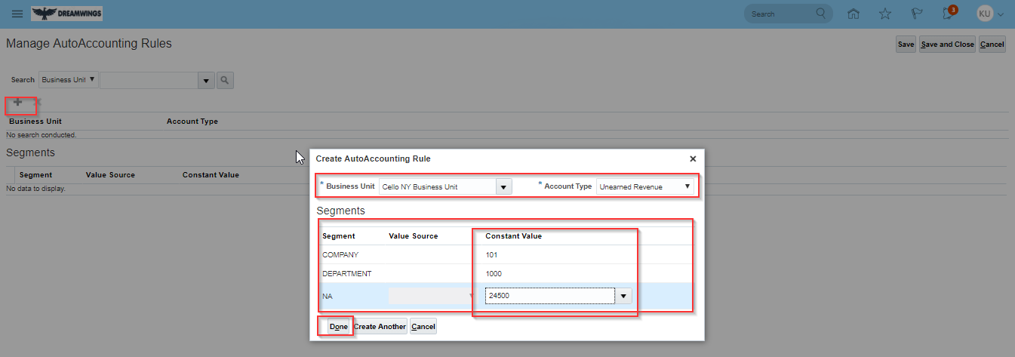

* Click on Done

### Unbilled receivables

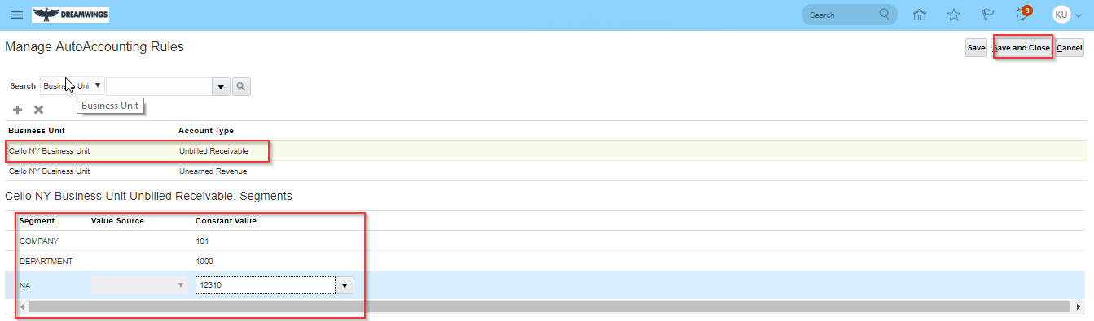

* Click on save and close

## Create Revenue Schedules (Accounting Rule)

### Fixed schedule

* Go to setup and maintenance
* Setup: Financials
* Functional area: Customer billing
* Task : %Manage% revenue% scheduling% rules%
* Select Manage Revenue Scheduling rules
* Click on + to create schedules
* Give the details like RDS, name, type and number of periods
* When you give the period the schedule will open in that percentage (revenue per month) will show if you want to edit the percentage you can edit through double click on that

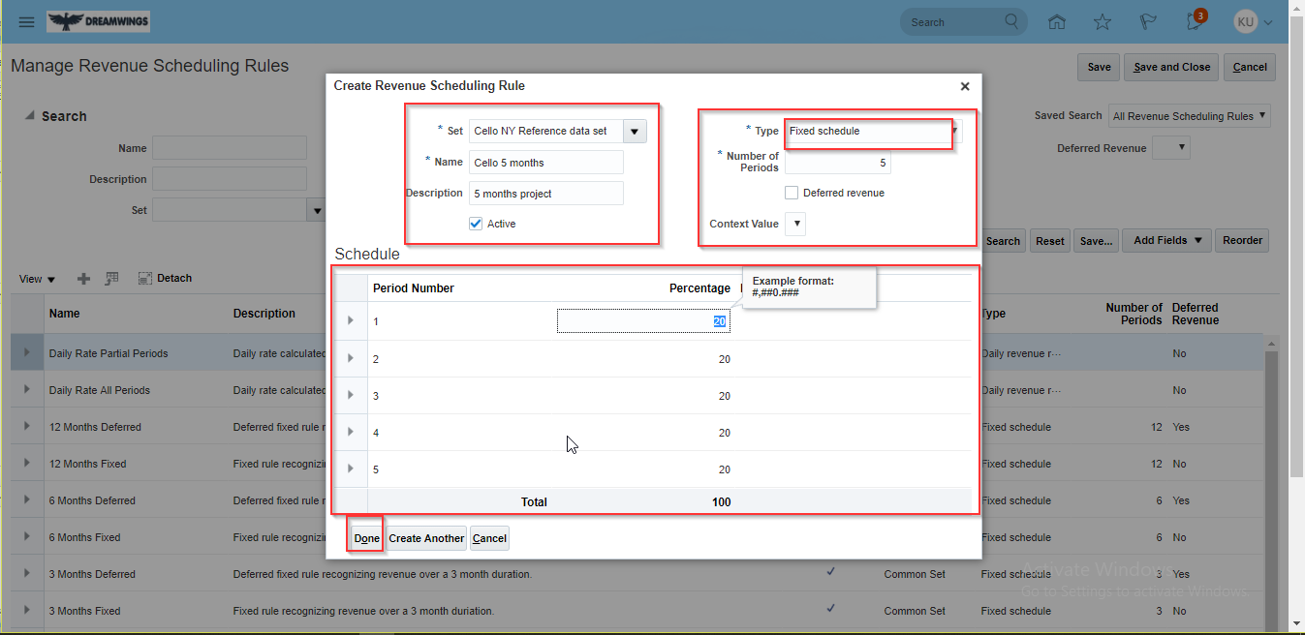

* Click on edit and save

### Variable schedule

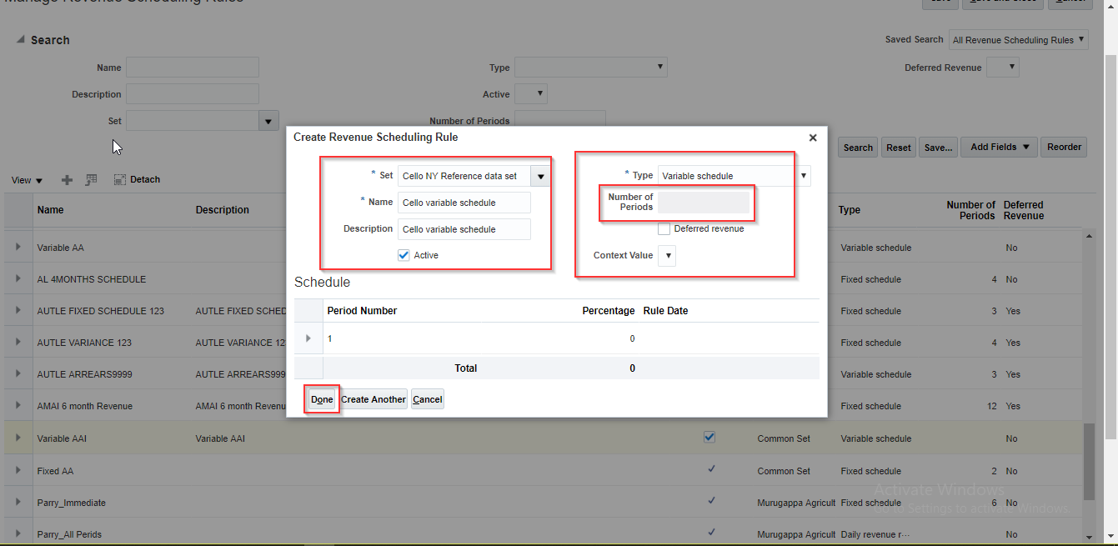

* Save and close

## Create Transaction including invoicing rule, revenue schedules

* Go to Home Page
* Click on Receivables
* Click on Billing
* Go to Task list and click on Crate Transaction
* Give the details like BU, Transaction source, type, customer name and invoice rule as if you took the amount in starting of the project mention as in advance or if you take the amount in the end of the project you can mention as in arrears
* Go to lines give the item, amount and quantity then go to revenue scheduling tab

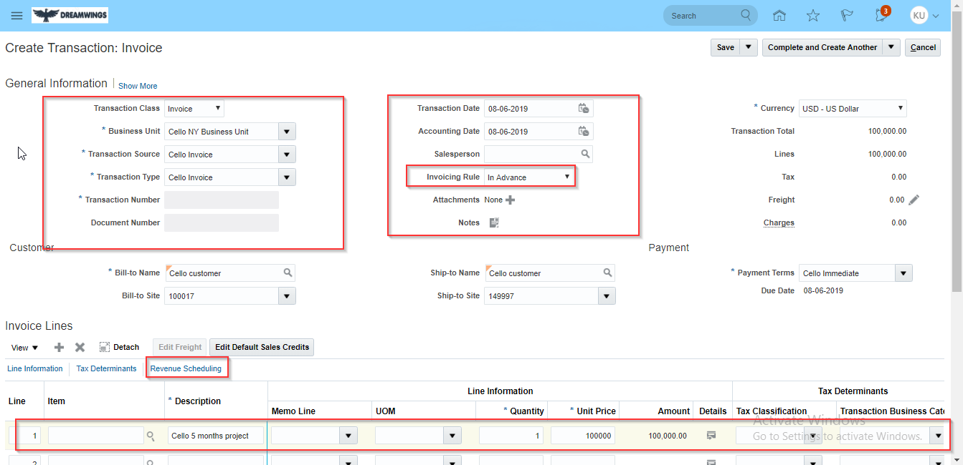

* Click on Revenue scheduling
* Give the rule as your defined rule and starting date depends on project starting date here I take today date means this month also system will recognize the revenue

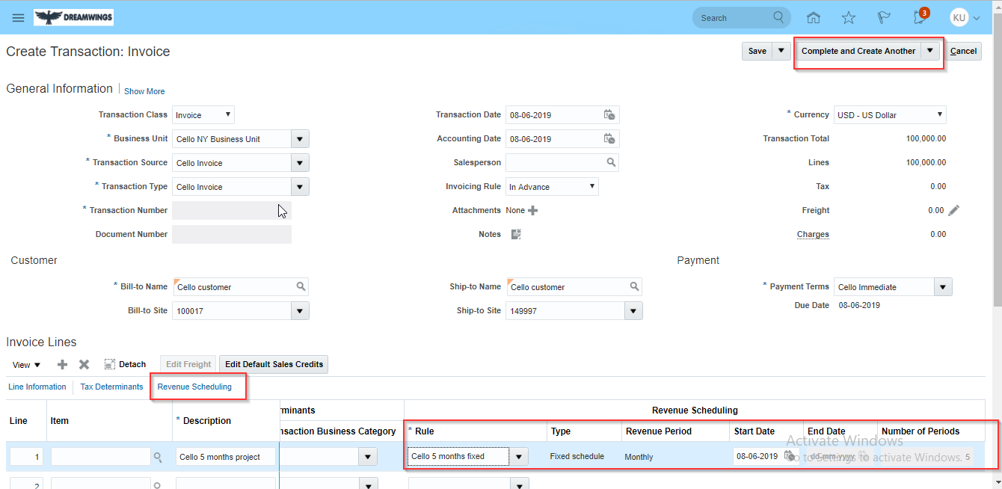

* Click on complete and review under the complete and create another
* Click on Edit and Distribution under Actions

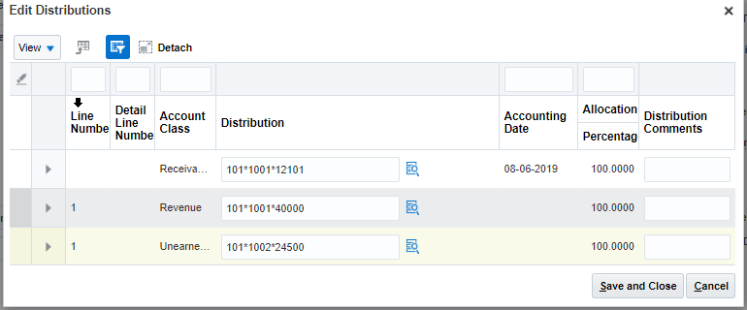

* Save and close
* System will create the revenue distribution for the 5 months once you run the recognition it will recognize the revenue

## Run “Revenue Recognition”

* You can run from revenue tab or ESS page
* Run the process called Recognize revenue

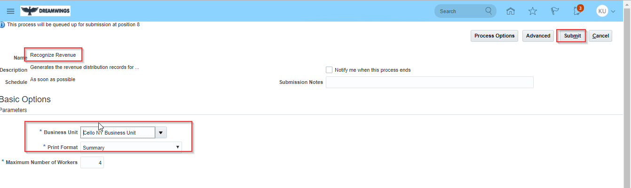

* Click on submit
* Go to transaction work bench
* Click on task then click on manage transaction
* Query with the number or date
* Then open the transaction go to actions click on review distribution then you can see the revenue recognition
* You can see the current month total amount and revenue recognition

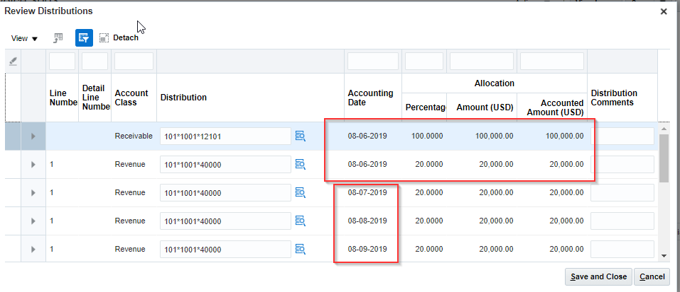

* You can see this month revenue recognition and this month revenue transaction
* If you run the next month revenue recognition then another month revenue will go up

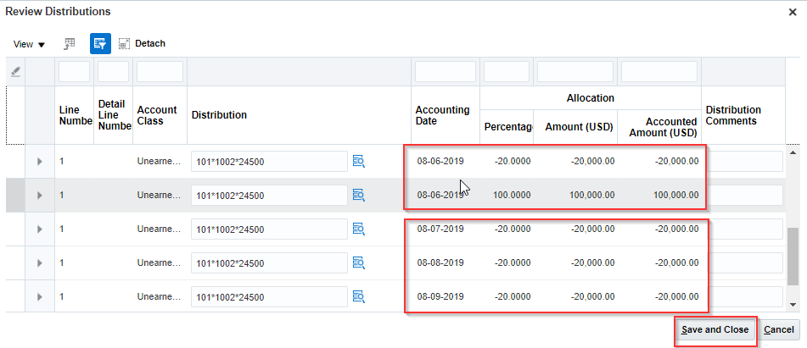

Click on save and close