**Uploading bulk users in oracle cloud**

**Introduction/ Issue:**

We are revoking bulk user’s roles access in oracle cloud using user.dat

To reproduce manual afford to remove roles in user’s account

**Why we need to do**

We noticed that users left the organization or terminated, we are following the revoking the roles in user accounts.

**Please find the below format we follows**

METADATA|UserRole|PersonNumber|RoleCommonName|AddRemoveRole

MERGE|UserRole|1001912|AR_INQUIRY_ROLE_CUSTOM|REMOVE

MERGE|UserRole|1001912|PER_EMPLOYEE_ABSTRACT_CUSTOM|REMOVE

We can upload more than 1000 records at a time

Here I am attaching the user dat file.



How to upload the file in oracle cloud.

Please login into oracle cloud.

Click on my client groups🡪 Data Exchange🡪 Import and load the data🡪Import

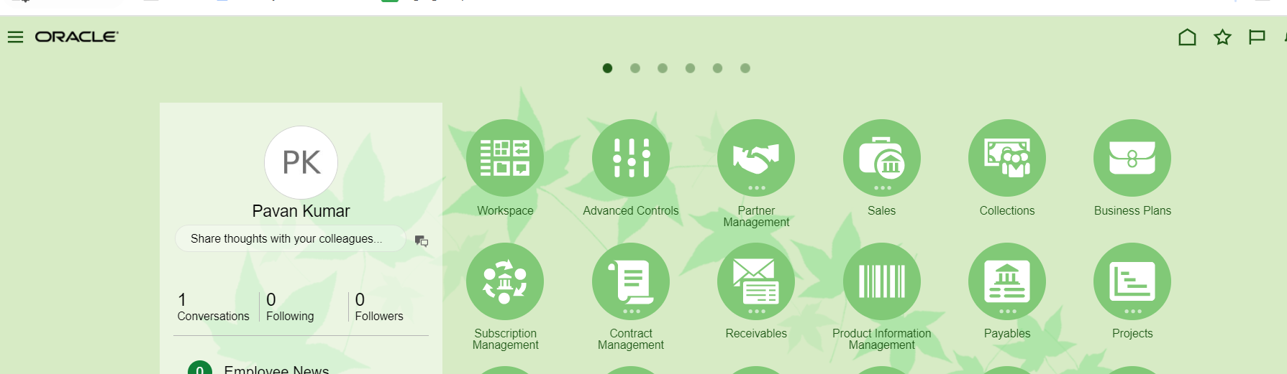

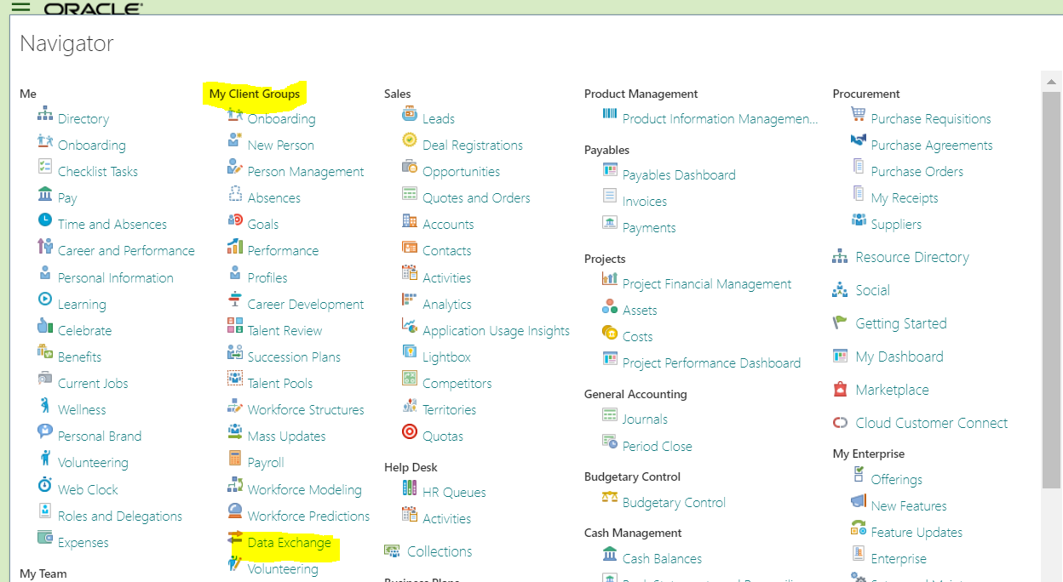

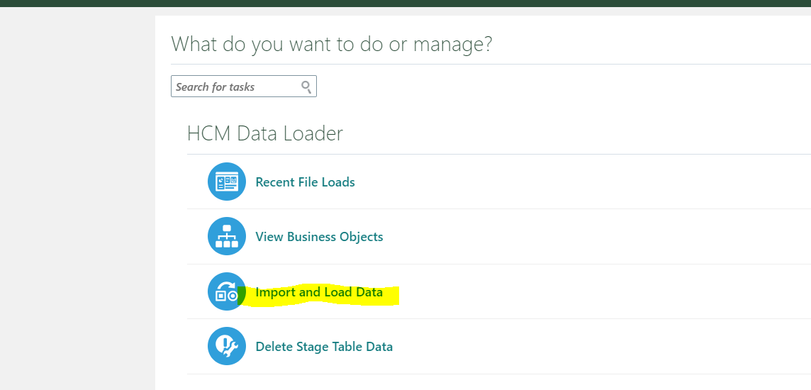

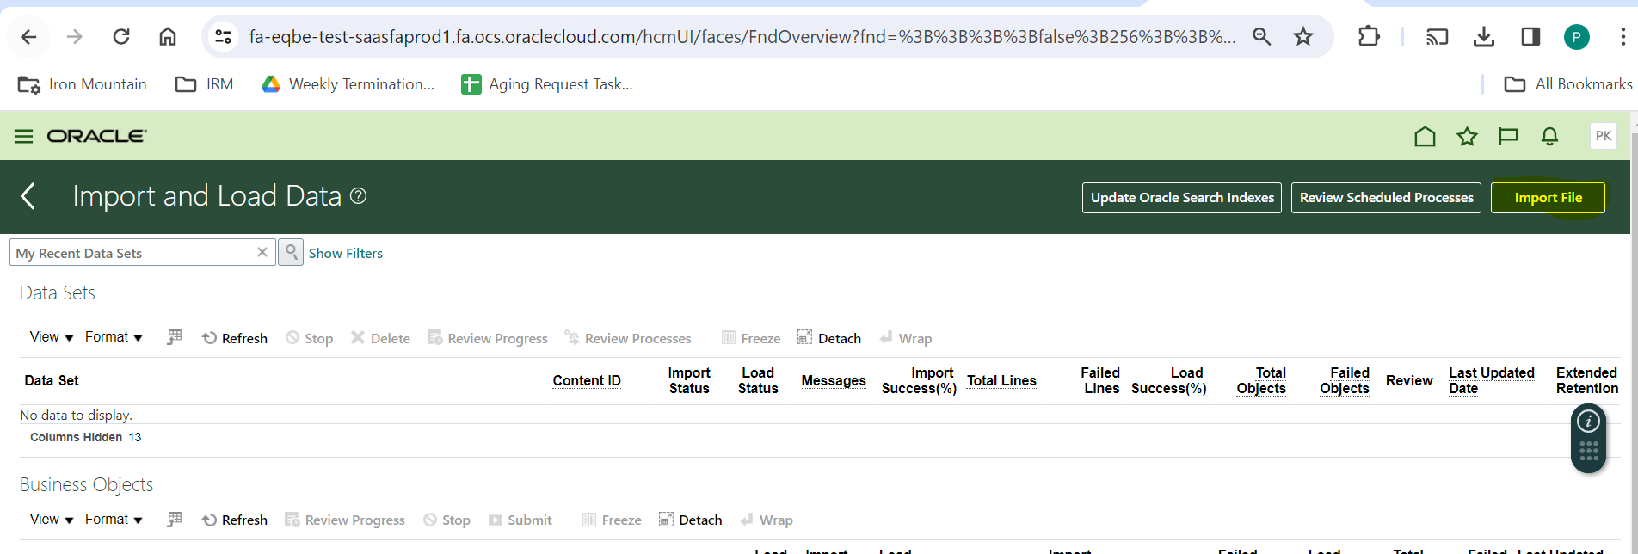

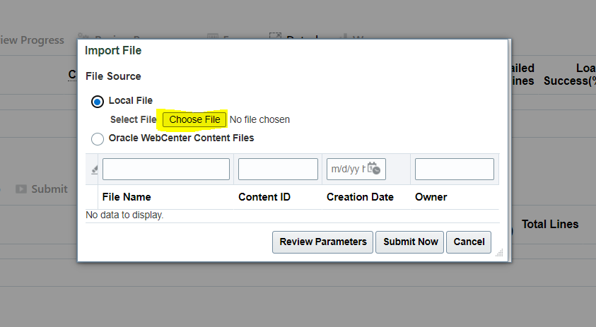

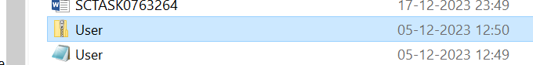

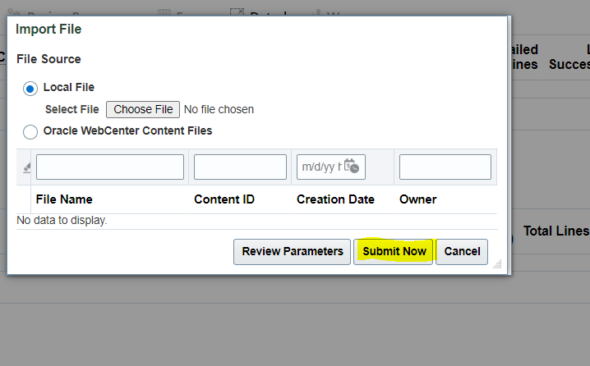

Once submit the file.

We need to check the process or not and once successfully completed.

We need run the Send pending LDAP request.

**Conclusion**

Once ESS job is completed, we need to check random users the roles removed or not.