**Introduction: Depreciation**

This Blog will explain about the Deprecation calculations

What is Depreciation?

Assets calculates depreciation using either the recoverable cost or the recoverable net book value as a basis: Asset cost: Assets calculates the fiscal year depreciation by multiplying the recoverable cost by the rate.

Why do asset Depreciate?

The value of your tangible or physical assets - such as vehicles, machinery and equipment - will fall as they are used and eventually wear out. This is depreciation and is used in your business accounts to write off the value of the assets you have bought over time.

Depreciation Method

Depreciation methods specify how to allocate the asset cost.

You can use:

* Oracle Assets predefined depreciation methods.
* Company-defined depreciation methods you define to accommodate your financial and accounting needs.

Straight Line Method  
  
This is the simplest and most used depreciation method. It is best for smaller businesses that are looking for a simple way to calculate depreciation. With the straight-line method, you are calculating a depreciation amount that is the same year after year for the life of the asset.8

Settings That Affect Depreciation Calculation

Prorate and Retirement Conventions

Oracle Assets uses prorate and retirement conventions to determine how much depreciation to take in the first and last year of an asset's life.

To determine depreciation, set up:

* Prorate conventions
* Retirement conventions

**Prorate convention**

* Oracle Assets uses prorate and retirement conventions to determine how much depreciation to take in the first and last year of an asset's life. To determine depreciation, set up: Prorate conventions. Retirement conventions.

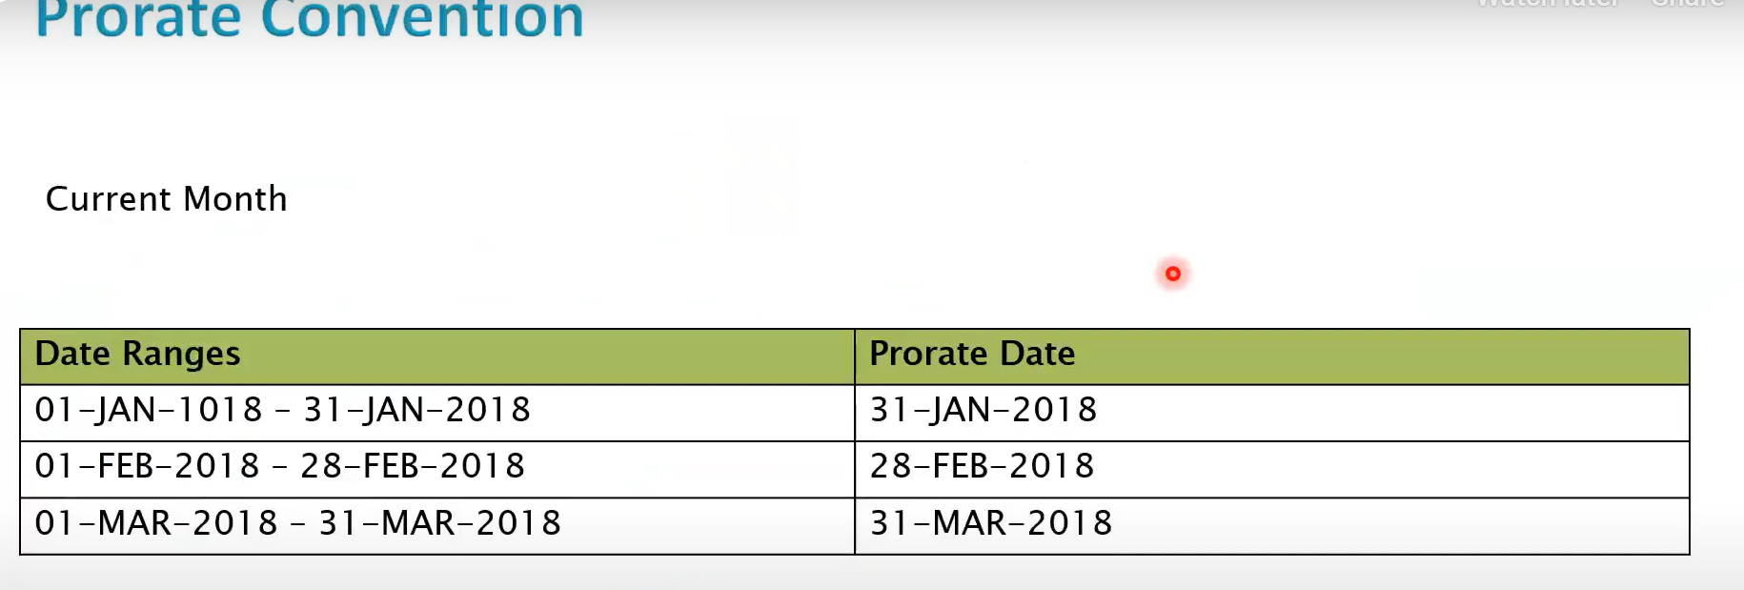

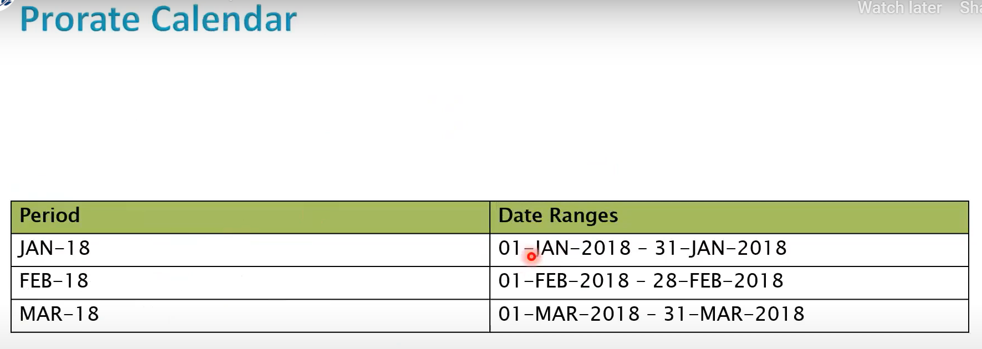

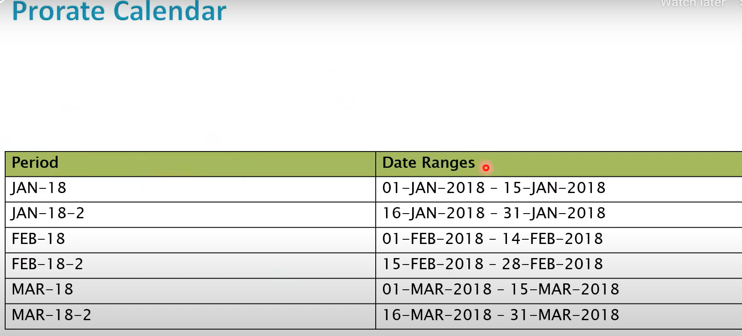

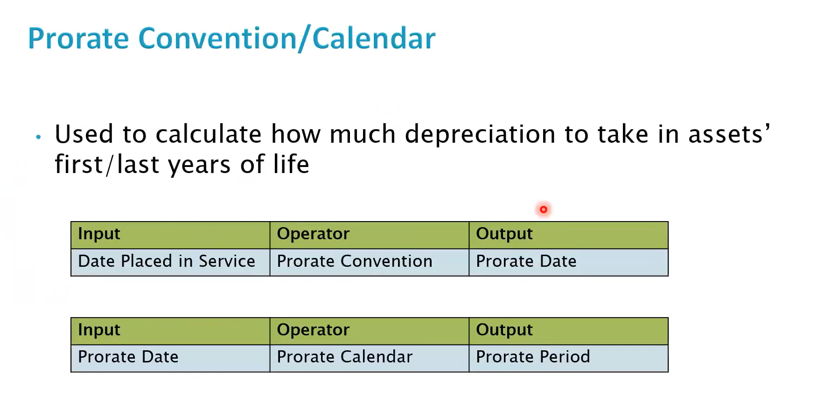

Assets uses the prorate date to choose a prorate period from the prorate calendar.

* Life-based methods: The prorate period and asset age determine which rate Assets selects from the rate table. The Calculate Depreciation process calculates the asset age from the date placed in service as the number of fiscal years that you have held the asset.
* If two assets are placed in service at different times, but have the same depreciation method and life, Assets uses the same rate table, but may choose a different rate from a different column and row in the table.

## **Conclusion:**

## **How Depreciation Is Calculated**

Calculated and table-based methods calculate annual depreciation by multiplying the depreciation rate by the recoverable cost or net book value as of the beginning of the fiscal year.

Flat-rate methods calculate annual depreciation as the depreciation rate multiplied by the recoverable cost or net book value, multiplied by the fraction of the year that the asset was held.

After calculating the annual depreciation amount, Assets uses the depreciation calendar and the options chosen for dividing depreciation and depreciating when an asset is placed in service to determine how much of the fiscal year depreciation to allocate to the period for which you ran depreciation.

You can choose to allocate depreciation:

* Evenly to each of your accounting periods: Assets divides the annual depreciation by the number of depreciation periods in your fiscal year to get the depreciation per period.
* According to the number of days in each period: Assets divides the annual depreciation by the number of days that the asset depreciates in the fiscal year and multiplies the result by the number of days in the appropriate accounting period.

Assets allocates the periodic depreciation to the assignments to which you assigned the asset, according to the fraction of the asset units that is assigned to each depreciation expense account.

**Note: Post the blog in SharePoint. After your manager’s review, you can post it in our website.**