Introduction/ Issue
In this document we shall see how to perform SPLIT in Fixed asset
Split
Divide an asset into separate units. Use the Split Assets routine to divide an asset into a specified number of new assets and divide the original asset's costs evenly between the newly created asset records.
Steps to split a source line:
1. Navigate to the Fixed Assets landing page, for the appropriate asset book
2. Search and select the source line to split.
3. Click on the Split button, when prompt to confirm the split, click Yes.
4. System will create the split and confirm the split was made. Click OK.

Steps to undo a split:
1. Navigate to the Fixed Assets landing page, for the appropriate asset book
2. Click on the Tasks > Prepare Source Line
3. Search for the asset book and the following:
- Queue = Split
- Description = {enter the description of the original source line}
4. Click the Search and select the source line
5. Click on Actions > Undo Split
6. Click Yes when prompt to confirm the undo split
7. Navigate to the Fixed Asset landing page and search for the source line description

Steps to split a source line
1. Navigate to the Fixed Assets landing page, for the appropriate asset book
2. Search and select the source line to split.
3. Click on the Split button, when prompt to confirm the split, click Yes.
4. System will create the split and confirm the split was made. Click OK.

1. Navigate to the Fixed Assets landing page, for the appropriate asset book  2. Search and select the source line to split.  3. Click on the Split button, when prompt to confirm the split, click Yes. | 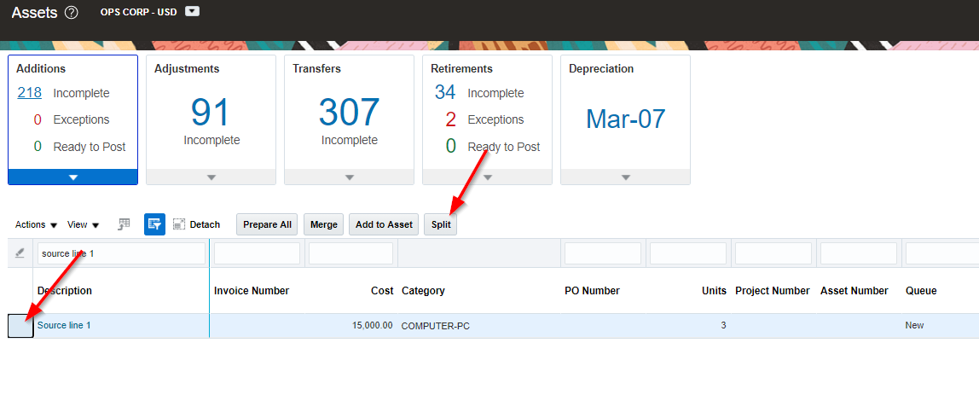  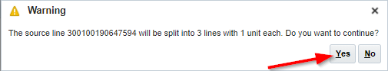
4. System will create the split and confirm the split was made. Click OK. | 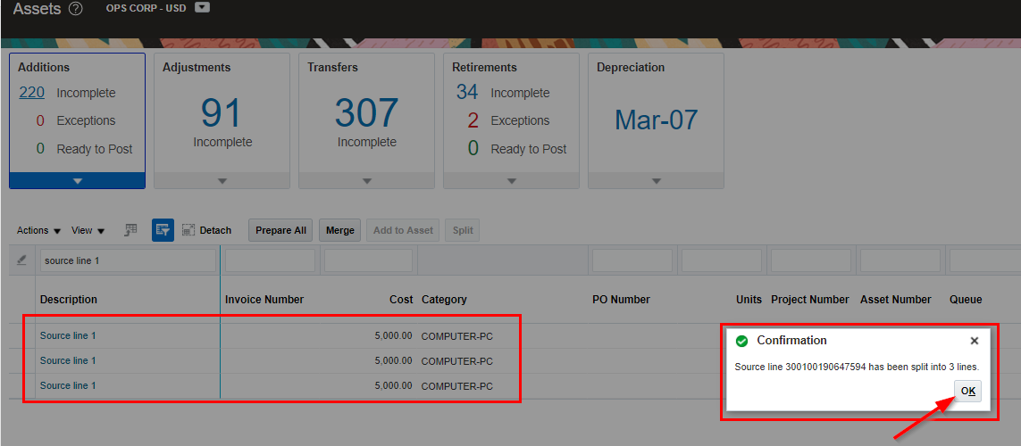  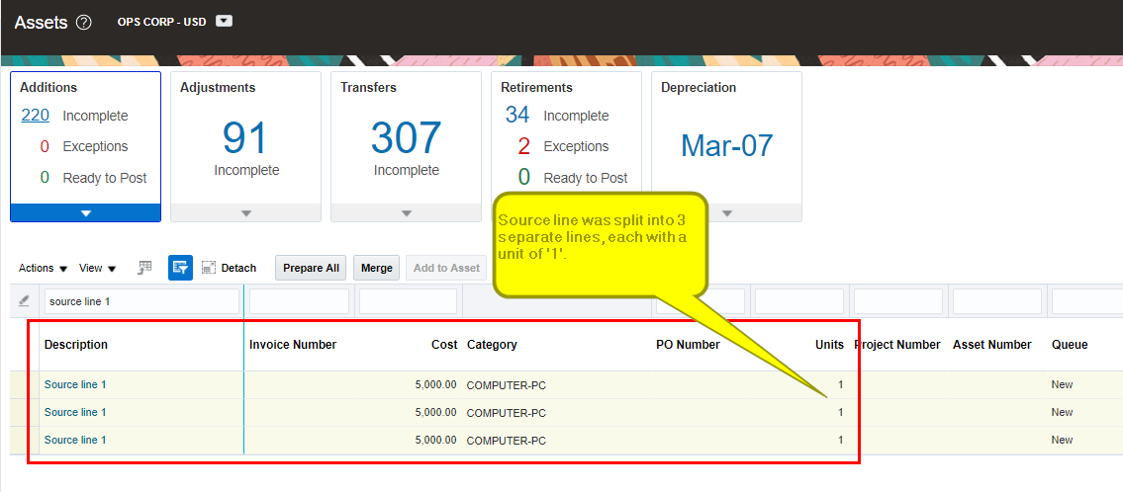

Steps to undo a split
1. Navigate to the Fixed Assets landing page, for the appropriate asset book
2. Click on the Tasks > Prepare Source Line
3. Search for the asset book and the following:
- Queue = Split
- Description = {enter the description of the original source line}
4. Click the Search and select the source line
5. Click on Actions > Undo Split
6. Click Yes when prompt to confirm the undo split
7. Navigate to the Fixed Asset landing page and search for the source line description

1. Navigate to the Fixed Assets landing page, for the appropriate asset book  2. Click on the Tasks > Prepare Source Line | 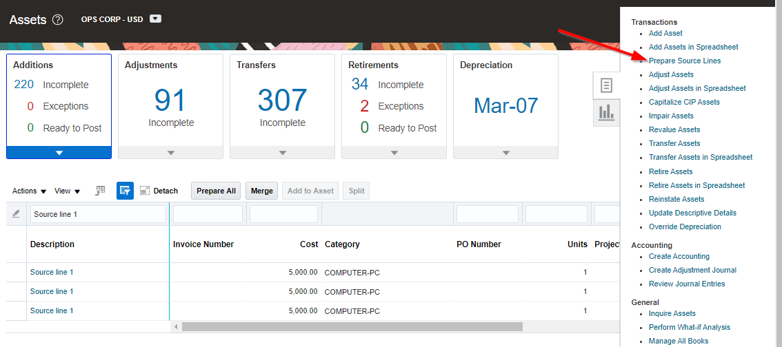
3. Search for the asset book and the following:  - Queue = Split  - Description = {enter the description of the original source line}  4. Click the Search and select the source line | 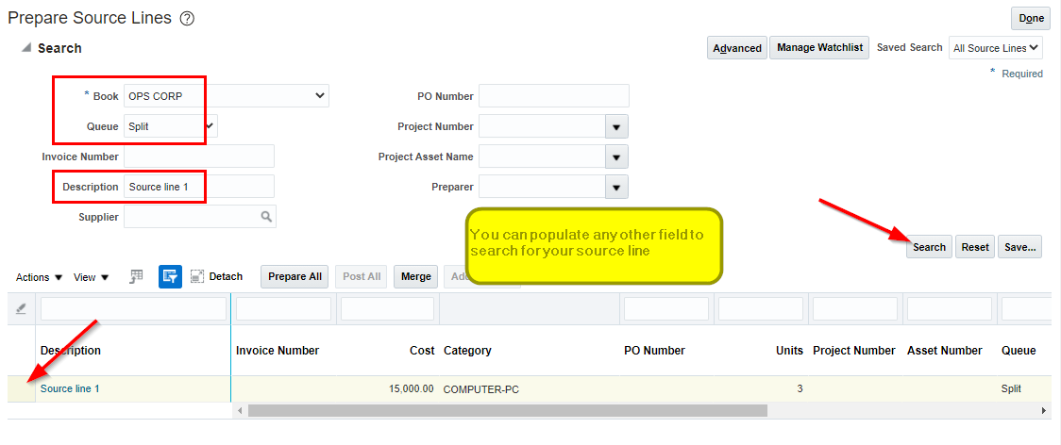
5. Click on Actions > Undo Split | 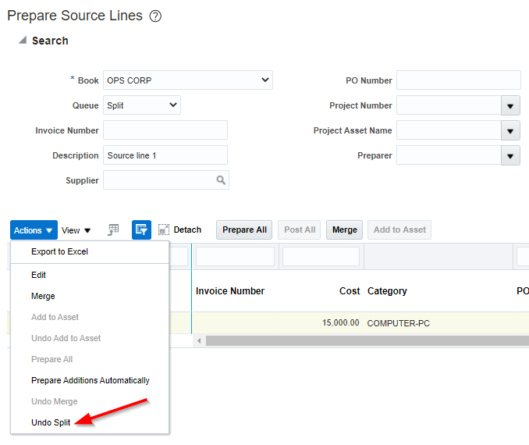
6. Click Yes when prompt to confirm the undo split | 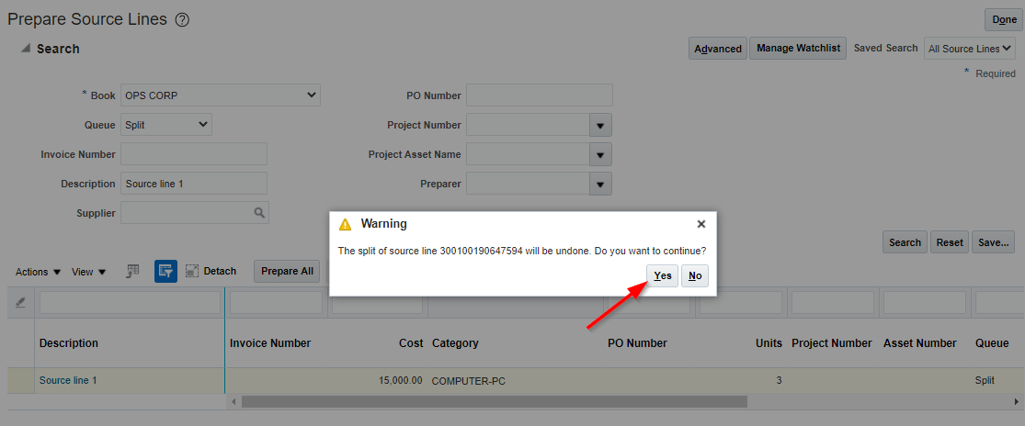
7. Navigate to the Fixed Asset landing page and search for the source line description | 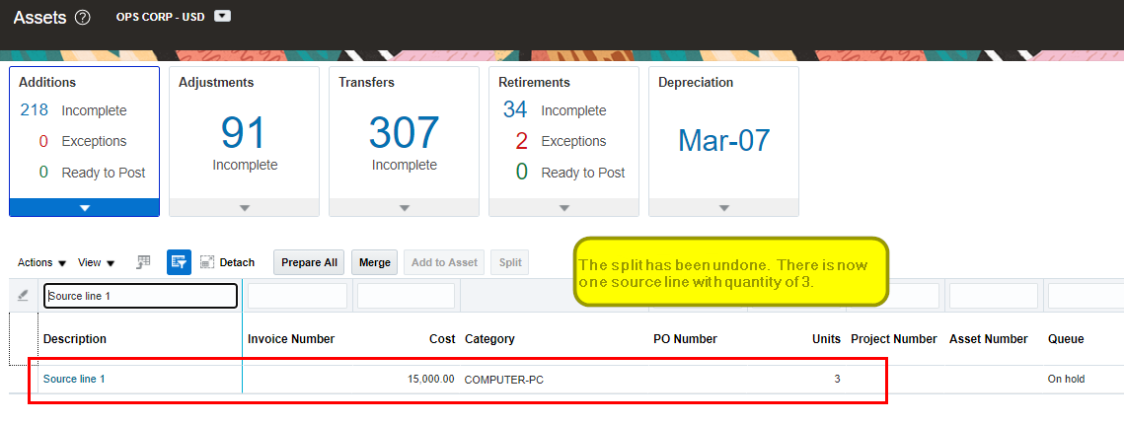

Note: Post the blog in SharePoint. After your manager’s review, you can post it in our website.

