**ORACLE CLOUD INTERGRATION:**

**Steps To Set Up Visual Builder On Oracle Cloud**

**1) Register & Log in to** the Oracle Cloud account, [**cloud.oracle.com**](http://cloud.oracle.com/).

**2)** Click on the hamburger menu, Under **More Oracle Cloud Services**, expand **Platform Services** and click on **Visual Builder** as shown below:

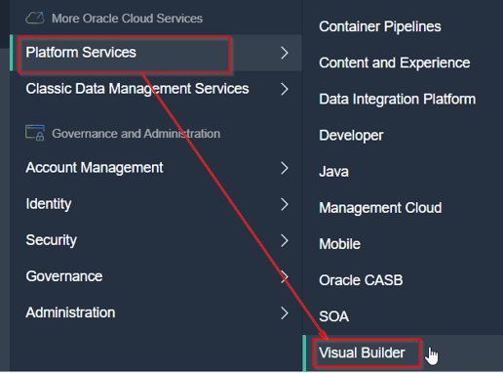

**3)** You will be redirected to a Welcome page when you click Visual Builder. Just click on **Instances**.

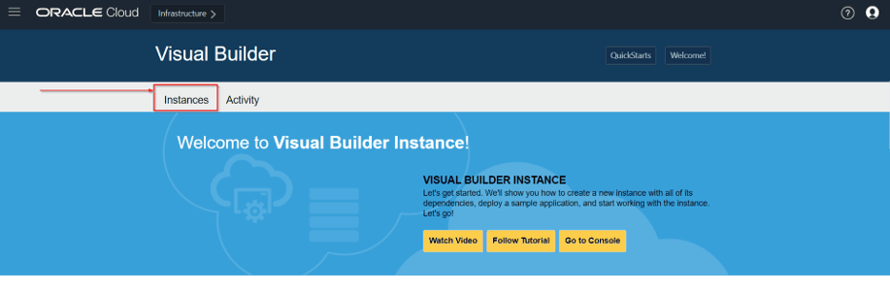

4) On the Visual Builder page, you can create an instance in two ways:

* Create QuickStart Instance
* Create a custom Instance

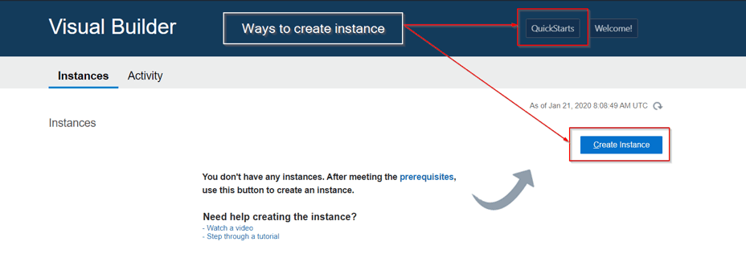

5) You will see a create instance page where you can name the new instance and can see a description of the features of the QuickStart instance. Type the instance name in the **Instance Name**field and click on create.

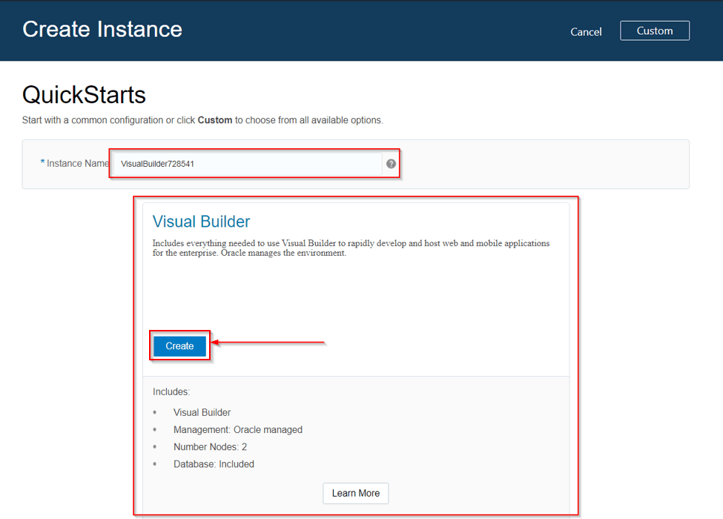

**4)** Once the services are created, an instance will be available on the **Visual Builder console**.

