**Updating bulk records pending under Inventory**

**Transactions using Oracle Visual Builder Add-in**

**Introduction:**

The Oracle Visual Builder Add-in for Excel connects Excel spreadsheets with REST services, enabling you to retrieve, analyze, and edit business data directly from the service. You can download data into an Excel spreadsheet, make modifications, and then upload your changes back to the service.

**Why we need to do / Cause of the issue:**

Utilizing the "Oracle Visual Builder" add-in to clear a large number of inventory transactions that are stuck in the interface table due to incorrect sub inventory locations of the items. This approach allows us to integrate the Staged Transactions REST API with Excel, enabling the download of errored transactions from the Manage Pending Inventory Transactions screen. These transactions can then be updated in bulk and re-uploaded to the cloud, streamlining the process and significantly reducing the workload compared to the traditional method of manually clearing each record.

**How do we solve:**

**Step1**:

Download the Oracle Visual Builder add-in for Microsoft Excel using the following link

<https://www.oracle.com/downloads/cloud/visual-builder-addin-downloads.html>

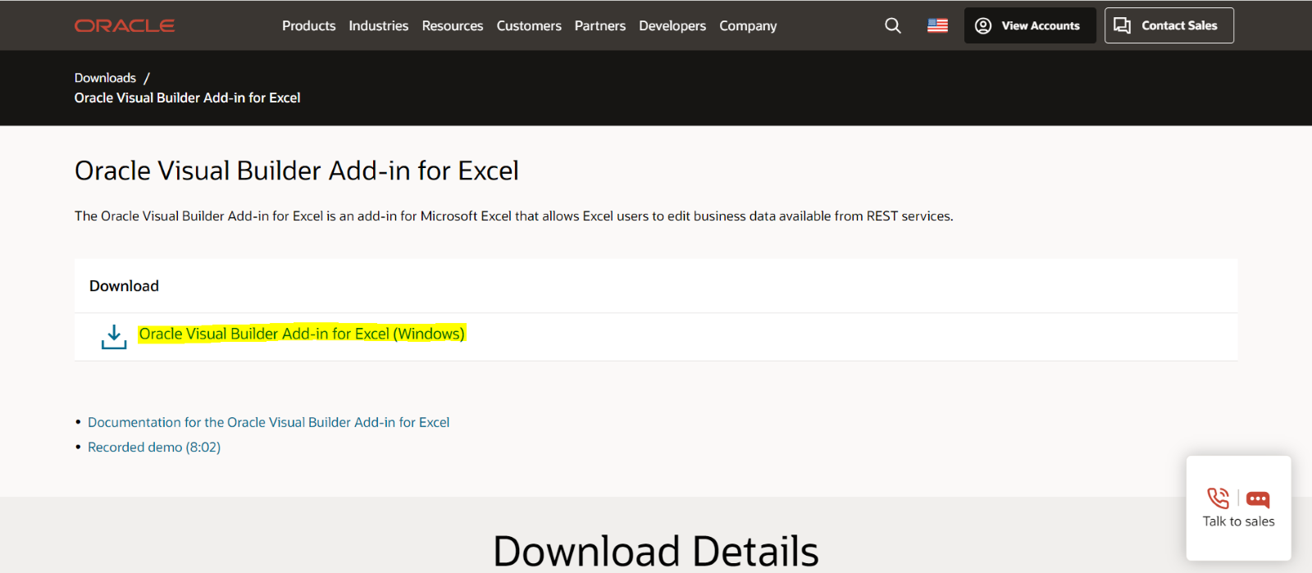

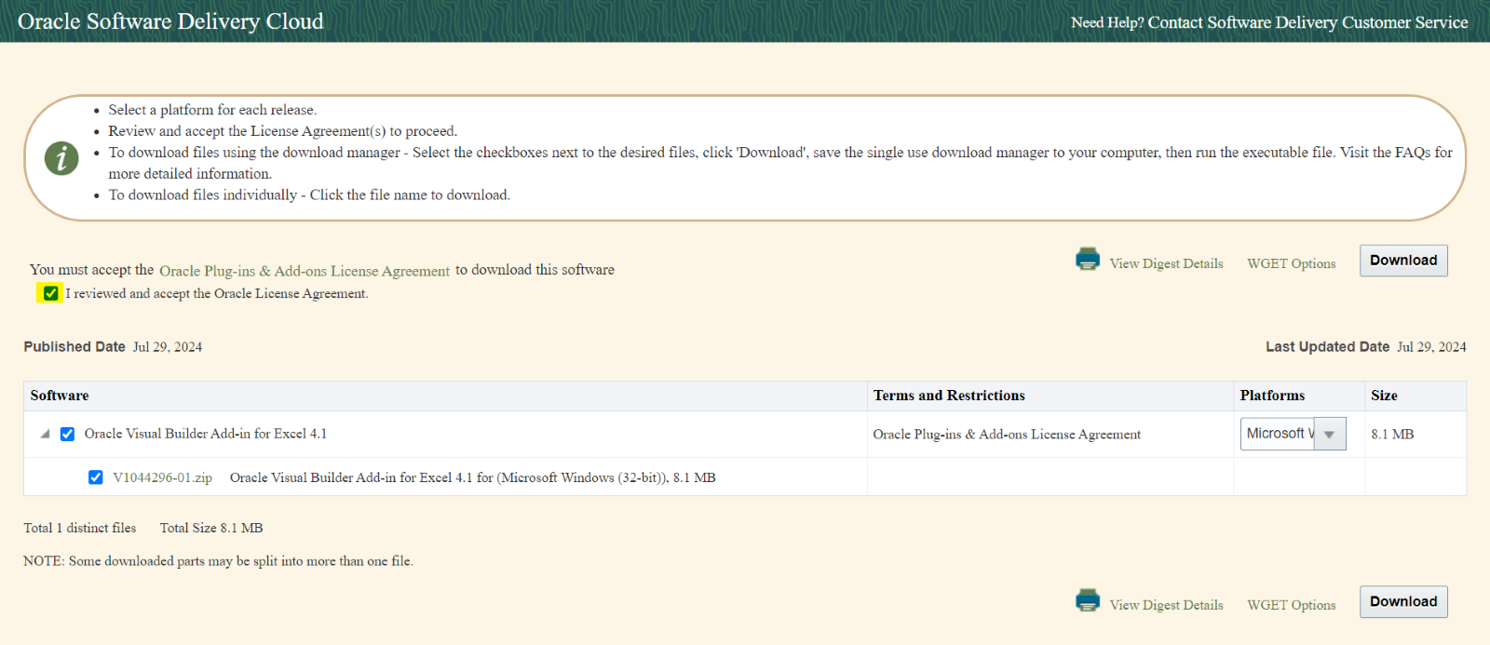

The following files will be downloaded in a zip folder

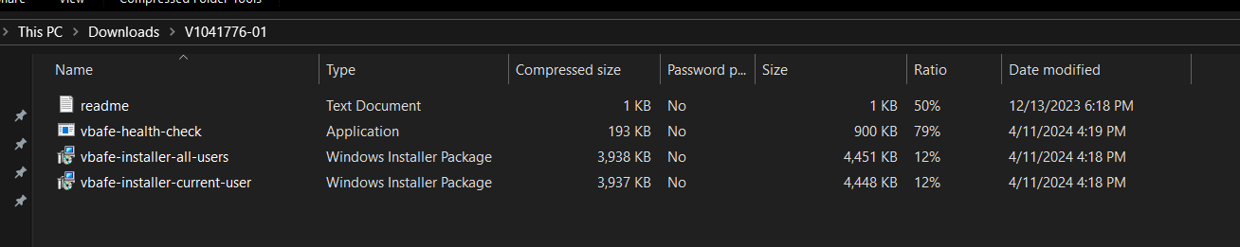

Click on the vbafe-installer-current-user file and install the Oracle visual Builder. After successful installation, Oracle visual builder is enabled in Excel

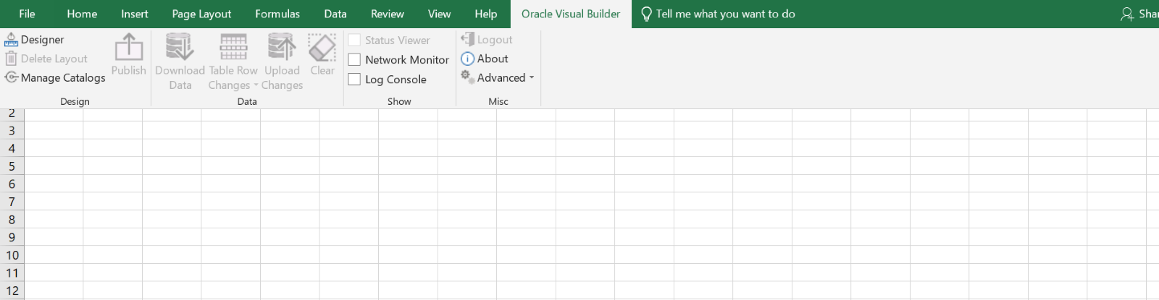

**Step 2:**

2.1: Click on the **Oracle visual builder** tab in Excel.



2.2: Click on the Designer option and add the Web address of staged transactions

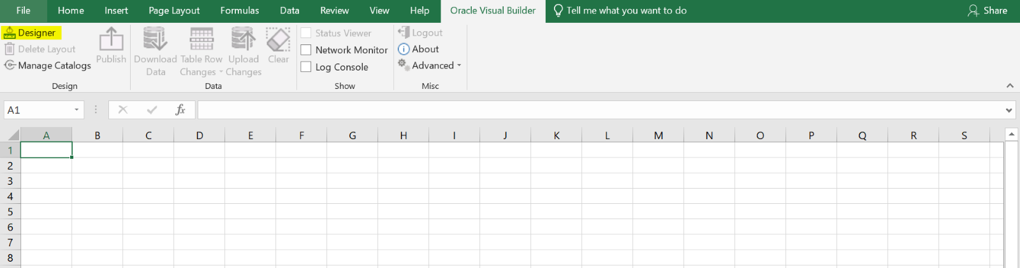

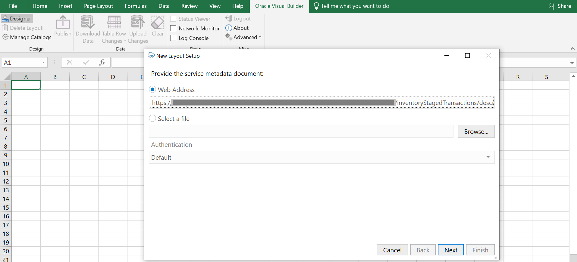

2.3: It will route to the application sign in

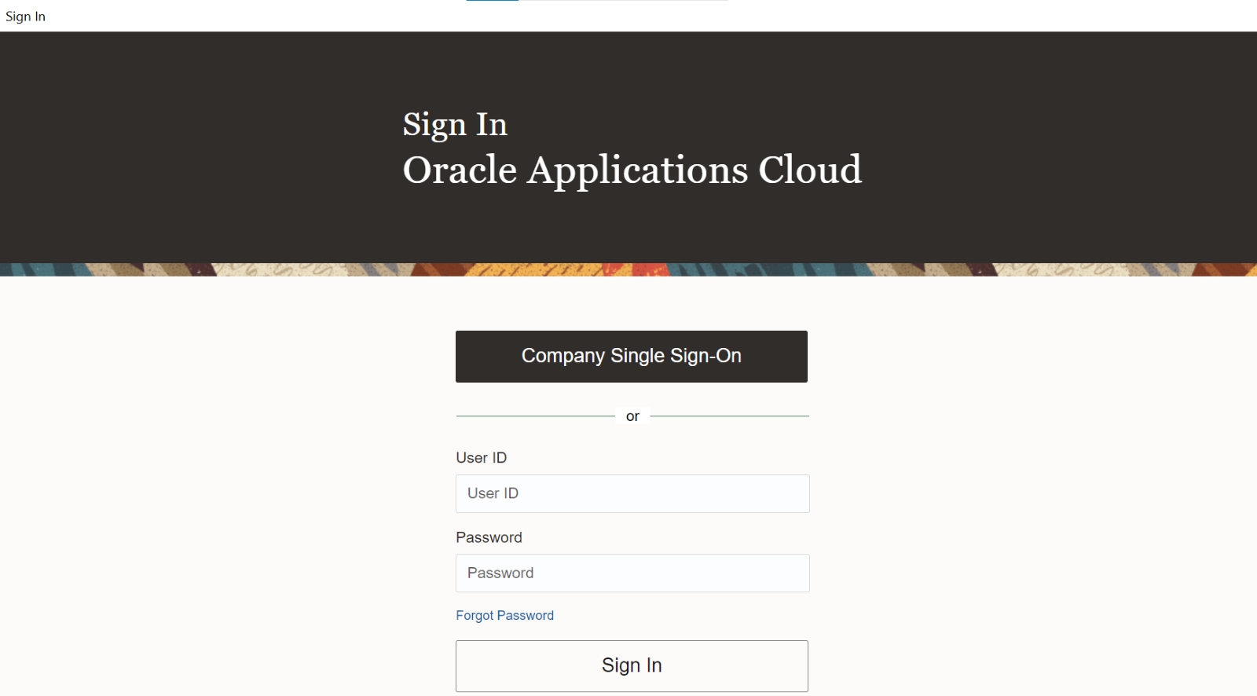

Log in to the application, then a new window pops up as shown below. Click on Next

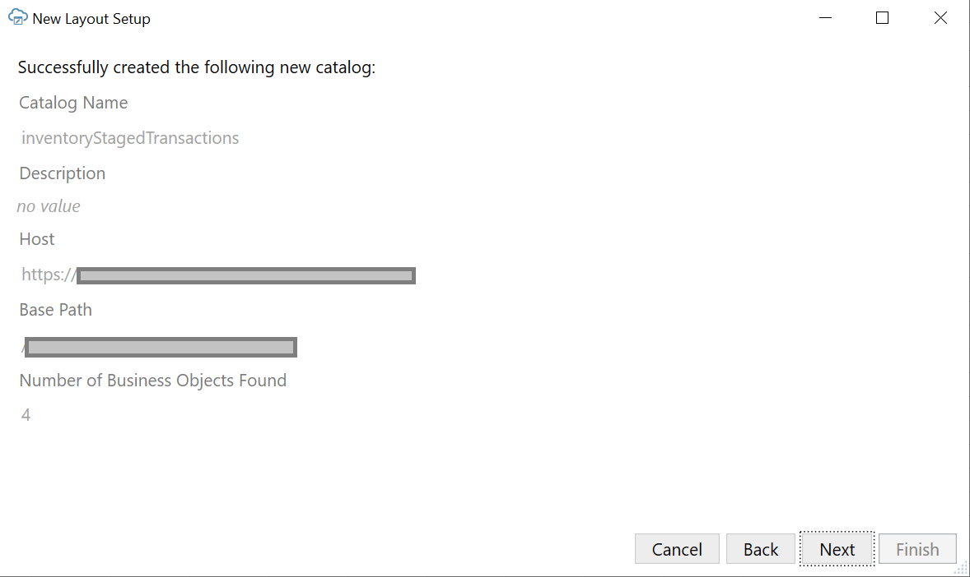

2.4: Select Inventory Staged transactions

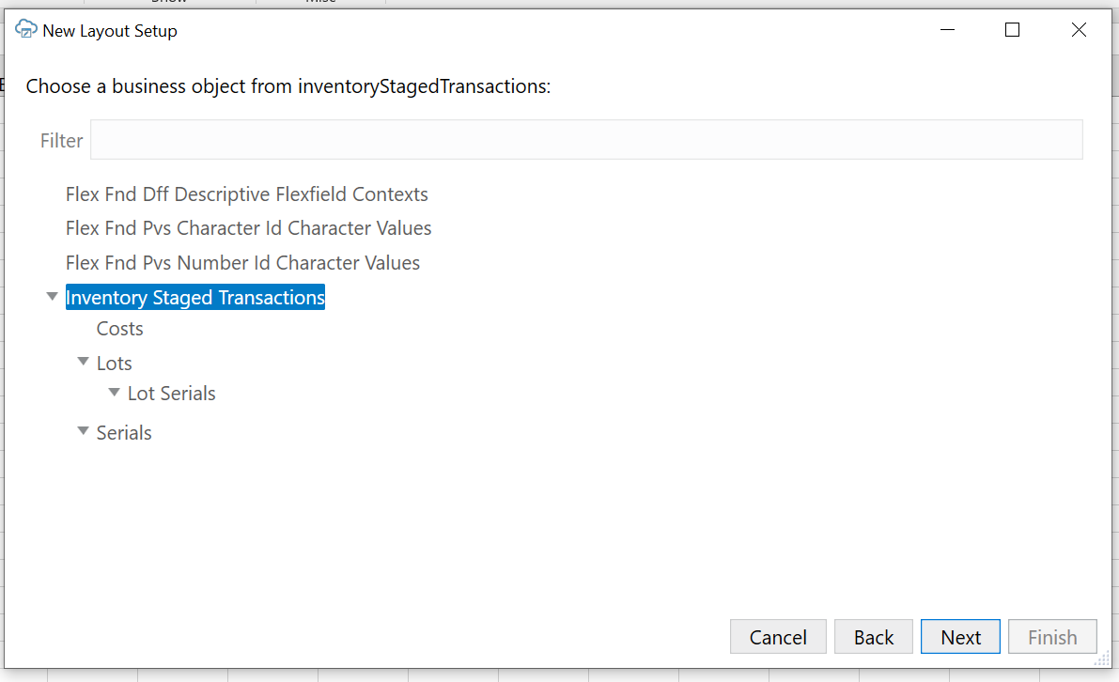

2.5: Select Table Layout

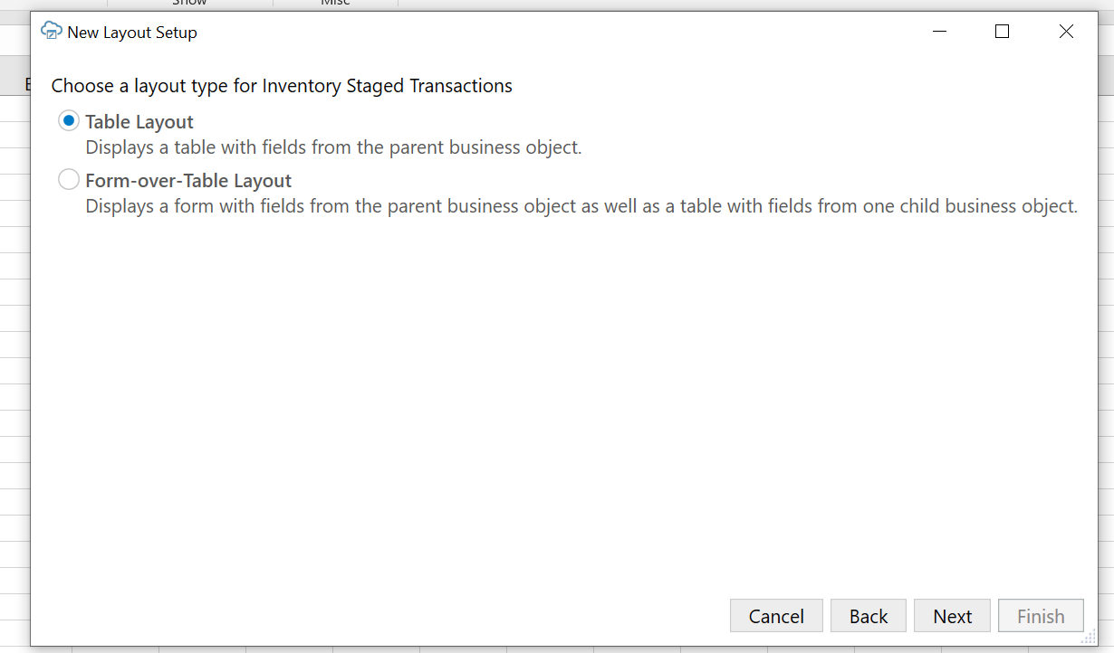

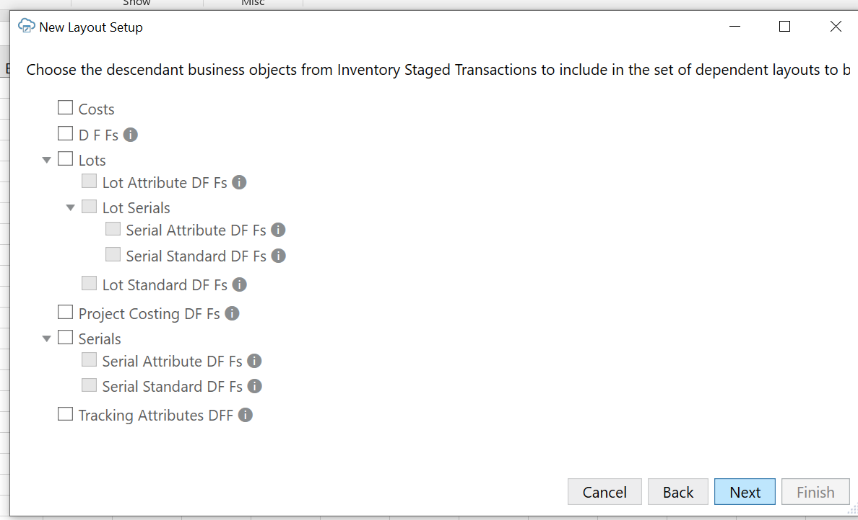

2.6: Review and click on finish

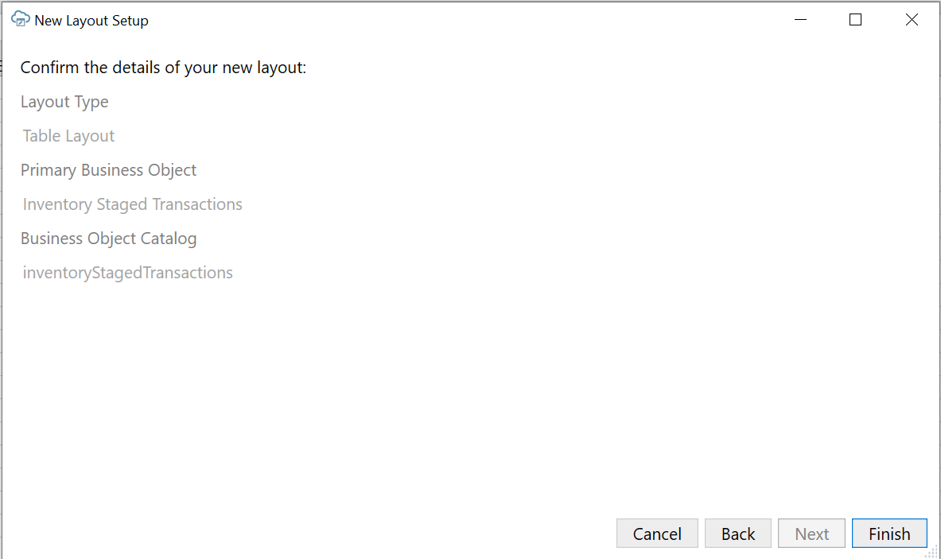

**Step 3:**

3.1: Select Query tab and click on edit icon

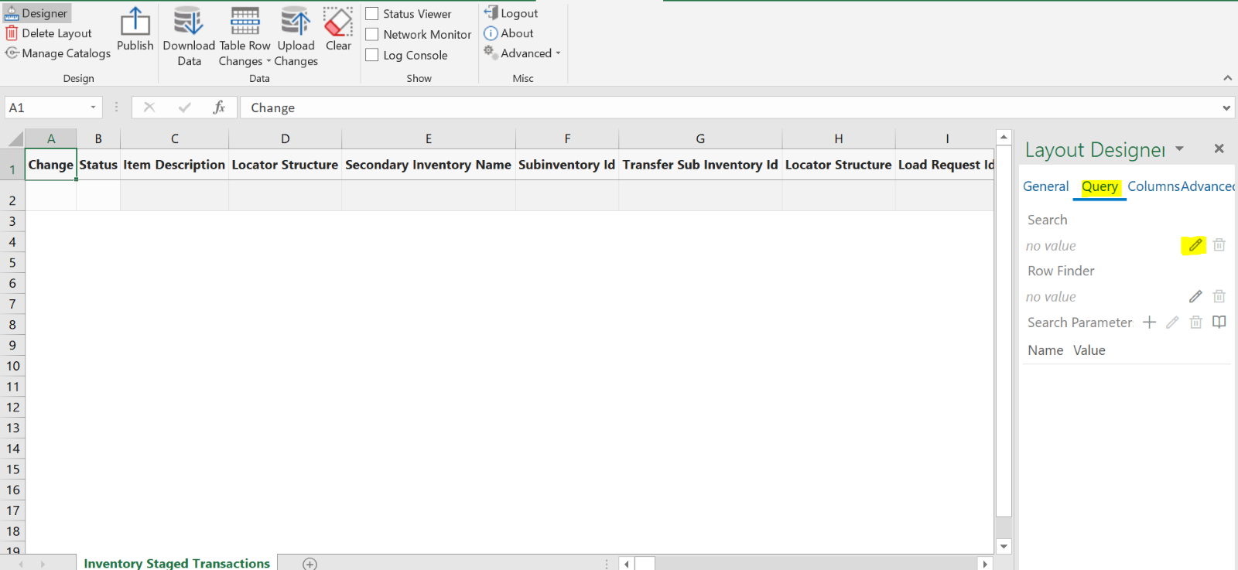

3.2: We can select different filter fields based on requirement

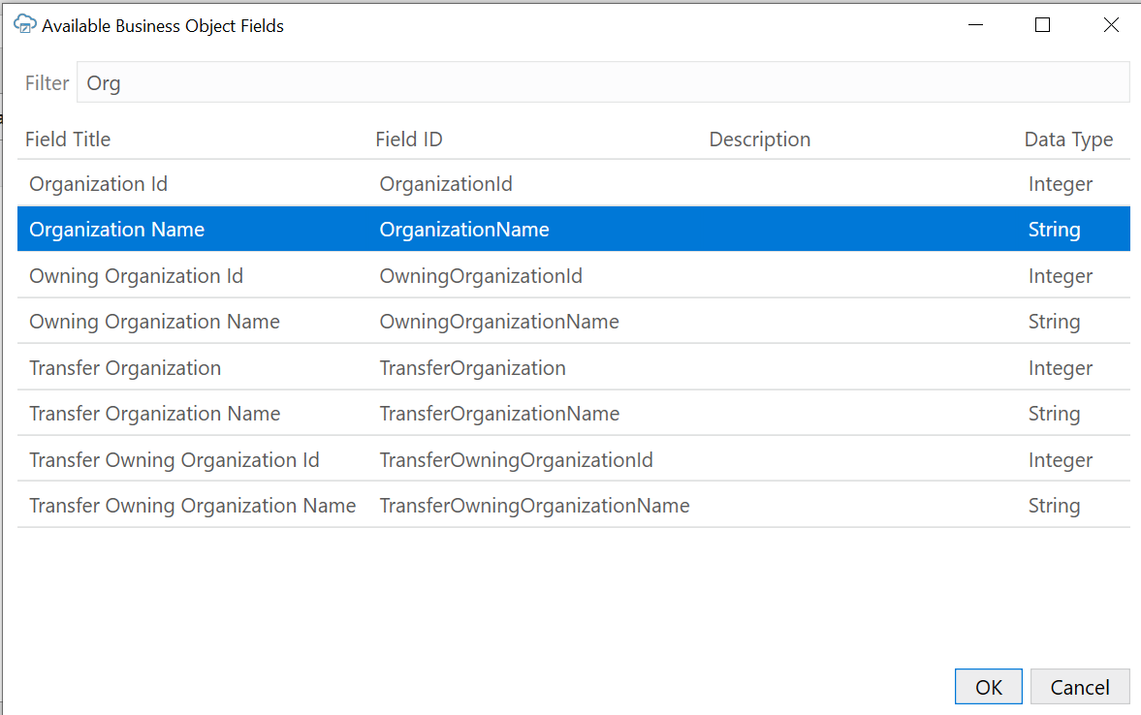

3.3: Click on Add Field to add more filter fields

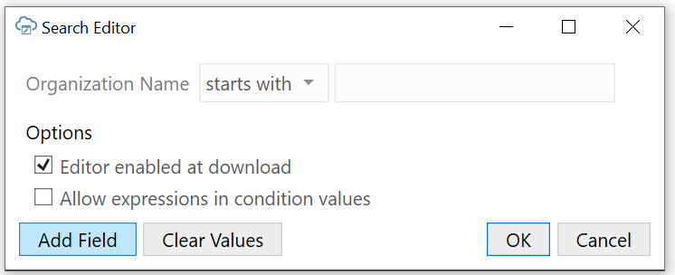

Provide the corresponding values. For example, organization name and item number for which there are pending transactions

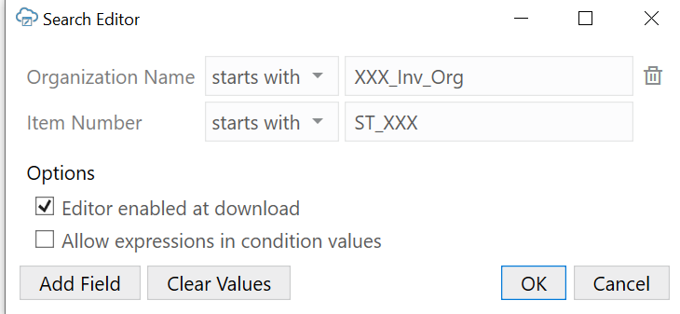  
**Step 4:**

Click on download data

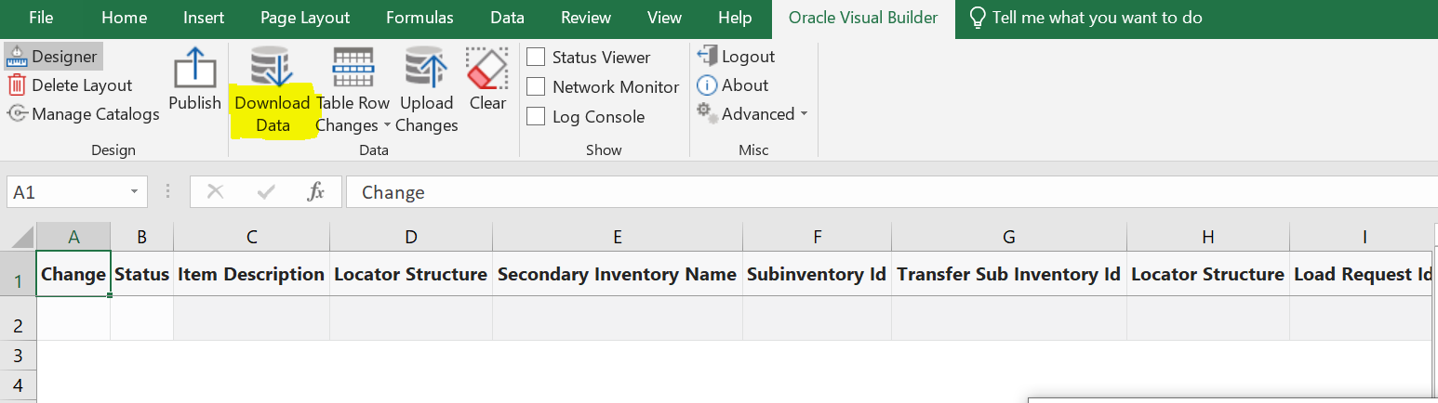

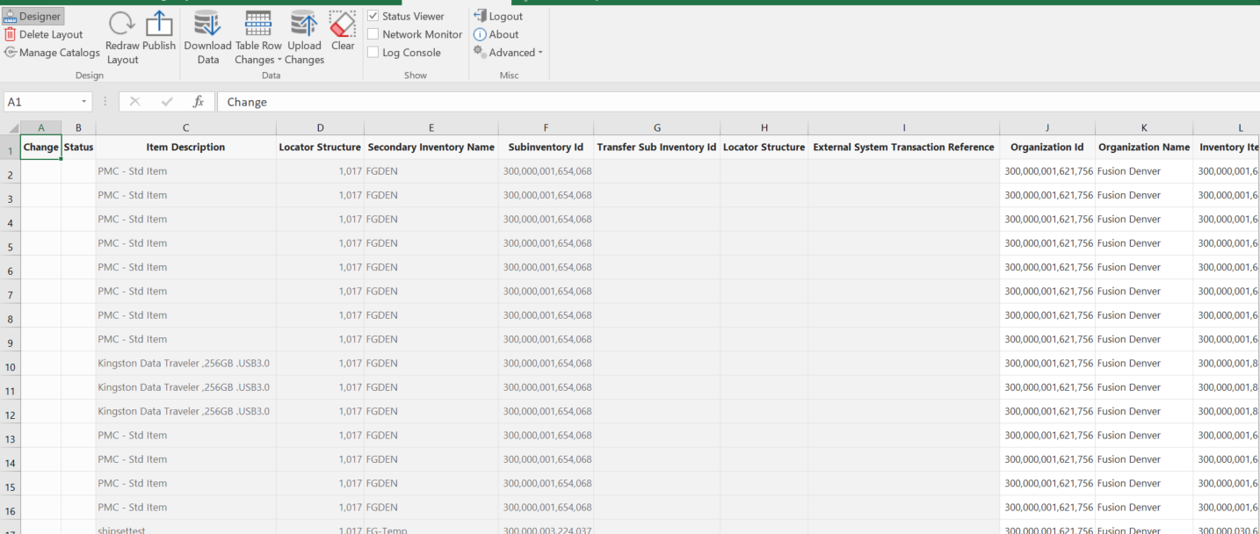

**Step 5:**

After the data is downloaded, update the changes in the transactions and click on upload changes to upload to instance

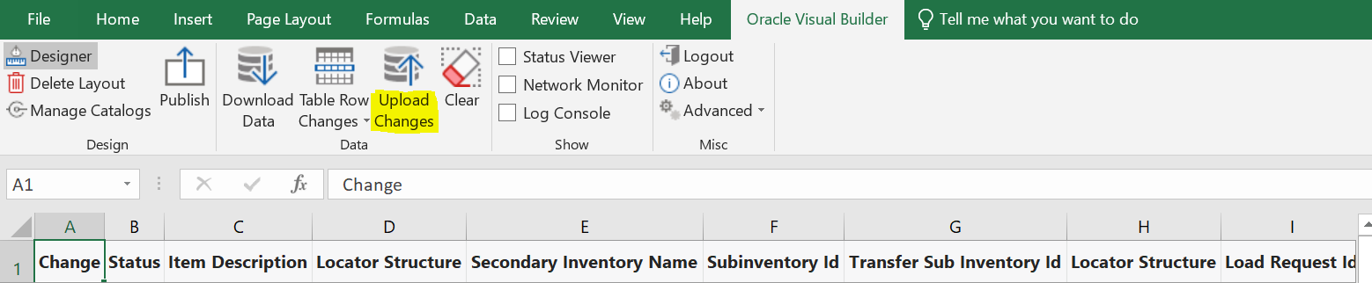

**Step 6:**

Navigate to Manage pending transactions under Supply chain Execution module in oracle instance to check the changes made.

**Step 7:**

7.1: Add the changed inventory transactions to schedule process

7.2: Run the schedule process “Manager inventory transactions”. Then it will clear out all pending inventory transactions

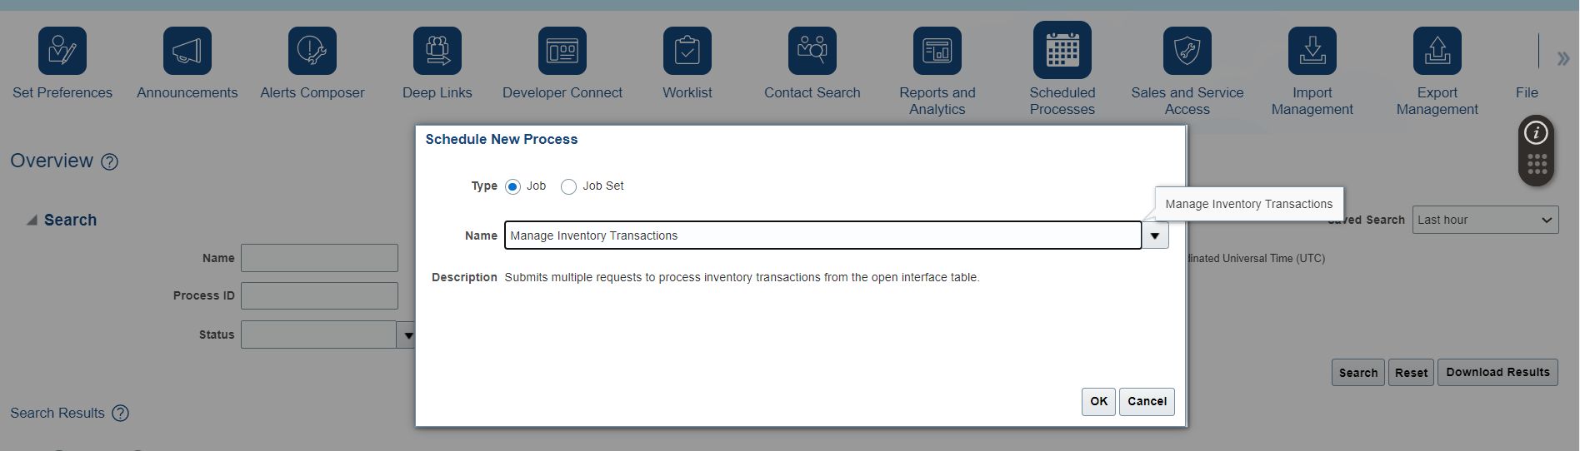

**Conclusion:**

By utilizing the Oracle Visual Builder add-in, we can efficiently update a large volume of pending inventory transactions directly within Excel. After making the necessary changes, the modified data can be easily re-uploaded to Oracle Fusion. This method significantly reduces the workload and time required compared to the traditional approach of manually updating each record individually within the system.