**Introduction/ Issue: *Write the issue that you face or the issue that you want to provide a solution through this blog.***

**Issue with the Oracle Fusion General Ledger where the Journals are not posted and in unposted status.**

**Why we need to do / Cause of the issue: *Write the details about the issue - how does it occur and what is the impact of it.***

## The issue happened because once the user the Open the periods all journals will reverse and will be in unposted status, as the Auto Post Criteria sets are not defined.

**How do we solve: *Write the Query or the steps to solve the issue with your real-time example or scenarios.***

## We have to configure the AutoPost Criteria Sets then we have to

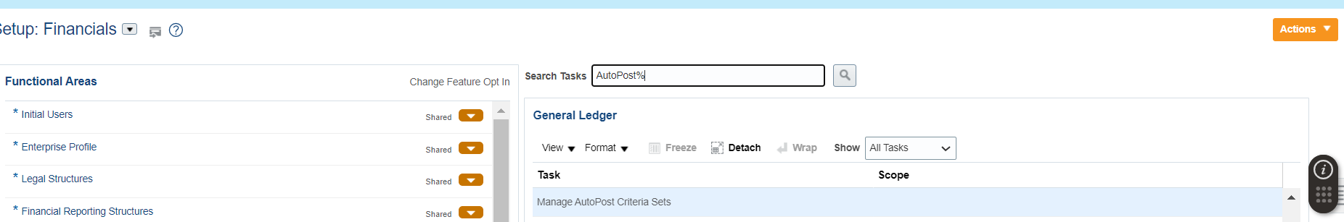

## Then we have to configure then for all ledgers so that once user run the “Run AutoPost” Program

## Once Program run successfully, all journals will Posted.

**Conclusion: *How did we provide an effective solution and resolve that issue/ unique solution given etc.***

**Note: Post the blog in SharePoint. After your manager’s review, you can post it in our website.**