**Introduction/ Issue:**

**User raise a ticket, FENIVISION APPLICATION getting drop .**

**Cause of the issue**

We got a ticket that Envision application getting drop frequently its happen due to internet getting huge packet loss and drop.

Impacted: Due to fenivison applications drop User not able to pass the billing / new purchase order , related all finance work .

**How do we solve:**

We setup a call with User and take the user Laptop on controlled .

We asked user how the accessing the application , user show us the steps we also found its getting drop.

We take the URL of application and did the nslookup on the command prompt of user pc ,

We get the application ip from User PC We did the frequently ping test of the Fenisvison applications , we found huge drop ..

Second step we did the continue ping test from User PC To internet and found Huge packet getting loss , the I got to know it’s the issue of internet side.

We rebooted the interne modem for a while, and we kept observed then its fixed the issue**.**

**Conclusion:**

We started troubleshooting from basis step from user Laptop end to till internet.

We did ping test , we did trace route from user pc to application end and internet end , its getting drop.

Demo snap :

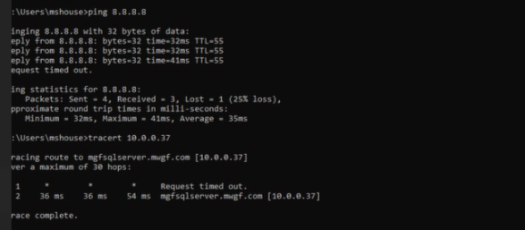

**Note: Post the blog in SharePoint. After your manager’s review, you can post it in our website.**