**Introduction/ Issue:**

If a switch will go down users unable to connect the internet not able to work any application and not able to access internet.

**How can troubleshooting for a Network switch down?**

* We need to trace out the switch IP For down switch.
* We will try to ping the switch ip from Command prompt and see the out put about the loss, I share demo ping snap.
* We will see the switch status in the Monitoring tool in SolarWinds.
* We will try to do SSH , But not able to do remote session out.

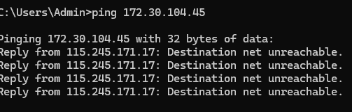

**Why we need to do / Cause of the issue:**

*How does issue occur?*

The switch will down for various reason, I will update couple of cause on below.

* Site power outage no power in the switch, its cause the switch goes down.
* Bad ups, Is switch connected UPS Is dead and not working,
* Power cable or power port damage.
* Uplink cable removed of damage.

**How do we solve:**

* We will do switch IP ping, trace, and we will try to login but no luck.
* We will connect with Local contact to check power status of device and power outage status of site.
* If power is available, we will go to check UPS bad or functioning properly or not.
* If all troubleshoot complete, we will check switch having power but not coming online,
* Next step we will reboot the switch for 30 seconds, then it will back restore.

**Conclusion:**

* We will do all the L1 Level the troubleshoot, like ping test , ssh, look the alerts status of SolarWinds.
* Then we will contact to LCON , Will check power status of site and switch power status.
* Then will Check Ups Status and uplink cable etc.
* If all ok and switch having power light all light, but not coming up .
* We will go final step to reboot the switch , once Switch reboot and restored , Switch will get to back online
* If all thing did but no luck, We will connect the console on switch help of the LCON AND We will try to take console and update **if any configuration Mismatch.**

**Note: Post the blog in SharePoint. After your manager’s review, you can post it in our website.**