Unable to cancel invoice due to error:you can’t cancel invoice because it would reduce the quantity or billed amount on the purchase order to less than zero

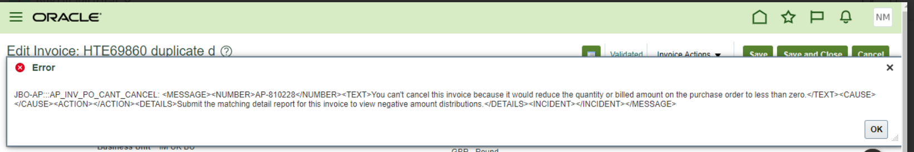

Action Plan:

1) Create dummy invoice with line matched to same PO schedule(amount equal or higher than the original billed amount)  
2) Cancel the impacted invoice  
3) Use self-correction for dummy invoice to update AP/PO Quantity Billed  
3.1. Self correction SH36  
3.2. Create profile option with code and name as AP_SHBYIV_ENABLE.  
3.3. Set profile option value as Y for User.  
3.4. Create profile option with code and name as AP_SHBYIV_PO_RCV_QTY_AMT_BILLED and set profile option value as Y for User.  
3.5. Login with same user and Run Invoice Validation ESS Job by passing Invoice Number as input parameter.  
3.6. Delete the Profile option AP_SHBYIV_ENABLE and AP_SHBYIV_PO_RCV_QTY_AMT_BILLED after transaction is corrected.  
4) Cancel the dummy invoice.