A **document sequence** uniquely numbers **documents** generated by an **Oracle Fusion** application. Using **Oracle Fusion** applications, you initiate a transaction by entering data through a form and generating a **document**, for example, an invoice. A document sequence generates an audit trail that identifies the application that created the transaction, for example, Oracle Receivables, and the original document that was generated, for example, invoice number 1234.

Document sequences can provide proof of completeness. For example, document sequences can be used to account for every transaction, even transactions that fail. Document sequences generate audit data, so even if documents are deleted, their audit records remain.

Document sequences can also provide an audit trail. For example, a document sequence can provide an audit trail from the general ledger into the subsidiary ledger, and to the document that originally affected the account balance

Below are the steps to create document Sequencing

Navigate to your Project and Search for a Task Manage Accounting and Reporting Sequences

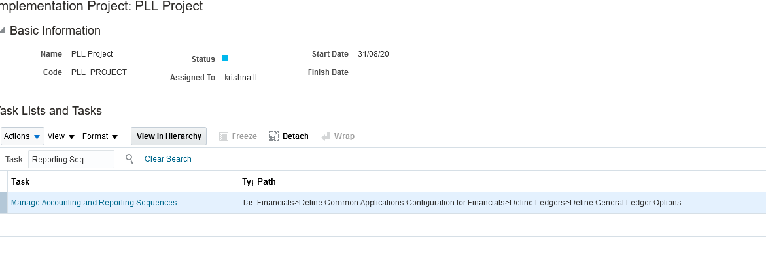

Apply and go to task

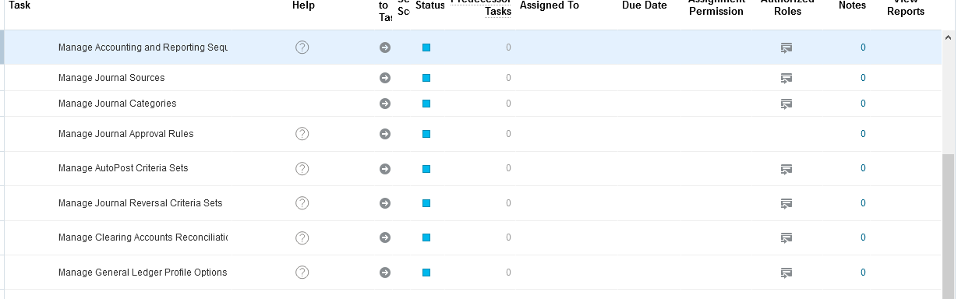

Enter the Details of the Sequence

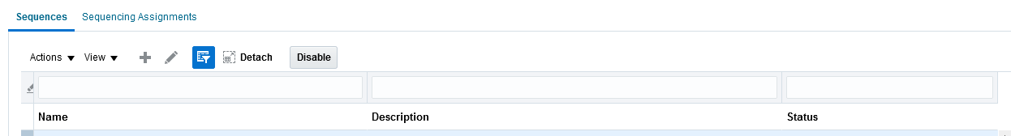

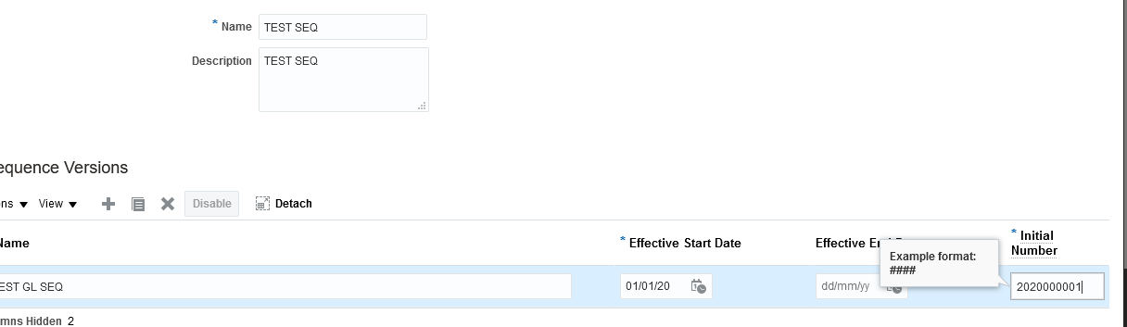

Save the Sequence

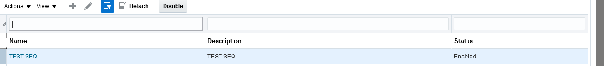

Navigate to Sequence Assignment

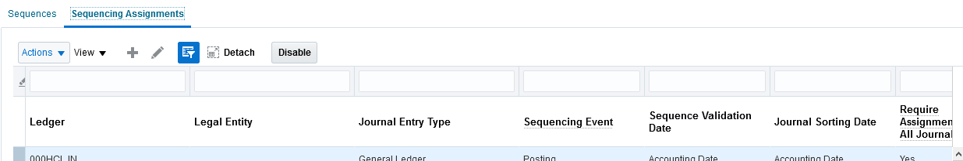

Enter the Ledger details

Journal Entry type you can choose as General ledger for Journals and Sub ledger for Sub ledger accounting Sequences

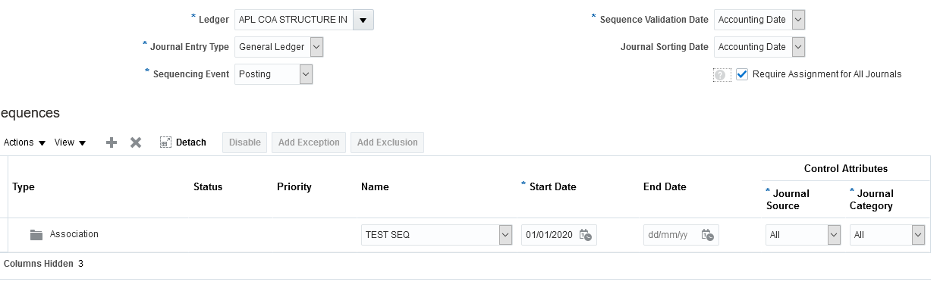

Save and close and enter the transaction to see the sequence generated

