AIM

MD.120 Create GST Location and Supplier site for Odisha

Author: **Saikumar Paturi**

Creation Date: 18-NOV-2020

Last Updated: 18-NOV-2020

Document Ref: <>

Target Instance FINP01

Associated Incident/Request: RITM0663409

Associated Change Request : **CHG0045558**

Version: 1.0

### Approvals:

<Approver 1>

<Approver 2>

Copy Number

**Date**

**Author**

**Version Change Reference**

# Document Control

### Change Record

|  |  |  |  |
| --- | --- | --- | --- |
| 18-NOV-2020 | **Saikumar Paturi** | 1.0 | No previous document |
|  |  |  |  |
|  |  |  |  |

### Reviewers

|  |  |
| --- | --- |
| **Name Position** | |
|  |  |

### Distribution

|  |  |  |
| --- | --- | --- |
| **Copy Name Location**  **No.** | | |
| 1 | Library Master | Project Library |
| 2 |  | Project Manager |
| 3 |  |  |
| 4 |  |  |

### Note To Holders:

If you receive an electronic copy of this document and print it out, please write your name on the equivalent of the cover page, for document control purposes.

If you receive a hard copy of this document, please write your name on the front cover, for document control purposes.

Contents

Document Control ii

Introduction 4

Purpose 4

Audience 4

Installation Pre-Requisites and Assumptions- 4

Back-out Plan- 4

Steps- 4

Open and Closed Issues for this Deliverable 7

Open Issues 7

Closed Issues 7

# Introduction

This document target is to Create new GST location and supplier Site for Odisha

## Purpose

User have transactions to be handled

## Audience

Oracle Account Payables

## Installation Pre-Requisites and Assumptions-

To be tested in FINS01and approved by business to move to FINP01

## Back-out Plan-

Based on business request the changes can be Made .

## 

## STEP 1 : TO be executed by AMS Team

## Responsibility – IM IN AP Super User

## Navigation – Suppliers-Entry

## >>Query the Supplier name as GST Tax Authority /supplier number - 346873

## >>Click on address book, click on create.

|  |  |
| --- | --- |
| Country | India |
| Address Line 1 | Plot no. 121/1277, Khata no. 253/100, Mouza Kantabada |
| Address Line 2 | S.R.O. Khandagiri , Thana-Chandaka , Thana no.26 |
| City | Bhubaneswar |
| Postal Code | 751030 |
| Address Name | Odisha |
| Address Purpose | Purchasing , Payment |
| Site Name | GST_OD |

## 

## >>Click on continue

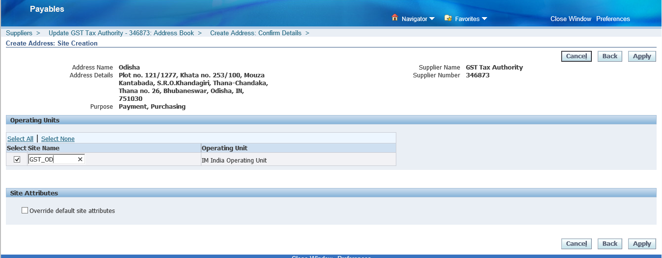

>> Click on apply

## 

2. To be Executed by AMS Team.

Please follow the excel document



# Open and Closed Issues for this Deliverable

## Open Issues

|  |  |  |  |  |  |
| --- | --- | --- | --- | --- | --- |
| **ID** | **Issue** | **Resolution** | **Responsibil ity** | **Target Date** | **Impact Date** |
|  |  |  |  |  |  |
|  |  |  |  |  |  |
|  |  |  |  |  |  |
|  |  |  |  |  |  |

## Closed Issues

|  |  |  |  |  |  |
| --- | --- | --- | --- | --- | --- |
| **ID** | **Issue** | **Resolution** | **Responsibil ity** | **Target Date** | **Impact Date** |
|  |  |  |  |  |  |
|  |  |  |  |  |  |
|  |  |  |  |  |  |
|  |  |  |  |  |  |