**Pay Alone Functionality in Oracle Fusion Application-**

By default multiple invoices are paid with 1 check, but if we have requirement to pay single invoice, controls are there in Oracle Fusion Application. We can use this concept to pay alone invoice instead of paying multiple invoices. A separate check will be generated by the system to pay single invoice. Below are main steps to enable this functionality-

1.Enable Pay Alone feature first at supplier level, site level.

2.Create 2 or more invoices and see which invoice gets selected while creating payments.

Go to Manage Supplier and search supplier and click edit- This option of Pay alone can be set up at various level (Supplier level, site level etc.)

**Supplier Profile level setup**?Search for supplier.

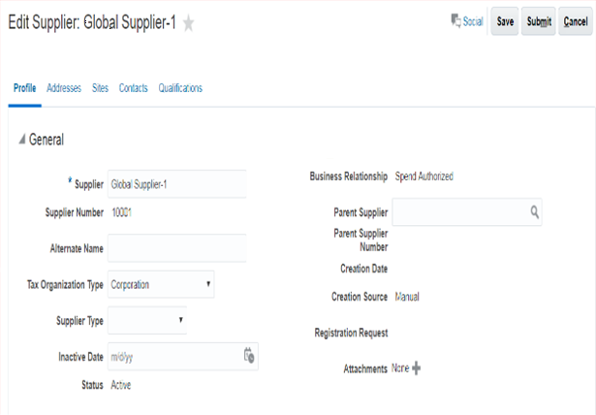

Go to Payment Tab and move to Payment Attributes

Go to Payment Specifications-enable check box for Pay Each Invoice Alone-

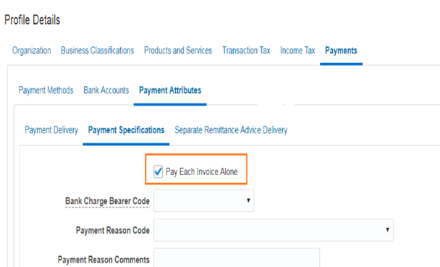

Save this.

Repeat same at Supplier Address Level- edit below information

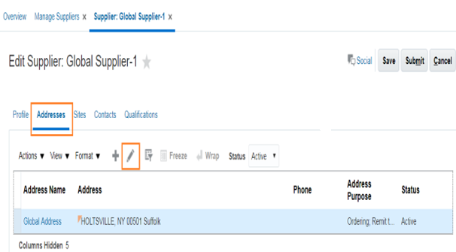

Enable Pay Each Invoice Alone at address level-

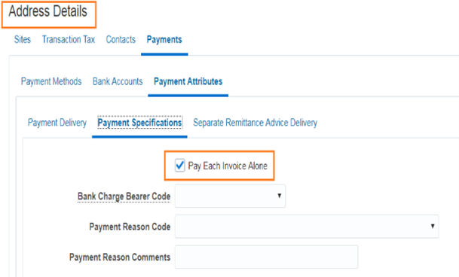

Now go to Site level- edit this information

Same will reflect in transaction

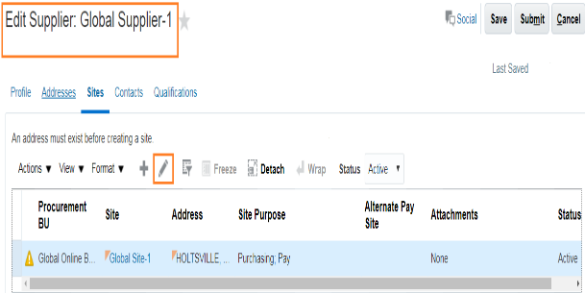

Edit this AND Enable Pay Each Invoice Alone at this level.

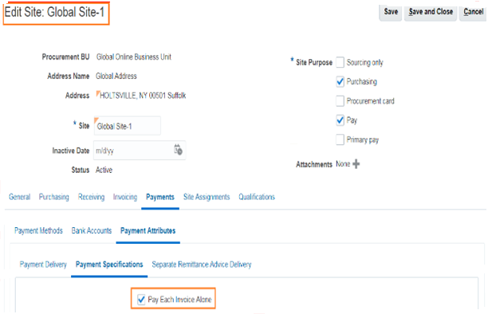

Save this.  Pay Each Invoice Alone feature is not applicable for previously created invoice before enabling this function.  For this supplier pay alone is activated now and all invoices created will be eligible for Pay Alone.

Create 2 or more invoices to see this feature working- While creating invoices, click on manage instalments under invoice action, verify that Pay alone option is defaulting as this was enabled-

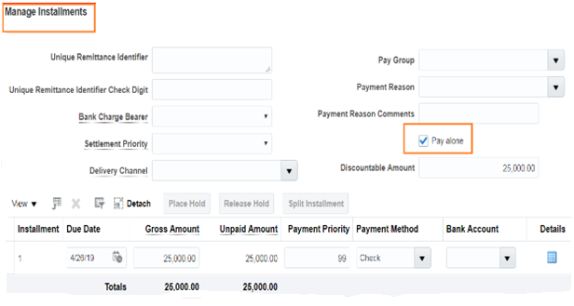

Create 1 more invoice. Now 2 invoices are there.

Go to payment work bench and create payments.

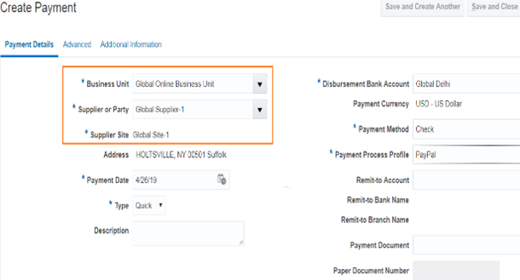

Go to Invoices to Pay and notice Pay alone invoices – Pay Alone feature is showing as Yes

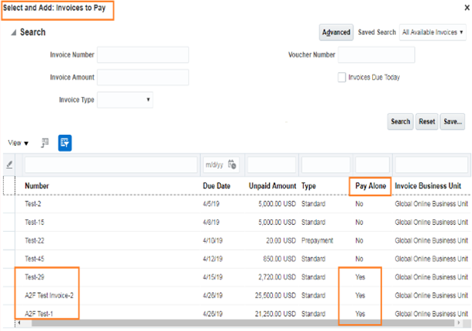

Select 1 of the invoice to Pay Alone and try selecting another invoice, and you will get below error message-

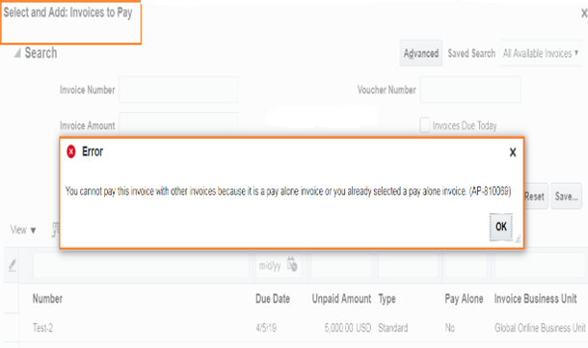

This means system will allow only 1 invoice to be paid under Pay Each Invoice Alone functionality.

Now process the payment for these 2 invoices separately.