Oracle Fusion has divided the Oracle Reporting system in 2 Parts.
BIP (Business intelligence publisher)
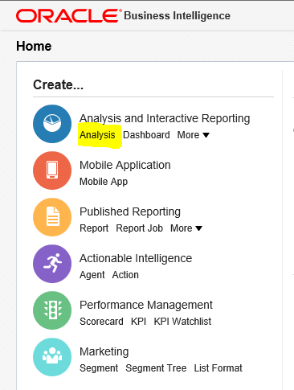
BIP :-
BIP is the customize reporting tool. Oracle Fusion has provided BIP to create custom reports or to meet the need of the business which is not achievable through OTBI reporting tool.
BIP is most similar like Oracle RDF report in which we creates Data Models , Different -2 groups then Link groups with Data Links. We can create Before and After Report triggers in form of event triggers. We can Create Parameters and List of Values also. We can also use custom Package also in the BIP.
But in Oracle R12 , we have very important useful tool set that Formula Columns , Placeholder and summary columns but these tool set is not available in BIP reports. We can do some calculation in BIP on columns but we cannot write separate code in BIP like Formula column in Oracle RDF. This is a Big limitation in BIP reports because Formula Columns and Placeholder and Summary Columns quite useful in designing Complex reports.
We can also create Lexical Parameters in Oracle Fusion BIP reports so that we can change the report query dynamically based on conditions. We can creates Lexical parameters with the help of Event trigger but this is also possible if you using Oracle Fusion PAAS service if you are using Oracle Fusion SAAS then you cannot use Event Triggers.

Step by Step to Create the Oracle Fusion BIP Reports

Step 1:- Login to Oracle Fusion and go to Menu Navigator as below and Click on Reports and Analysis option.
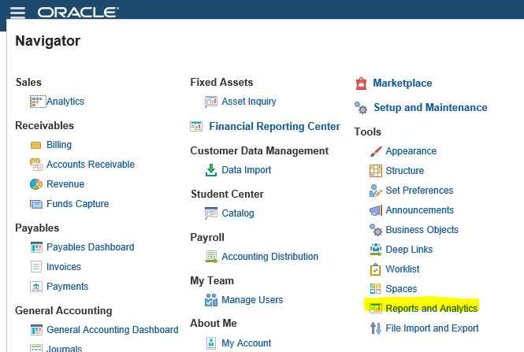
Step2:- go to report and analytic
Step3:- Click on + sign and Data set will be open as below
Give the name of Data Set:= XX_INVOICE_DETAILS
Data Source:= ApplicaionDB_FSCM
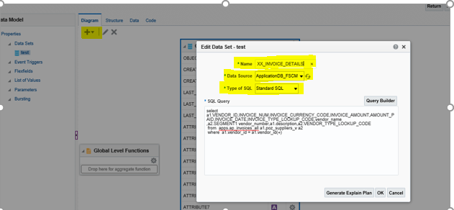

Step4:-
Again Click on + sign and Data set will be open as below
Give the name of Data Set:= XX_SUPPLIER_SITES
Data Source:= ApplicaionDB_FSCM

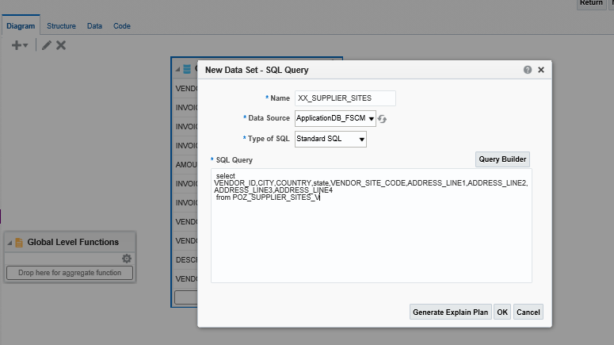
Step 5:-
Now these two data sets has been created and now we will join these two group by data link so Click on Vendor_id column and select Create Link
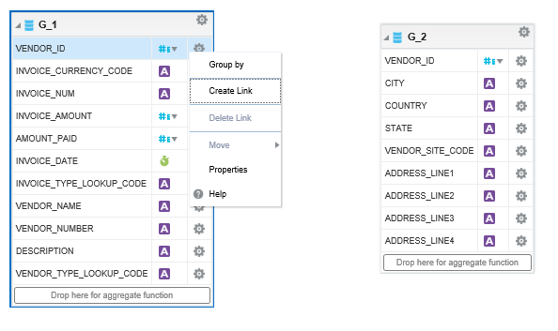
Step 6:- we will join these two group by data link so Click on Vendor_id column
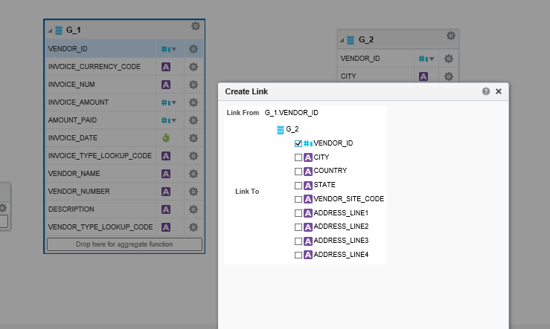

Step 7:- Now Save the Data model as below in right folder under Invoices Folder.

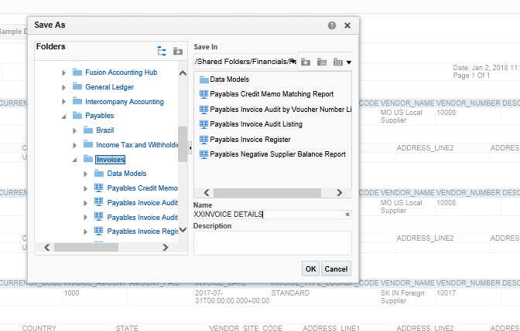

Step 8:- Now we will Create Parameters. I am going to create Vendor Name parameter for this as below.
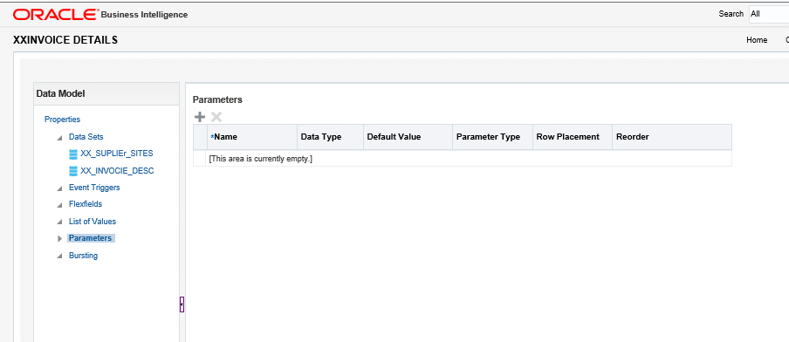

Step 9:-

