**Back to Back Sales Order Cycle Setups and Process Flow in R12.2**

**Back to Back Orders in Oracle**

**Setups Required:**

**Step1: Create Transaction type.**

Use Order Fulfillment flow as Order Flow – Generic.

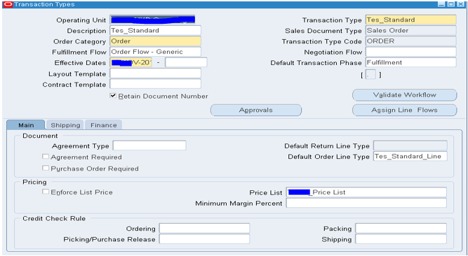

Use the Line flow and validate the workflow then create a document sequence and assign to the above transaction type.

**Step2: Create an Item with attributes.**

Go to Inventory and create an item (**B2B item1** here)

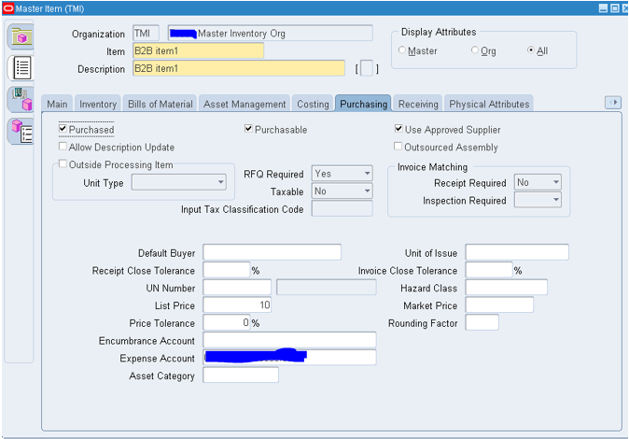

Enable "**Use Approved Supplier**" attribute and enter "**List Price**" in Purchasing TAB.

In General Planning tab enter "**Make or Buy Field to BUY**".

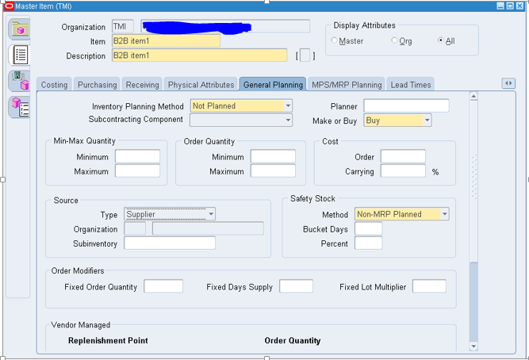

In Work in Process tab check the "**Build in WIP**" check Box as below.

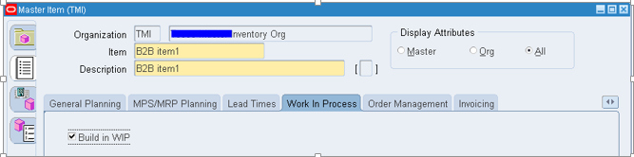

In order Management tab, make sure you check "**Assemble to Order**" check box.

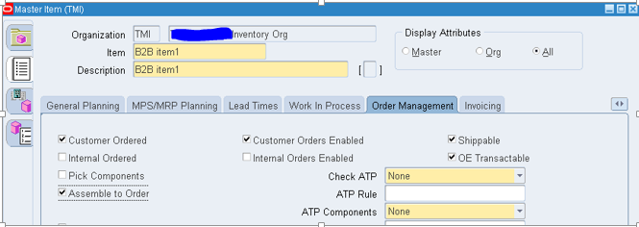

**Step3: Create approved supplier list.**

**Go to Purchasing Responsibility.**

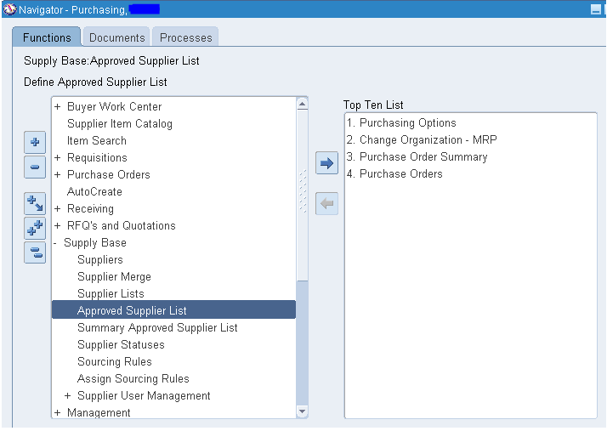

Select the Item and give the supplier and make the status to approve as below.

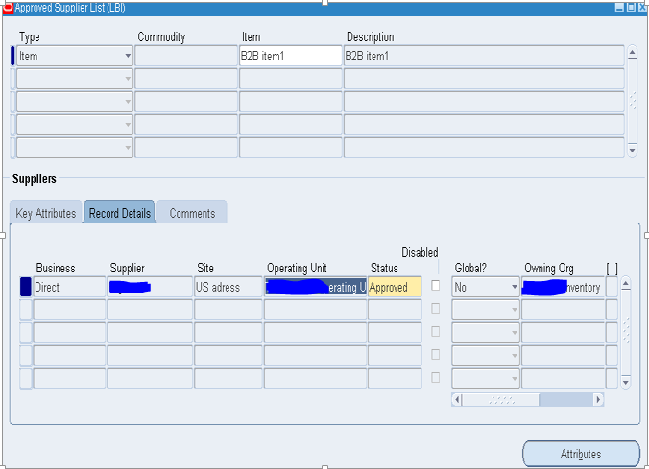

**Step4: Create Sourcing rules.**

**Navigation: Supply Base > Sourcing Rules.**

Create a sourcing rule with type as "**Buy From**" and the selected supplier and allocate the Rank as below and save.

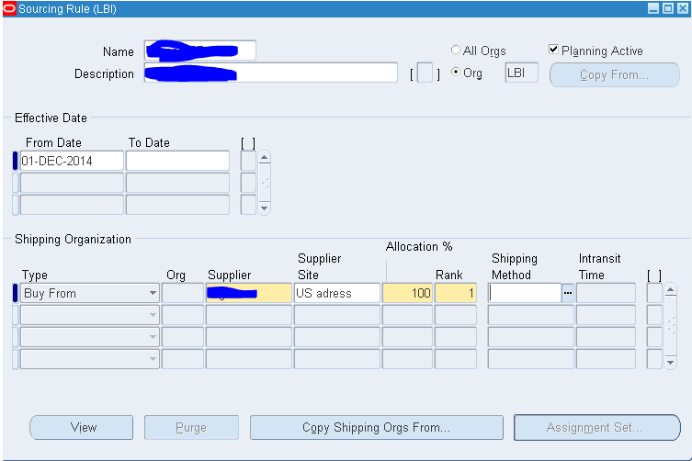

**Step5: Create Assignment set.**

**Navigation: Supply Base > Assign Sourcing Rule.**

Create an Assignment set as below and assign the item and organization.

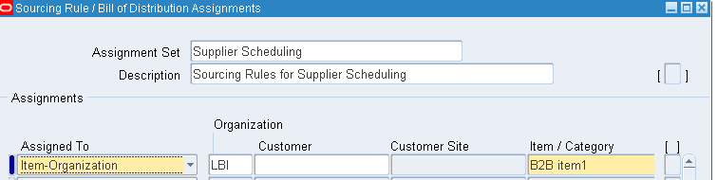

Go to Sourcing rule field and assign the sourcing rule created earlier.

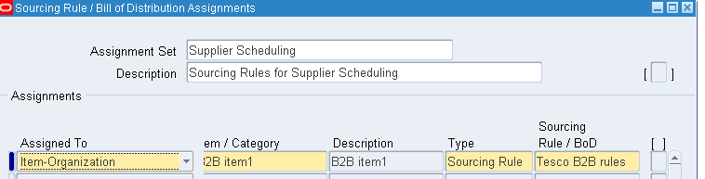

**Step6: Change MRP default assignment profile option**.

Make sure that the assignment set with sourcing rules should be entered in the below given profile option.

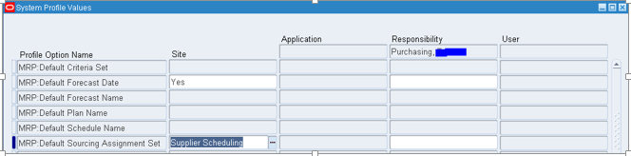

**Back To Back Order Process Flow:**

Create a Sales order and book the Order.

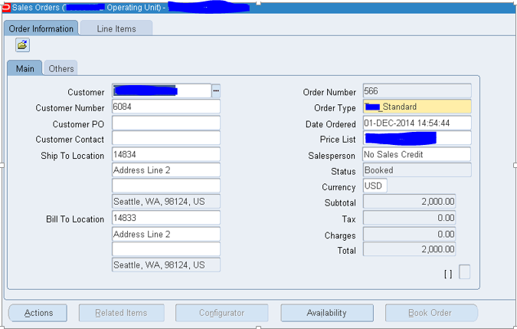

Note that the line status becomes "**Supply Eligible**".

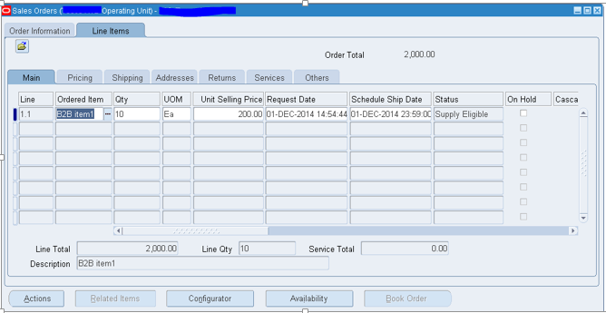

Click "Actions" or right click on the status and say “**Progress Order**” and say OK.

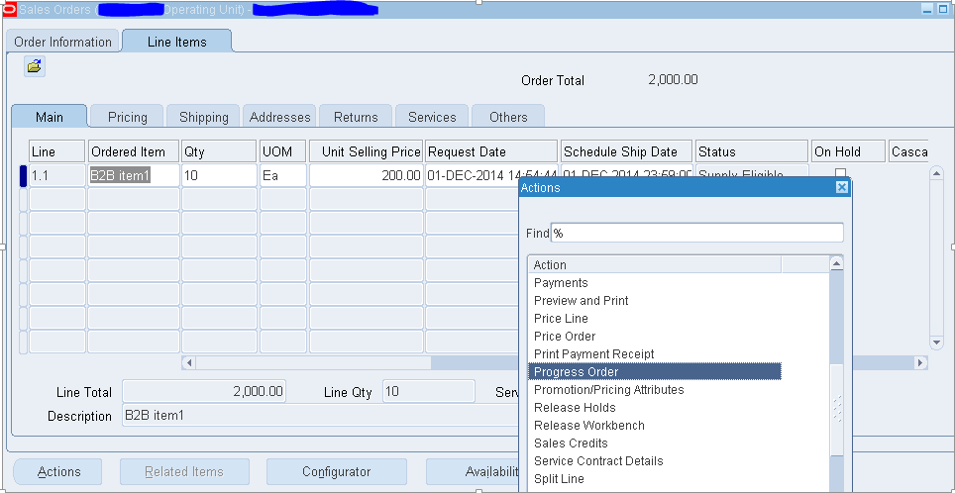

You will get a popup message as below saying “**Create Supply Order- Eligible**”

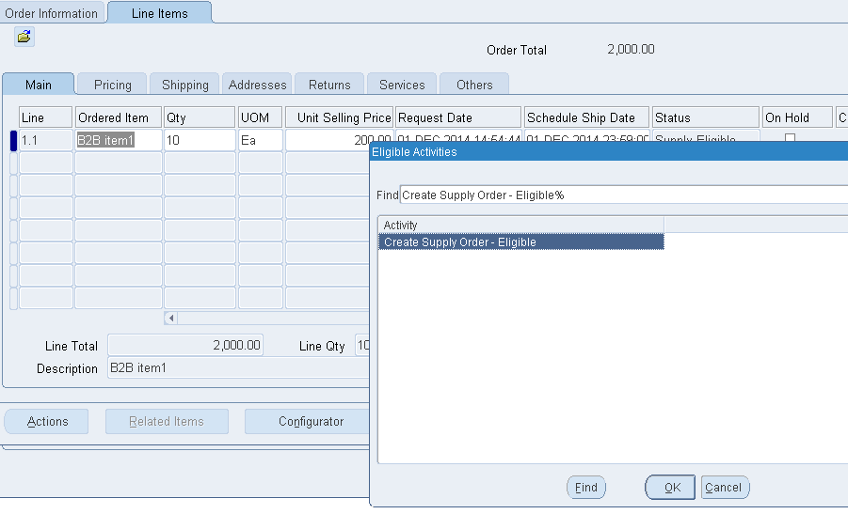

Now if you check the order status it says “**External Req Requested**”

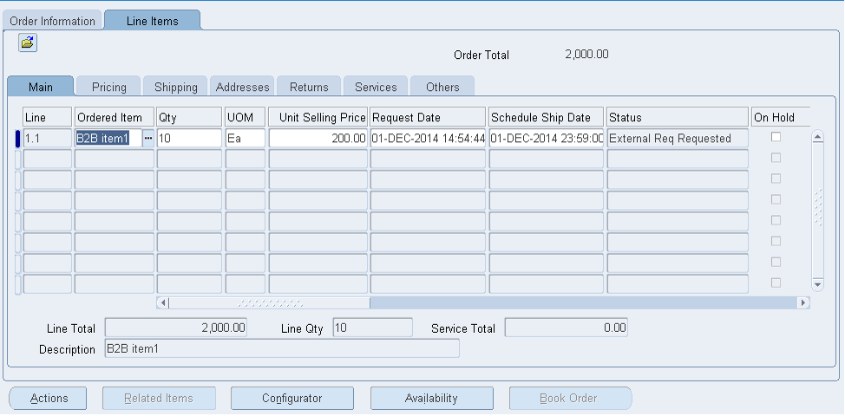

Then Go to Purchasing and run the "**Requisition Import**" report with **CTO** as Import Source.

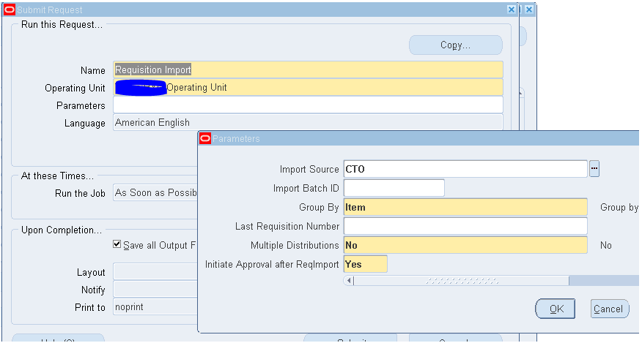

Check the output where you can notice one requisition got created.

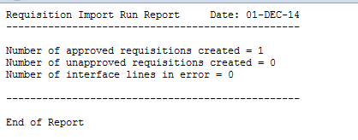

Go back to the Order and note the status now changed to “**External Req Open**”.

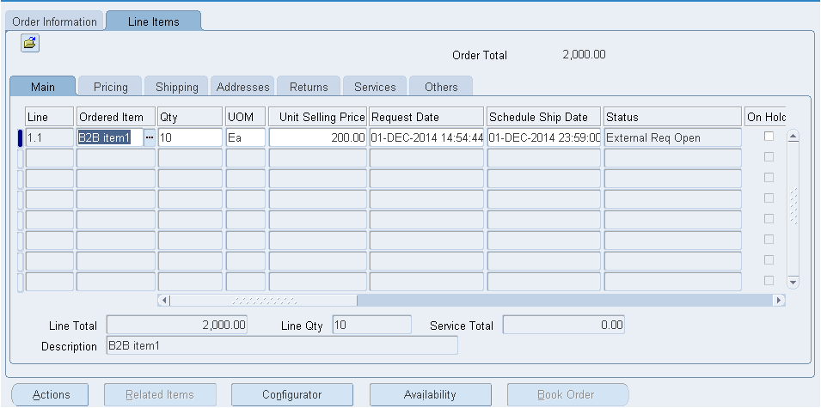

Go to Purchasing and check the Requisition created.

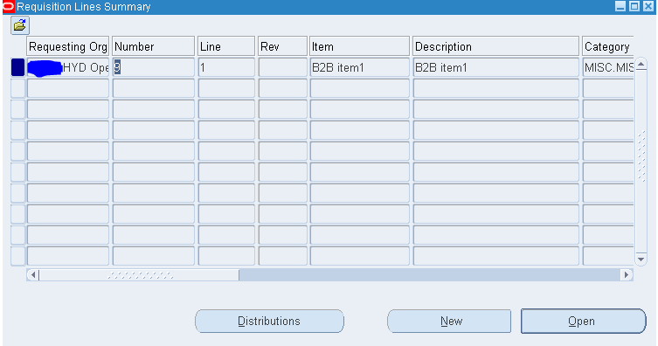

Auto create the requisition to purchase order.

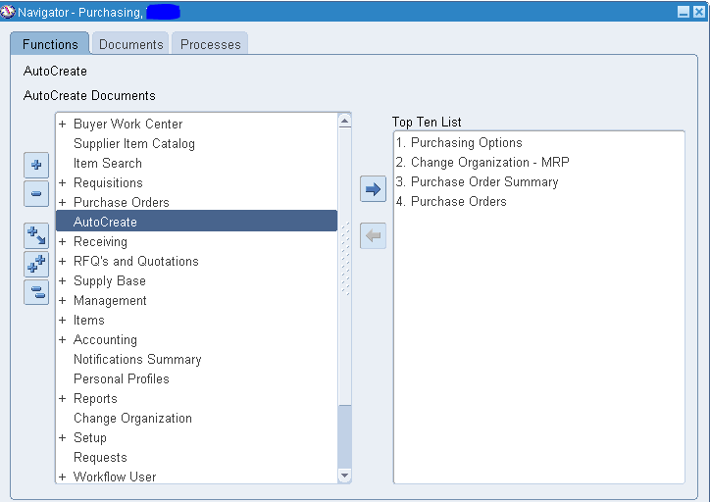

Select the requisition line and say Create.

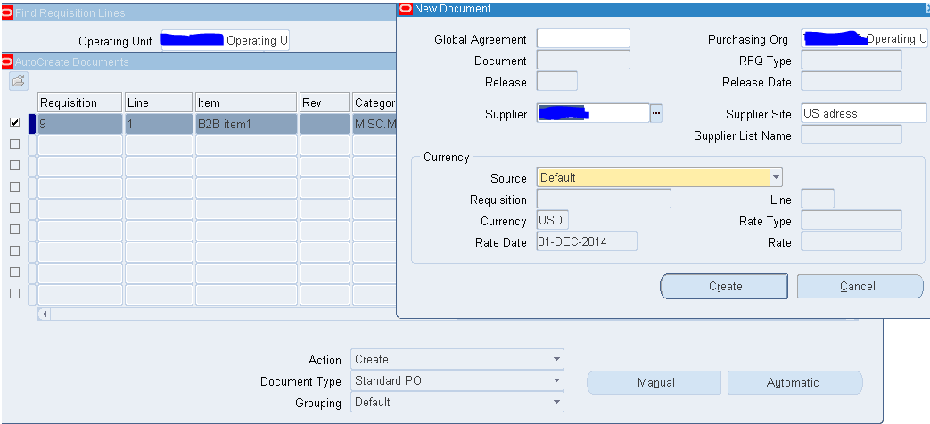

You will be directed to purchase order form.

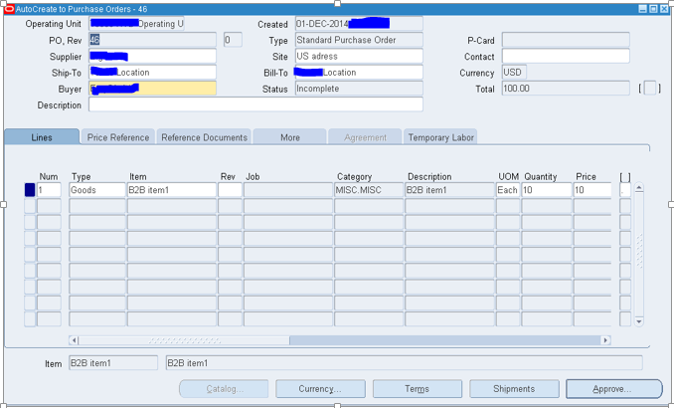

Make sure you get the purchase order approved as below.

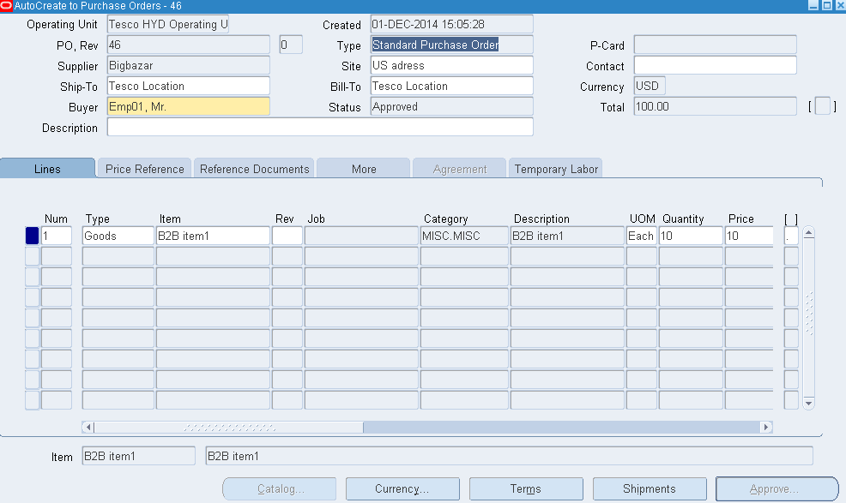

Go back to the Order and check the status changed to “**PO Open**”

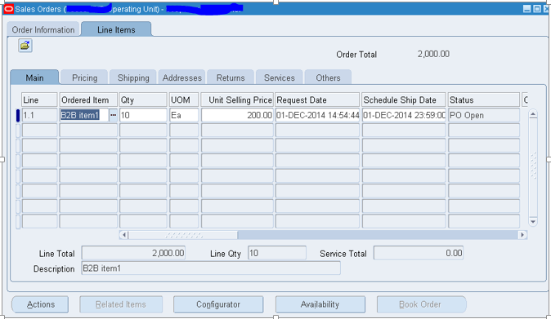

Complete the Receiving process as below.

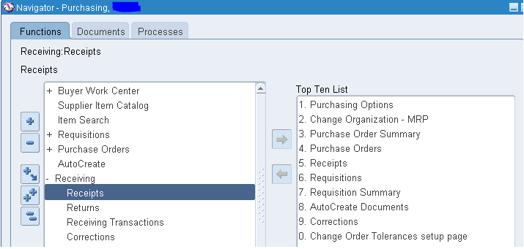

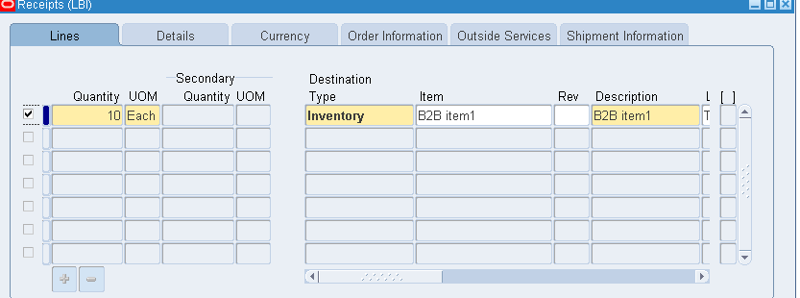

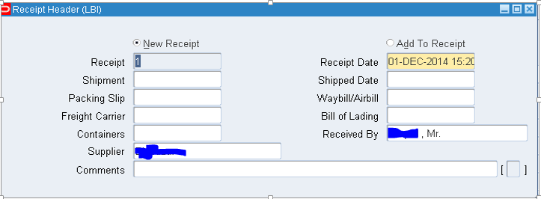

Now if you notice the sales order status is “**Awaiting Shipping**”, means now you can pick release and ship the order to customer.

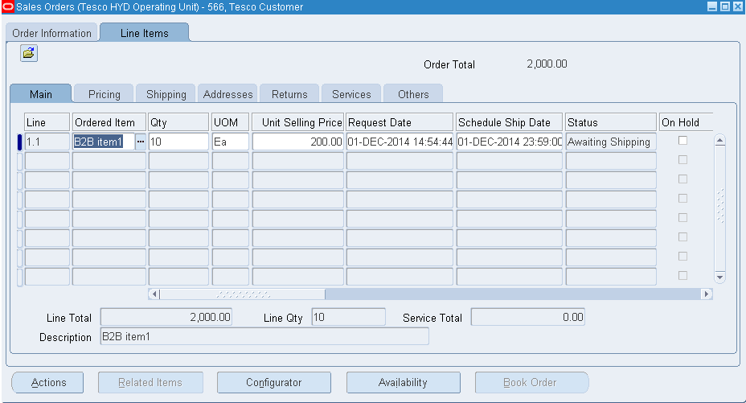

Pick Release the Order.

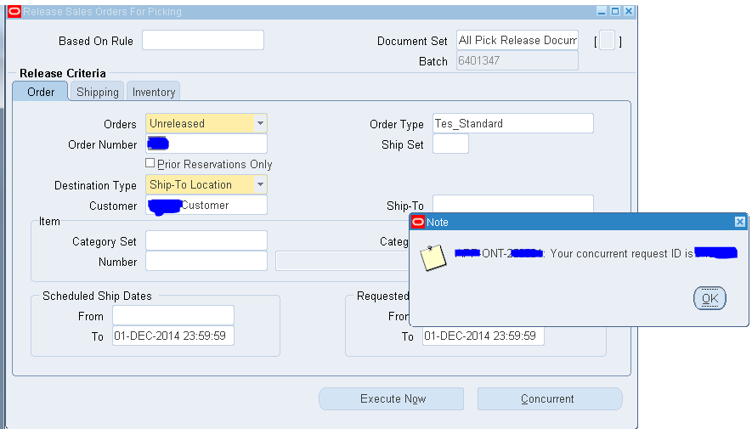

Pick Slip Report.

Ship the Order.

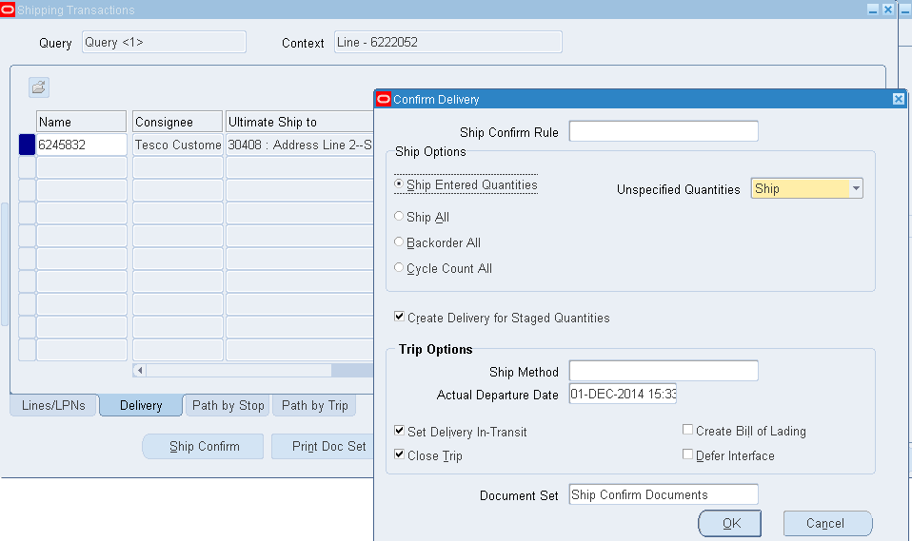

Sales Order got interfaced to Receivables as below.

