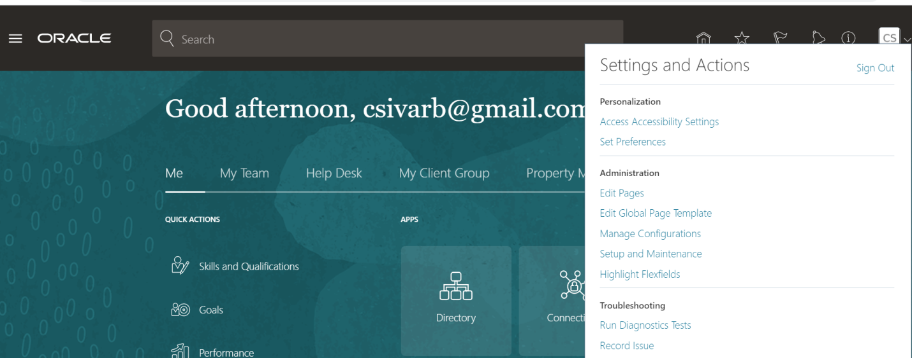

Click on Run Diagnostics Test

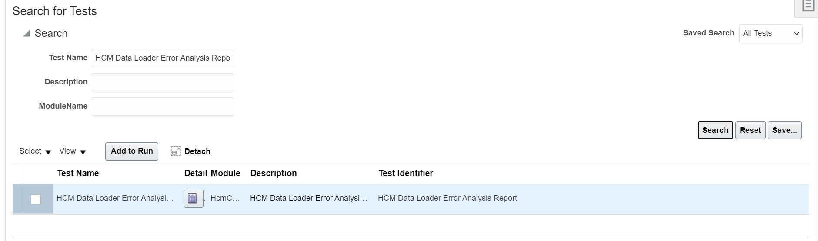Select the check box for Test name and Click on Run

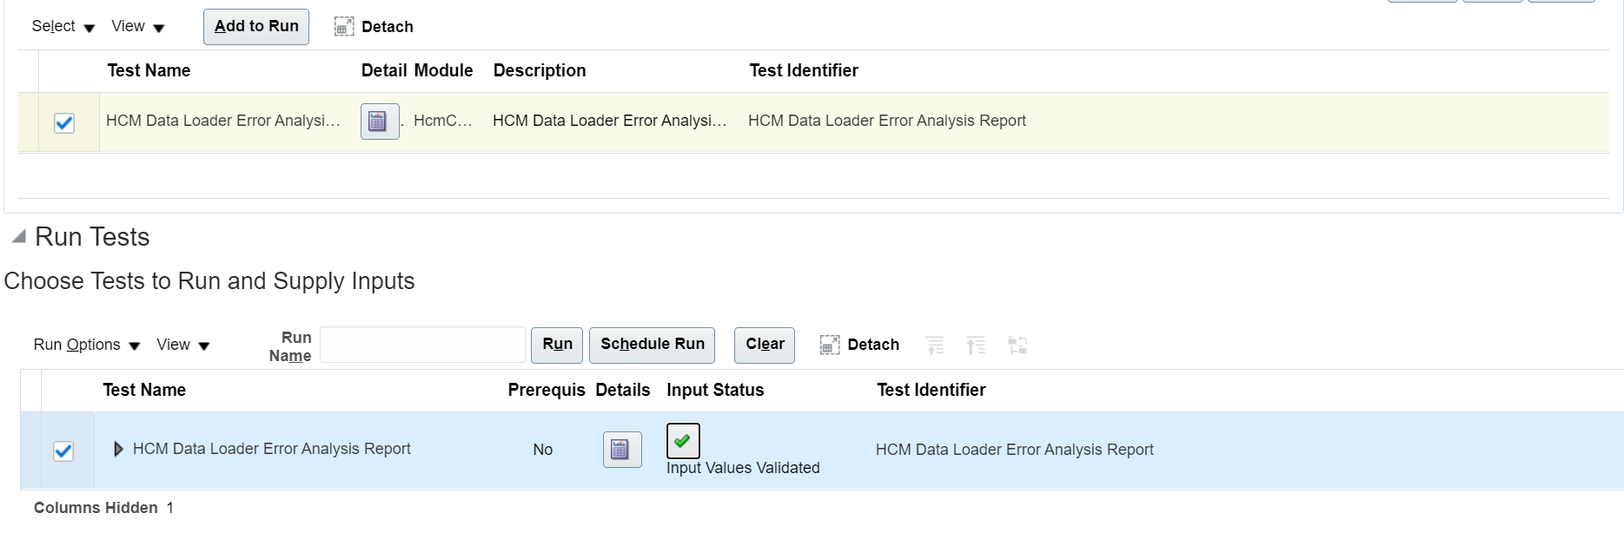

Click on the input Values Validated button to provide the input values for Content Id and Detailed Flag etc

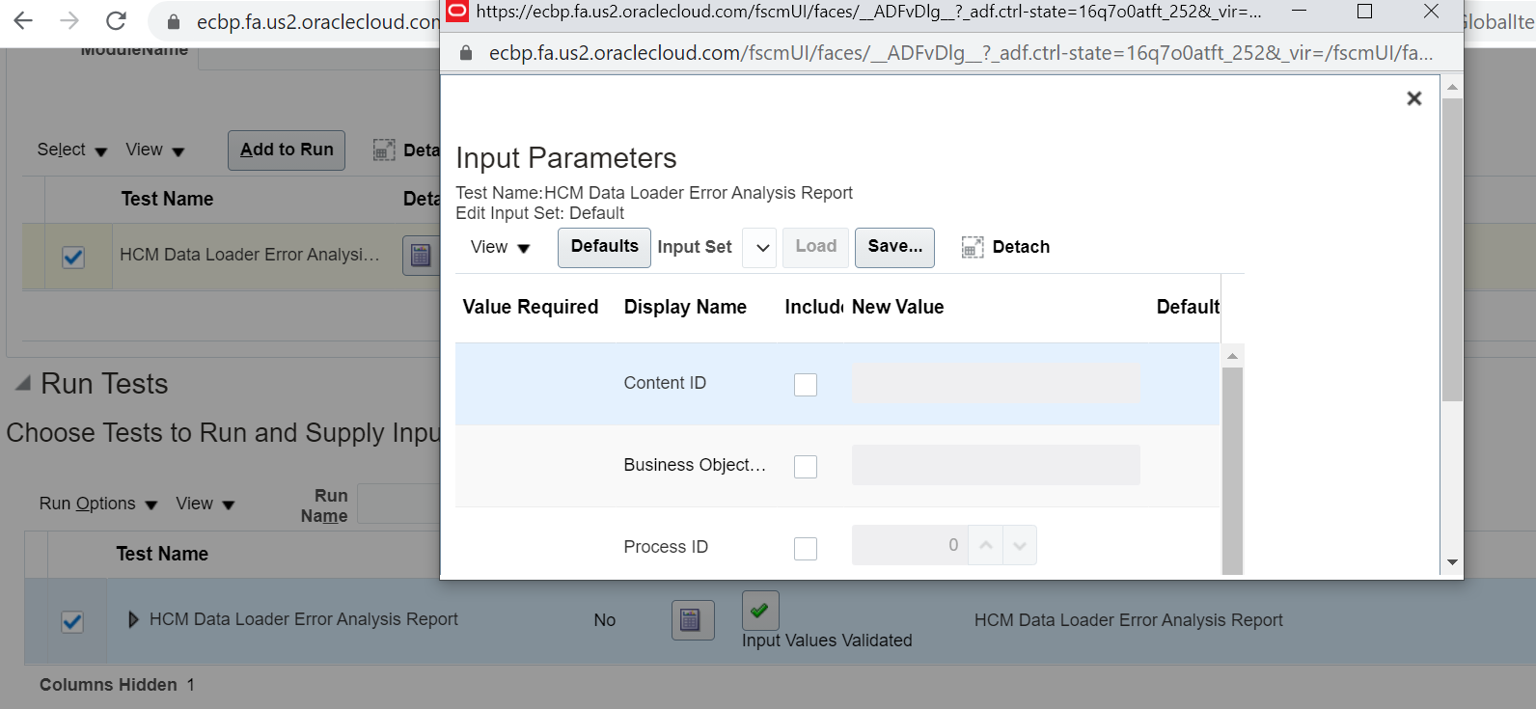

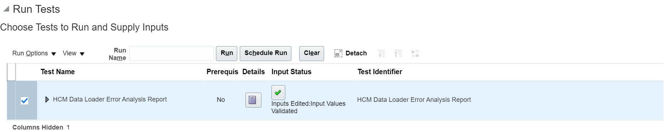

And Click on the Run Button

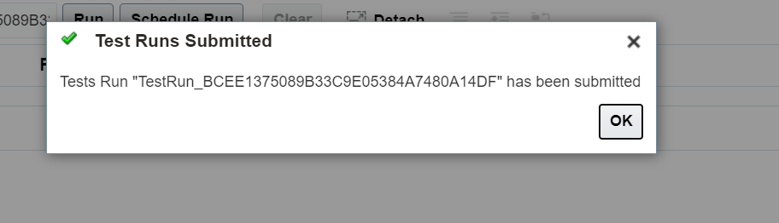

Copy the Test Run Name and search for the result.