Interactive Grids button’s customization

This document will help you to change the IG Buttons name and logo.

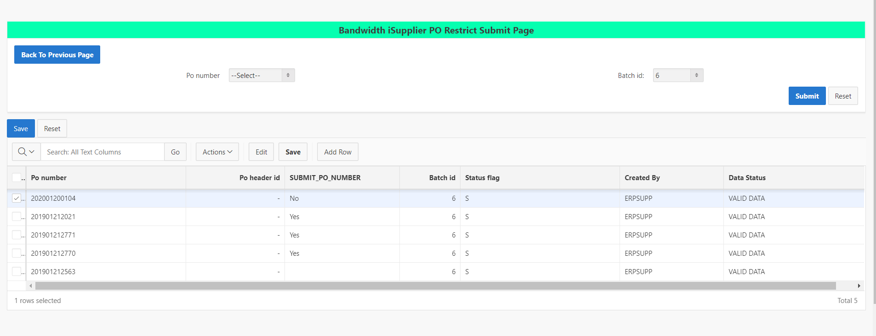Here You can check the design.

After adding the code You can see the difference. Here we added logo and level as per our requirement.

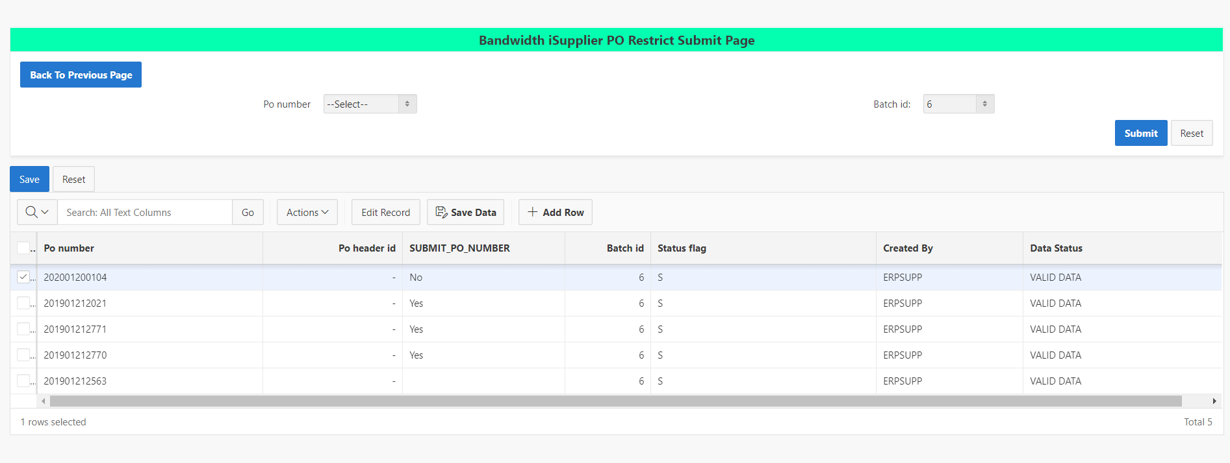

Using Java Script You can Achieve this.

Go to IG attribute ->In advance You can paste the code ,(Name You can modify as per your requirement)