Navigate to My Client Group🡪Data Exchange

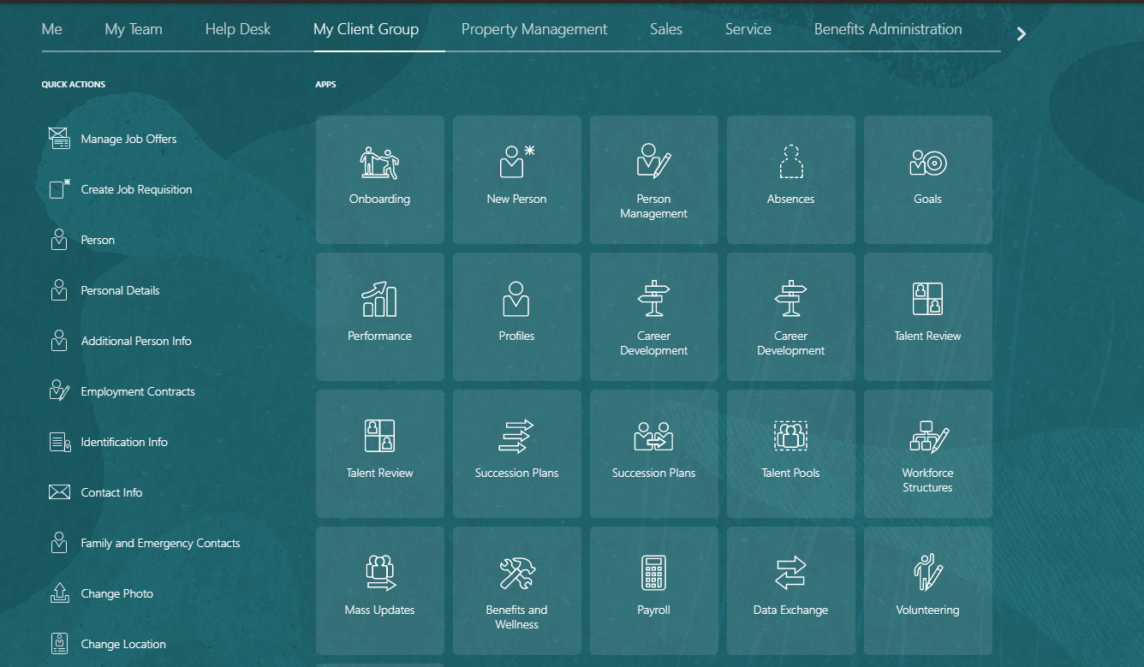

Under Data Exchange Click for View Business Objects.

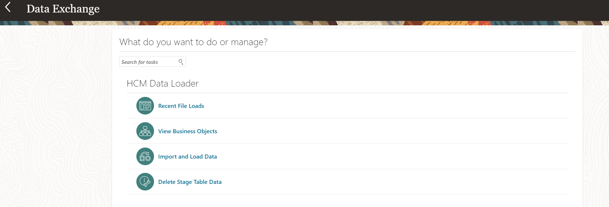

Search for the required Business object file

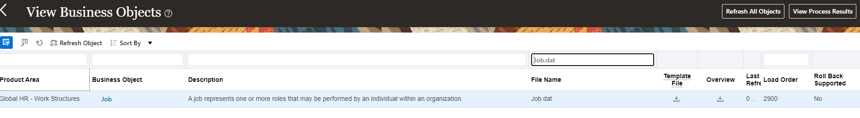

Click on download option under Template File.

