1. Create any asynchronous or synchronous integration.
2. From the Actions drag and drop Java script action to the integration.

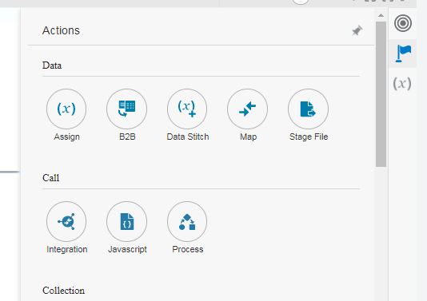

1. Provide the name for Java Script end point

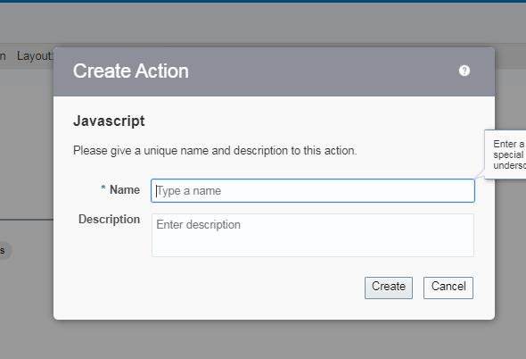

1. After clicking on create select the Java Script Function which you want to add.

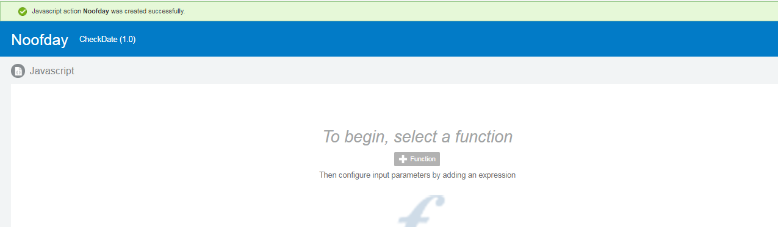

1. From the list select the required function

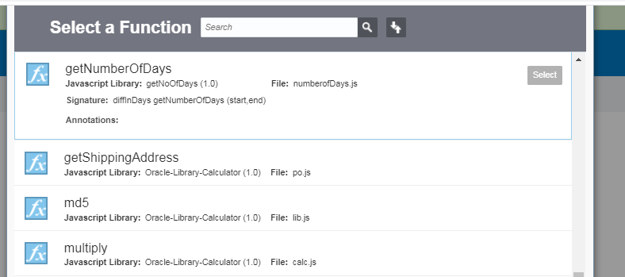

1. Provide values for input parameters if any and click on Validate and Close.

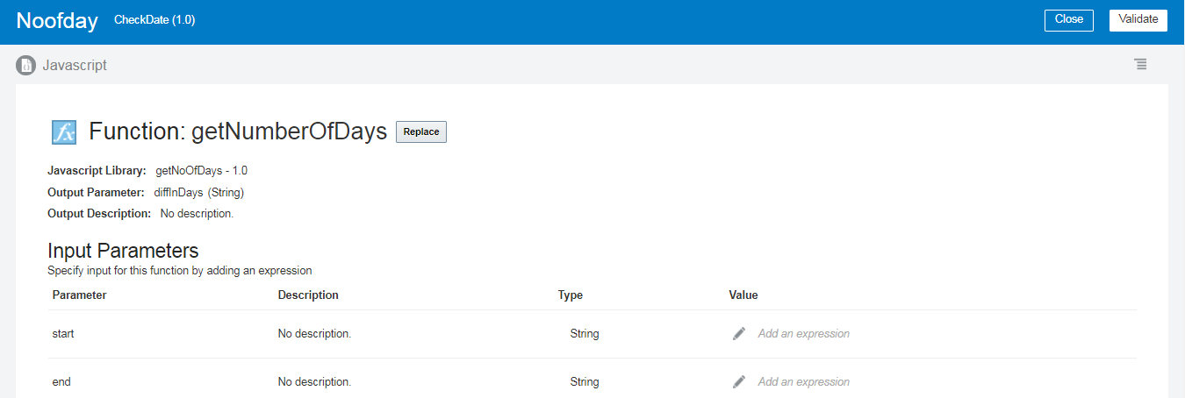

1. After that you can see Java Script node is added to Integration.

