**Optimizing MEMBER OF with APEX_STRING.SPLIT**

This is very helpful. Apex_string.split is a great utility that allows you to take a delimited list and make it queryable. By help of this you can split comma (,), underscore ( _ ) and mostly special Character You can Split**. You can use this while separate (csv) file while using this function/procedure.**

**For Example – any Column value having data like TESTING_DATA_CHENNAIYou can split value like** –

* SIFY
* TIDELPARK
* CHENNAI

**Syntax-** **apex_string.split(column name/string, Separator)**

**QUERY EXAMPLE -**

**select column_value from TABLE(apex_string.split('TESTING_DATA_CHENNAI', '_'));**OUT PUT-

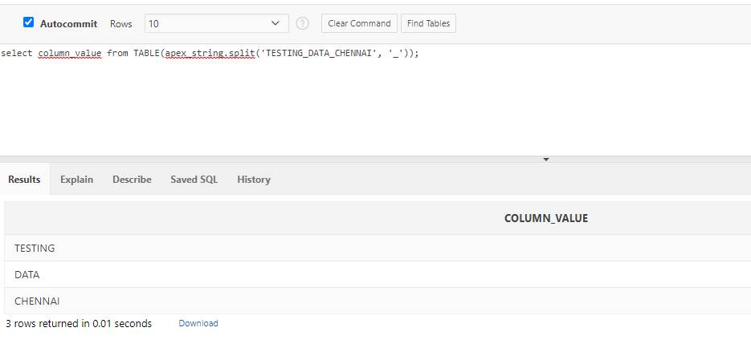

You can create your own procedure and use this. For example-

**create or replace function word_split(**

**p_str in varchar2,**

**p_sep in varchar2)**

**return wwv_flow_t_varchar2**

**as**

**begin**

**return apex_string.split(**

**p_str => p_str,**

**p_sep => p_sep**

**);**

**end word_split;**