1. Navigate to Data Exchange 🡪 Import and Load Data Task

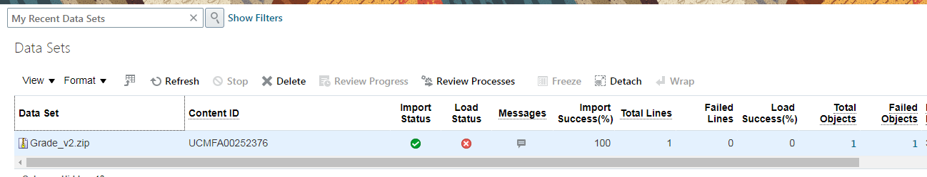

1. Now select on the total objects as shown screen below.

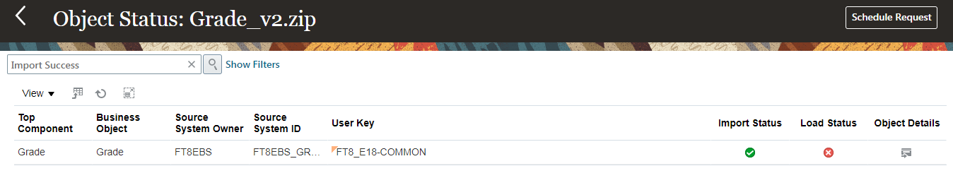

1. Click on Schedule Request

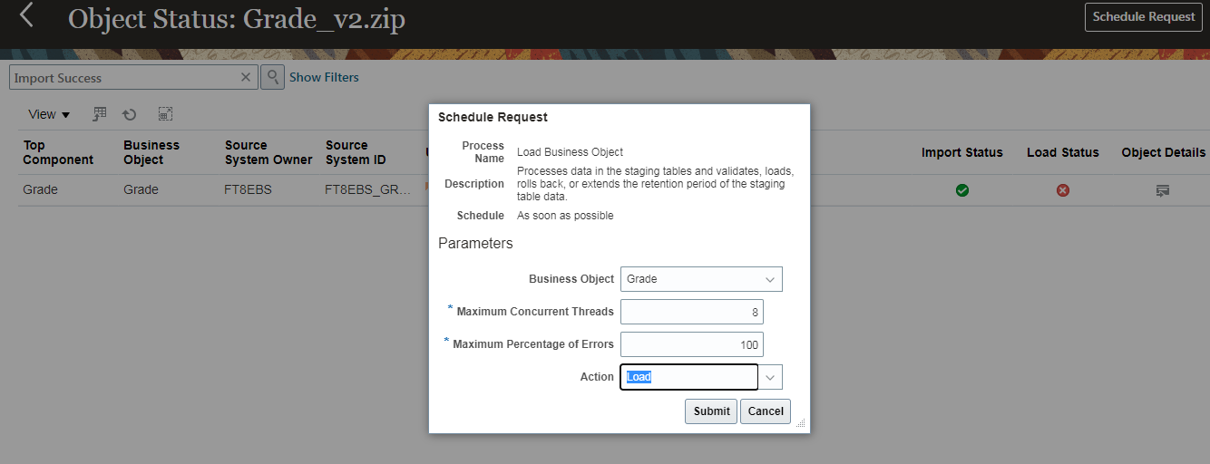

1. Select the Action as Rollback and click on Submit button.

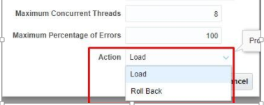

Once submitted, a process will be initiated to roll back the entries created by respective data set.