**Utilities-Recycle Bin In Apex,Restore dropping Objects**

As You know that The role of Recycle Bin ,In Apex Recycle bin Also work similar. As a developer prospective it is really helpful to get back to deleted object which are required. Suppose we delete some table, Procedure or package

But after that we realize, that is /are important. So without any worried we can revert back.

Path->SQl workshop->utilities->Recycle bin

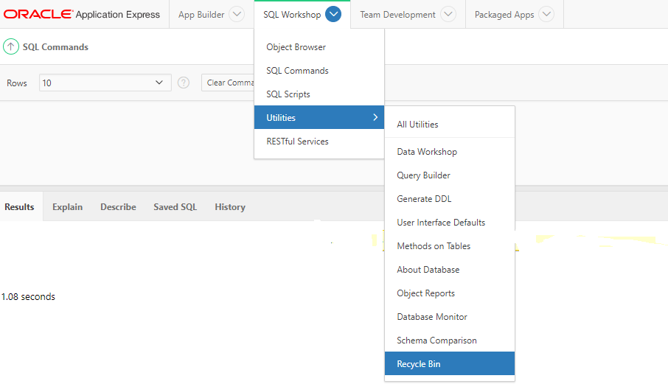

After click on Recycle Bin – Page will be open , Here You can see two option,

1. Dropped objects- Here You can see the details of Drop objects.
2. Purge Recycle Bin- if You will purge, all object will delete permanently.

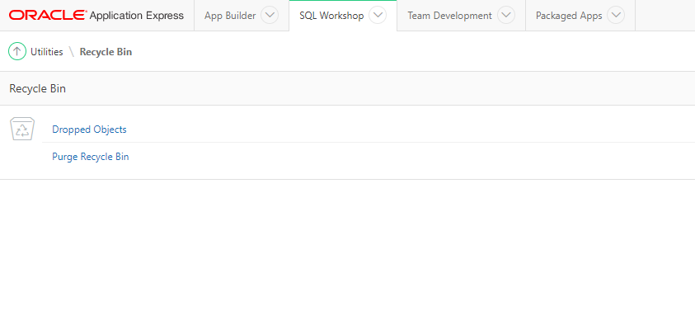

1.Dropped object- Once You Click on Dropped Objects, You can See the dropped Objects with time log.

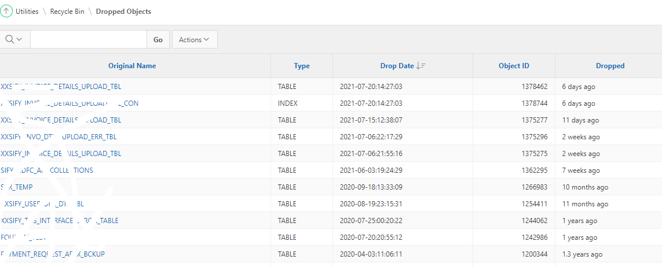

All Object Name is link, once You will click, it will show all details regarding that object structure .and also show three button cancel, Purge Object ,Restore object. You can see the below image for clarity.

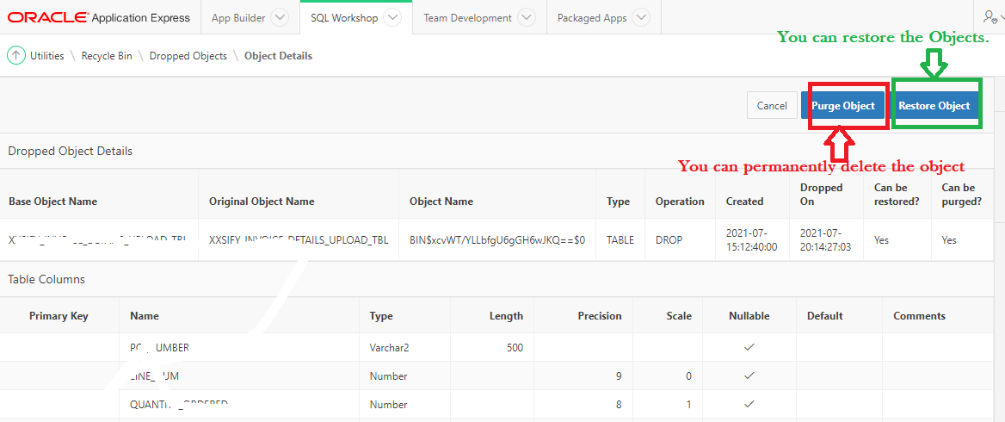

2.Purge Recycle bin-> it will clear all objects which are available in Recycle bin. Screen shot for Reference.

