**ORACLE UNPIVOT**

The Oracle UNPIVOT clause allows you to transpose columns to rows.

The UNPIVOT clause is opposite to the [PIVOT](https://www.oracletutorial.com/oracle-basics/oracle-pivot/) clause except that it does not de-aggregate data during the transposing process.

It’s Very helpful when you are using this under Sub Query .

For example – You can see the image for difference

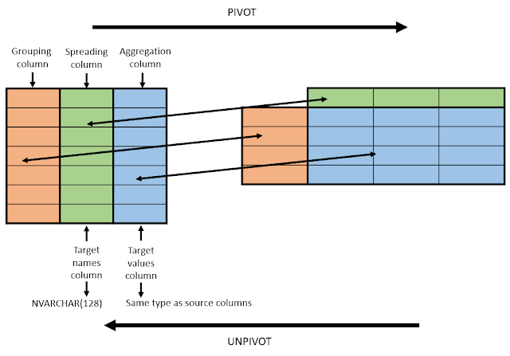

Syntax for UNPIVOT-

**SELECT select_list FROM table_name**

**UNPIVOT [INCLUDE | EXCLUDE NULLS](**

**unpivot_clause**

**unpivot_for_clause**

**unpivot_in_clause**

**);**

**Types of UNPIOVT**

* The **unpivot_clause** helps by allowing the user to specify a name for a column that will represents the unpivoted measure values.
* The unpivot_for_clause helps by allowing the user to specify the name for each column which will hold the measure’s values.
* The unpivot_in_clause will contain the pivoted columns that will be unpivoted.

**The INCLUDE | EXCLUDE NULLS clause allows user to include or exclude null-valued rows.**

* The INCLUDE NULLS clause will instruct Oracle to include the null-valued rows.
* The EXCLUDE NULLS clause, will eliminates the null-valued rows from the returned result set.

For Code example-

We create one table and make some entry.

**CREATE TABLE company_prouduct_test(id number PRIMARY KEY,**

**fiscal_year number,**

**test_product_a number,**

**test_product_b number,**

**test_product_c number);**

We done some entry-

### **INSERT INTO company_prouduct_test(id, fiscal_year, test_product_a, test_product_b, test_product_c)**

### **VALUES(4,2019, NULL, 5000, 750000);**

### **INSERT INTO company_prouduct_test(id, fiscal_year, test_product_a, test_product_b, test_product_c)**

### **VALUES(1,2020, NULL, 5000, 750000);**

### **INSERT INTO company_prouduct_test(id, fiscal_year, test_product_a, test_product_b, test_product_c)**

### **VALUES(2,2021, 7500, NULL, 20000);**

### **INSERT INTO company_prouduct_test(id, fiscal_year, test_product_a, test_product_b, test_product_c)**

### **VALUES(3,2022, 7500, 22000, NULL);**

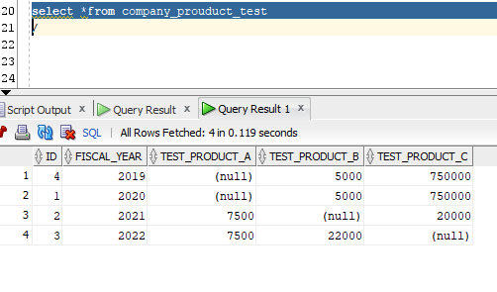

And now I can show you by using unpivot how we can represent the data.

## **SELECT * FROM company_prouduct_test**

## **UNPIVOT INCLUDE NULLS ( quantity**

## **FOR product_code**

## **IN (test_product_a AS 'A',**

## **test_product_b AS 'B',**

## **test_product_c AS 'C' ));**

Note:- You can exclude the null also

