**ISSUE:**

Automatic Modifier with a Qualifier of 'Customer Name', the Modifier is not getting applied on Service Contract.

**Navigation:** Service Contract Manager 🡪 Tools 🡪 Pricing Adjustment

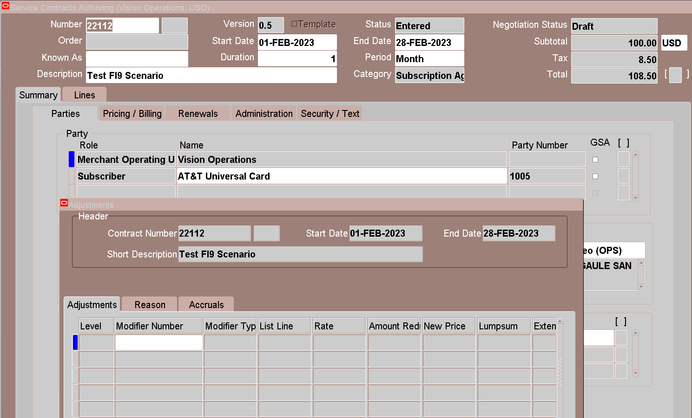

**CAUSE OF THE ISSUE:**

The issue occurs because the Attribute Mapping setup is missing for the attribute 'Customer'.

**SOLUTION:**

**Navigation:** Oracle Advance Pricing 🡪 Setup 🡪 Attribute Management 🡪 Attribute Linking and Mapping

Pricing Transaction Entity = Order Fulfillment  
Context Type = Qualifier Context

Select (Highlight) Context as Customer

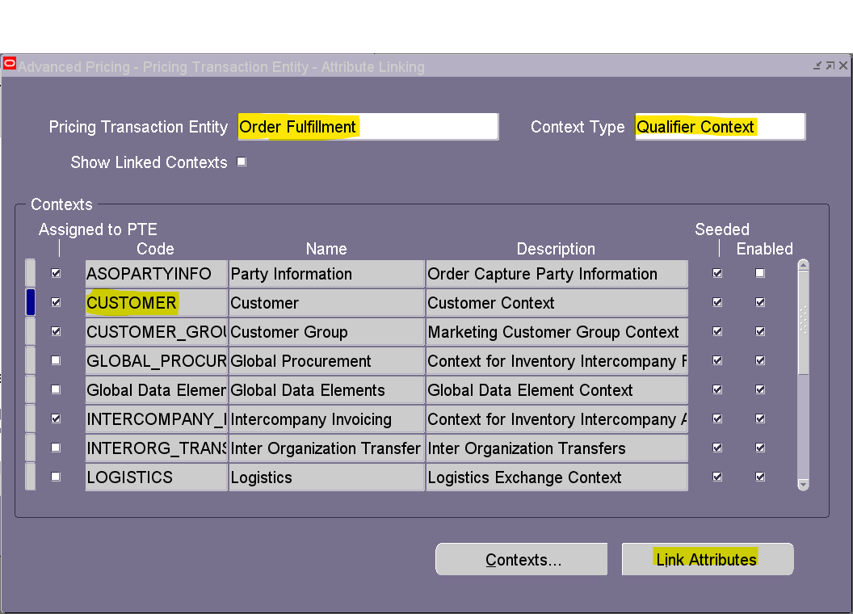

Click on Link Attributes Button

Select Code as SOLD_TO_ORG_ID and Name as Customer Name

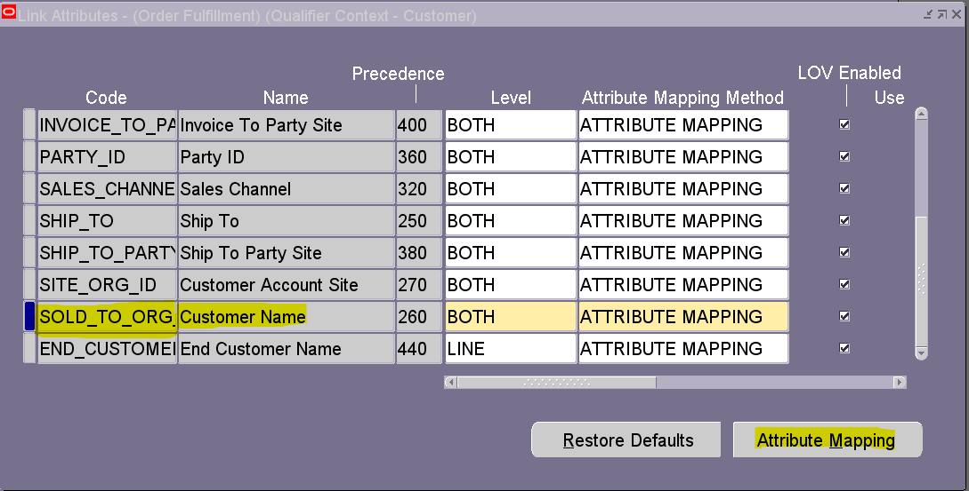

Click on Attribute Mapping

Under Request Type find  
Application as Service Contracts and Request type as OKS

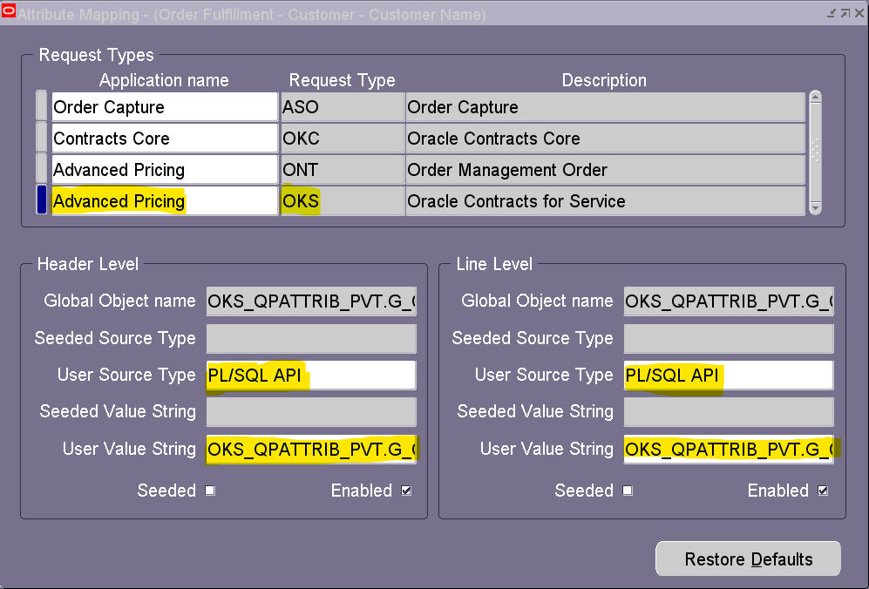

**Header level:**

Global Object name: OKS_QPATTRIB_PVT.G_CONTRACT_HDRREC

User Source Type: PL/SQL API  
User Value String: OKS_QPATTRIB_PVT.G_CONTRACT_HDRREC.CUSTOMER_ID

**Line level:**

Global Object Name: OKS_QPATTRIB_PVT.G_CONTRACT_LINREC  
User Source Type: PL/SQL API  
User Value String: OKS_QPATTRIB_PVT.G_CONTRACT_LINREC.CUSTOMER_ID