Carrier Lookups used for Goods Delivery in Oracle Fusion Procurement SCM

Table of Contents
Contents
1. Overview 3
2. Technologies and Tools Used 3
3. Use Case 3
4. Architecture 4

Overview

Carrier Lookups - Used to optimize the delivery of goods that are scheduled in varied time zones

Carrier Lookups provide the best possible ways to handle the delivery of goods which can be optimized

The shipments need to pass through multiple routes and gateways, so keeping track of their quality and scheduled timing becomes difficult.

Delivery of Goods through Carriers provides complete real-time visibility of the goods throughout the supply chain until it reaches the customers. So accordingly, management can plan and optimize the routes and provide better on-time delivery. It also accelerates secure multi-carrier shipping.

Further, it boosts collaboration between suppliers, freight forwarders, and clients.

Technologies and Tools Used
The following technology has been used to achieve the same.
- Oracle Application Development Framework - JDEVADF_12.2.1.6.0ADF-REL132304-PROD-BP_GENERIC_230524.1521.S
- Oracle Middleware Extensions for Applications -ATGPF_PT.12C.2304_GENERIC_230525.1402.REL13BP68.6

Use Case
NA

Architecture
Steps:
- Navigation → Setup and Maintenance → Procurement Foundation → Task → Manage Carriers Lookups
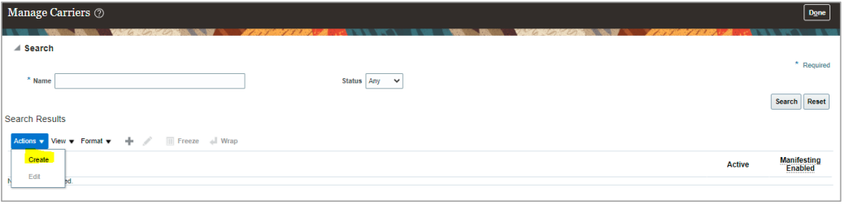
Provide the Carrier Name: DHL
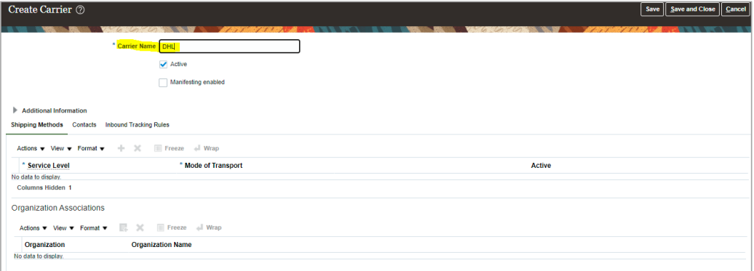
Now Click Add Row and provide the value as highlighted below
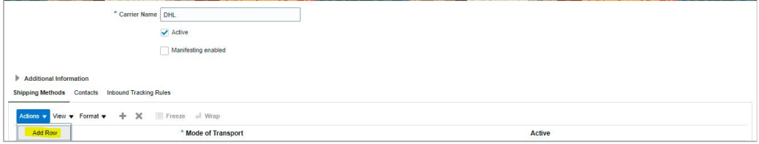
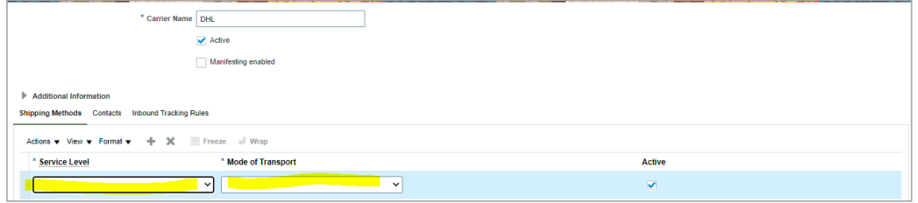
For example, the Setup will display carrier details as per below screen
