**Introduction/ Issue:** In this Blog we will be discuss about Oracle general ledger setup steps r12 to create the Organization Accounting structure. We do implement the Organizational structure using Oracle general ledger setup steps r12. These are all the mandatory Oracle general ledger setup steps r12 with detail explanation.

**Concept of Oracle general ledger setup steps r12**

**Organization Structure in Oracle apps**

 As below, this is the Organization structure in oracle apps so to implement any Organization in oracle apps, we need to divide the organization structure as per that.

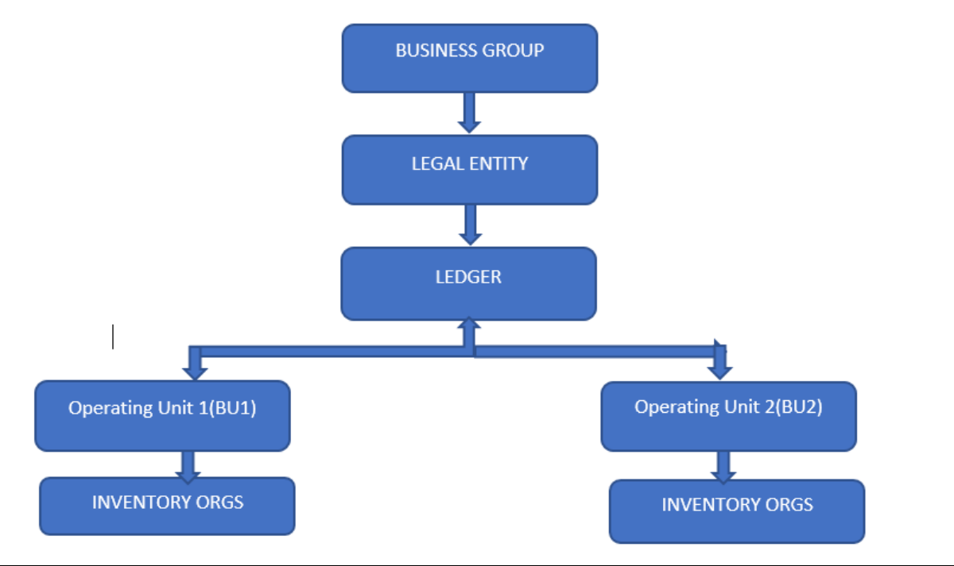

1. Create Legal Entity for the Organization Structure. Legal Entity is something comes under the Legal Registration of the company. In Legal Entity, We do mentioned the Registration information information’s of the Organization as per the Government documents for the Company.

2. Once the Legal Entity Created, We need to create the Ledger under that Legal Entity.

To Create Any Ledger, we need 3 C’s.

3. 3 C’s means Chart Of accounts, Currency & Calendar.

4. To create any Ledger, we must need to create the Chart Of accounts, Currency & Calendar first.

**Step by Step to Implement General ledger in oracle apps r12**

1.       First thing, we need for the GL setup is ‘Chart of Account’.

Chart of Account helps to define Organization Accounting structure. Chart of Account is one of the most important Part to decide and configure for any organization accounting structure.

2.       To Create Chart of Account, We need to go.

Setup ➔ Financials ➔ Flex fields ➔ Key ➔ Segments

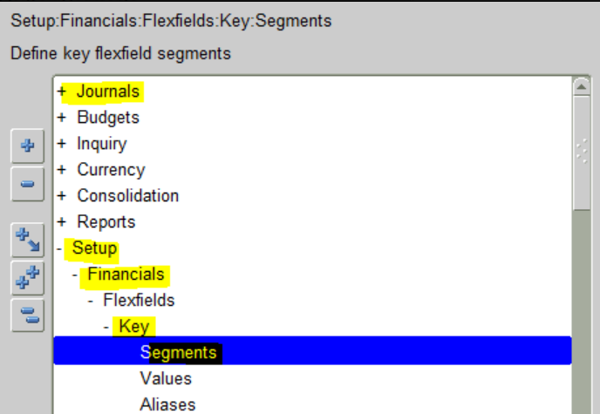

**Why we need to do Oracle general ledger:**

### 

The below are the mandatory setups we need to perform to transact

1.       Chart of Account Creation

2.       GL Calendar Creation

3.       Currency Creation

4.       Legal Entity Creation

5.       Ledger Creation

6.       Accounting setups Creations