**Restricting Self-Approval in Oracle Fusion**

**Introduction/ Issue:**

Addressing the self-approval concern for expenses and other documents after setting up a vacation rule in Oracle Fusion. You can prevent self-approval of expenses by selecting the "Prohibit Self-Approval by Users" checkbox in BPM under task configuration.

**Why we need to do / Cause of the issue:**

In Oracle Fusion, granting a manager’s approval access to a subordinate during the vacation rule setup can raise self-approval concerns for auditing purposes.

This issue can be better understood with the following Scenario

**Scenario**: Employee Sam reports to Manager Anand. As a result, all of Sam's expense reports and other purchase documents are routed to Anand for approval.

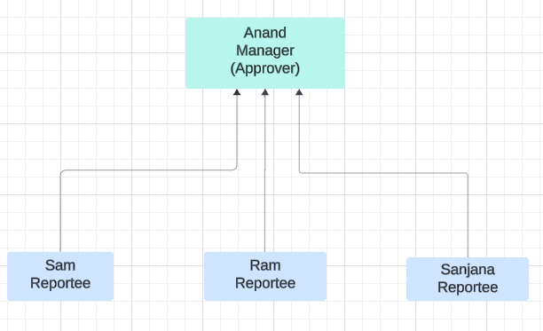

Anand has set up a vacation rule that delegates all workflow notifications to Sam during his vacation. As a result, Sam is now approving all claims and orders that were initially routed to Anand for approval.

Issue:

When Sam claims expense or creates requisitions, the approval is sent to Anand. However, based due to the vacation rule, it returns to Sam for approval, resulting in self-approval, which poses an audit concern.

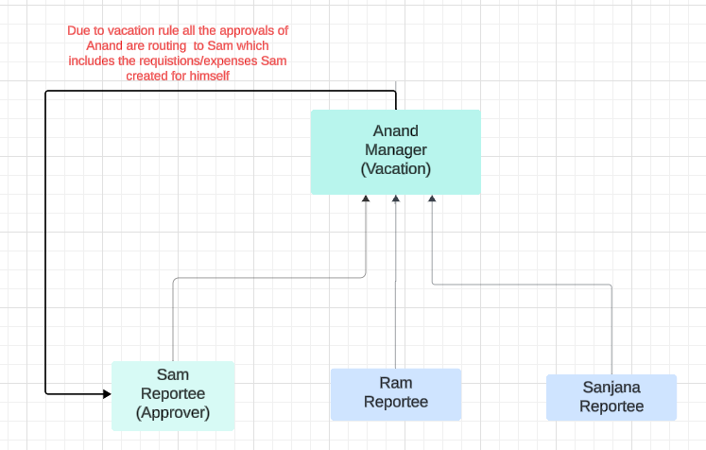

**How do we solve:**

In Oracle Fusion, the Business Process Management (BPM) setup allows administrators to implement specific controls that can restrict self-approval of documents, such as expense reports and purchase orders. This is particularly useful when setting up vacation rules or delegation of authority, where there is a risk that a subordinate, who has been temporarily granted approval authority, might approve their own documents or those where there could be a conflict of interest.

**Step 1**: Navigate to instance and click on notifications icon > More details. It opens BPM worklist

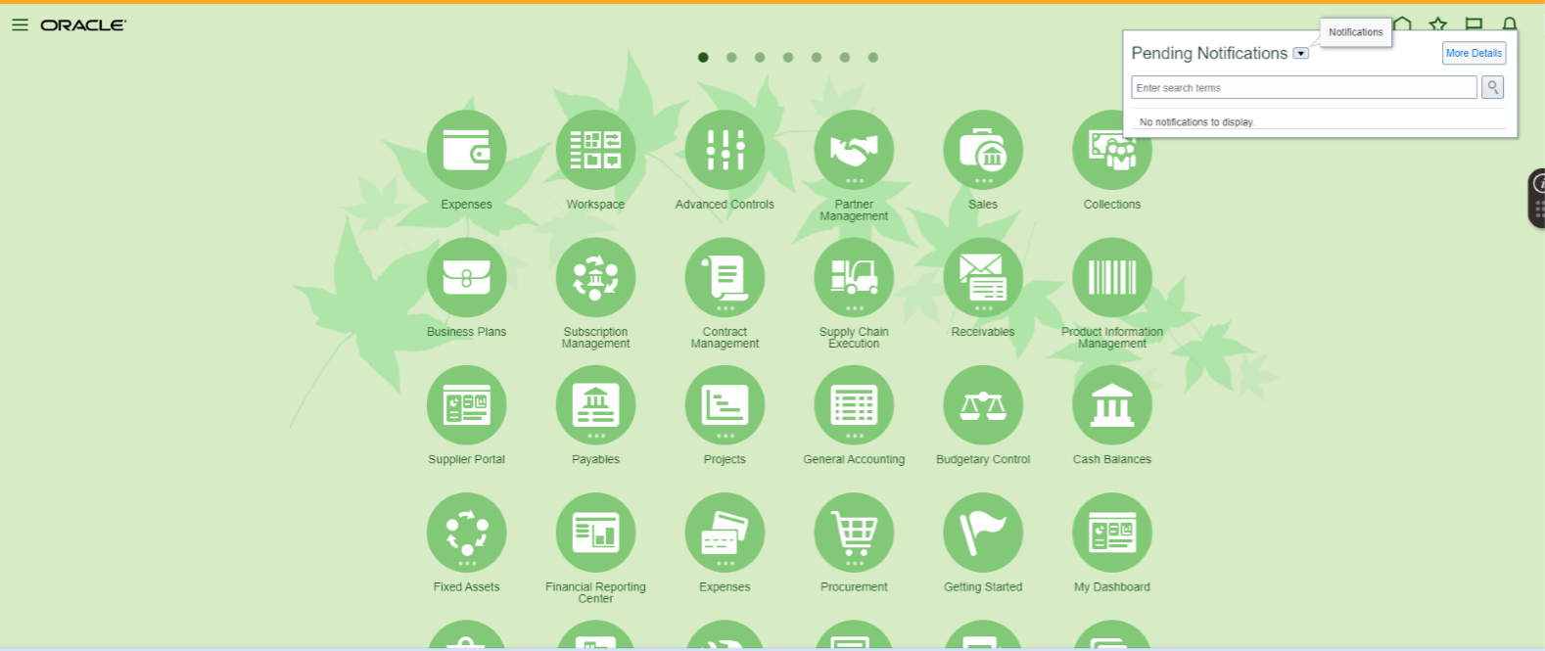

**Step 2:** Click on Profile name > Select Administration > Click on Task configuration

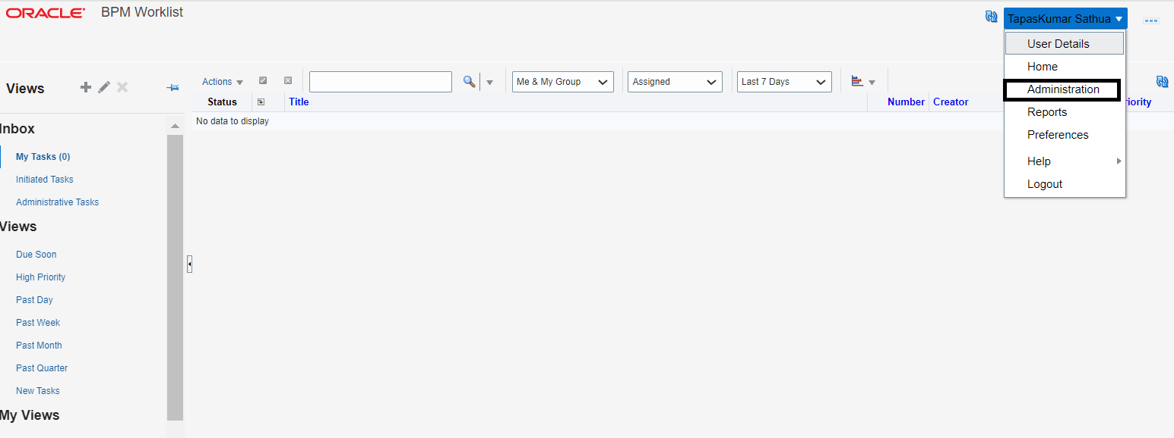

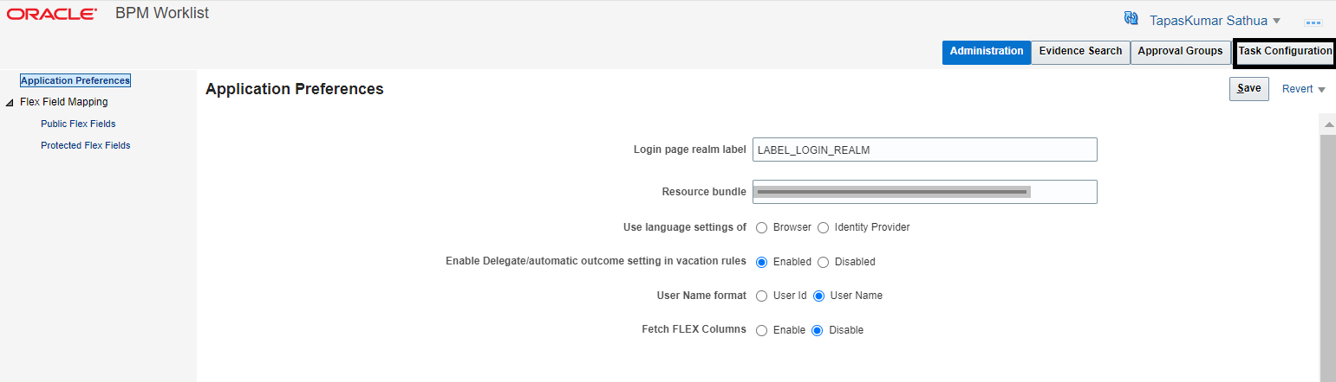

**Step 3:** Search for **FinExmWorkflowExpenseApproval**

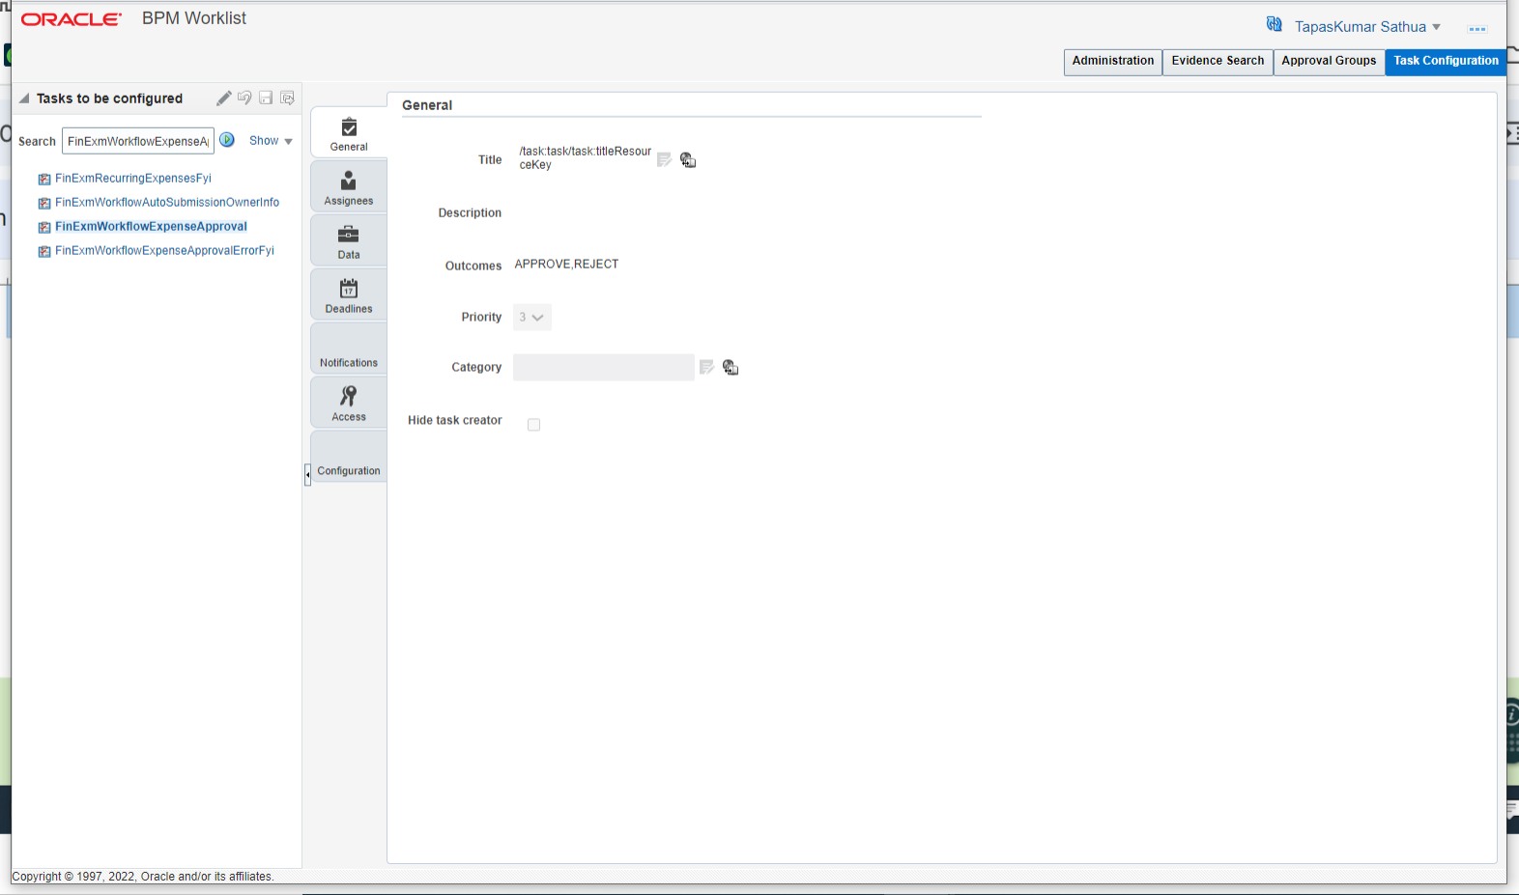

**Step 5:** Click on Edit task > Select configuration

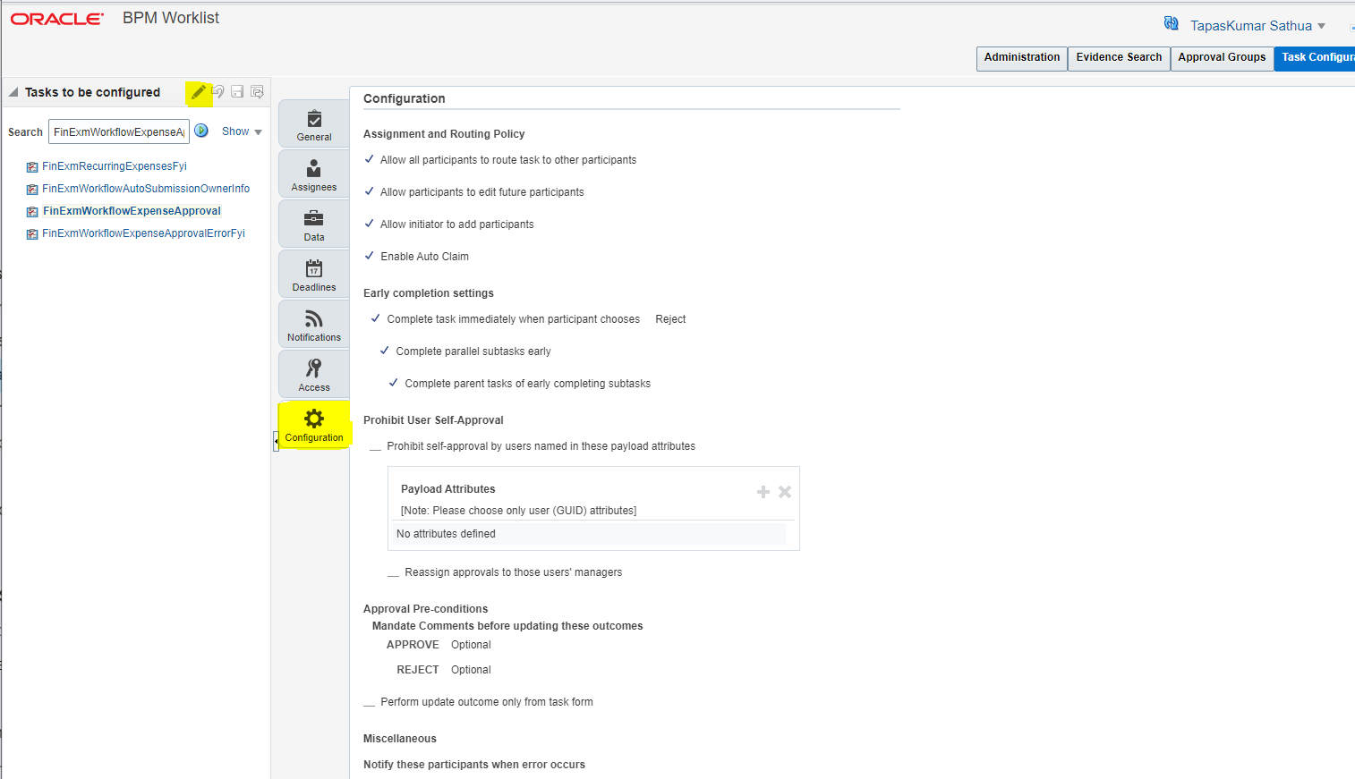

**Step 6:**

6.1: Enable check box “Prohibit self-approval by users named in these payload attributes”

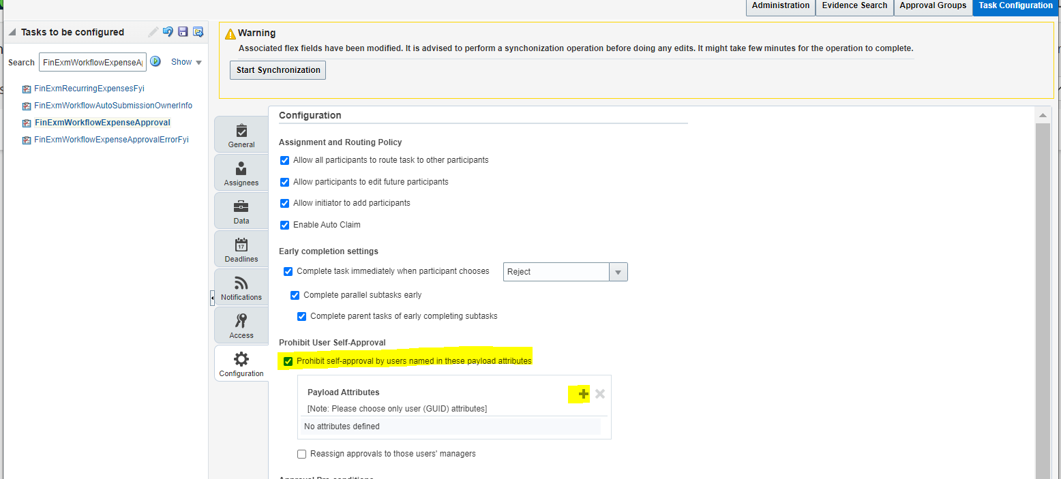

6.2: Click on plus icon and add the attribute “task creator”, click on insert into expression

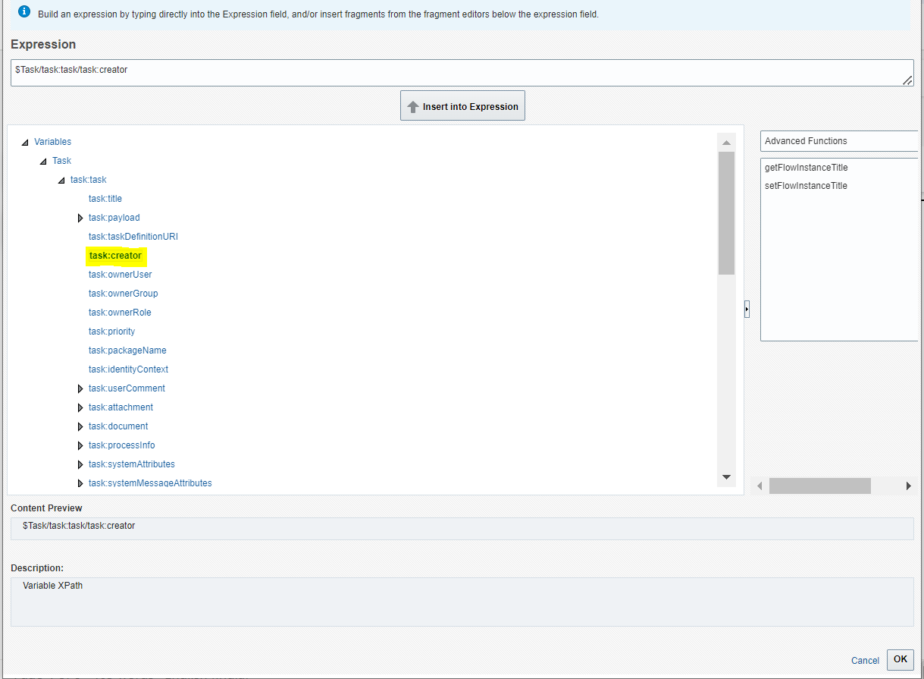

6.3: Also Enable the check box “Reassign approvals to the user’s manager”

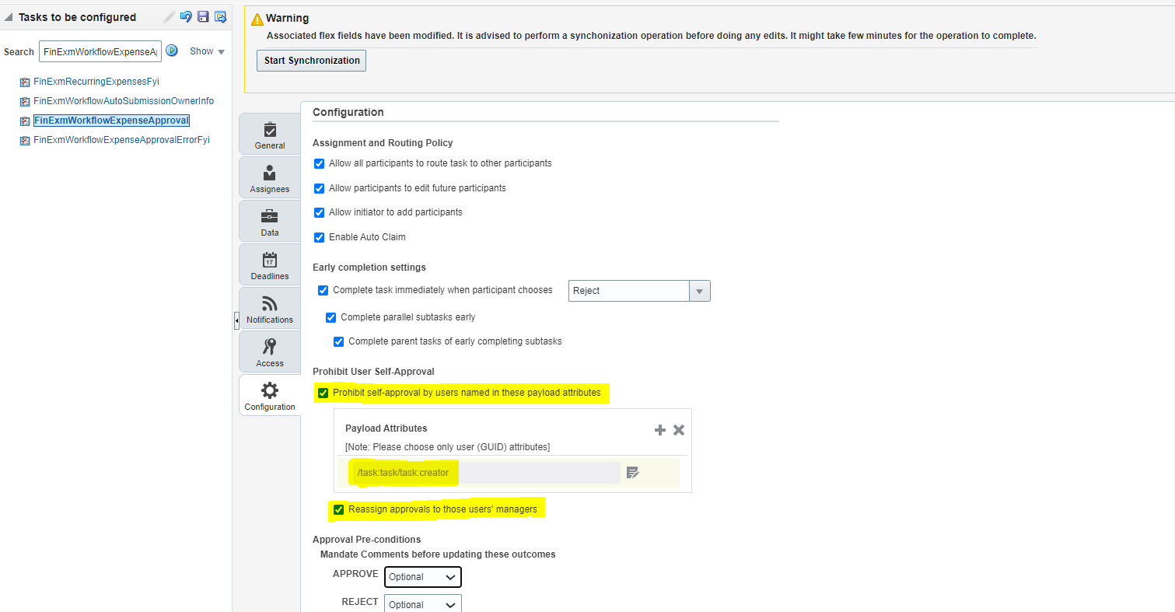

**Step 7:** Click on save and commit

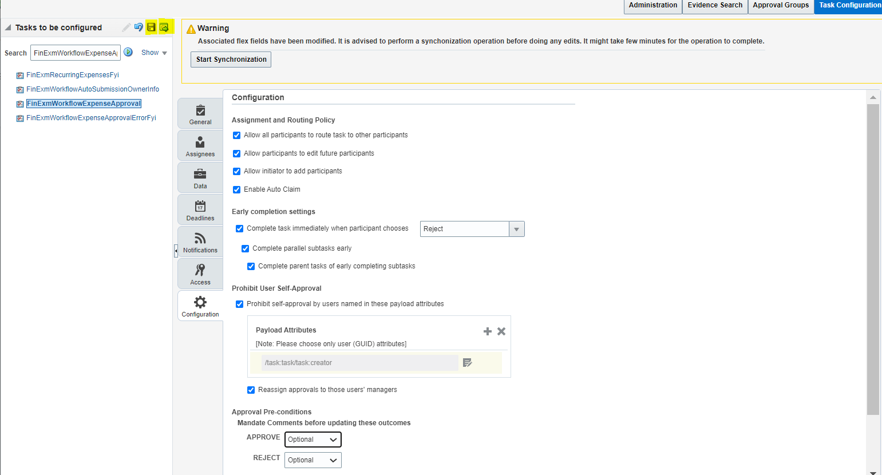

**Conclusion:**

By implementing this approach, we can effectively prevent self-approval of expense and other purchase documents, ensuring that the vacation rule does not trigger any audit concerns in Oracle Fusion. This method safeguards the integrity of the approval process, maintaining compliance and avoiding potential conflicts of interest during the manager's absence.