**IN Transit Parameter**

**Step 1**

Before Purging check the status code for delivery details use this query.

**Document Attached**



**Step 2**

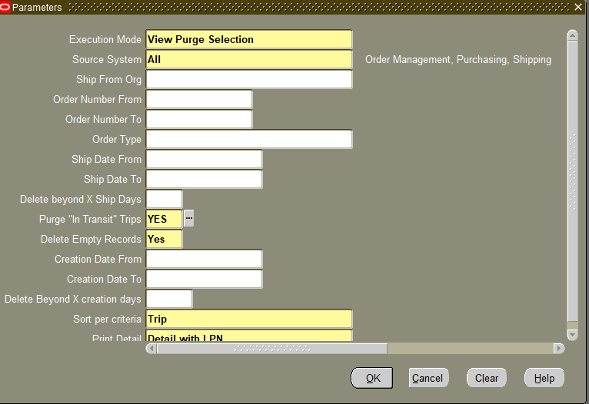

There are some deliveries status codes is ‘IT’ when before purging the program give the ship from /to date range and give the Purge In transit Trips should YES and delete Empty records should YES and creation from/to date should give same date range.