**TITLE: SHIPPING PURGE NAVIGATION PATH**

**Order management**:

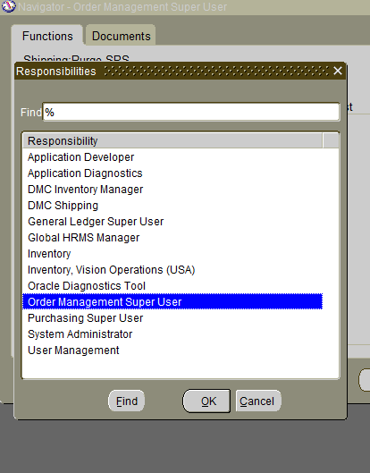

* Select the Order Management responsibility.

* Select the Shipping menu.

* Click the Purge SRS Concurrent Program.

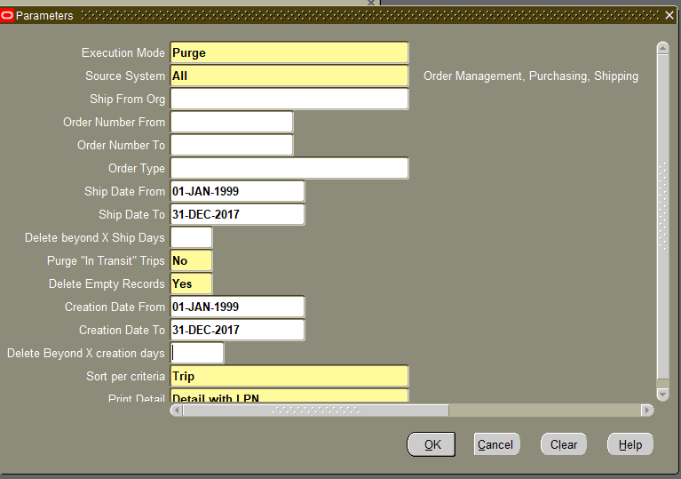

**For Ship Date From/To refer to table WSH_NEW_DELIVERIES table's INITIAL_PICKUP_DATE column. The same date range should be applied to the Creation Date From/To. Set 'Delete Empty Records' to Yes and then submit the program.**

Note: Give the date range for six months to run the program.

Date: START DATE 01-JAN-1999 END DATE 31-DEC-2017.